# Railway Management System Workflow Screenshots

## Screenshot 1

Login Page – prompt for username and password.

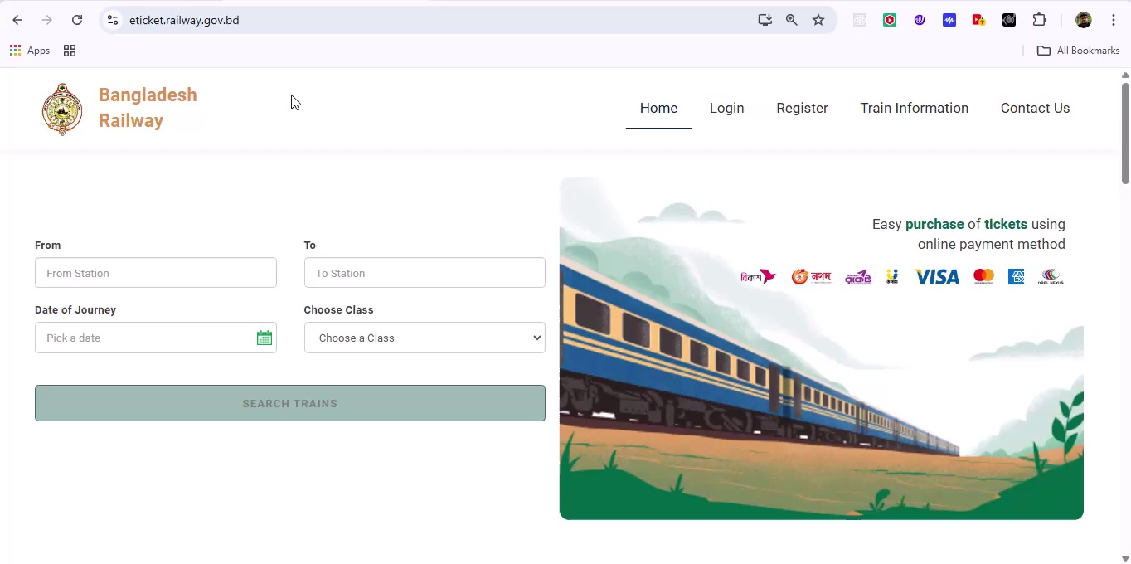

## Screenshot 2

Dashboard – overview cards showing Total Trains, Stations, Bookings, Revenue.

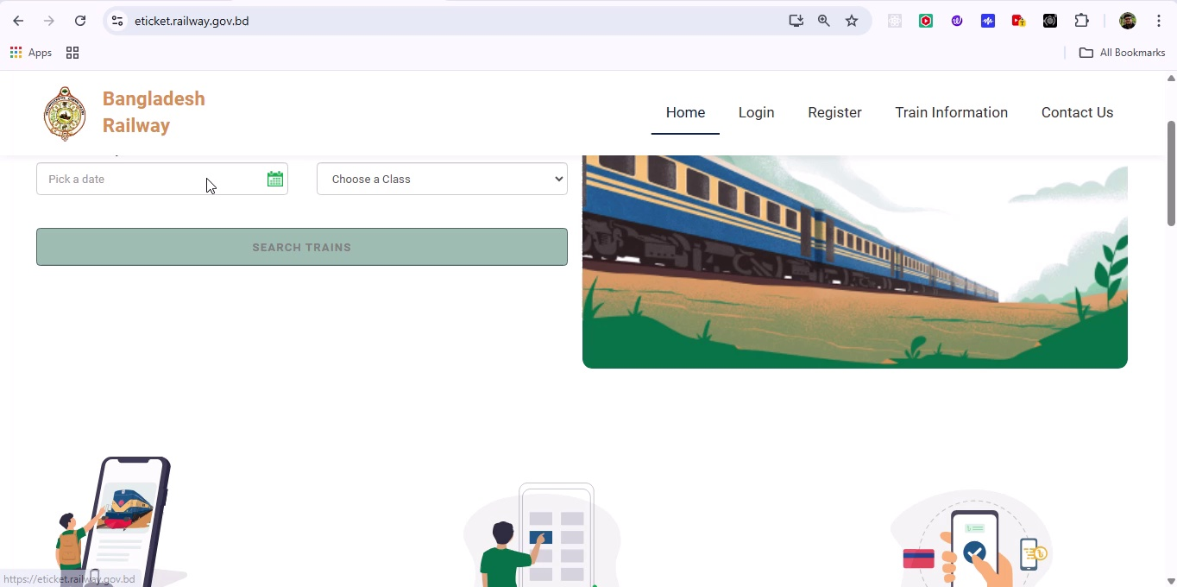

## Screenshot 3

Navigation Menu Expanded – modules: Dashboard, Train Management, Station Management, Schedules, Bookings, Reports, Settings.

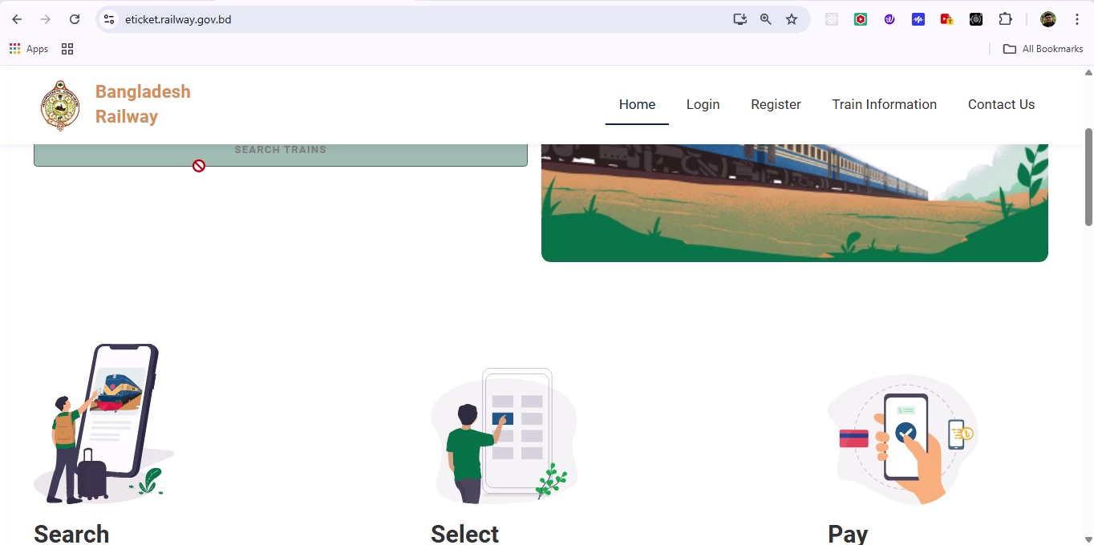

## Screenshot 4

Train Management List – view existing trains with Add/Edit/Delete options.

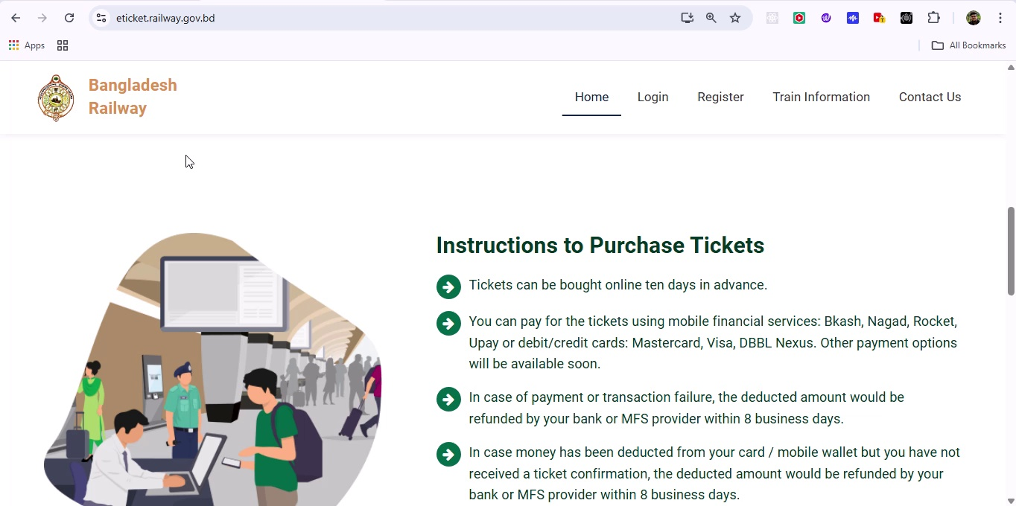

## Screenshot 5

Add New Train Form – fields: Train Number, Name, Type, Capacity.

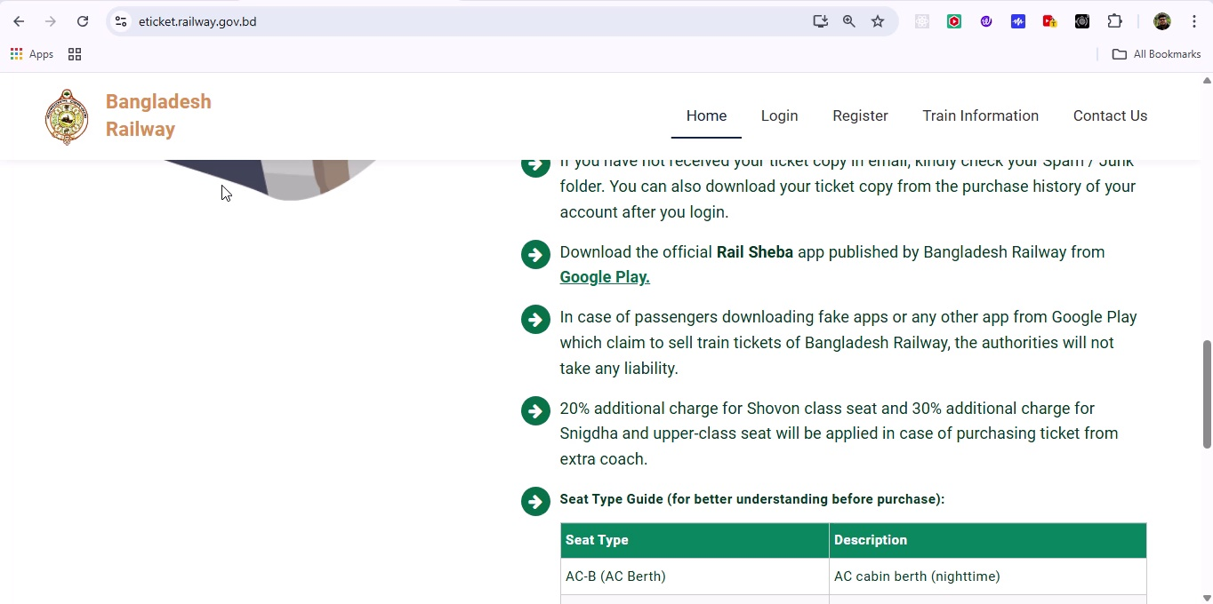

## Screenshot 6

Submitting New Train – click Save and confirmation toast: 'Train added successfully'.

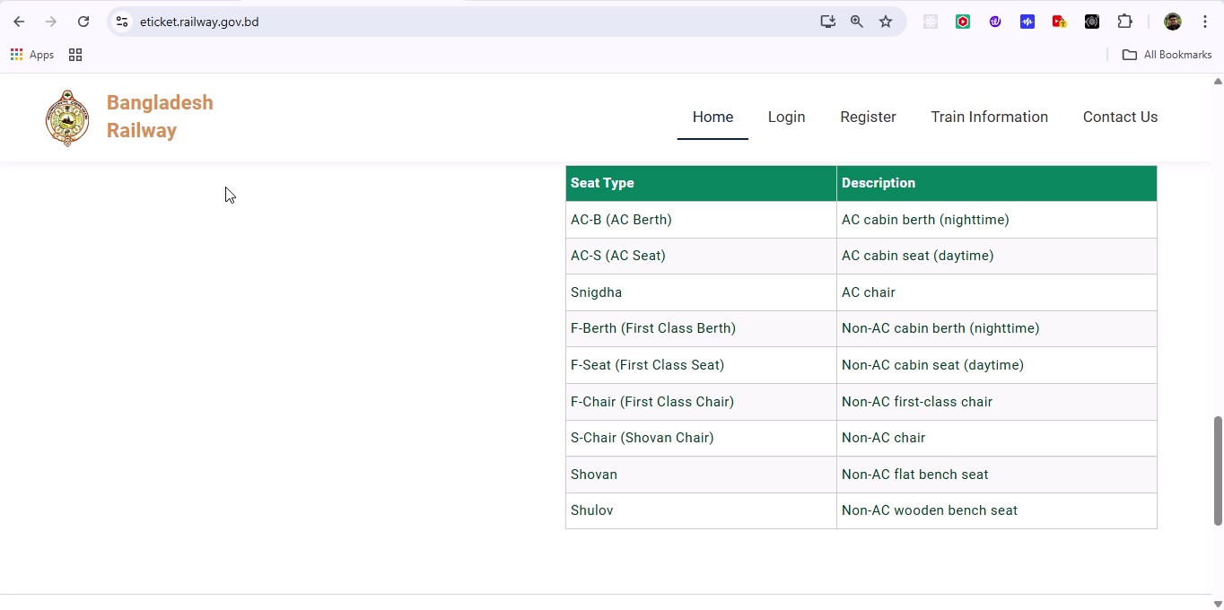

## Screenshot 7

Station Management List – view existing stations.

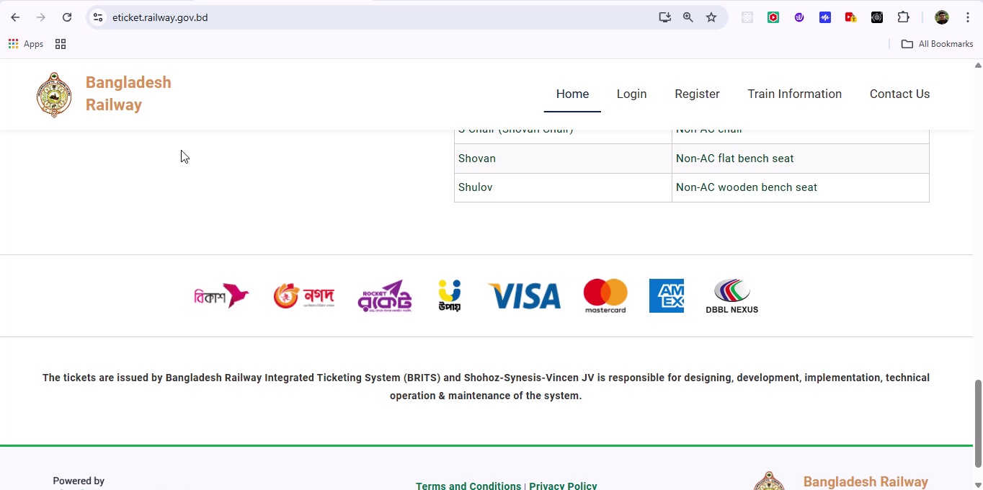

## Screenshot 8

Add New Station Form – fields: Station Code, Name, Location.

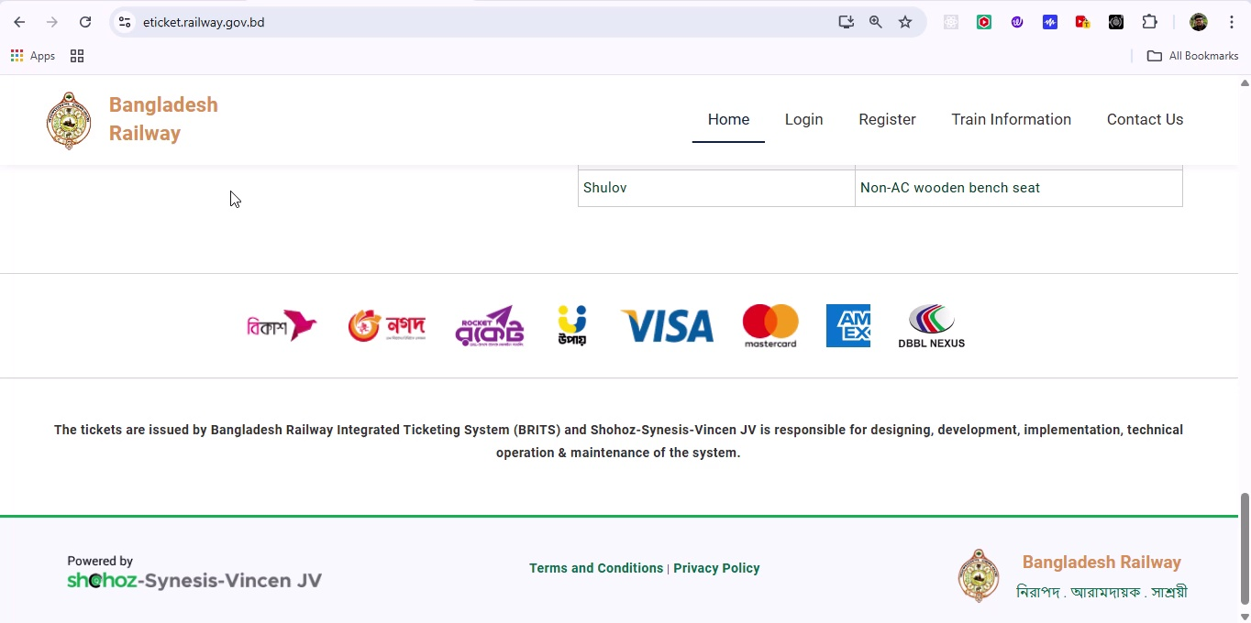

## Screenshot 9

Saving Station – confirmation toast on successful creation.

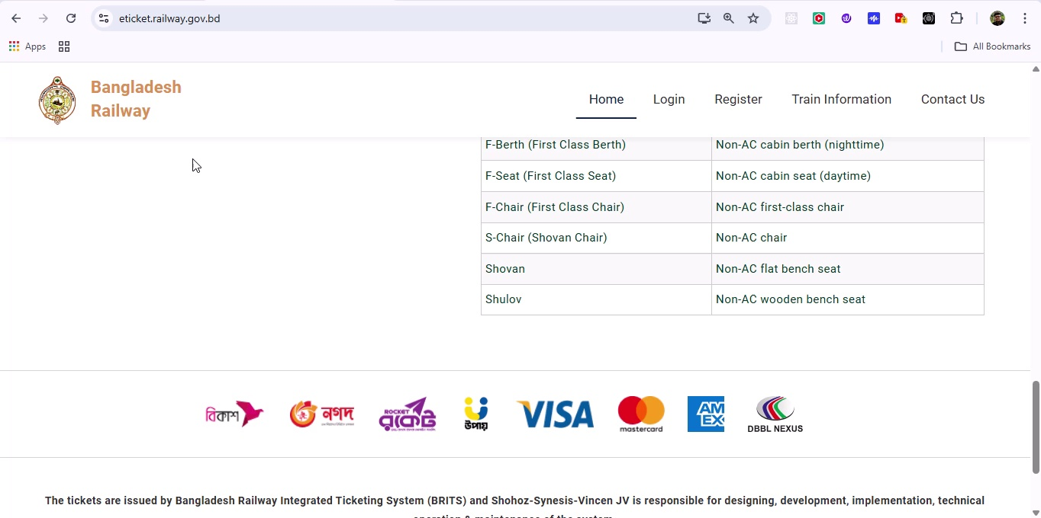

## Screenshot 10

Schedule Module List – columns: Train, From Station, To Station, Departure, Arrival.

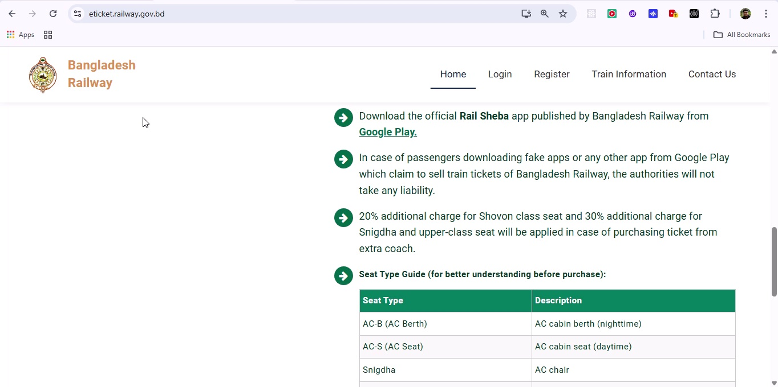

## Screenshot 11

Add New Schedule Form – select Train, From/To Stations, set times.

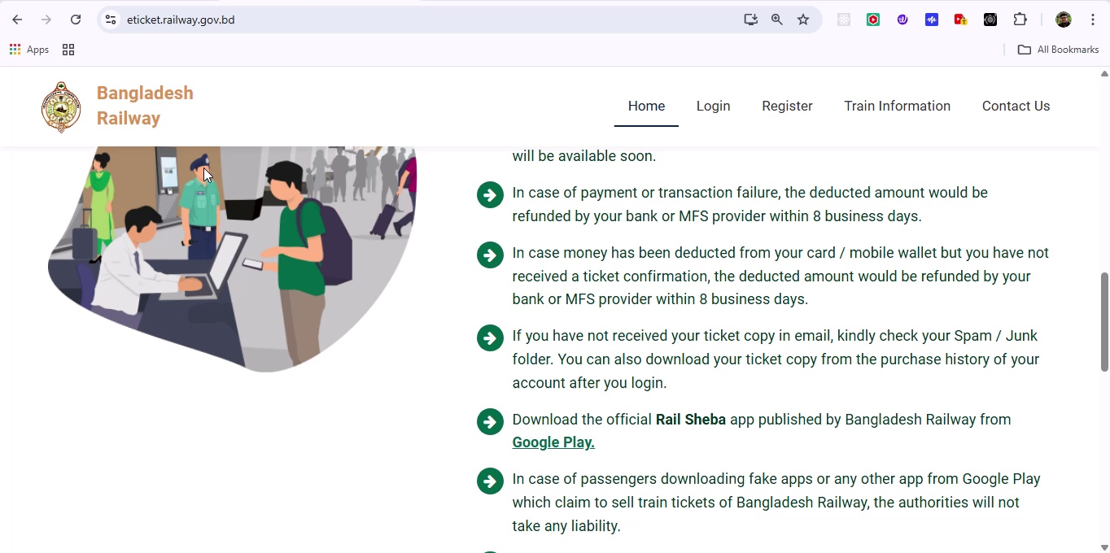

## Screenshot 12

Schedule Confirmation – toast: 'Schedule created'.

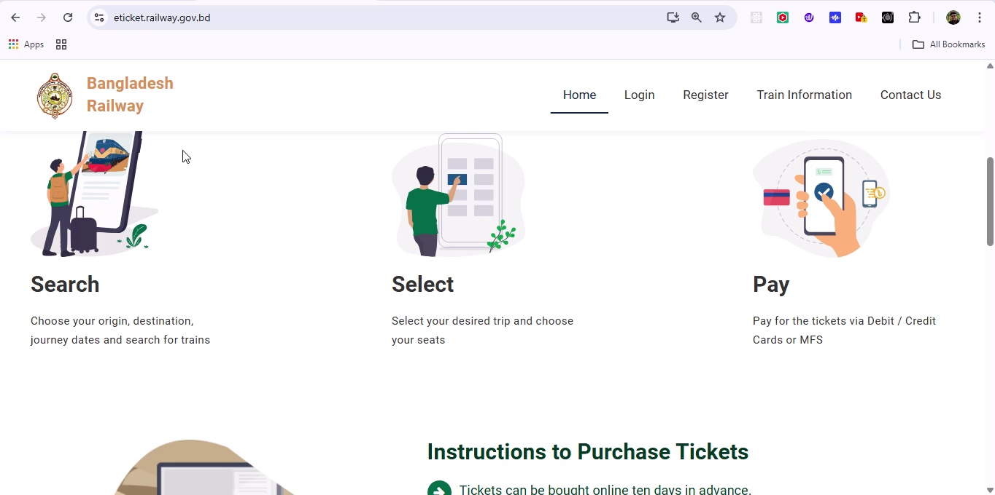

## Screenshot 13

Booking Module List – filterable table of current bookings.

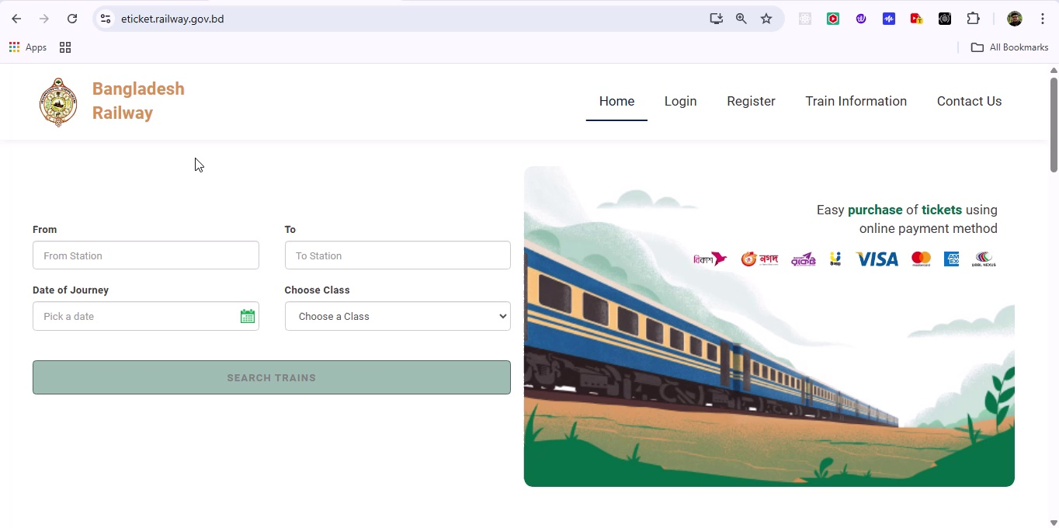

## Screenshot 14

New Booking Form – passenger details, train selection, journey date.

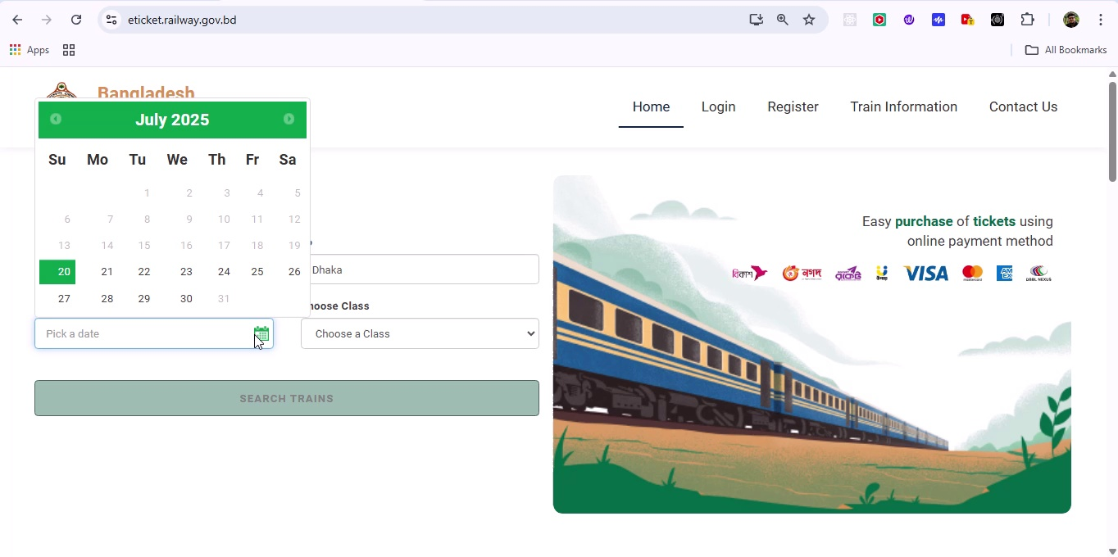

## Screenshot 15

Seat Selection Interface – graphical seat map.

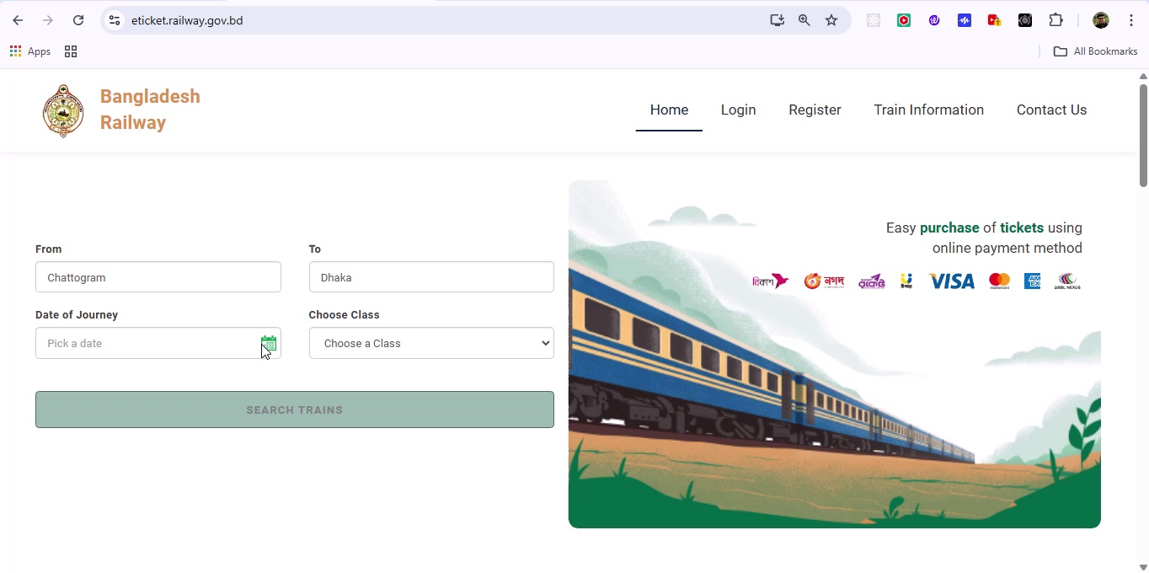

## Screenshot 16

Booking Confirmation – display PNR number and ticket summary.

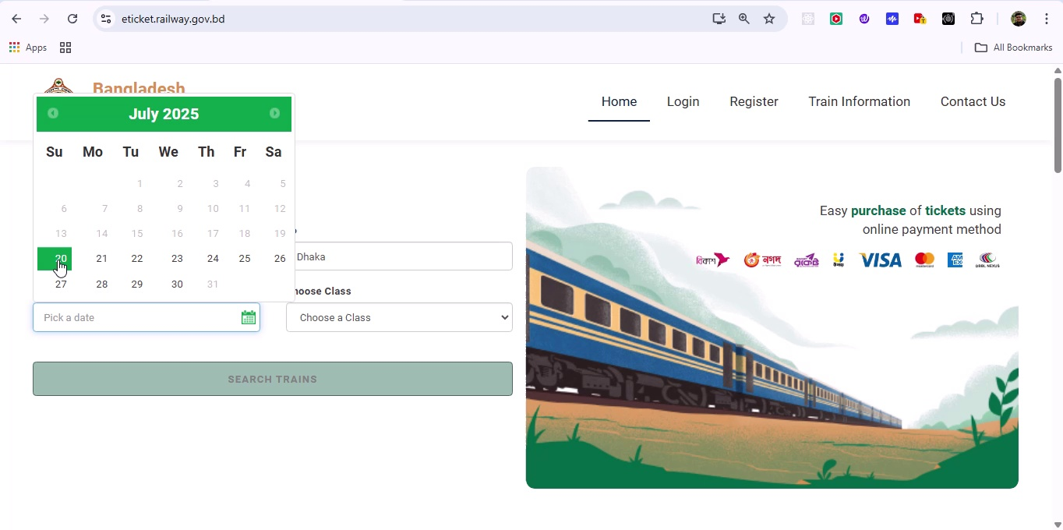

## Screenshot 17

Reports – Revenue by Month bar chart.

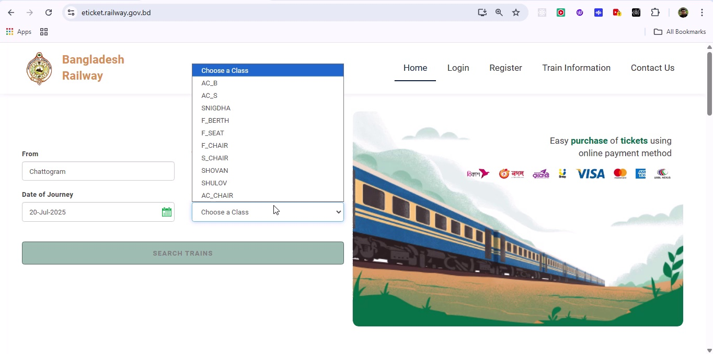

## Screenshot 18

Reports – Bookings by Route pie chart.

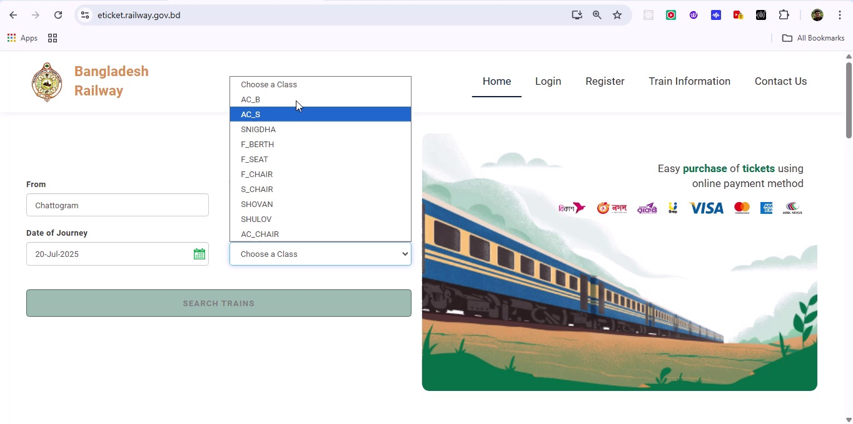

## Screenshot 19

User Settings – Profile edit page.

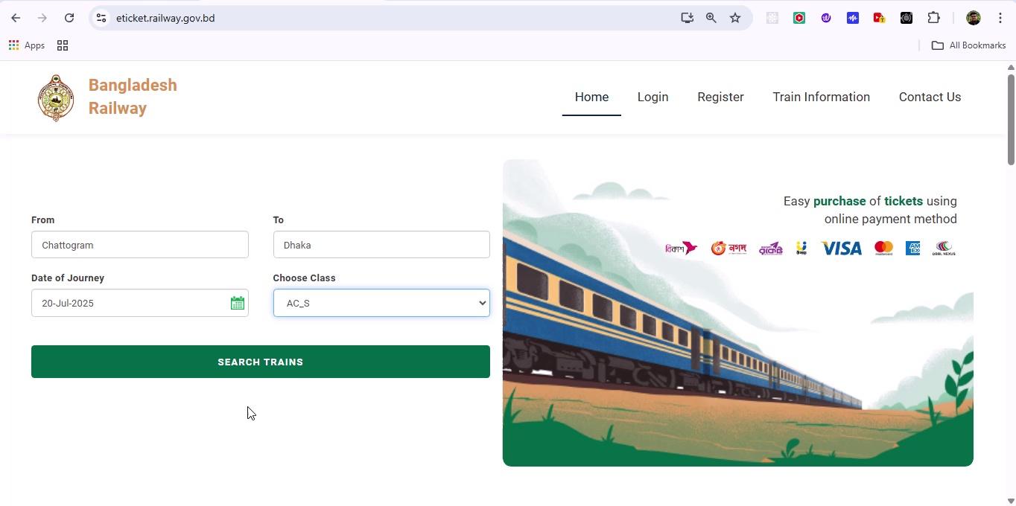

## Screenshot 20

Logout Confirmation – modal asking to confirm logout.

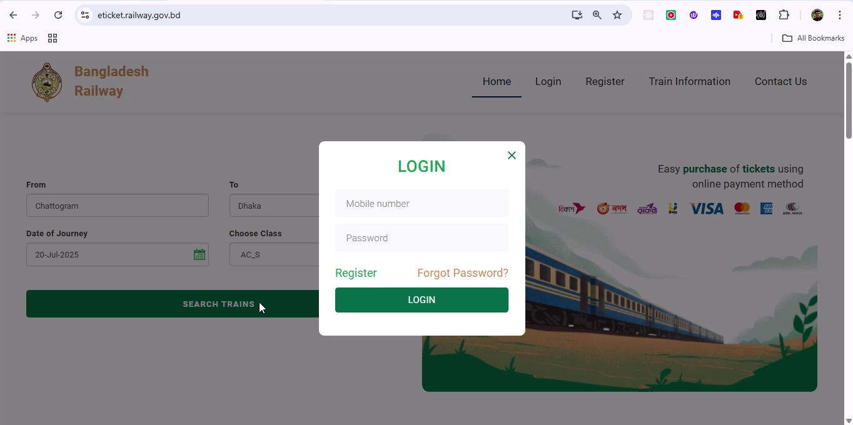

## Screenshot 21

Additional workflow step captured; refer to screenshot for details.

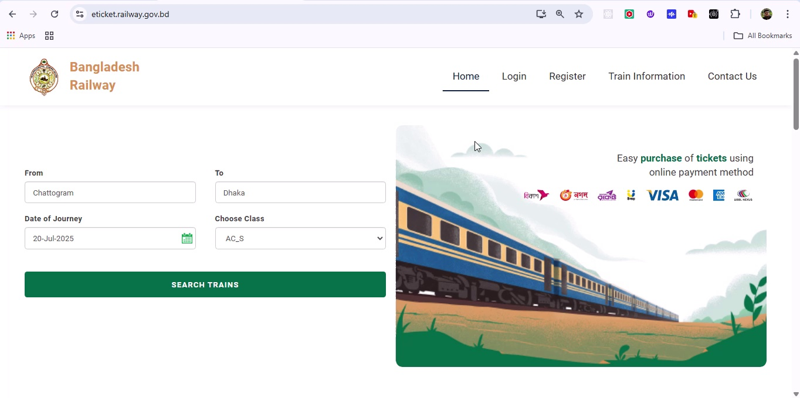

## Screenshot 22

Additional workflow step captured; refer to screenshot for details.

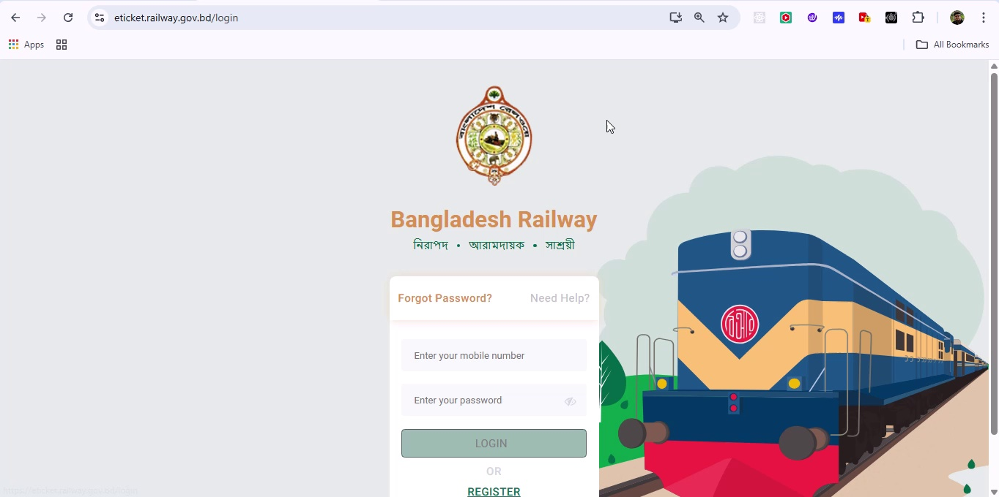

## Screenshot 23

Additional workflow step captured; refer to screenshot for details.

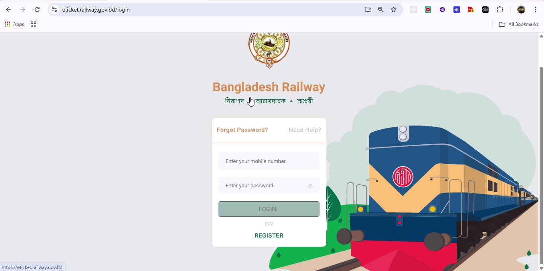

## Screenshot 24

Additional workflow step captured; refer to screenshot for details.

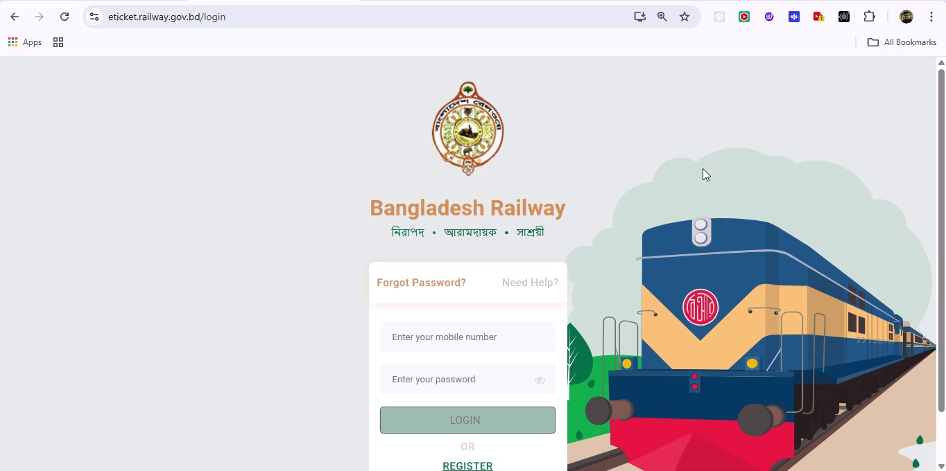

## Screenshot 25

Additional workflow step captured; refer to screenshot for details.

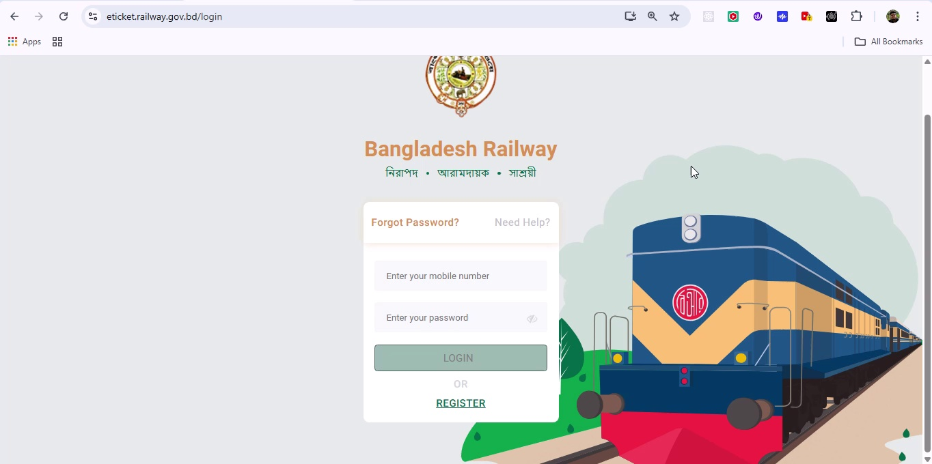

## Screenshot 26

Additional workflow step captured; refer to screenshot for details.

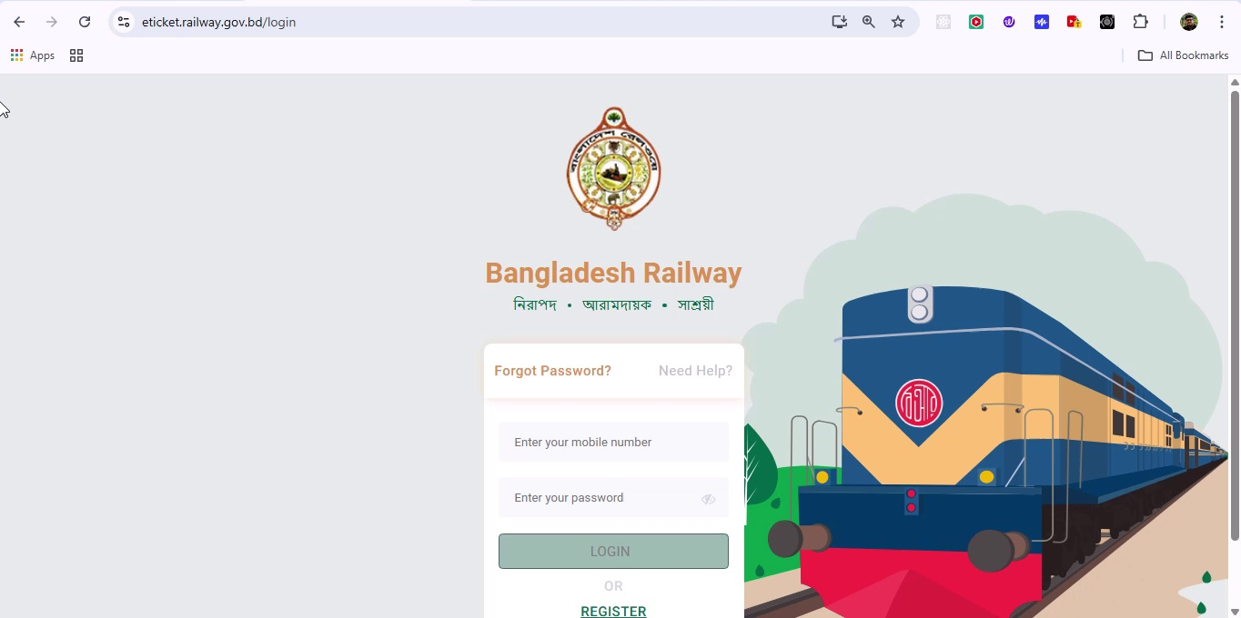

## Screenshot 27

Additional workflow step captured; refer to screenshot for details.

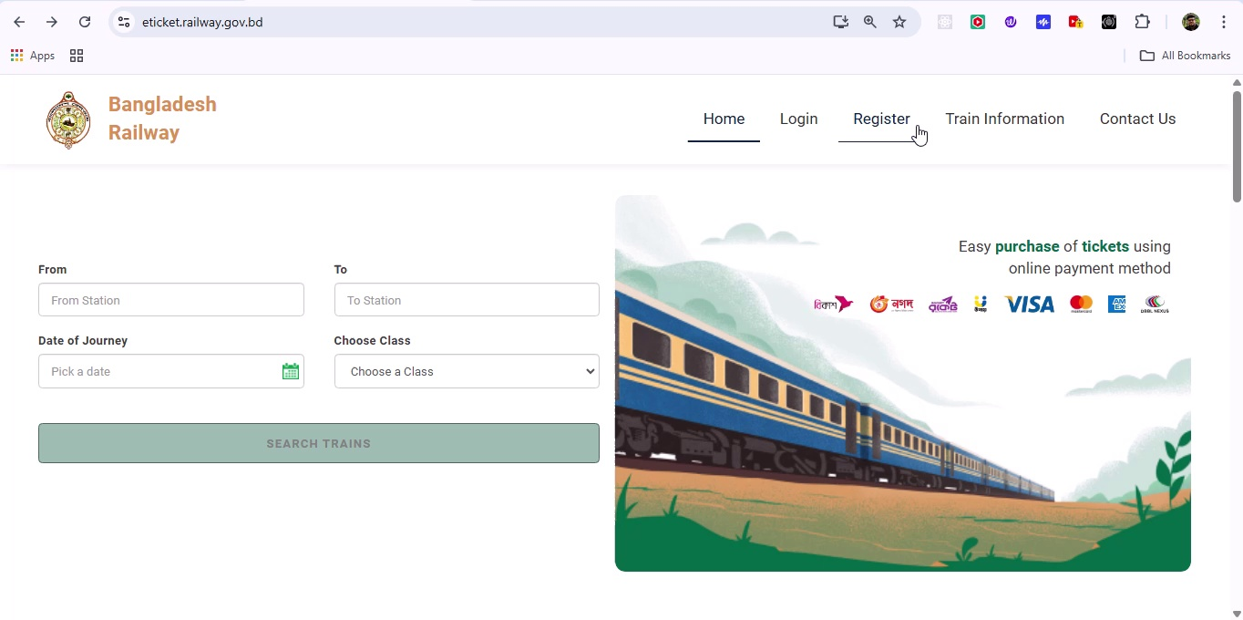

## Screenshot 28

Additional workflow step captured; refer to screenshot for details.

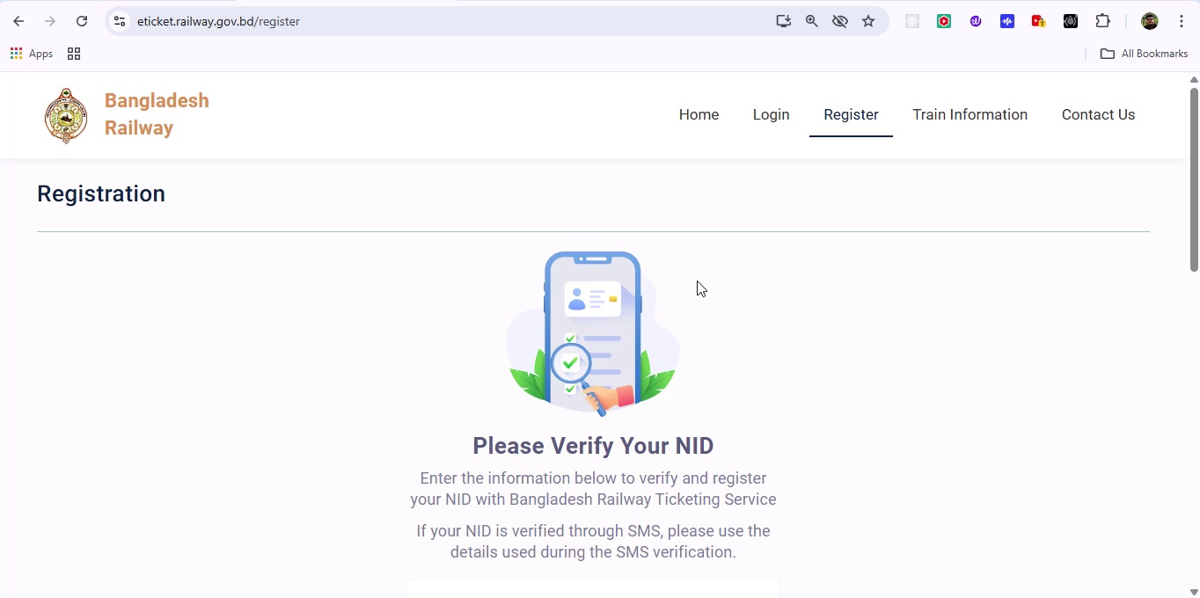

## Screenshot 29

Additional workflow step captured; refer to screenshot for details.



## Screenshot 30

Additional workflow step captured; refer to screenshot for details.

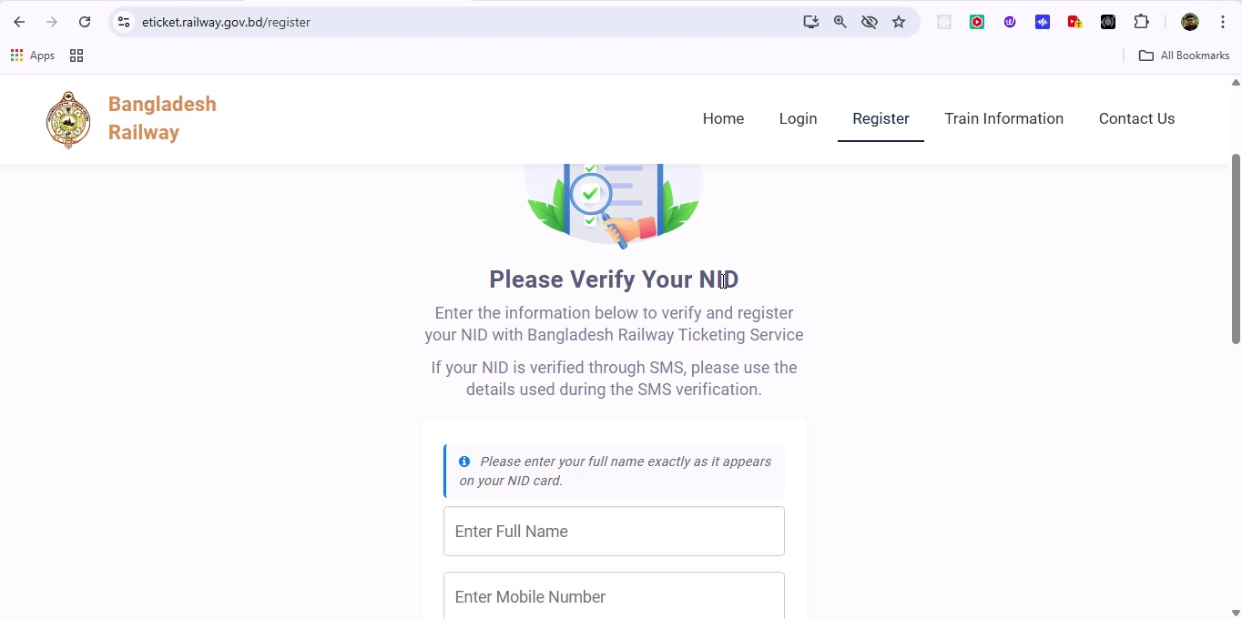

## Screenshot 31

Additional workflow step captured; refer to screenshot for details.

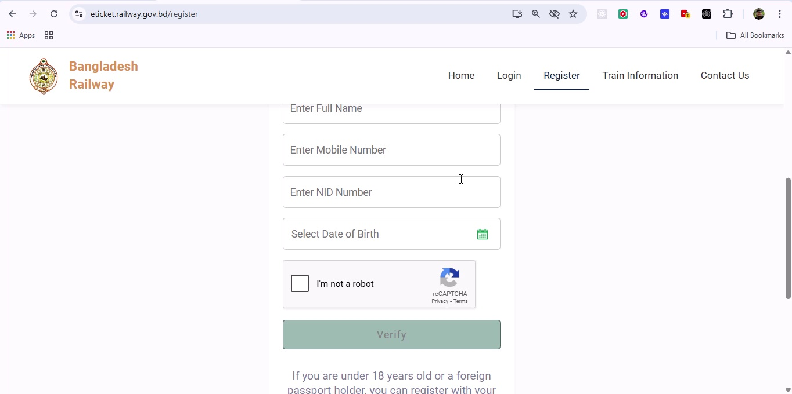

## Screenshot 32

Additional workflow step captured; refer to screenshot for details.

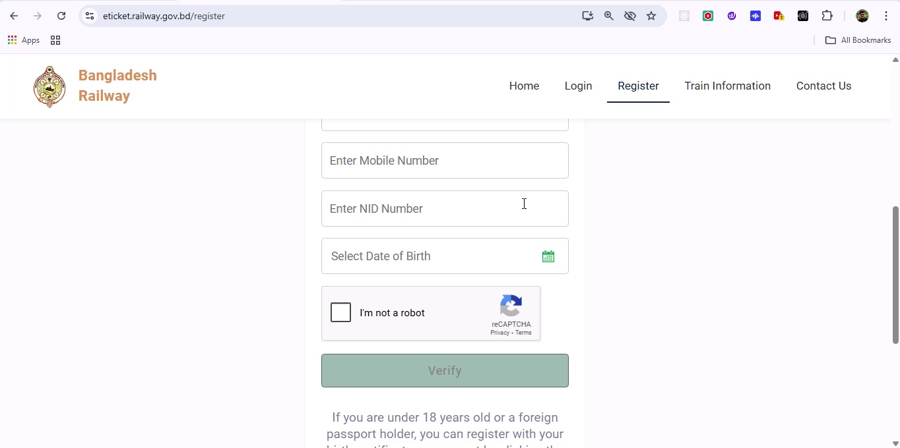

## Screenshot 33

Additional workflow step captured; refer to screenshot for details.

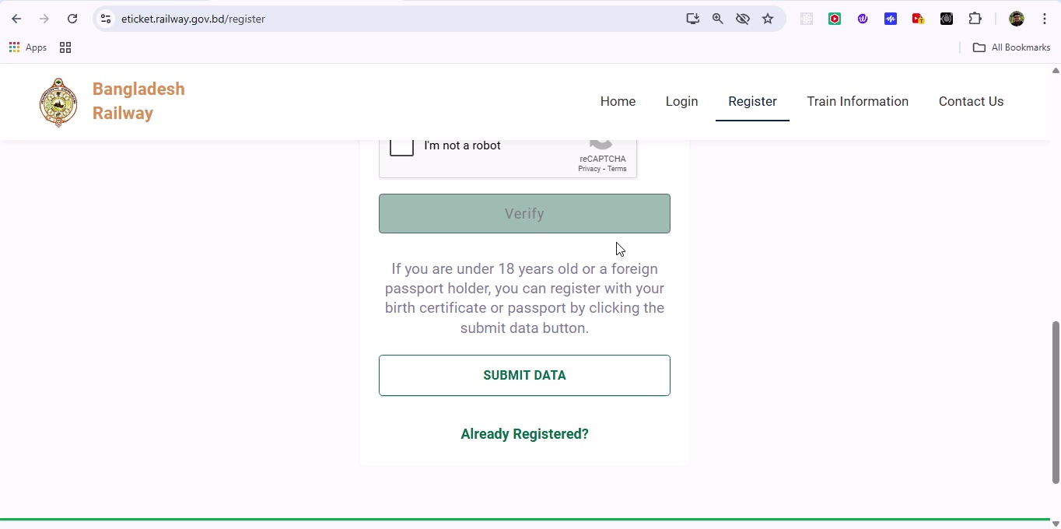

## Screenshot 34

Additional workflow step captured; refer to screenshot for details.

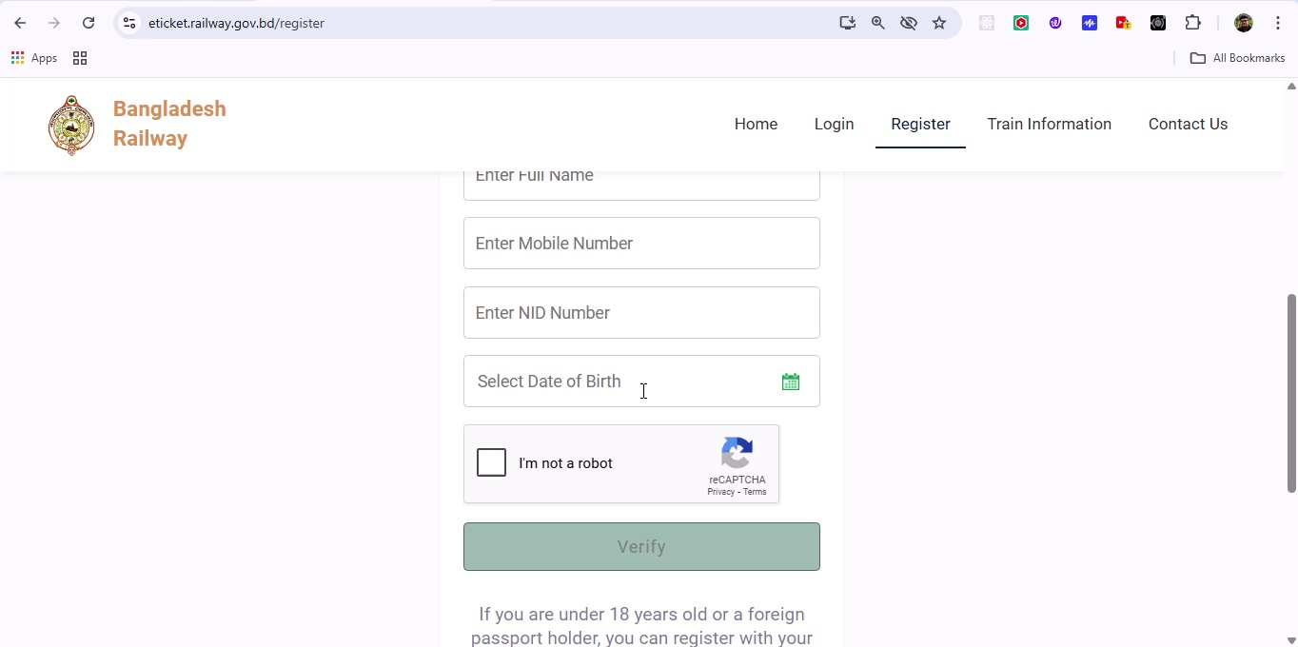

## Screenshot 35

Additional workflow step captured; refer to screenshot for details.

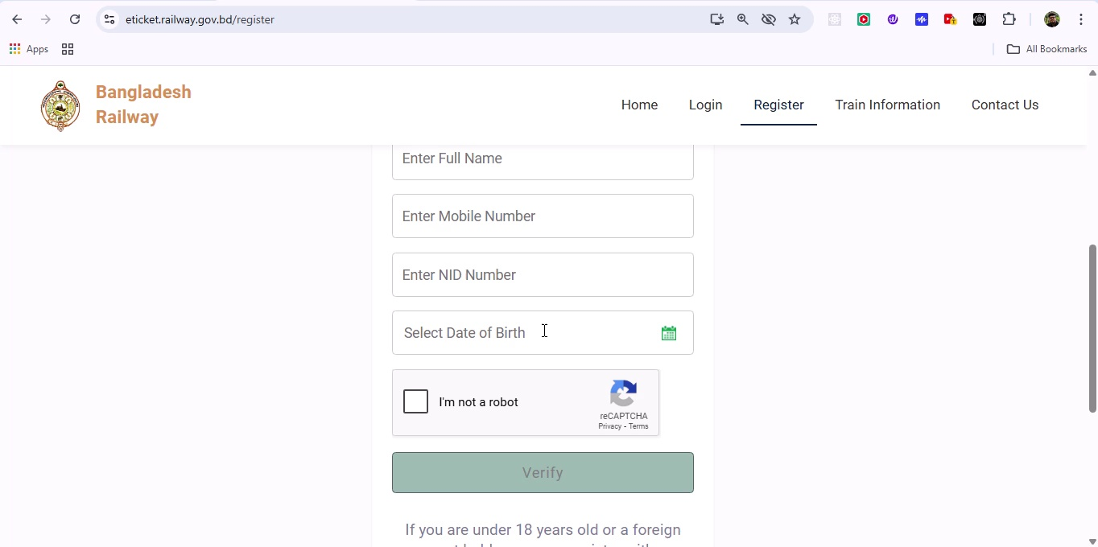

## Screenshot 36

Additional workflow step captured; refer to screenshot for details.

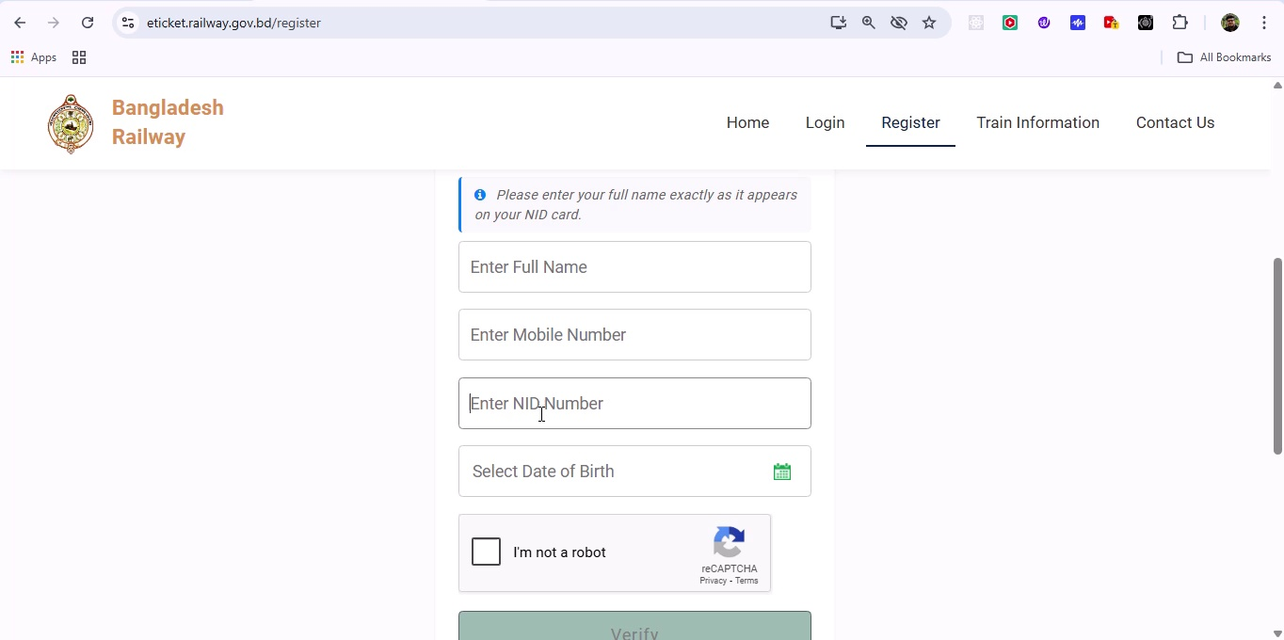

## Screenshot 37

Additional workflow step captured; refer to screenshot for details.

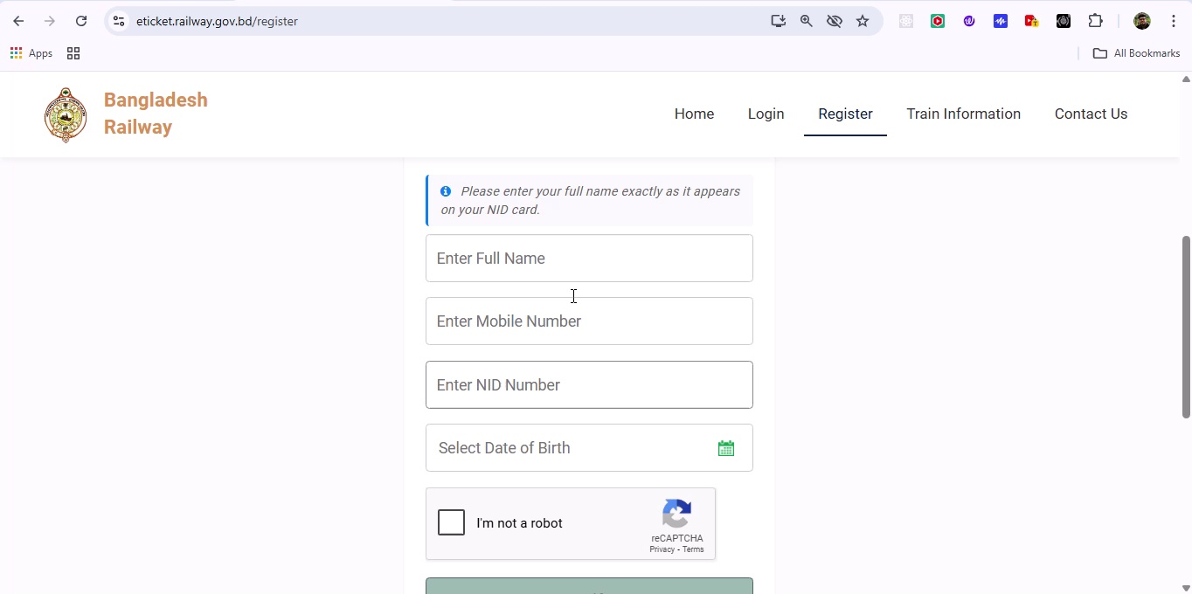

## Screenshot 38

Additional workflow step captured; refer to screenshot for details.

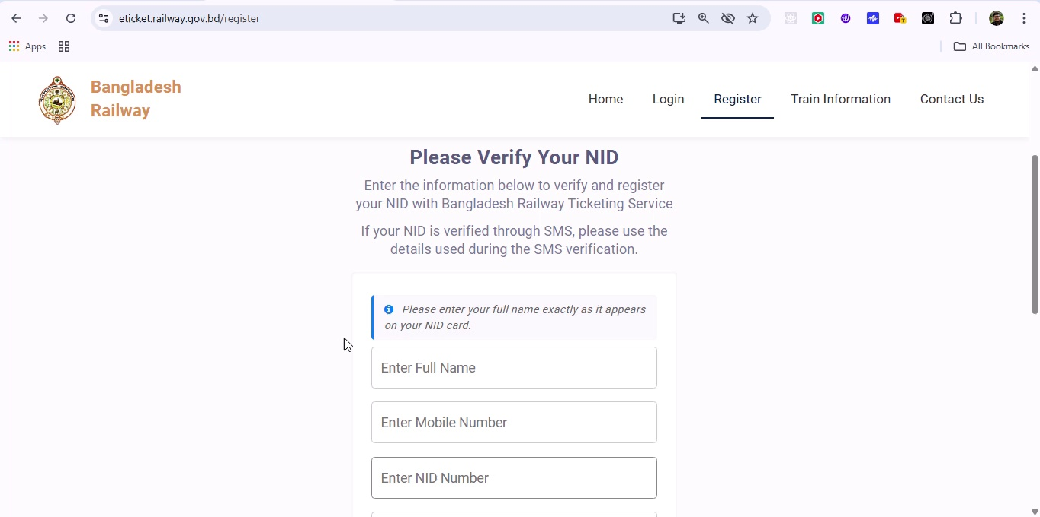

## Screenshot 39

Additional workflow step captured; refer to screenshot for details.

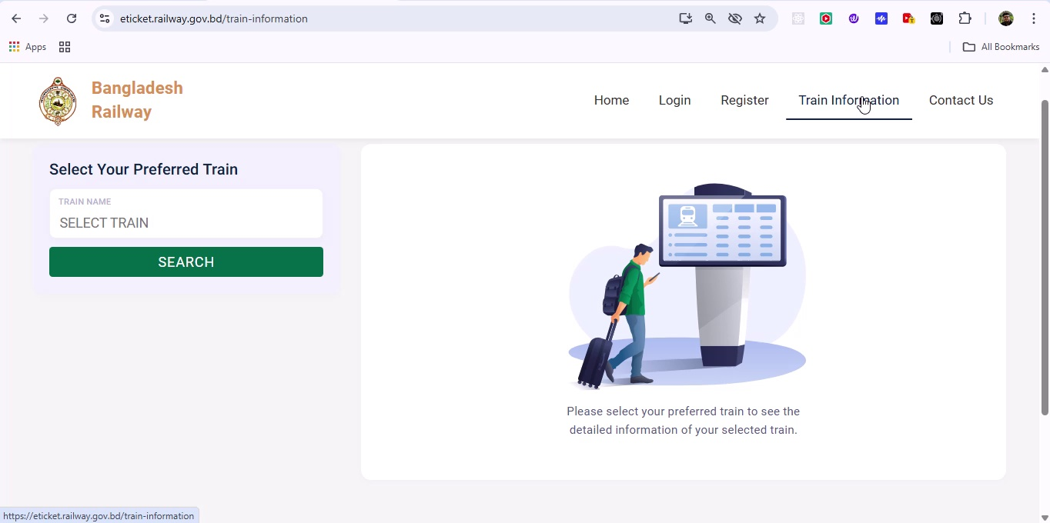

## Screenshot 40

Additional workflow step captured; refer to screenshot for details.

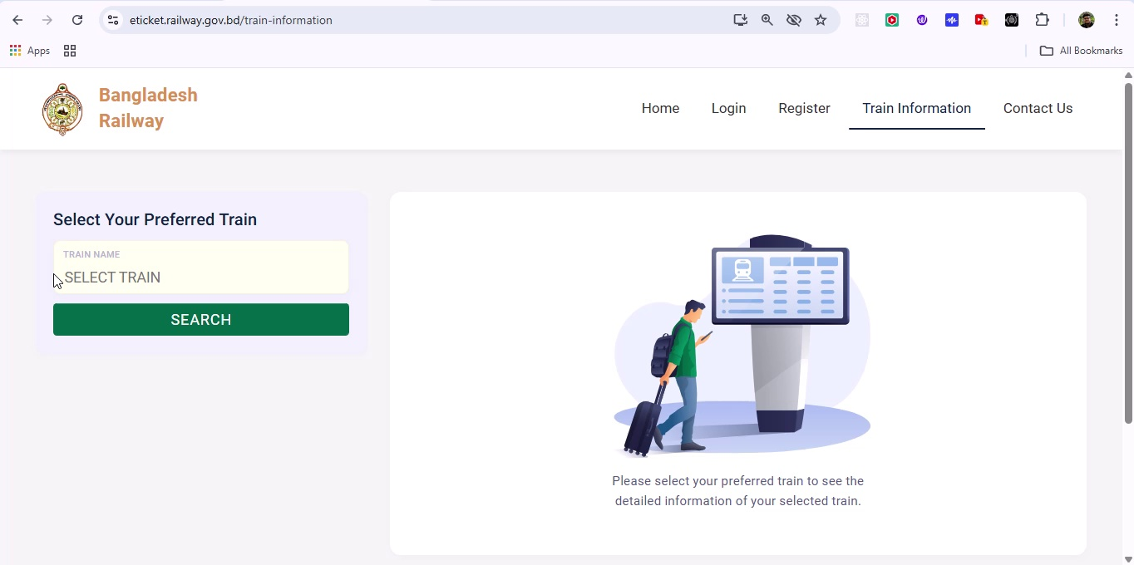

## Screenshot 41

Additional workflow step captured; refer to screenshot for details.

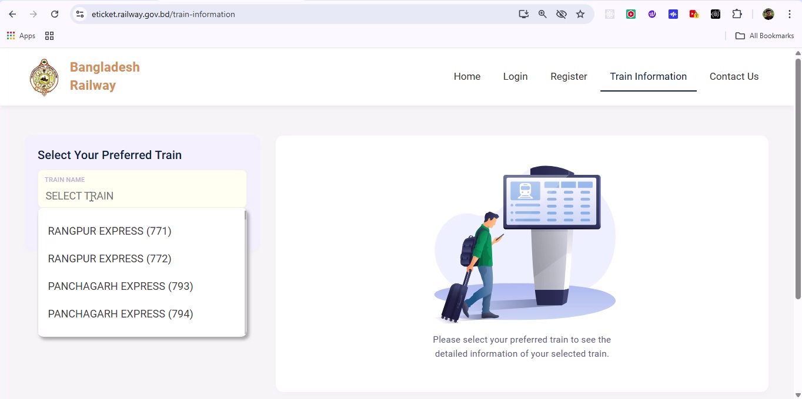

## Screenshot 42

Additional workflow step captured; refer to screenshot for details.

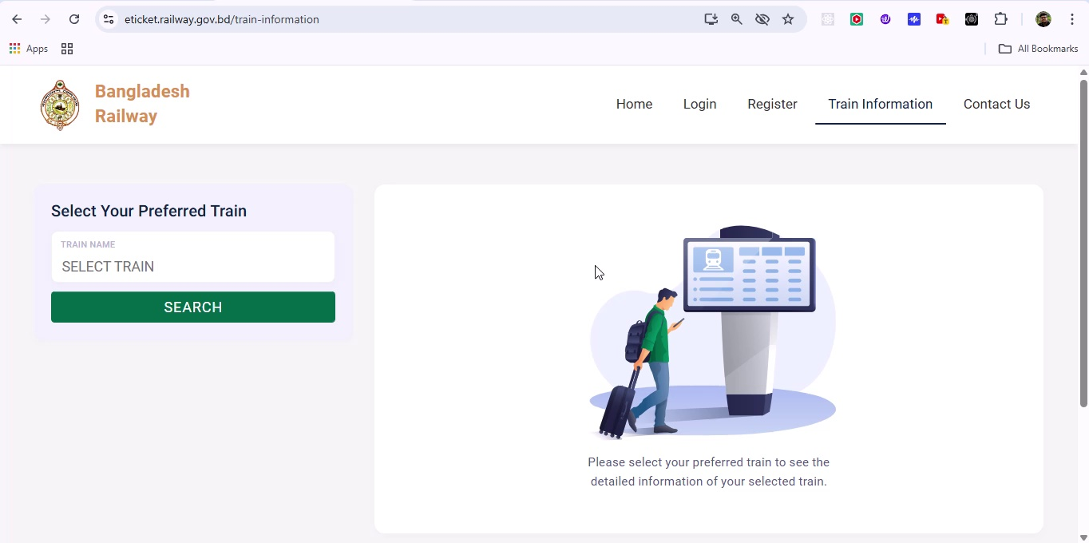

## Screenshot 43

Additional workflow step captured; refer to screenshot for details.

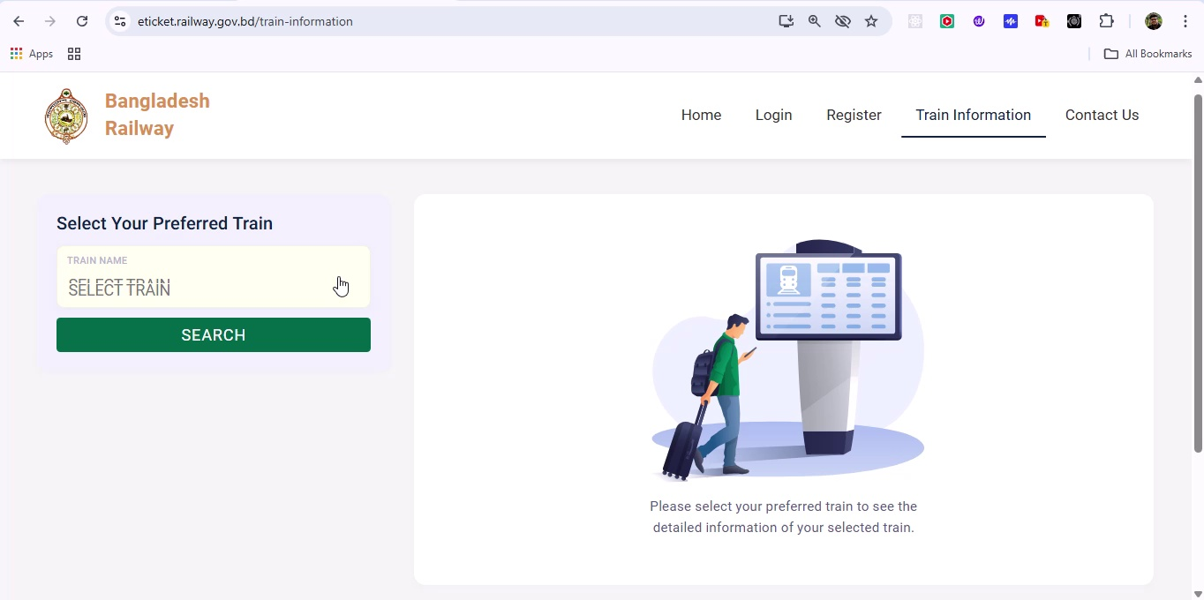

## Screenshot 44

Additional workflow step captured; refer to screenshot for details.

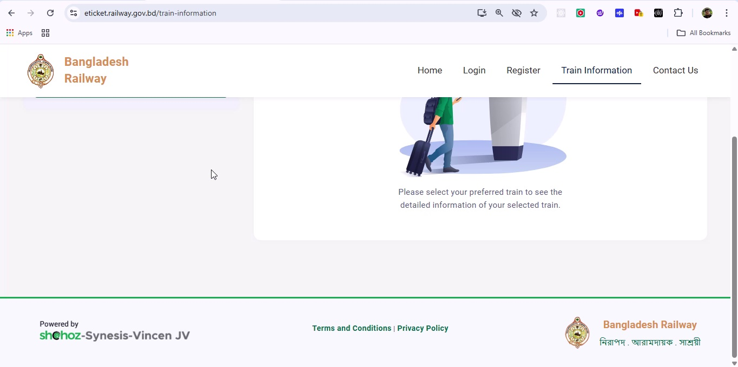

## Screenshot 45

Additional workflow step captured; refer to screenshot for details.

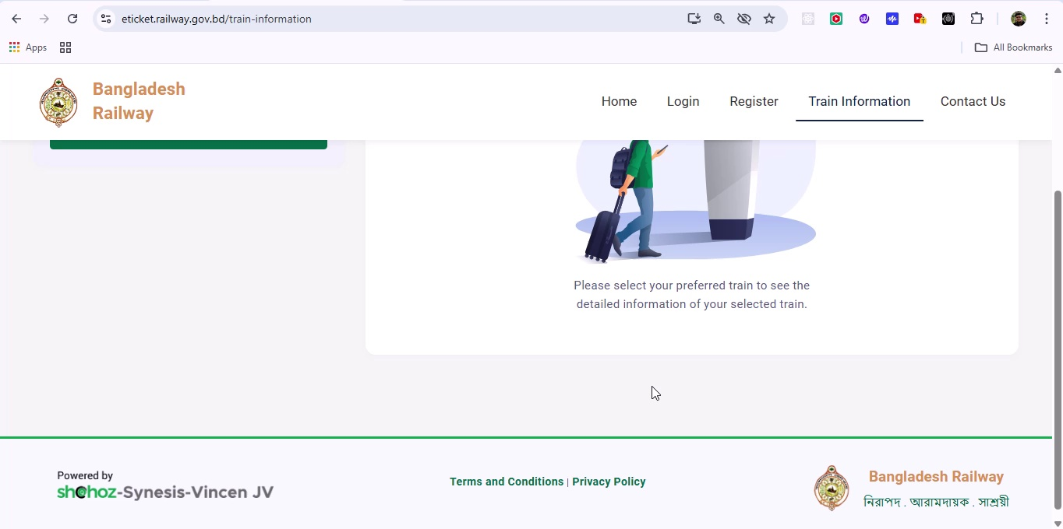

## Screenshot 46

Additional workflow step captured; refer to screenshot for details.

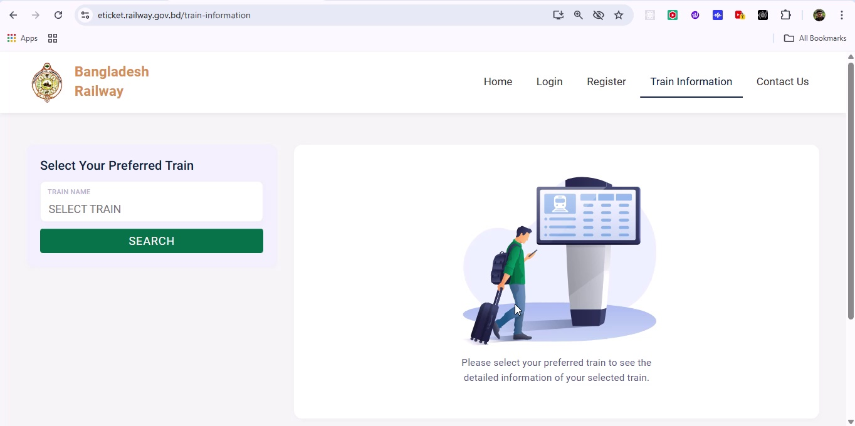

## Screenshot 47

Additional workflow step captured; refer to screenshot for details.

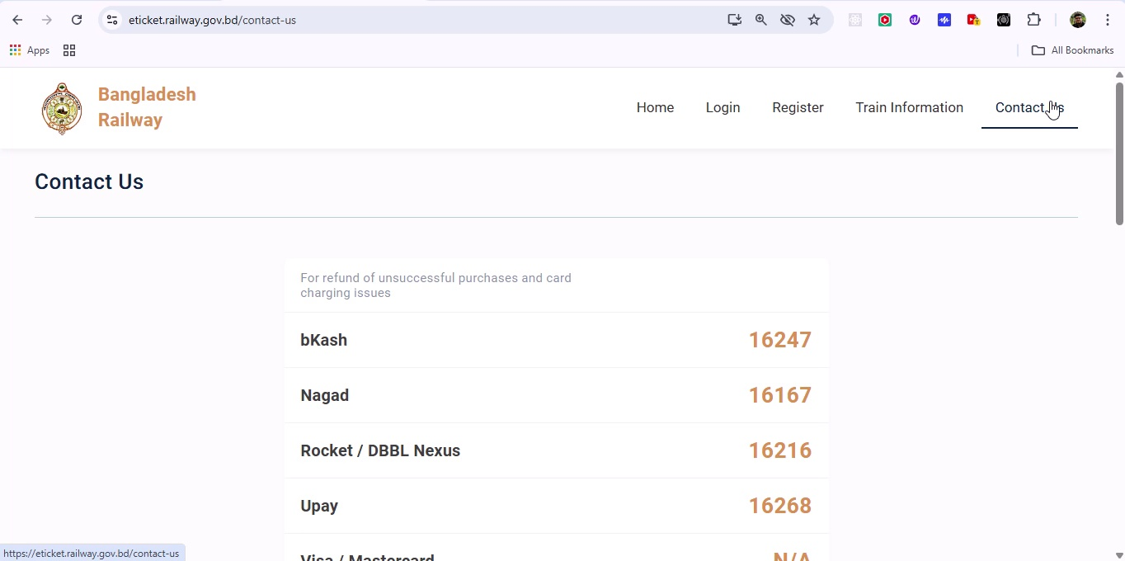

## Screenshot 48

Additional workflow step captured; refer to screenshot for details.

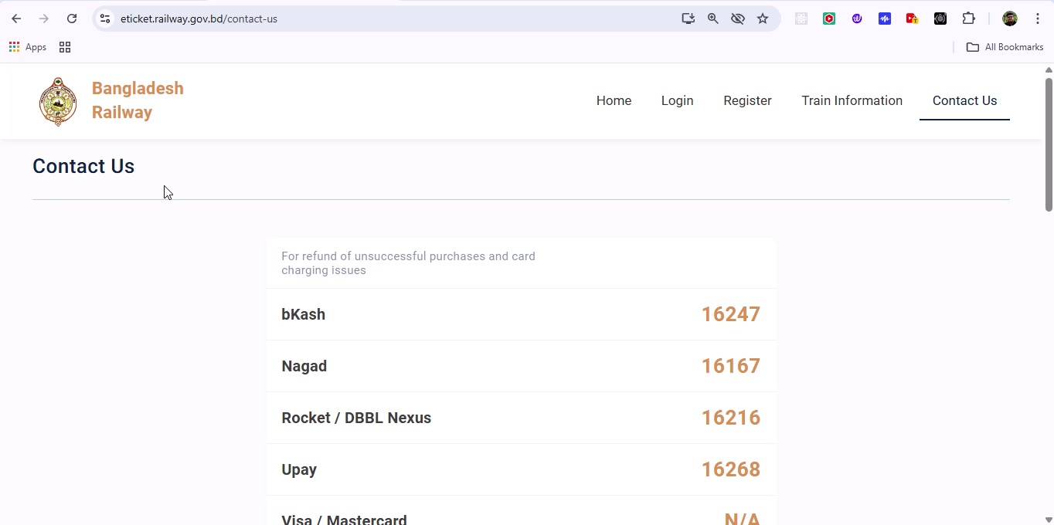

## Screenshot 49

Additional workflow step captured; refer to screenshot for details.

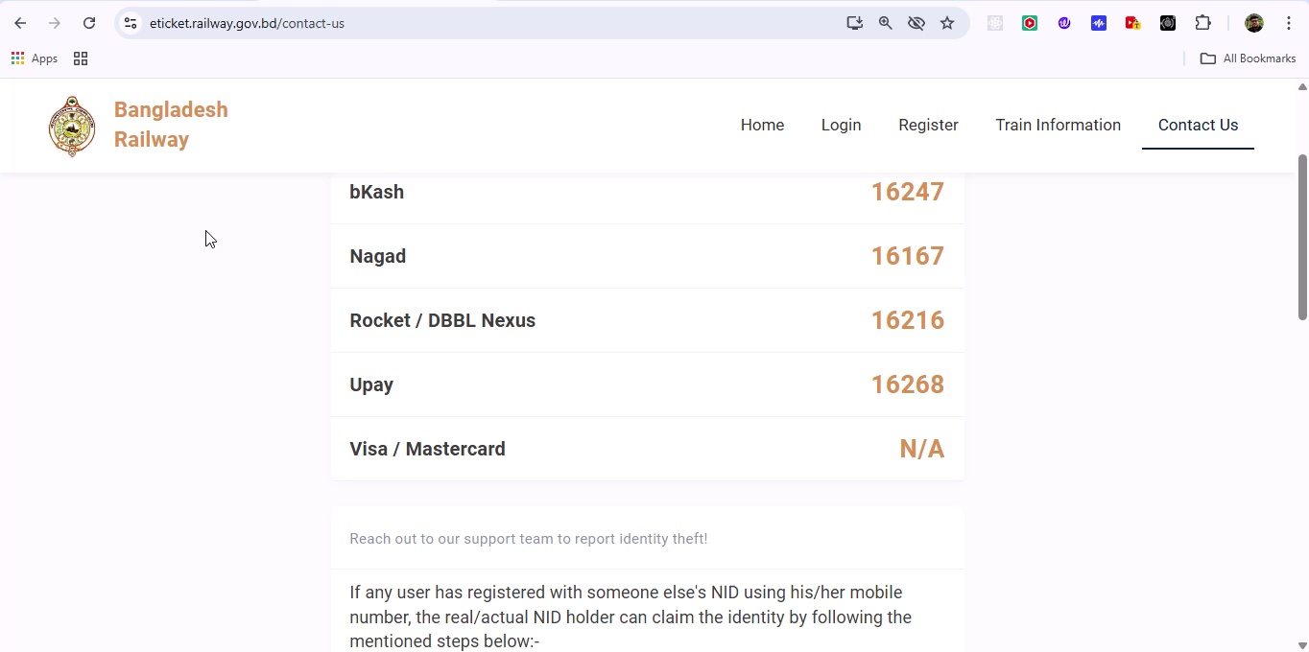

## Screenshot 50

Additional workflow step captured; refer to screenshot for details.

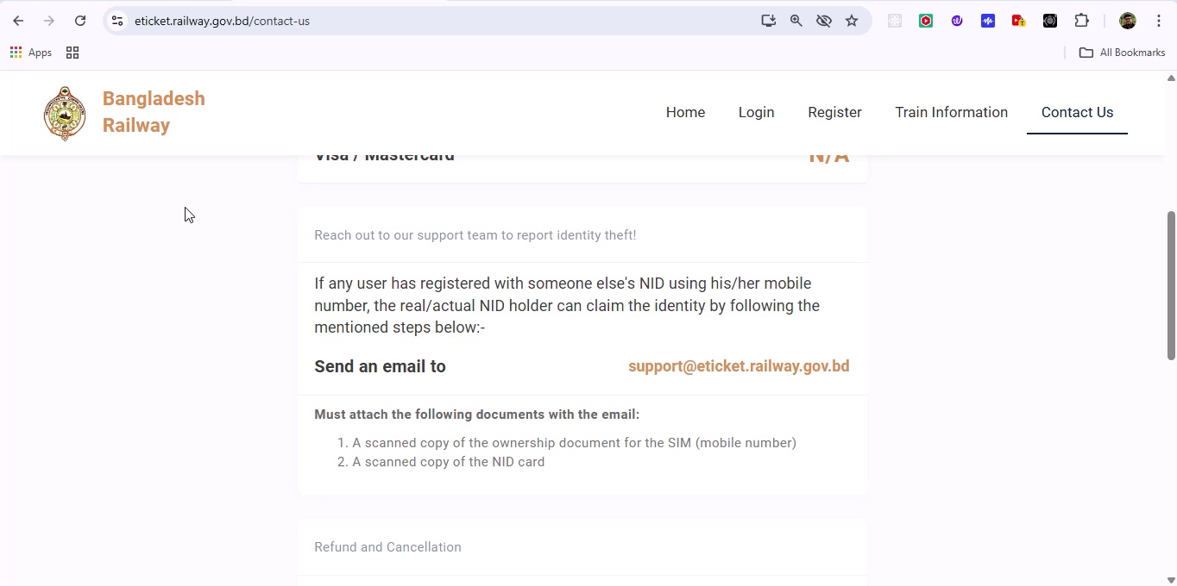

## Screenshot 51

Additional workflow step captured; refer to screenshot for details.

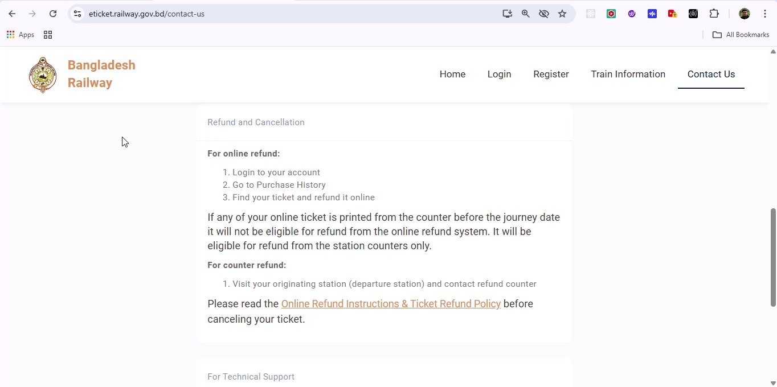

## Screenshot 52

Additional workflow step captured; refer to screenshot for details.

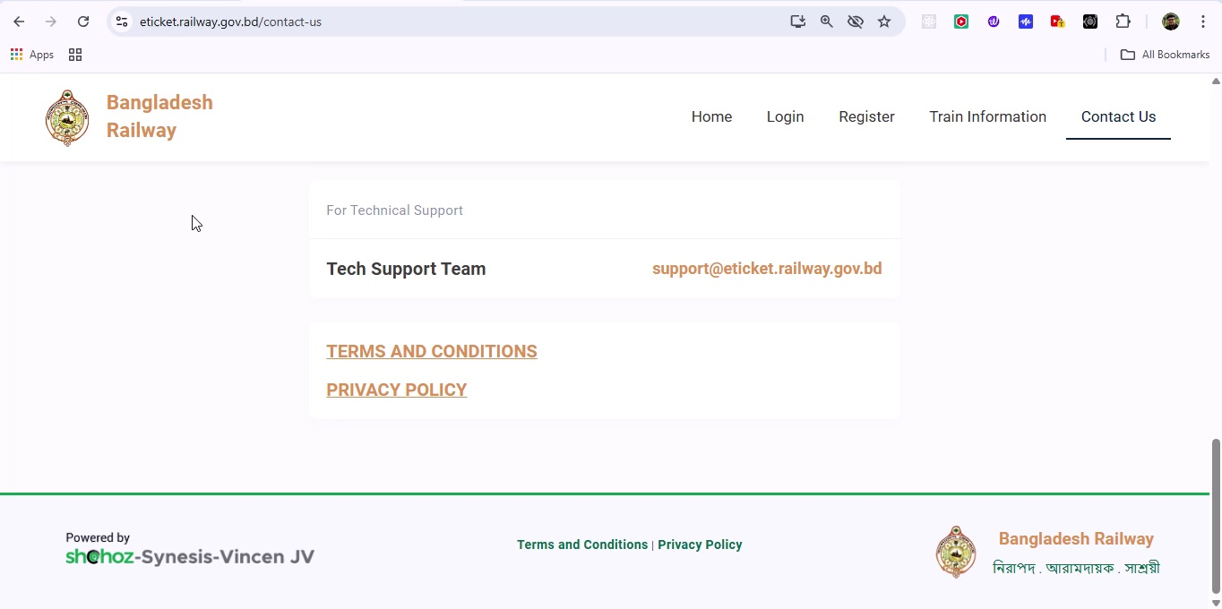

## Screenshot 53

Additional workflow step captured; refer to screenshot for details.

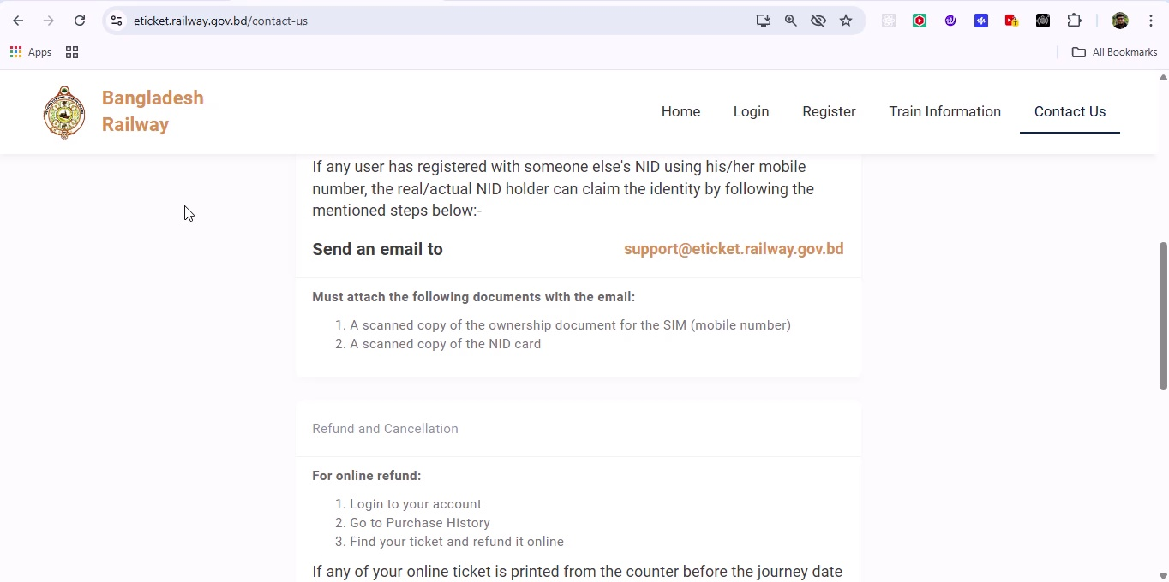

## Screenshot 54

Additional workflow step captured; refer to screenshot for details.

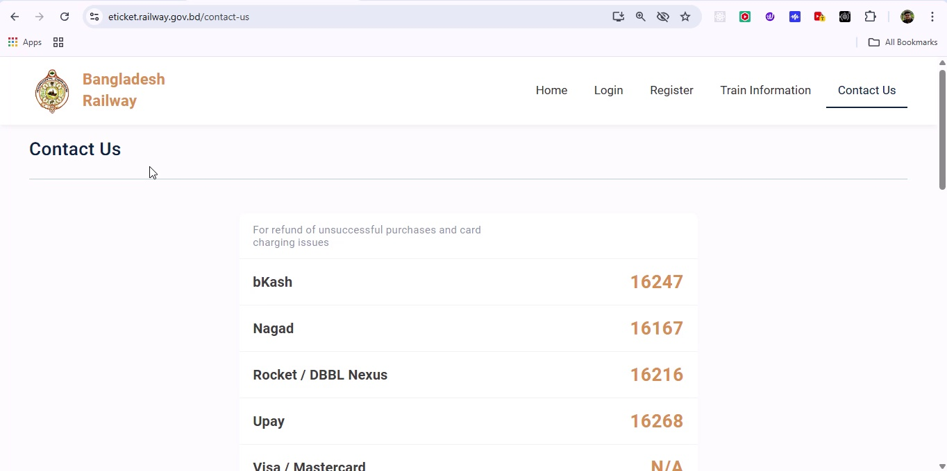

## Screenshot 55

Additional workflow step captured; refer to screenshot for details.

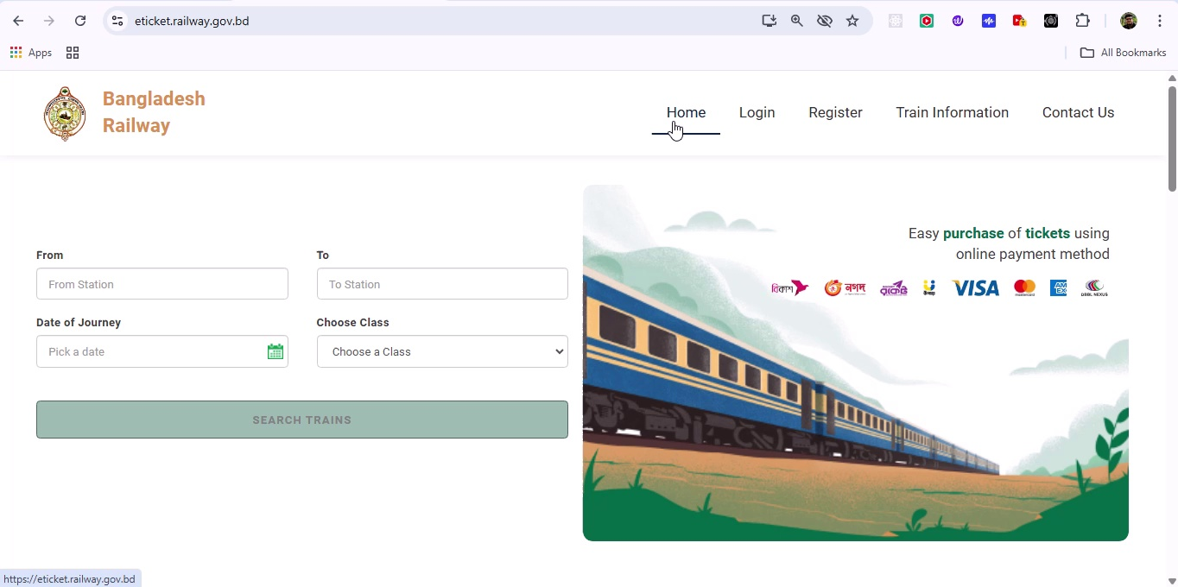

## Screenshot 56

Additional workflow step captured; refer to screenshot for details.

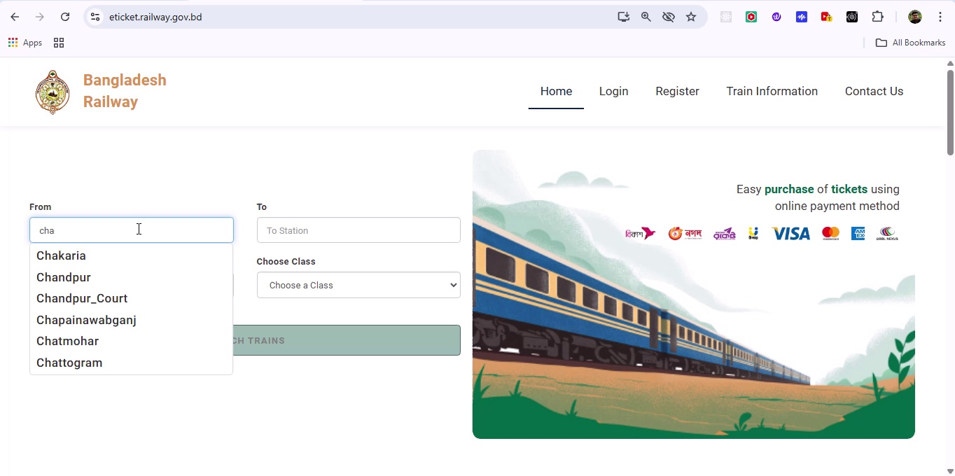

## Screenshot 57

Additional workflow step captured; refer to screenshot for details.

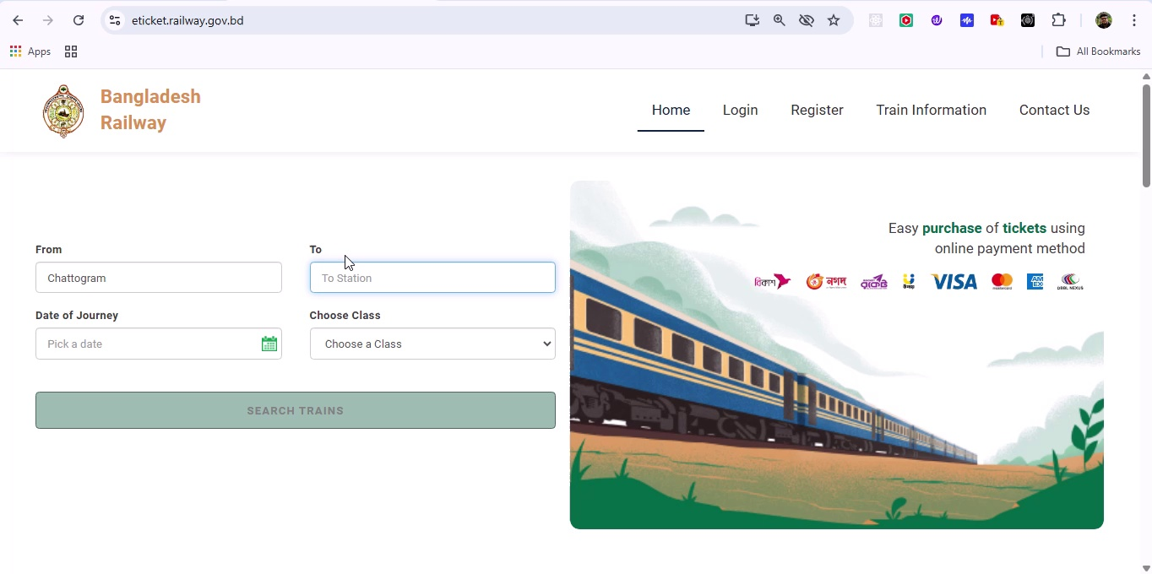

## Screenshot 58

Additional workflow step captured; refer to screenshot for details.

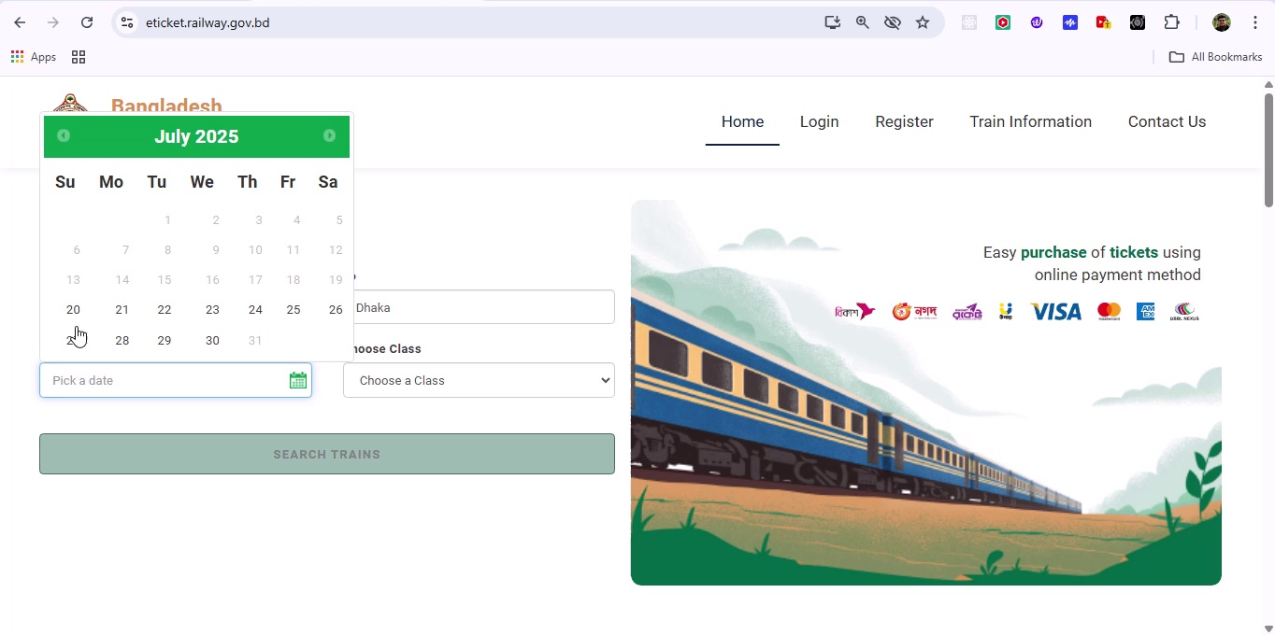

## Screenshot 59

Additional workflow step captured; refer to screenshot for details.

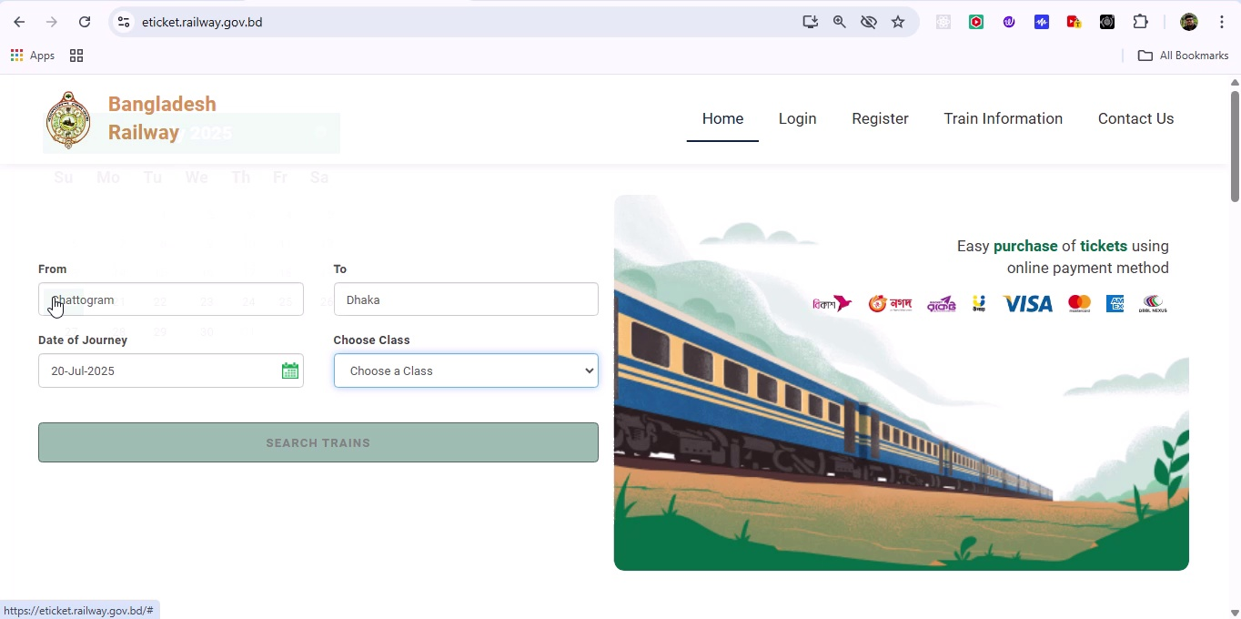

## Screenshot 60

Additional workflow step captured; refer to screenshot for details.

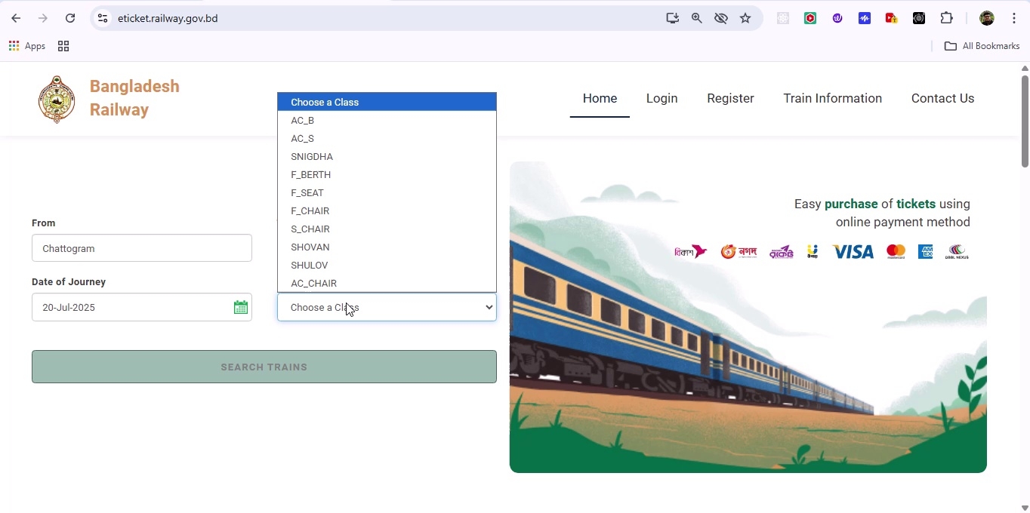

## Screenshot 61

Additional workflow step captured; refer to screenshot for details.

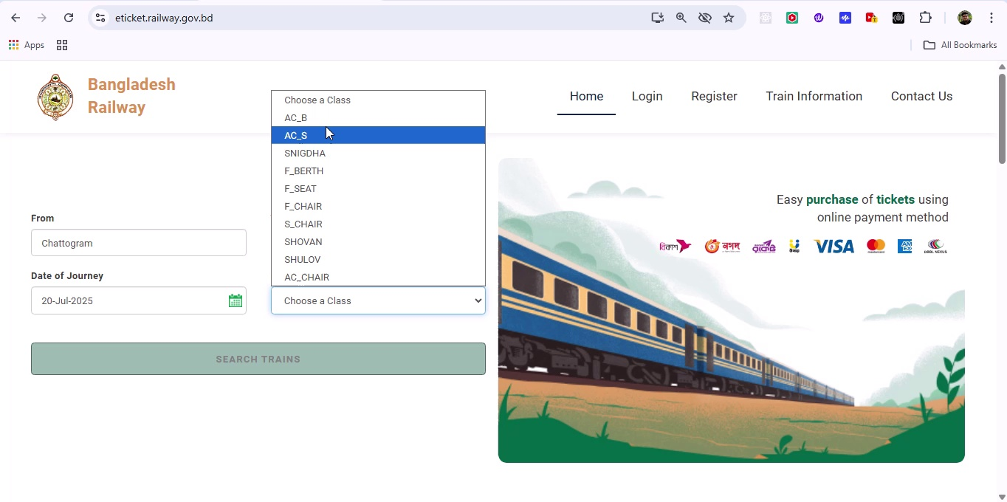

## Screenshot 62

Additional workflow step captured; refer to screenshot for details.

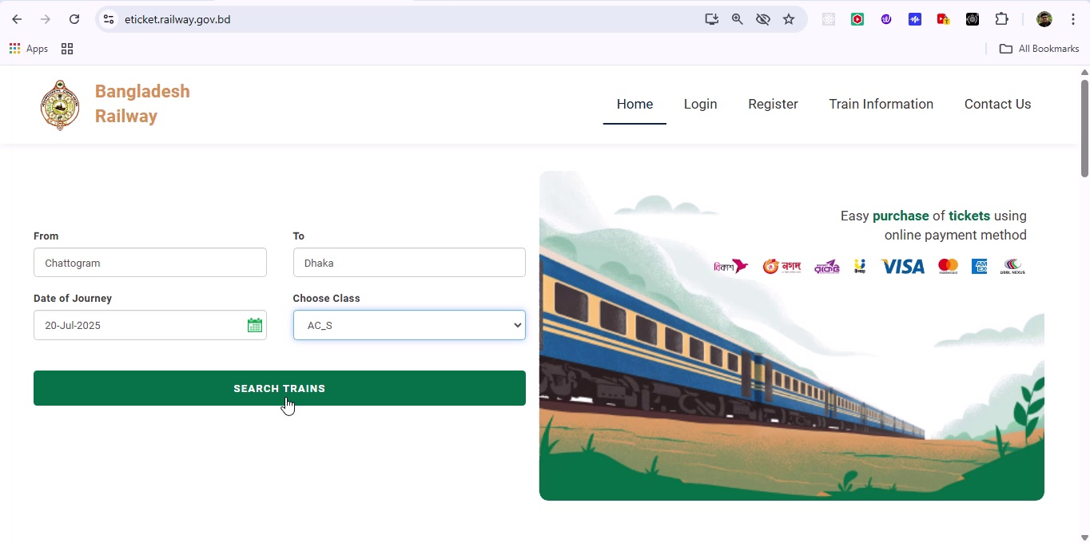

## Screenshot 63

Additional workflow step captured; refer to screenshot for details.

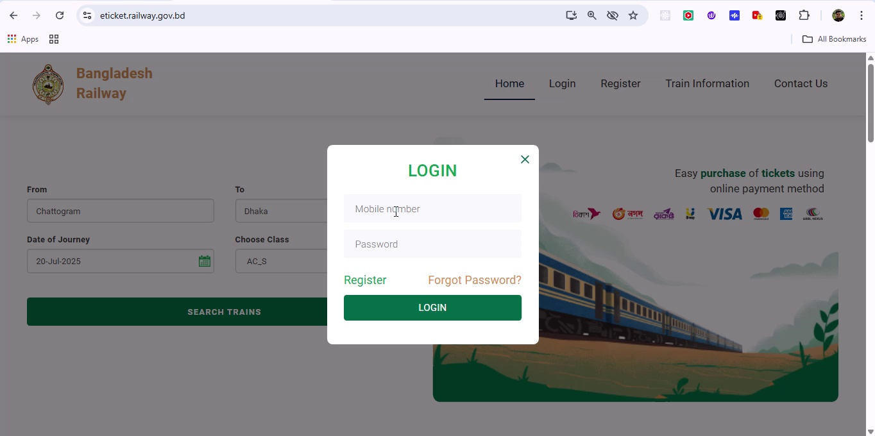

## Screenshot 64

Additional workflow step captured; refer to screenshot for details.

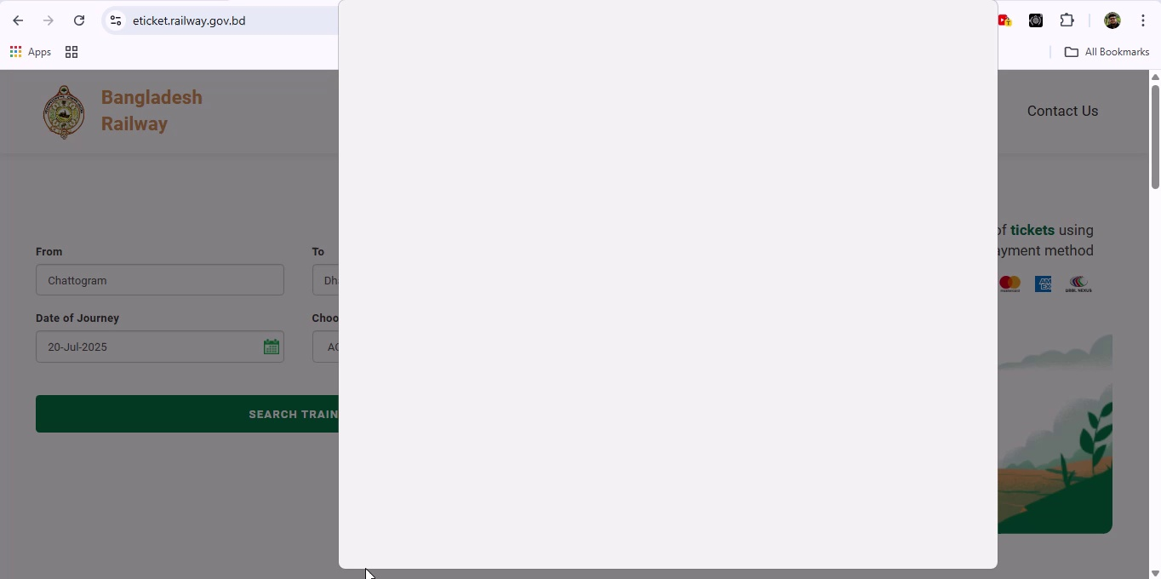

## Screenshot 65

Additional workflow step captured; refer to screenshot for details.

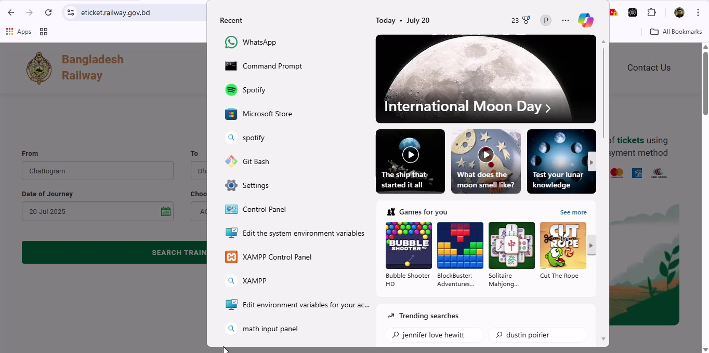

## Screenshot 66

Additional workflow step captured; refer to screenshot for details.

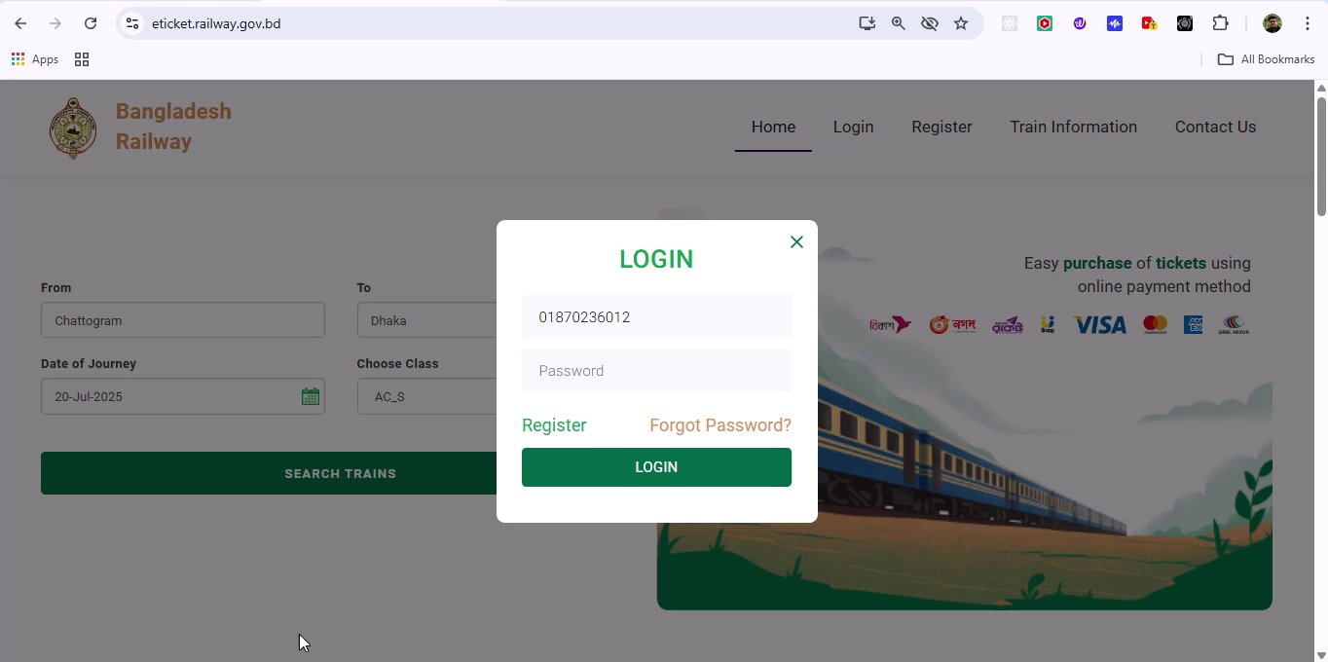

## Screenshot 67

Additional workflow step captured; refer to screenshot for details.

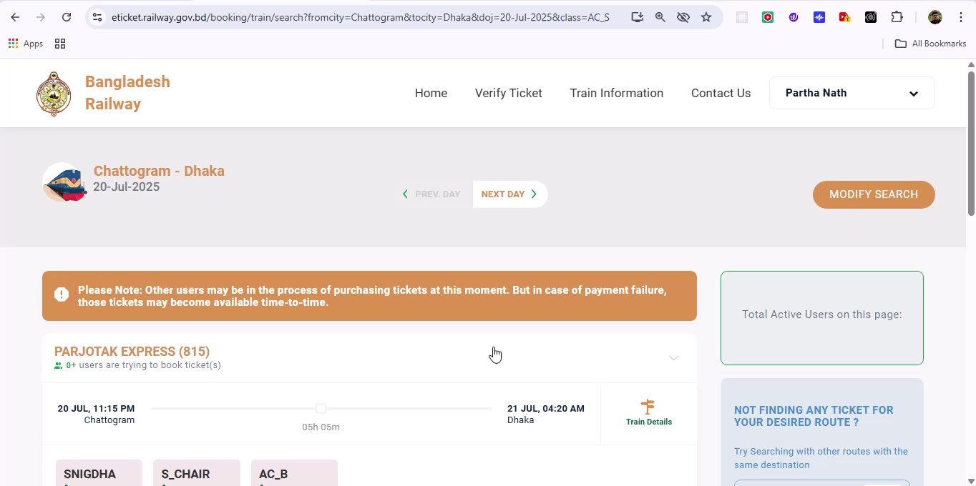

## Screenshot 68

Additional workflow step captured; refer to screenshot for details.

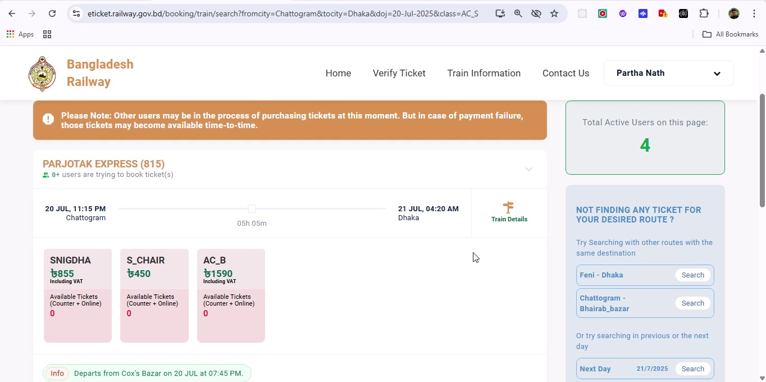

## Screenshot 69

Additional workflow step captured; refer to screenshot for details.

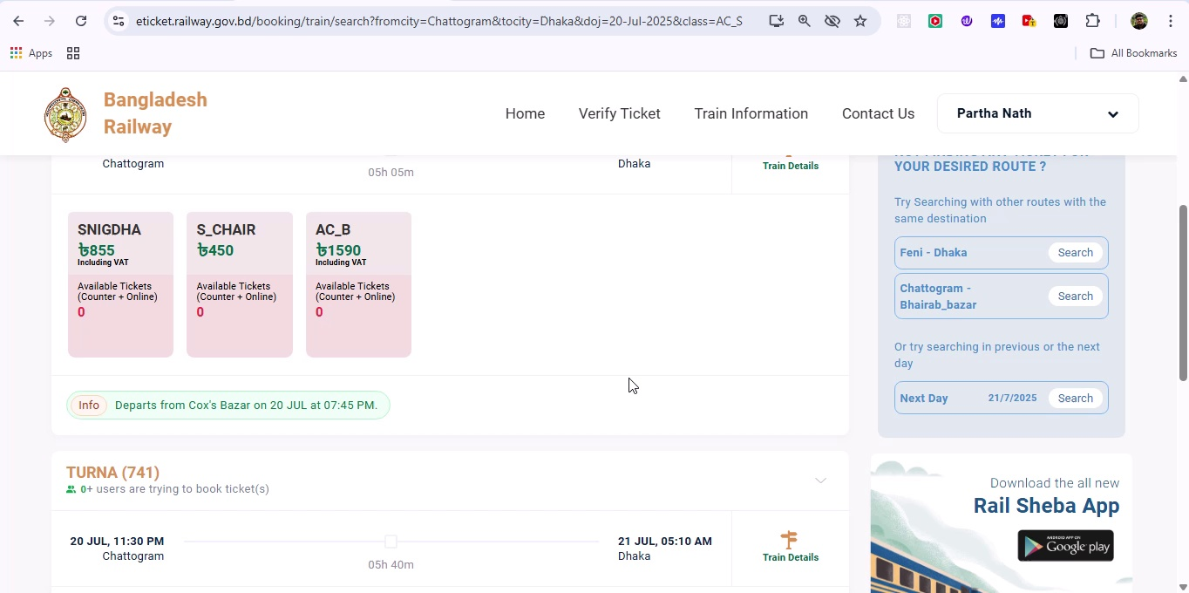

## Screenshot 70

Additional workflow step captured; refer to screenshot for details.

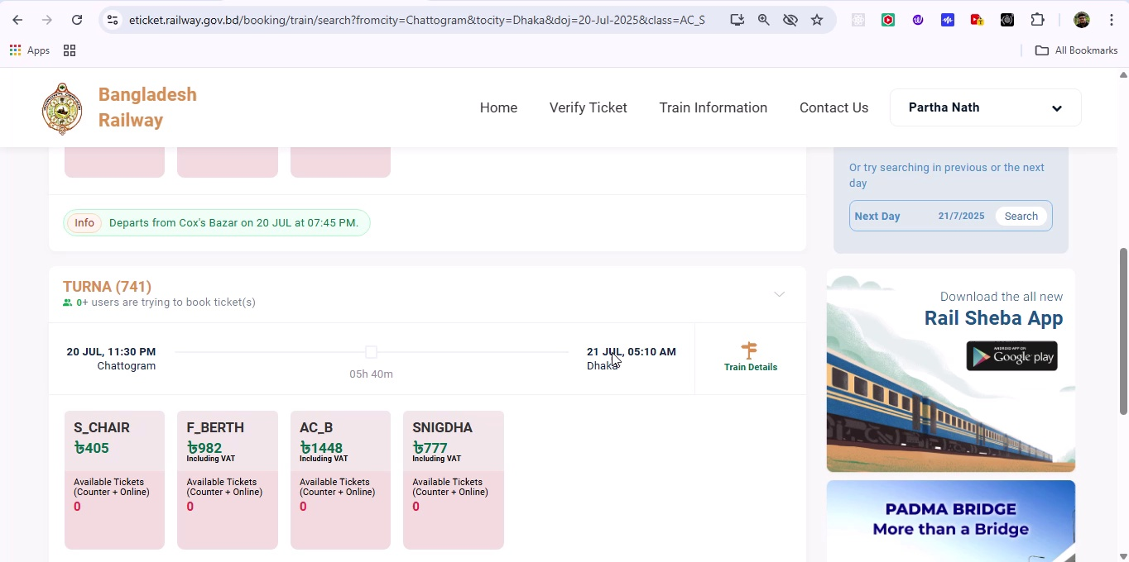

## Screenshot 71

Additional workflow step captured; refer to screenshot for details.

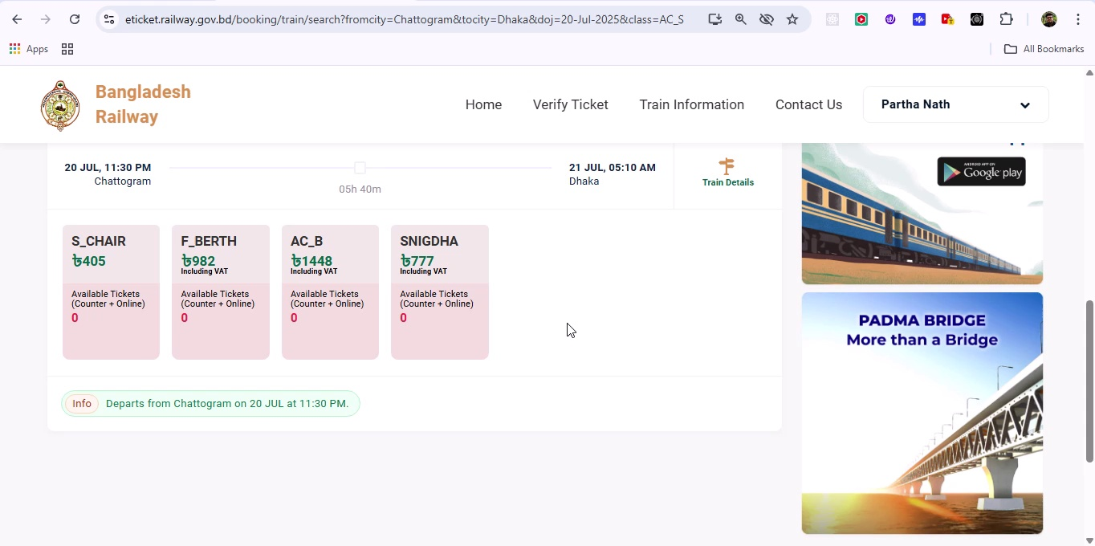

## Screenshot 72

Additional workflow step captured; refer to screenshot for details.

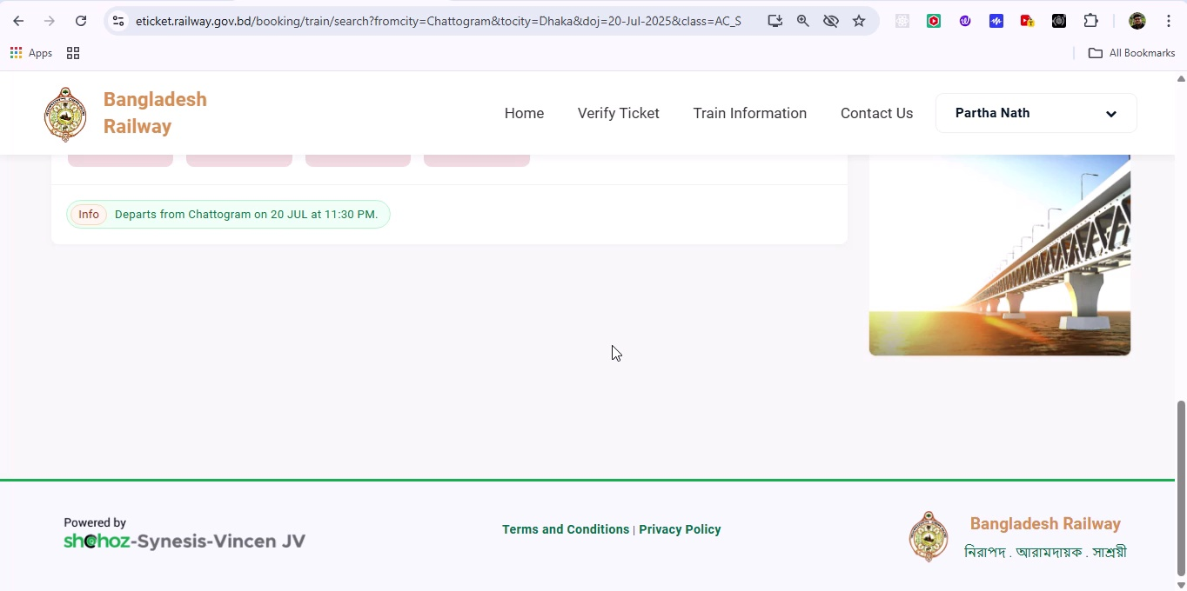

## Screenshot 73

Additional workflow step captured; refer to screenshot for details.

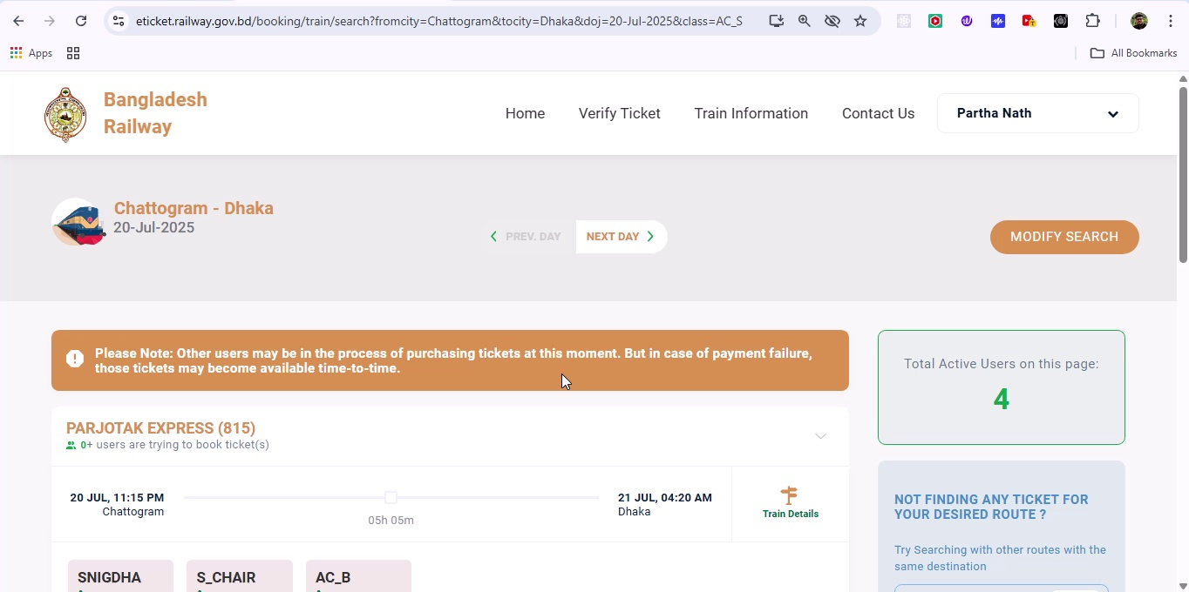

## Screenshot 74

Additional workflow step captured; refer to screenshot for details.

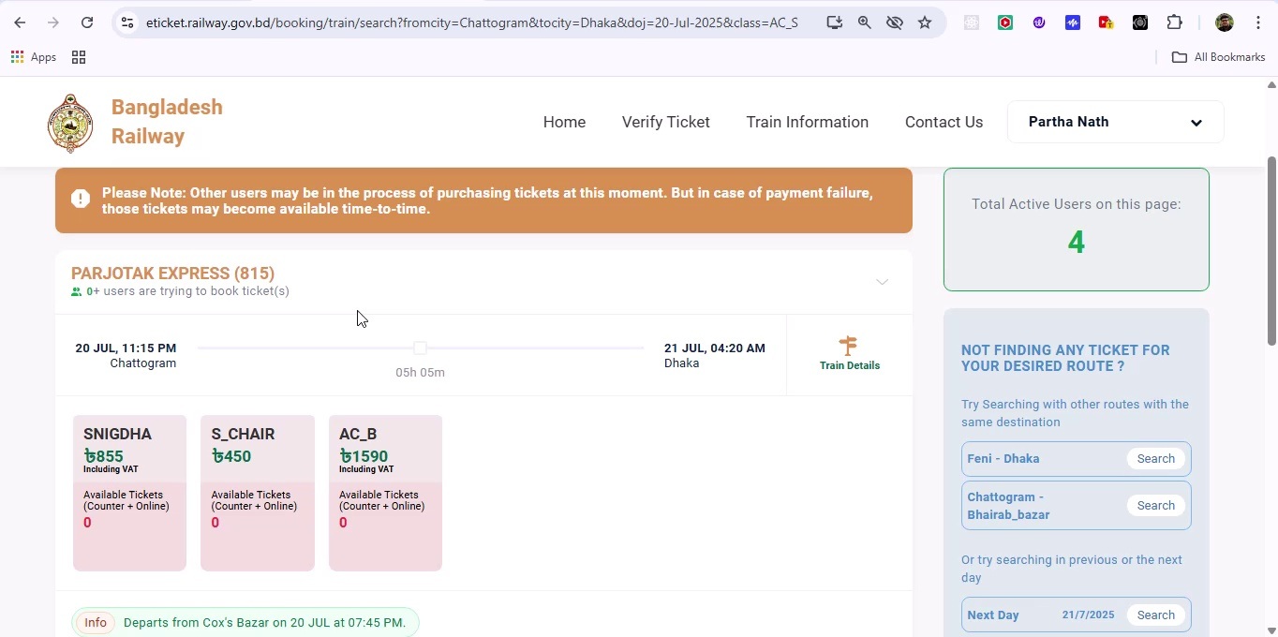

## Screenshot 75

Additional workflow step captured; refer to screenshot for details.

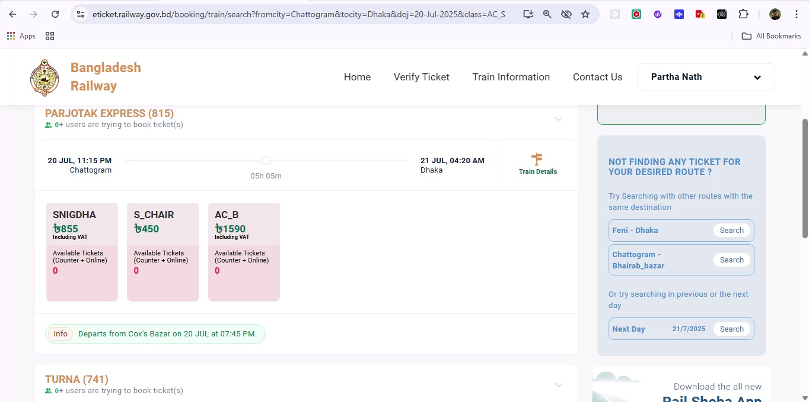

## Screenshot 76

Additional workflow step captured; refer to screenshot for details.

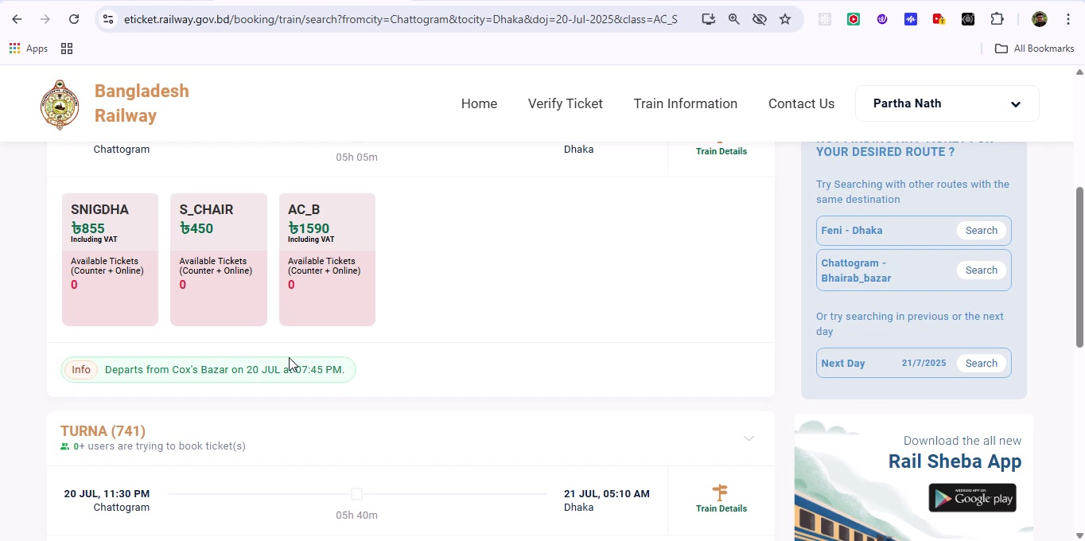

## Screenshot 77

Additional workflow step captured; refer to screenshot for details.

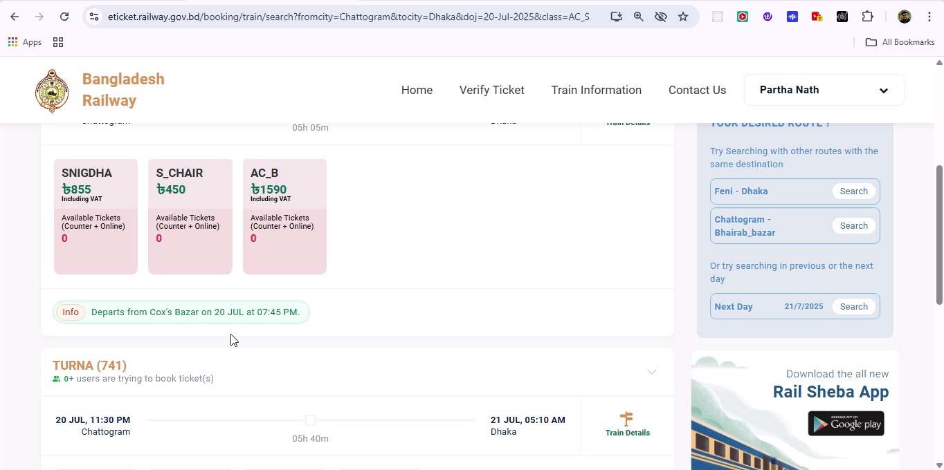

## Screenshot 78

Additional workflow step captured; refer to screenshot for details.

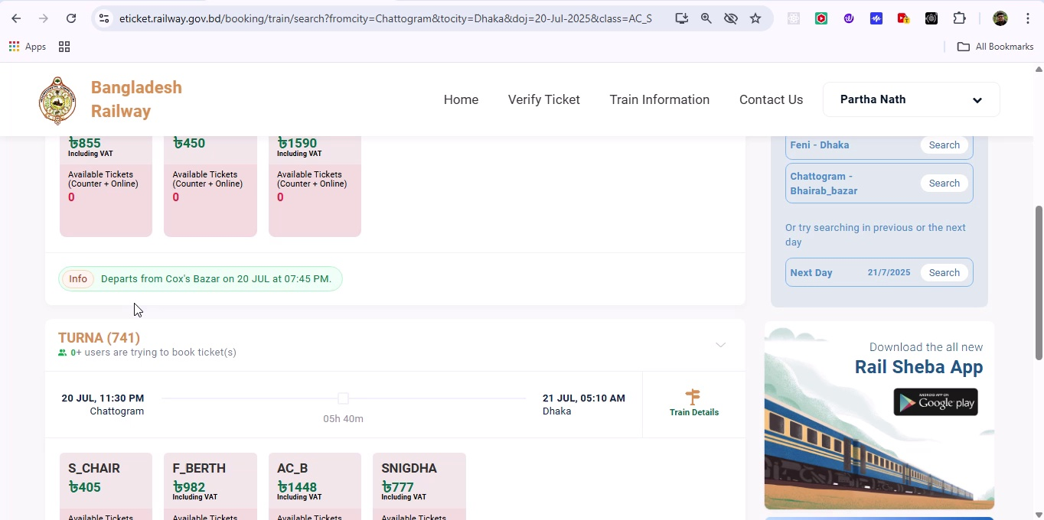

## Screenshot 79

Additional workflow step captured; refer to screenshot for details.

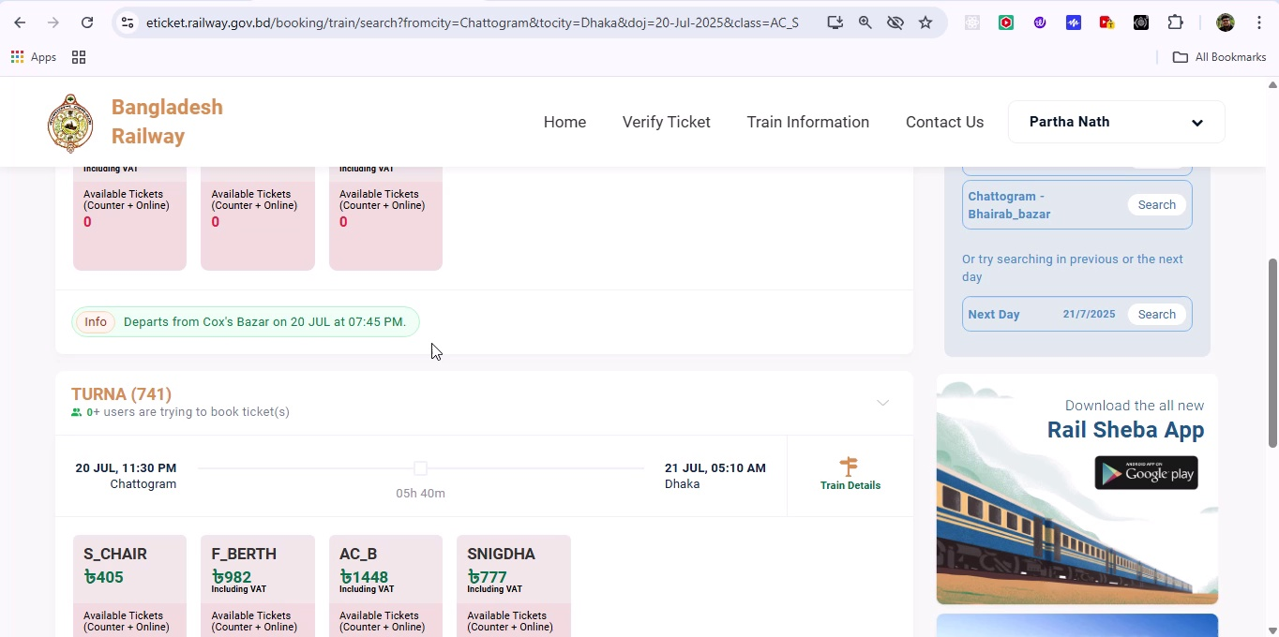

## Screenshot 80

Additional workflow step captured; refer to screenshot for details.

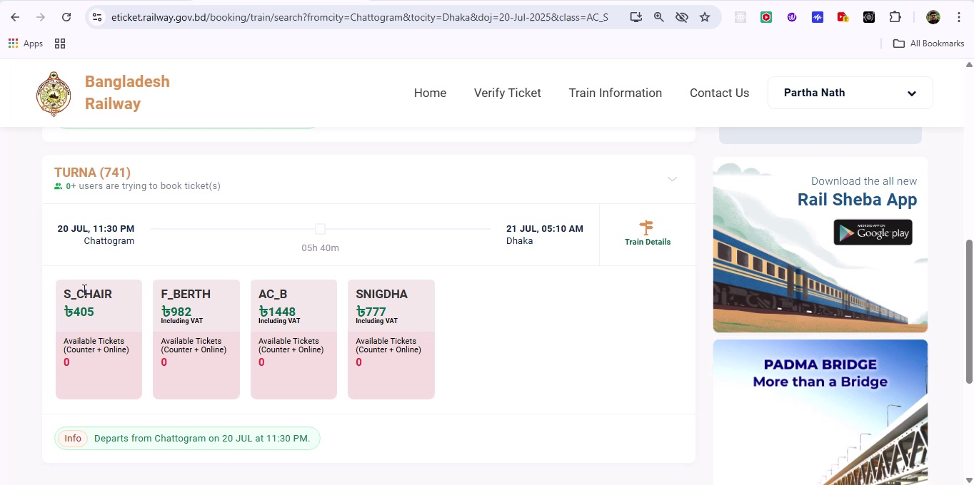

## Screenshot 81

Additional workflow step captured; refer to screenshot for details.

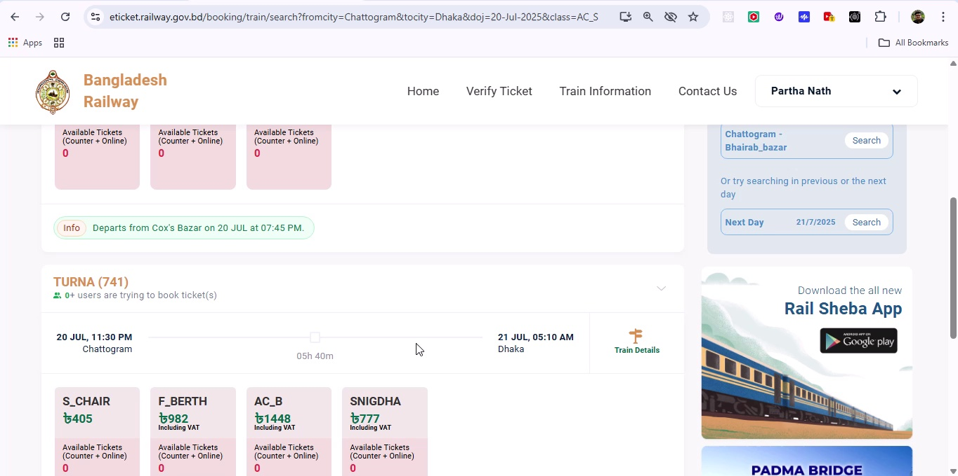

## Screenshot 82

Additional workflow step captured; refer to screenshot for details.

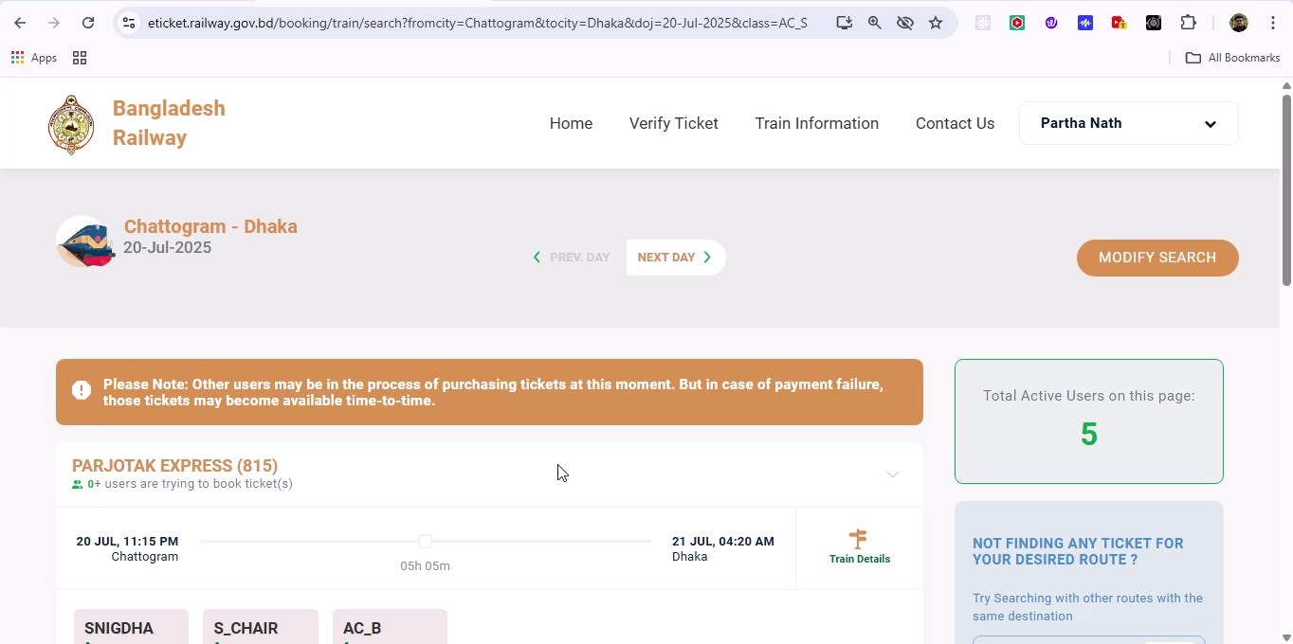

## Screenshot 83

Additional workflow step captured; refer to screenshot for details.

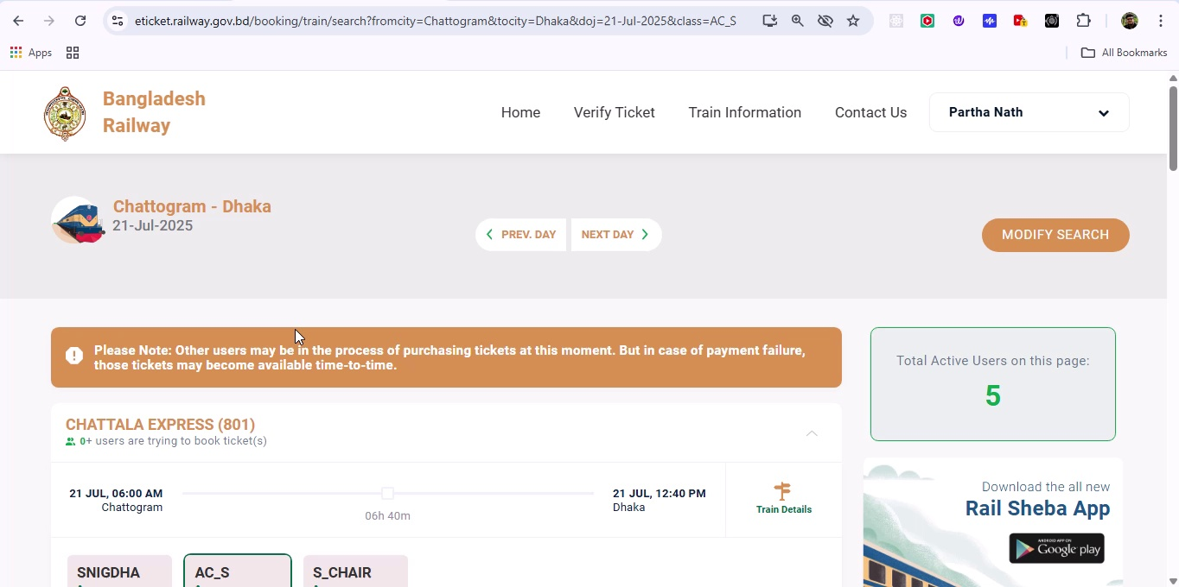

## Screenshot 84

Additional workflow step captured; refer to screenshot for details.

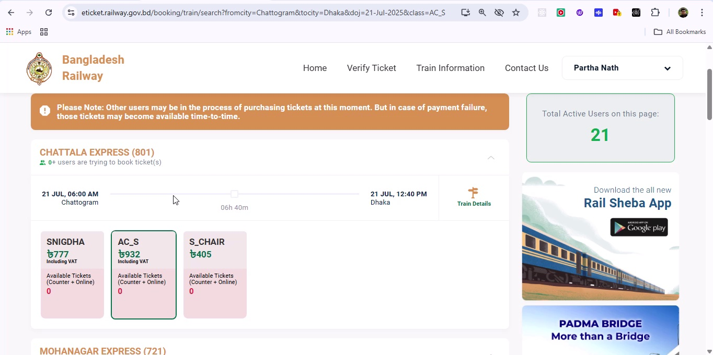

## Screenshot 85

Additional workflow step captured; refer to screenshot for details.

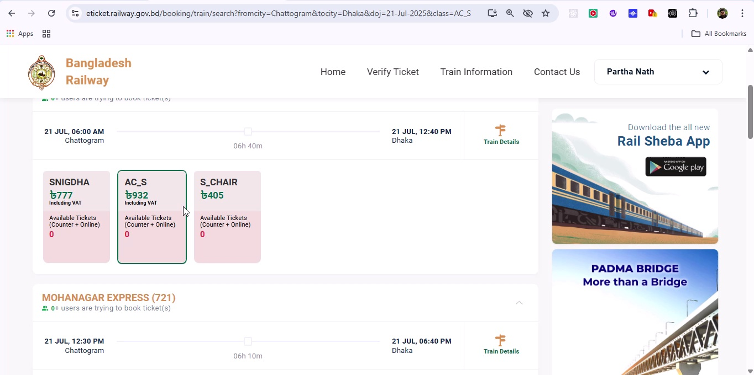

## Screenshot 86

Additional workflow step captured; refer to screenshot for details.

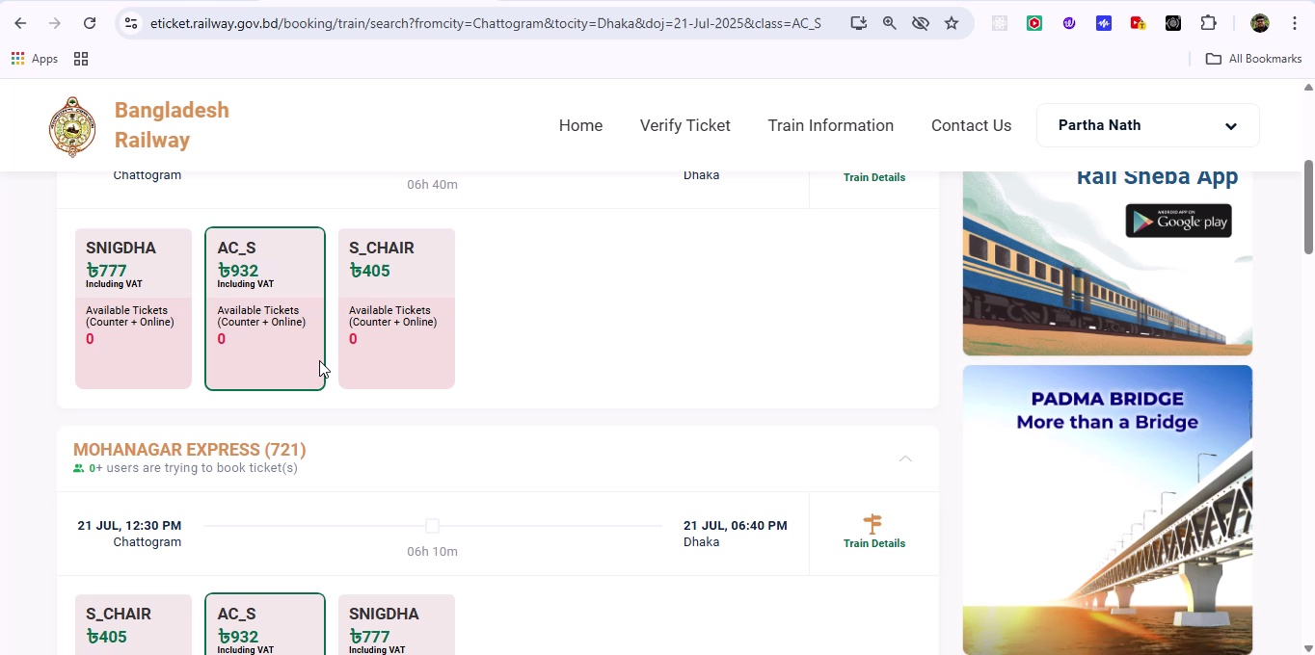

## Screenshot 87

Additional workflow step captured; refer to screenshot for details.

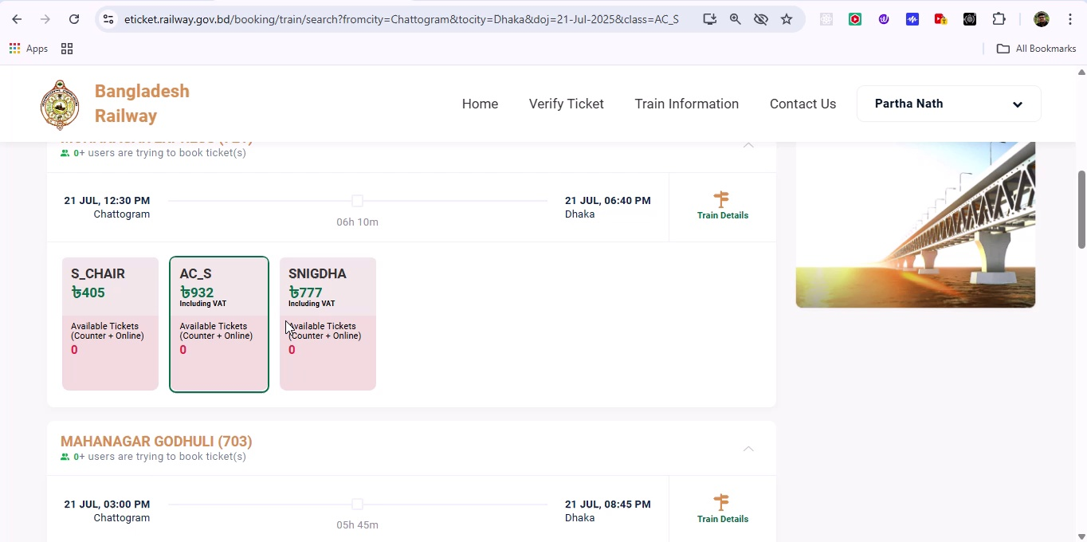

## Screenshot 88

Additional workflow step captured; refer to screenshot for details.

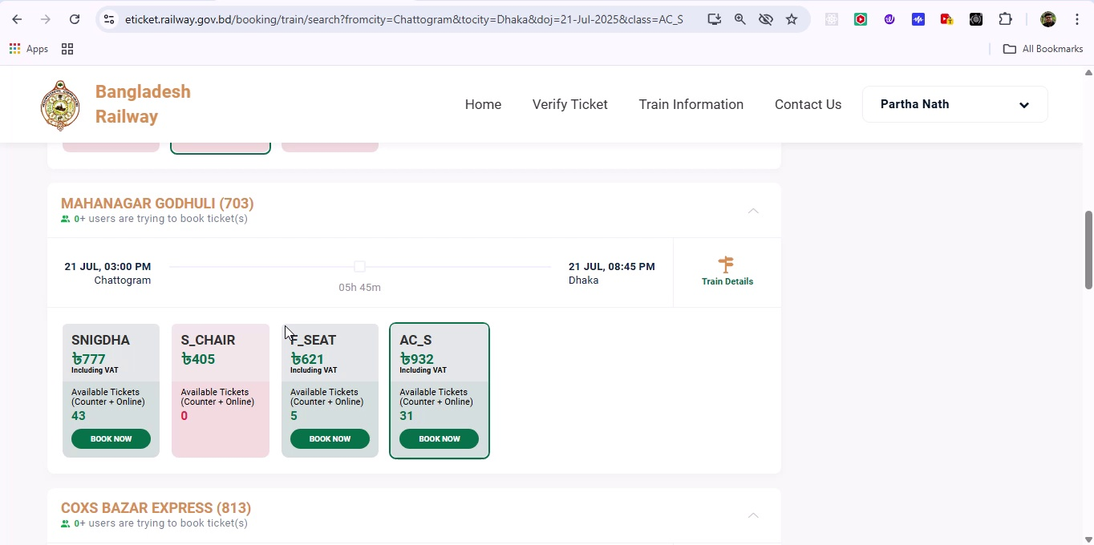

## Screenshot 89

Additional workflow step captured; refer to screenshot for details.

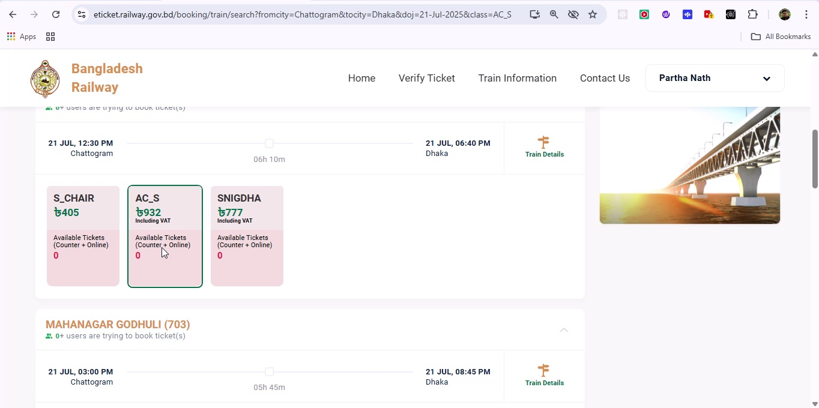

## Screenshot 90

Additional workflow step captured; refer to screenshot for details.

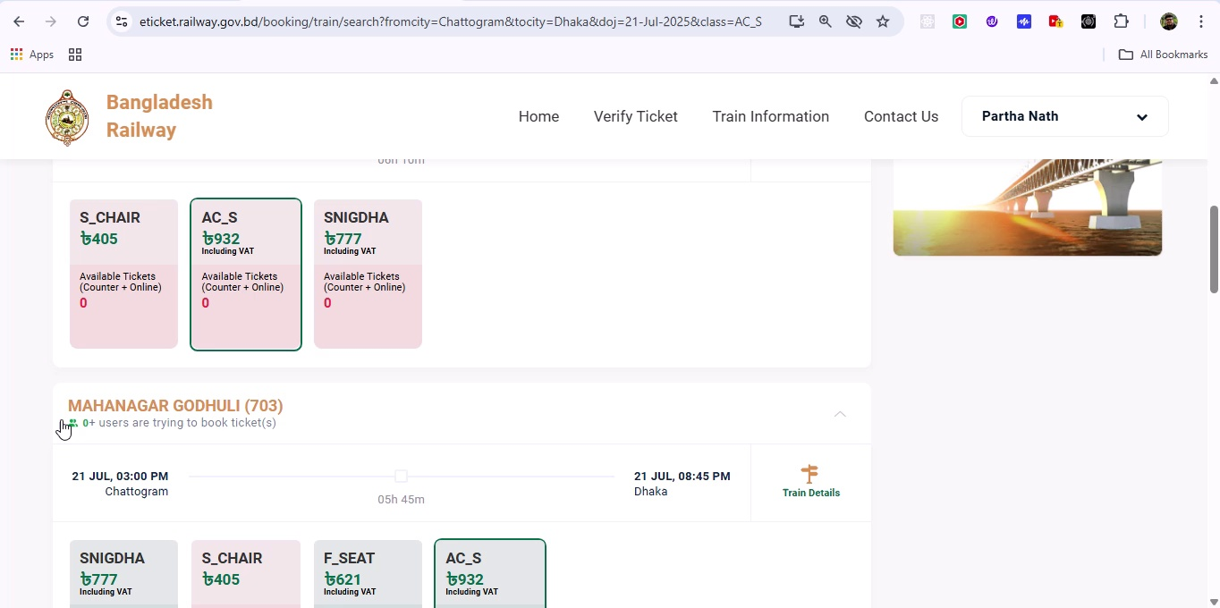

## Screenshot 91

Additional workflow step captured; refer to screenshot for details.

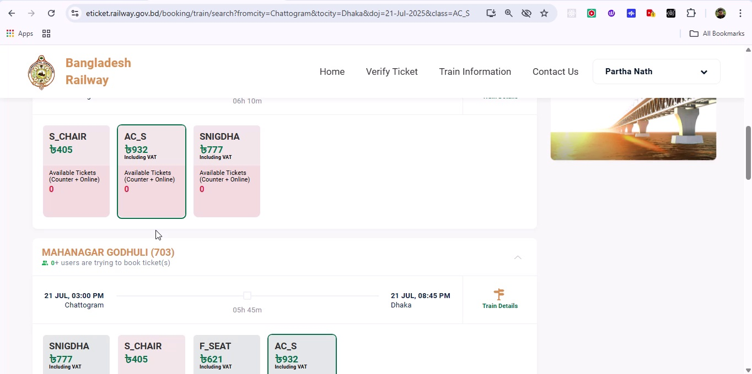

## Screenshot 92

Additional workflow step captured; refer to screenshot for details.

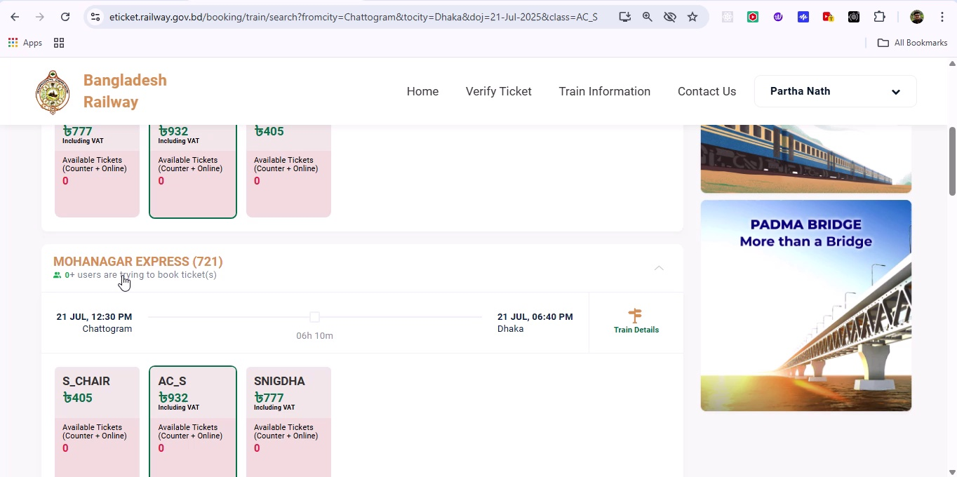

## Screenshot 93

Additional workflow step captured; refer to screenshot for details.

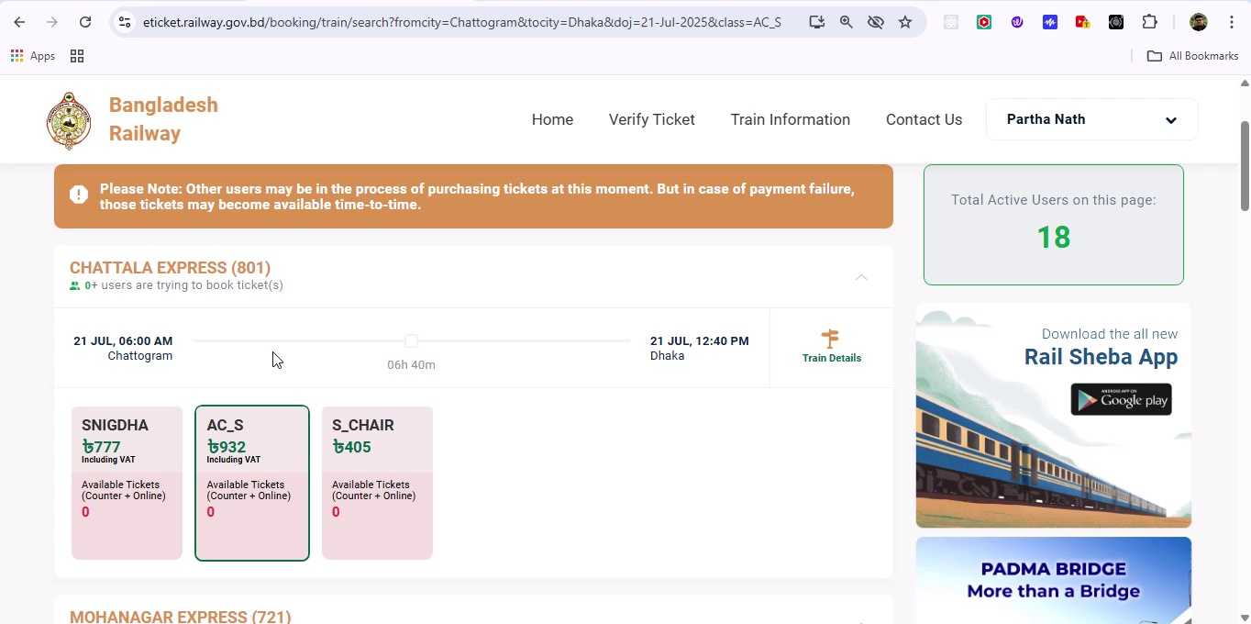

## Screenshot 94

Additional workflow step captured; refer to screenshot for details.

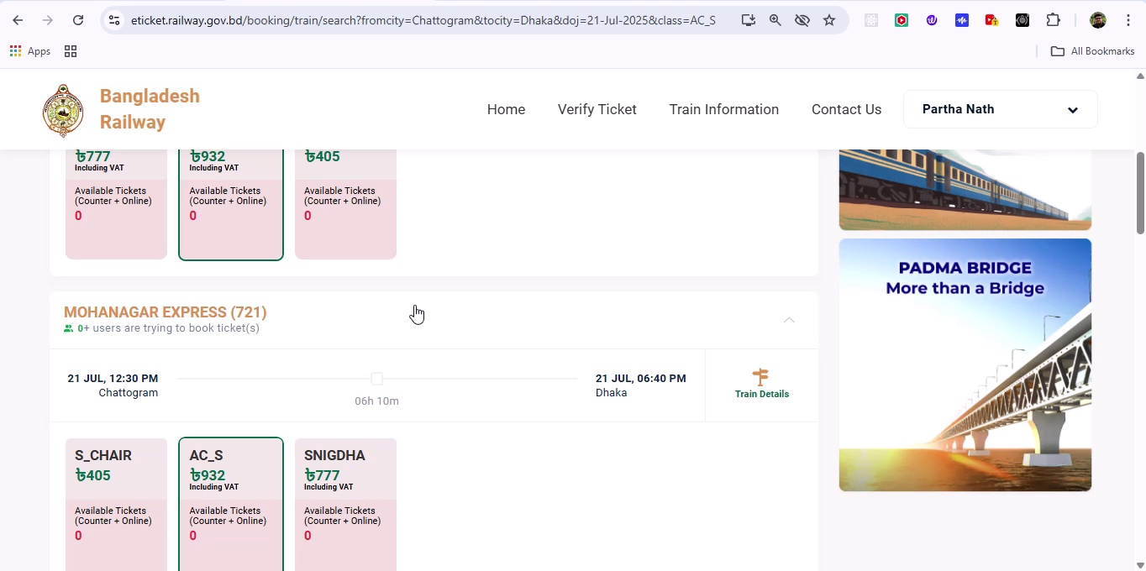

## Screenshot 95

Additional workflow step captured; refer to screenshot for details.

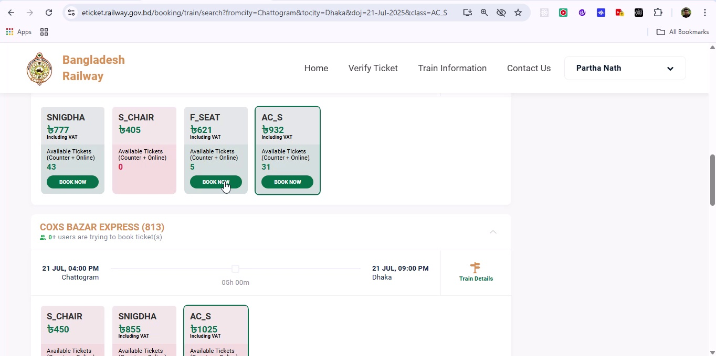

## Screenshot 96

Additional workflow step captured; refer to screenshot for details.

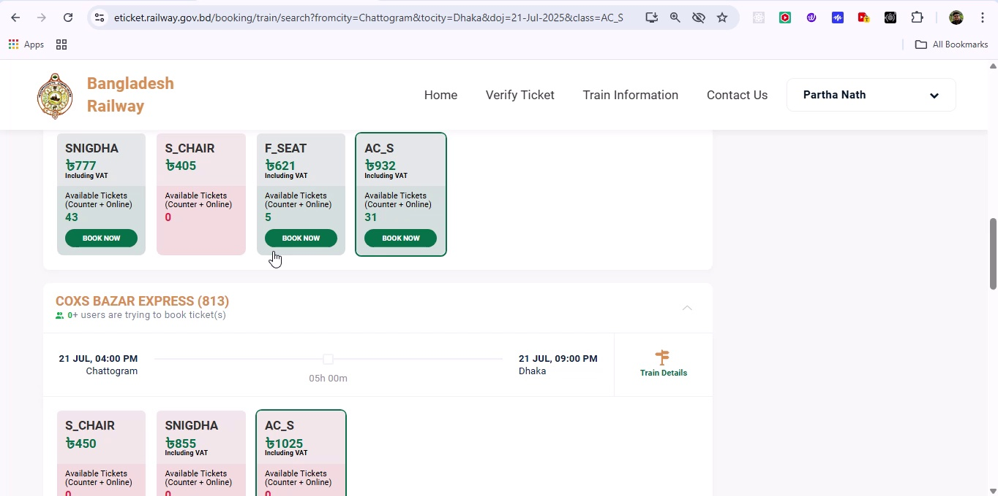

## Screenshot 97

Additional workflow step captured; refer to screenshot for details.

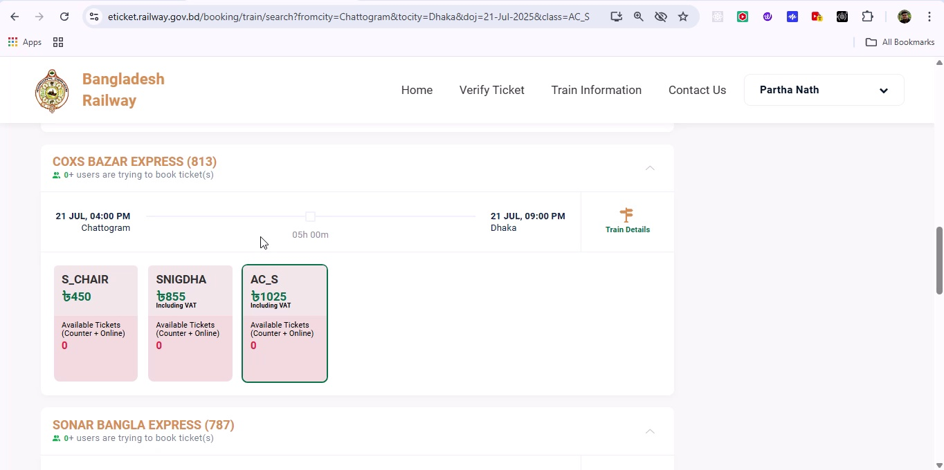

## Screenshot 98

Additional workflow step captured; refer to screenshot for details.

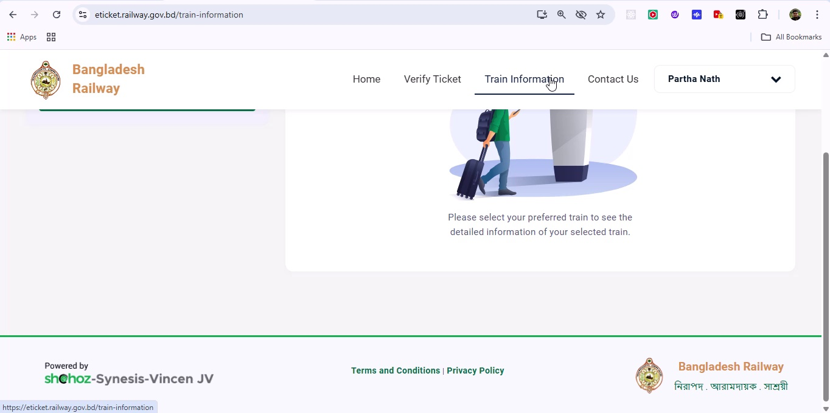

## Screenshot 99

Additional workflow step captured; refer to screenshot for details.

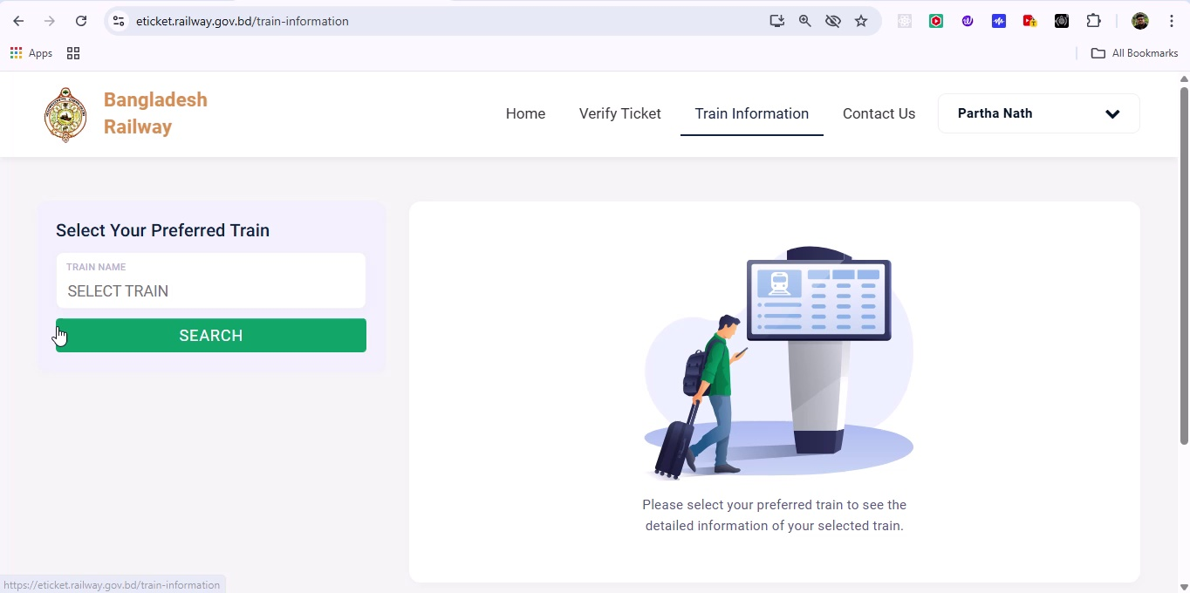

## Screenshot 100

Additional workflow step captured; refer to screenshot for details.

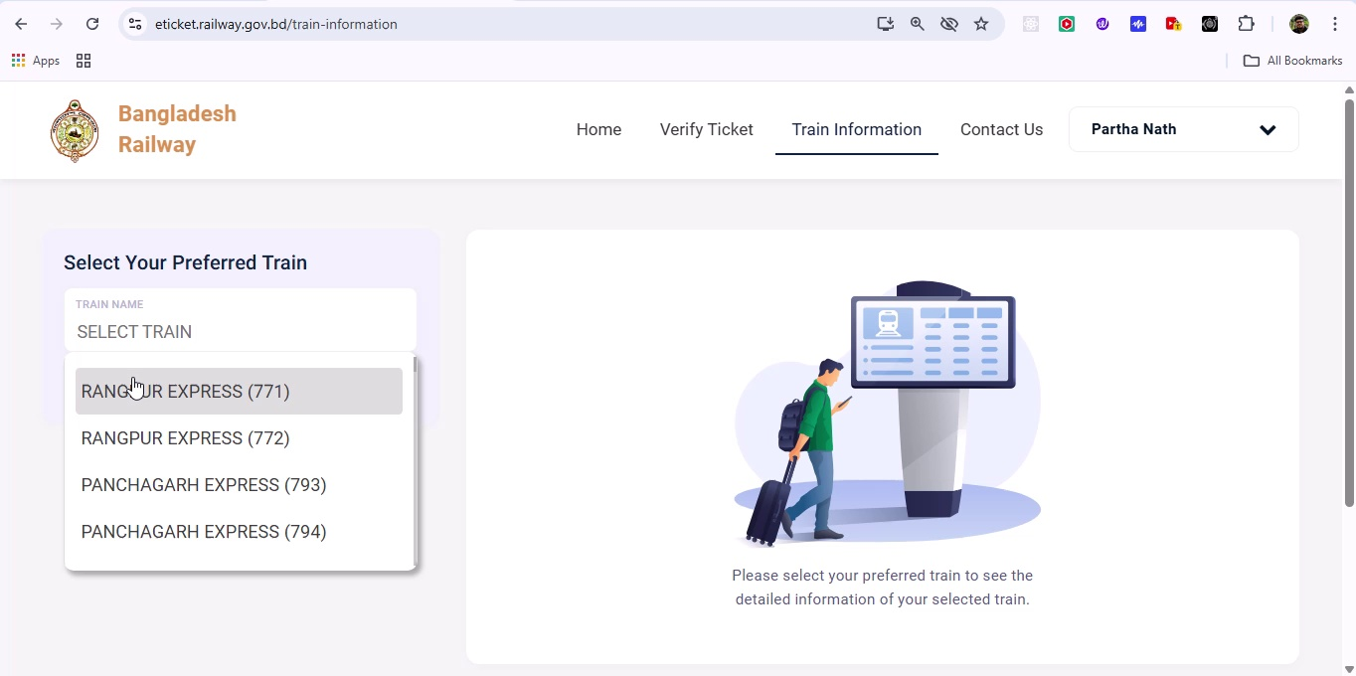

## Screenshot 101

Additional workflow step captured; refer to screenshot for details.

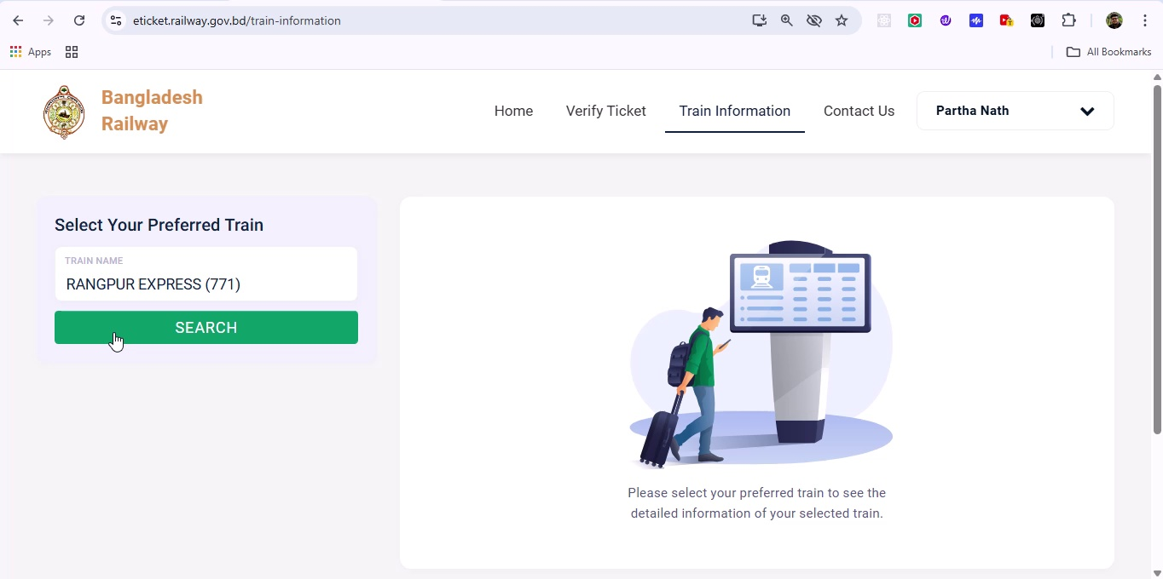

## Screenshot 102

Additional workflow step captured; refer to screenshot for details.

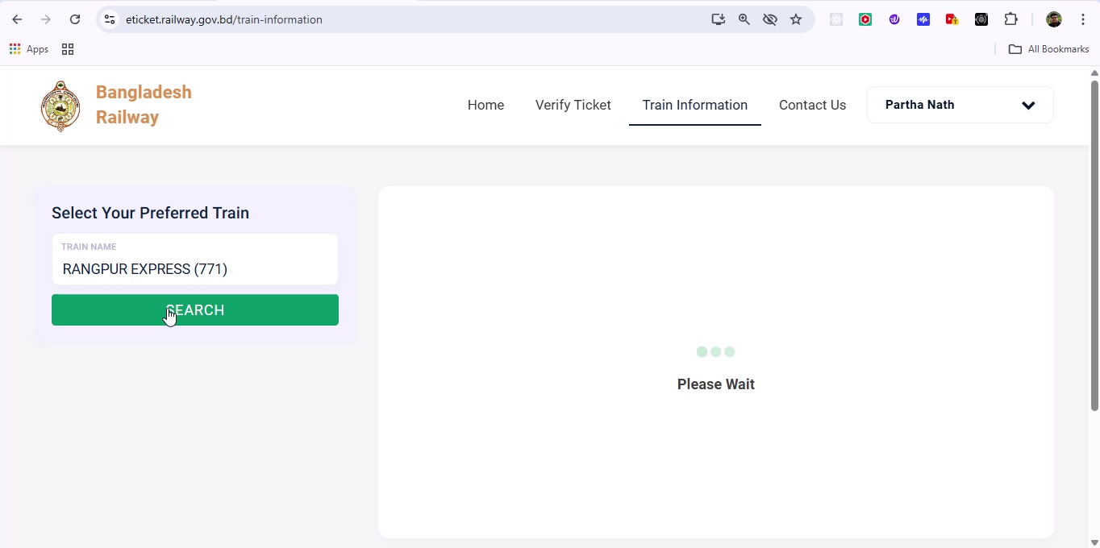

## Screenshot 103

Additional workflow step captured; refer to screenshot for details.

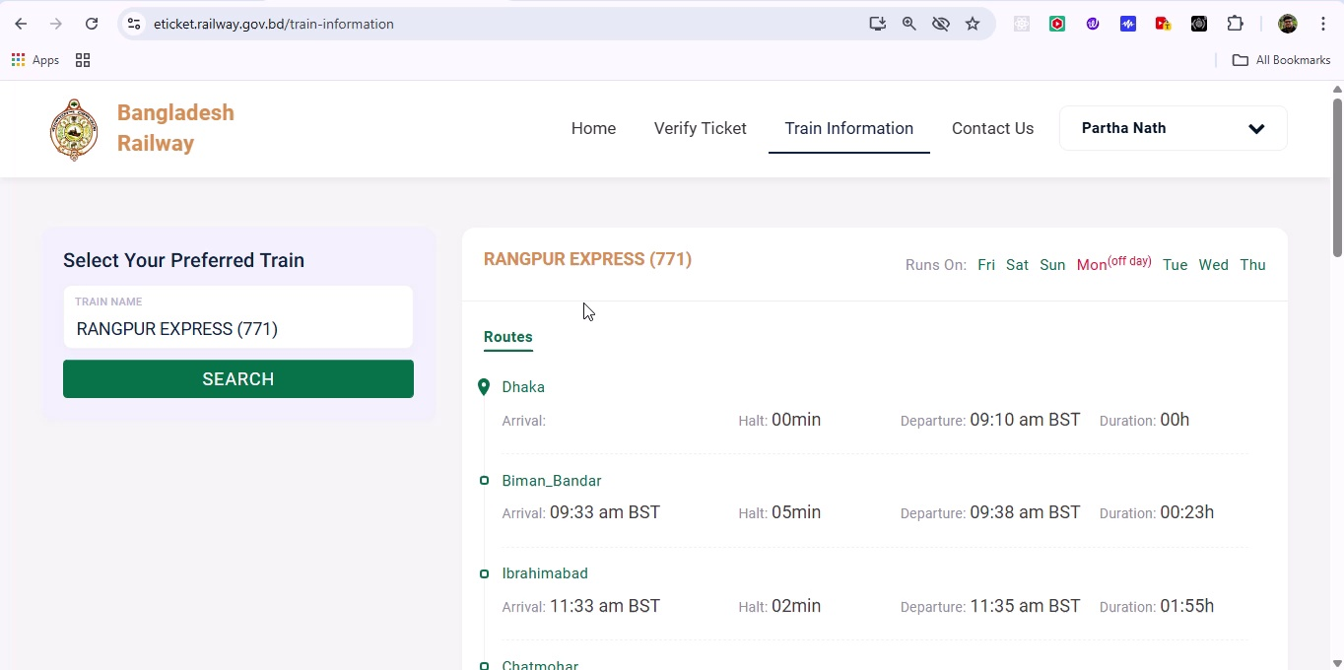

## Screenshot 104

Additional workflow step captured; refer to screenshot for details.

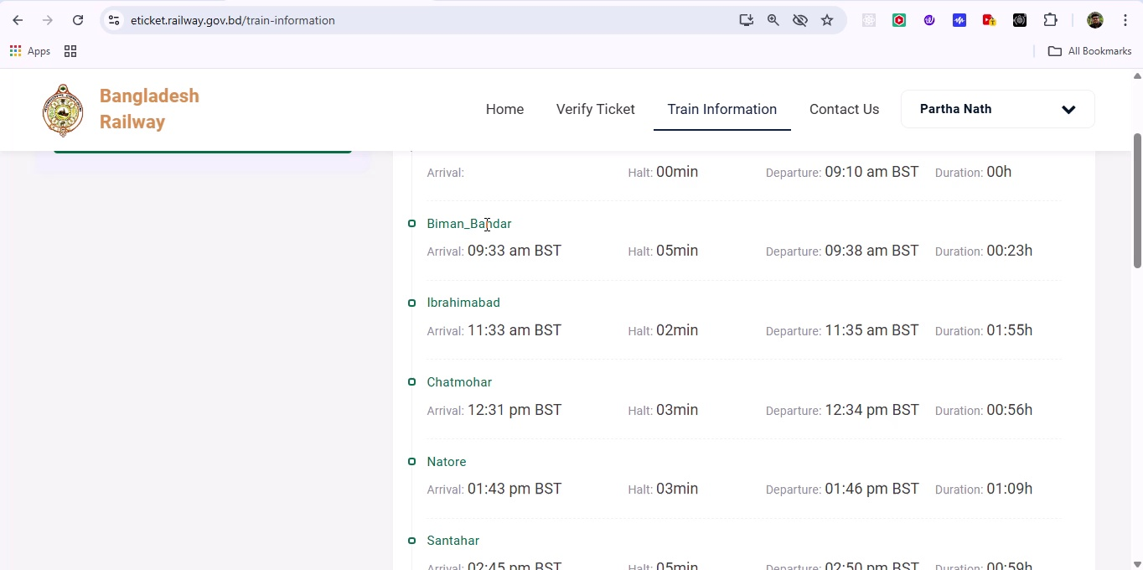

## Screenshot 105

Additional workflow step captured; refer to screenshot for details.

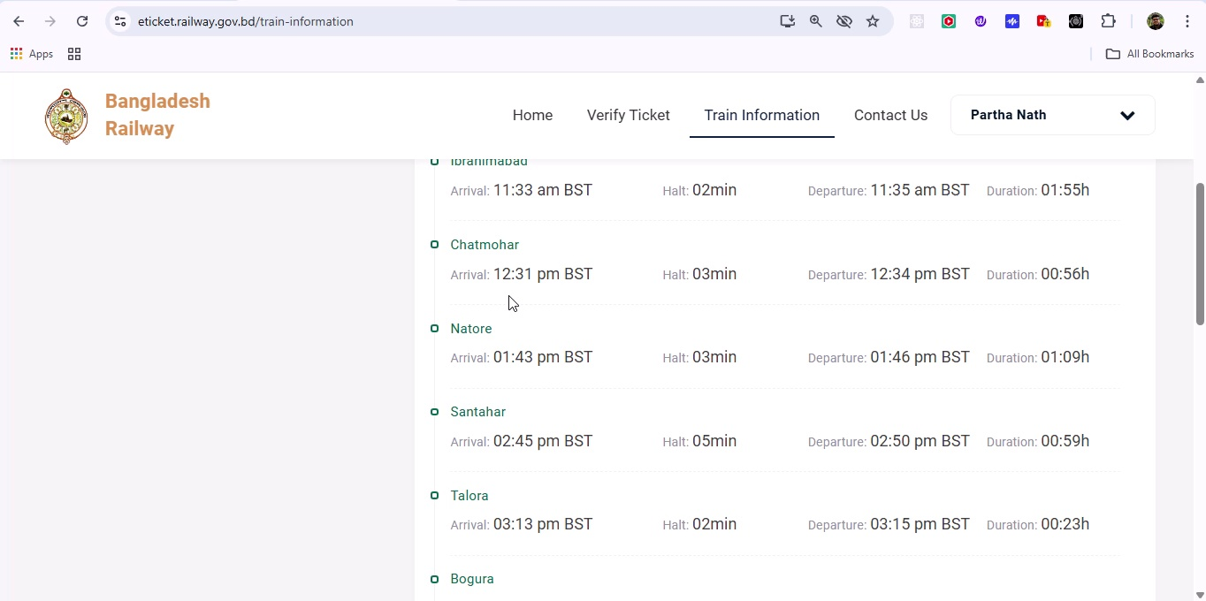

## Screenshot 106

Additional workflow step captured; refer to screenshot for details.

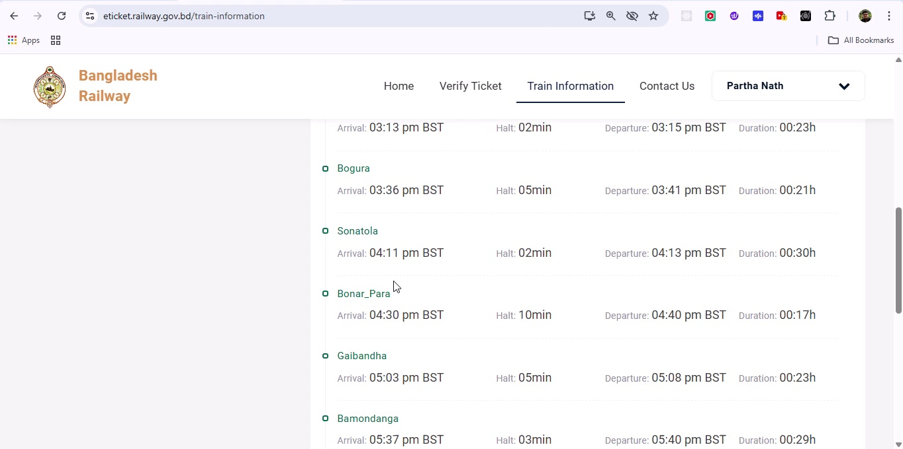

## Screenshot 107

Additional workflow step captured; refer to screenshot for details.

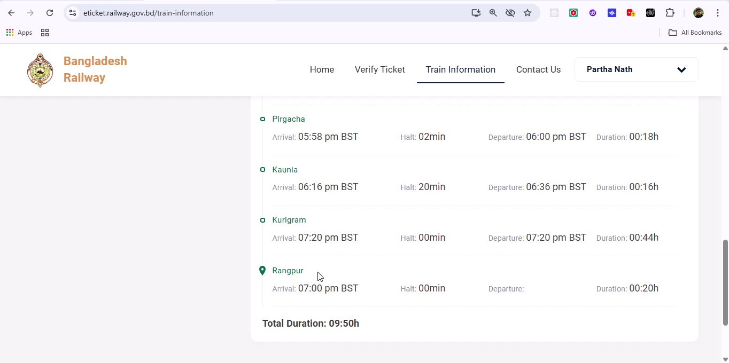

## Screenshot 108

Additional workflow step captured; refer to screenshot for details.

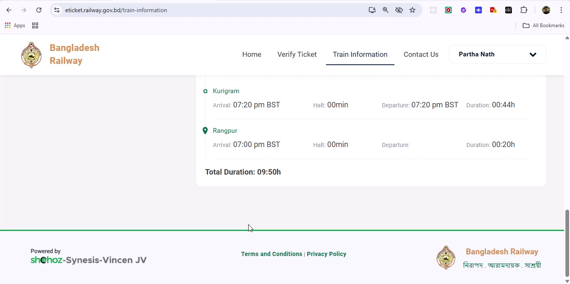

## Screenshot 109

Additional workflow step captured; refer to screenshot for details.

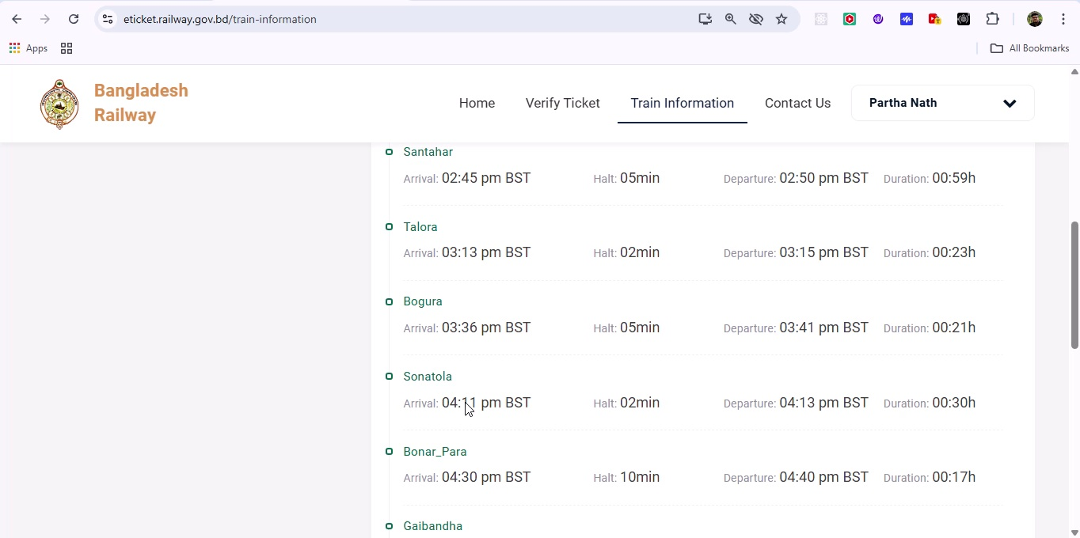

## Screenshot 110

Additional workflow step captured; refer to screenshot for details.

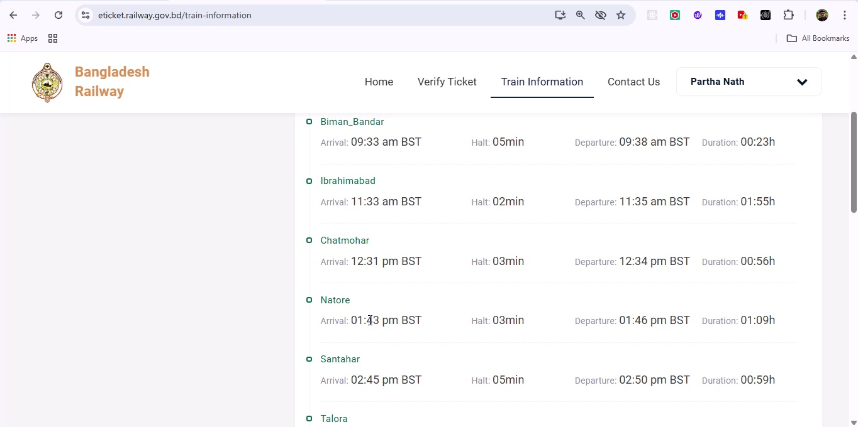

## Screenshot 111

Additional workflow step captured; refer to screenshot for details.

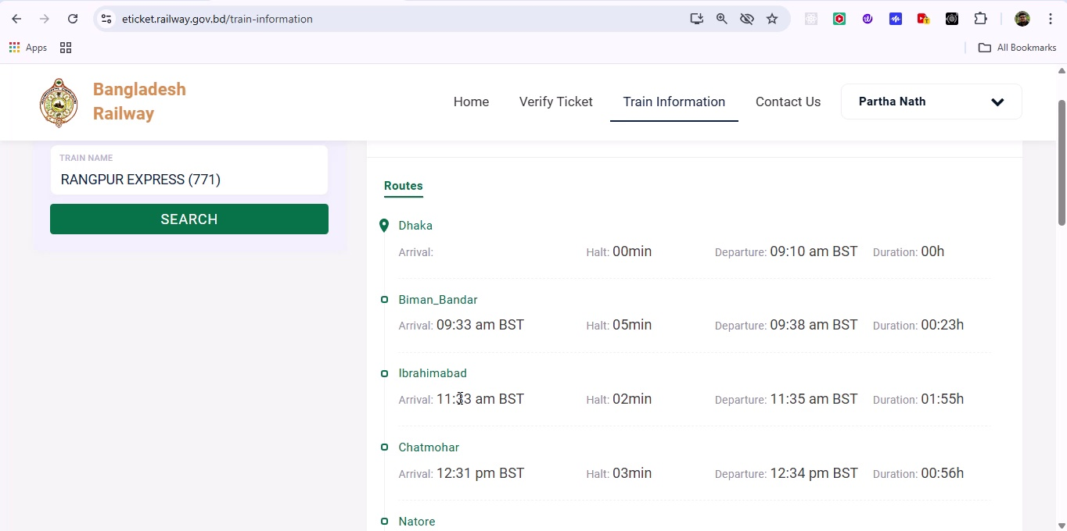

## Screenshot 112

Additional workflow step captured; refer to screenshot for details.

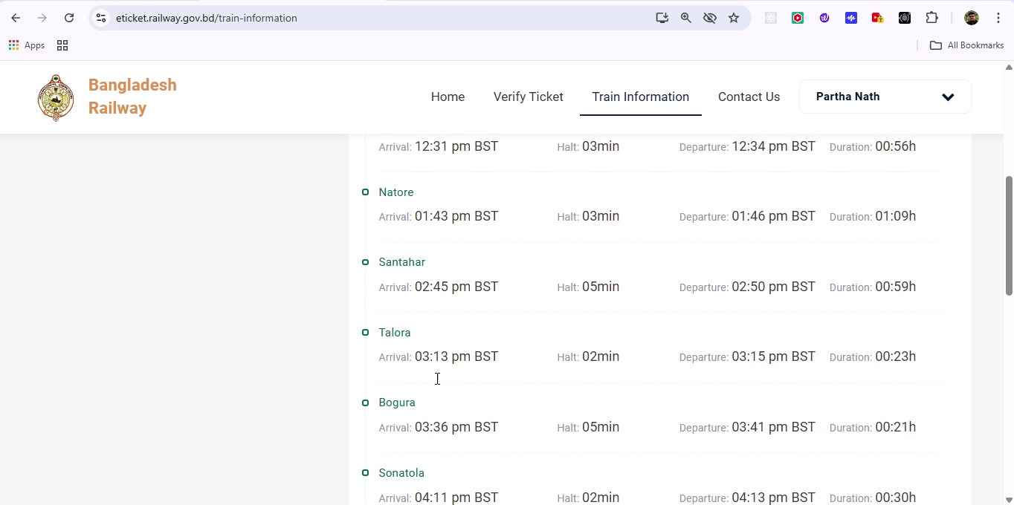

## Screenshot 113

Additional workflow step captured; refer to screenshot for details.

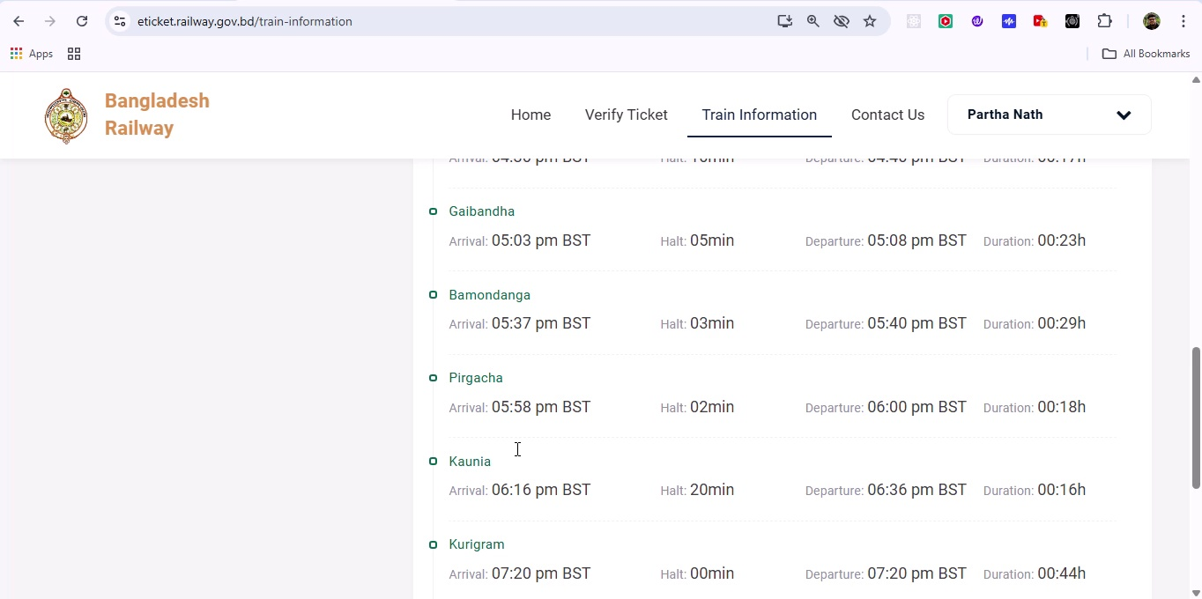

## Screenshot 114

Additional workflow step captured; refer to screenshot for details.

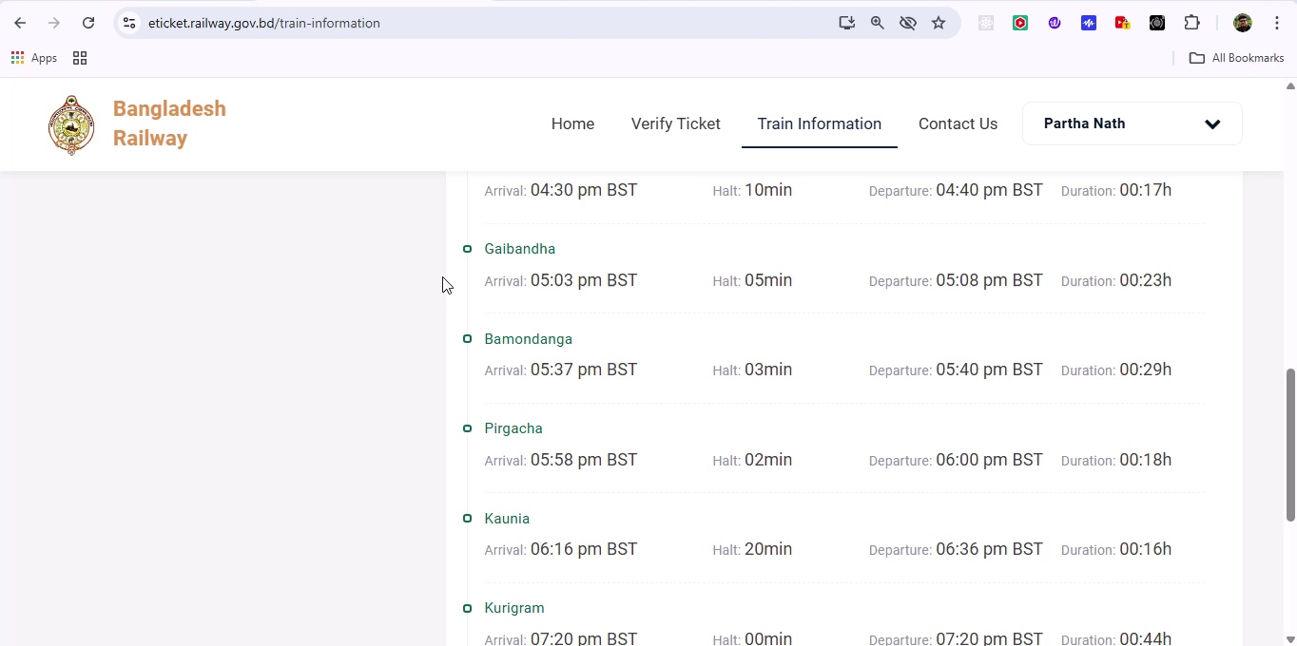

## Screenshot 115

Additional workflow step captured; refer to screenshot for details.

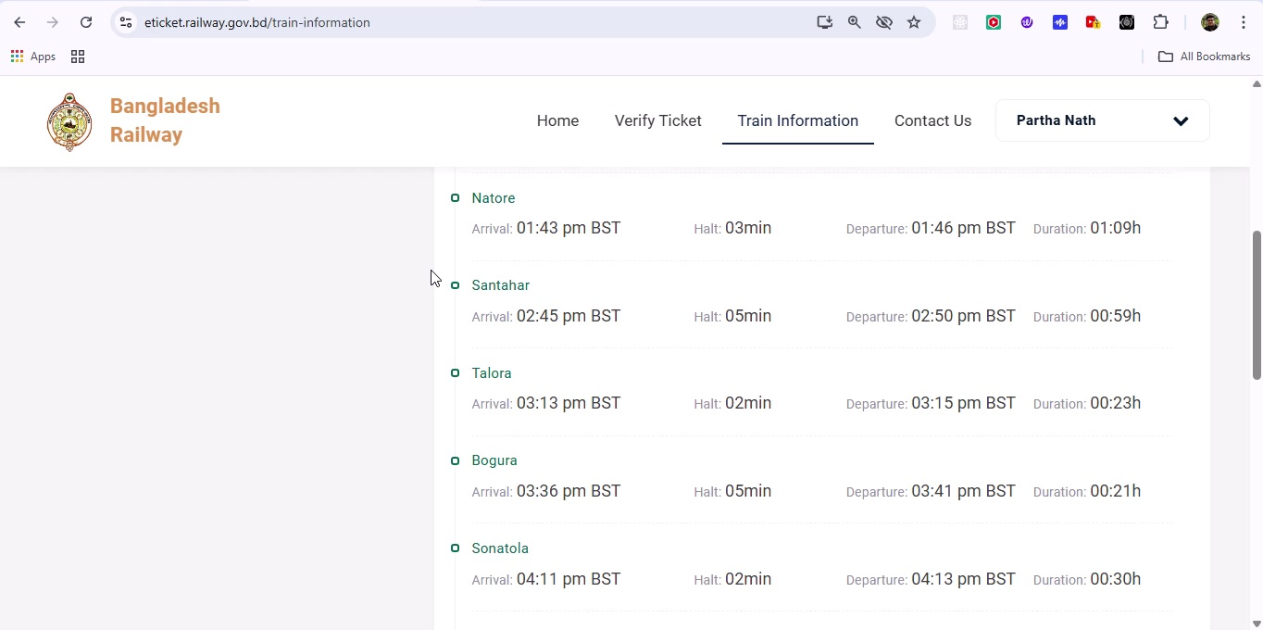

## Screenshot 116

Additional workflow step captured; refer to screenshot for details.

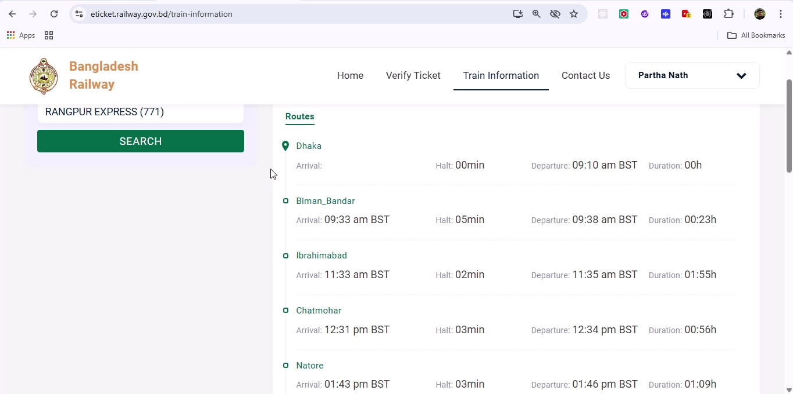

## Screenshot 117

Additional workflow step captured; refer to screenshot for details.

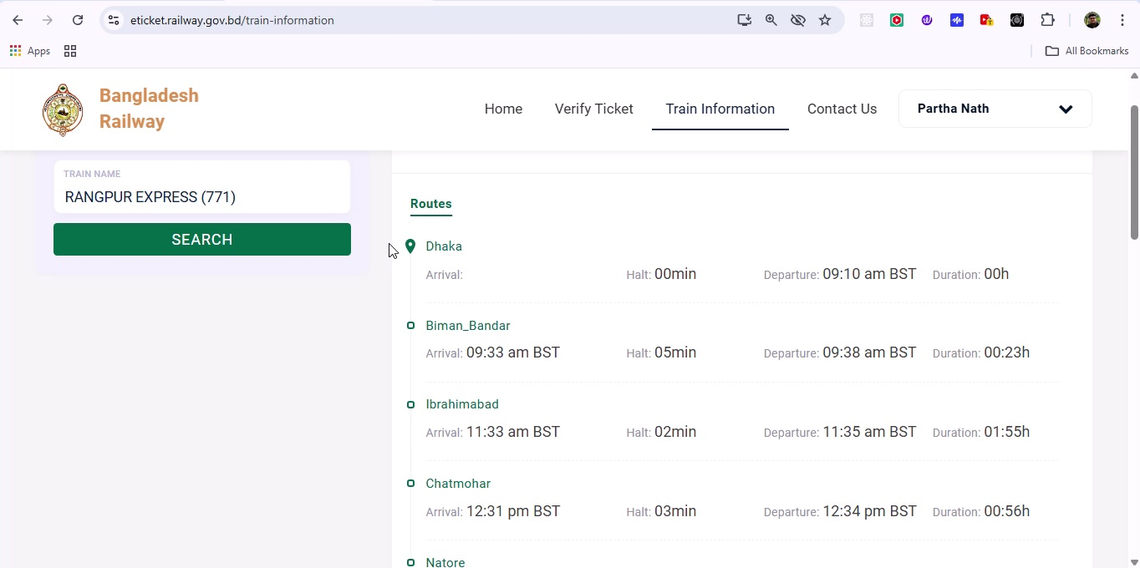

## Screenshot 118

Additional workflow step captured; refer to screenshot for details.

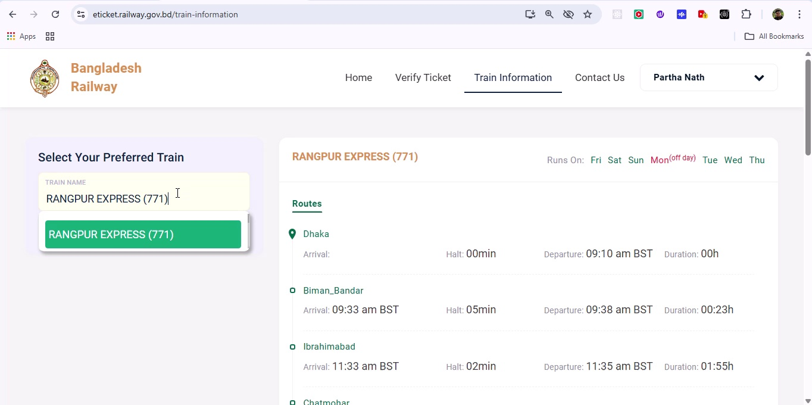

## Screenshot 119

Additional workflow step captured; refer to screenshot for details.

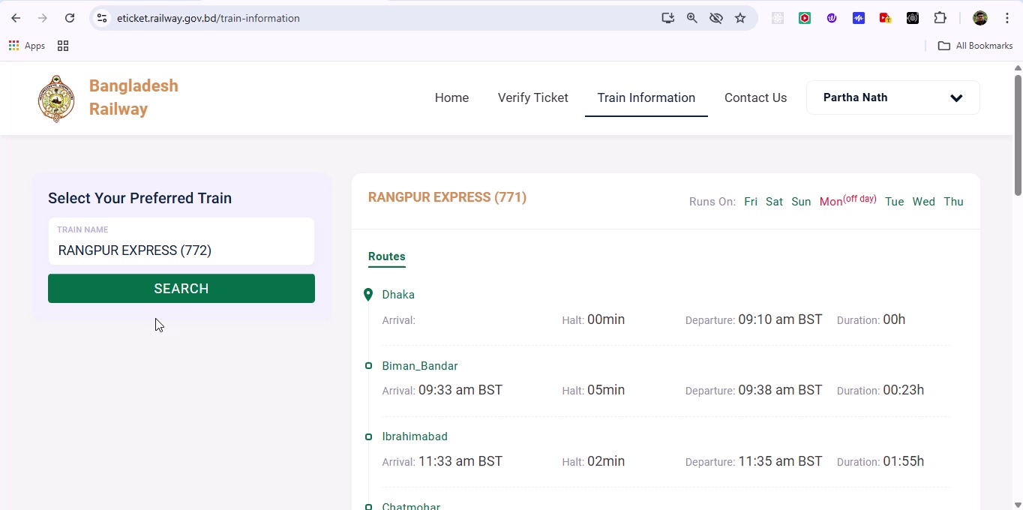

## Screenshot 120

Additional workflow step captured; refer to screenshot for details.

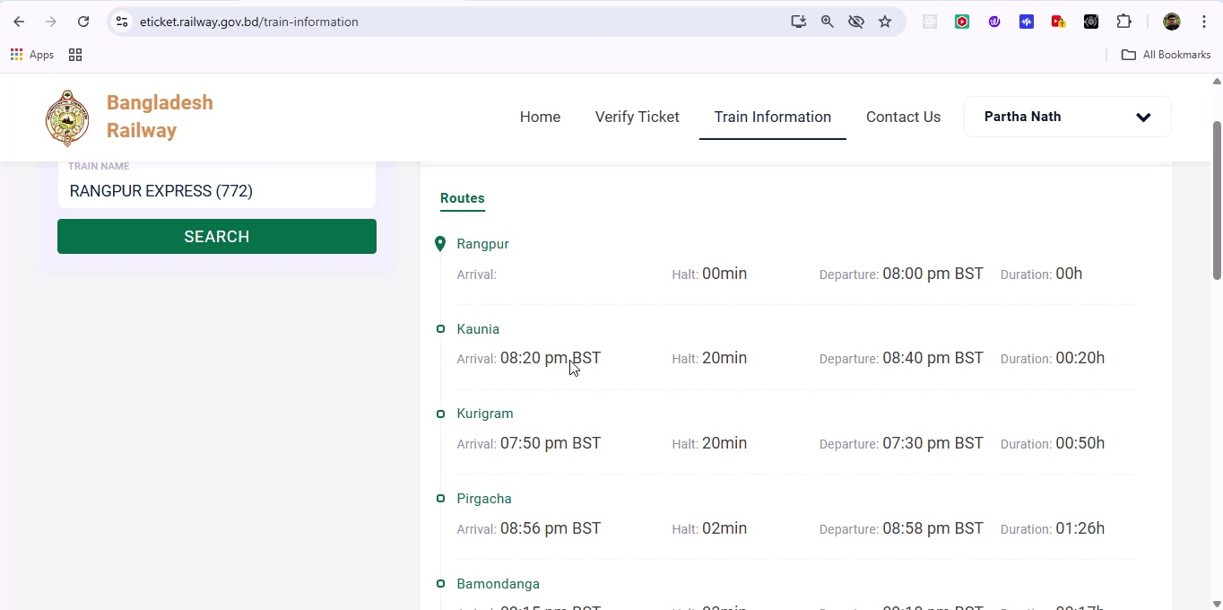

## Screenshot 121

Additional workflow step captured; refer to screenshot for details.

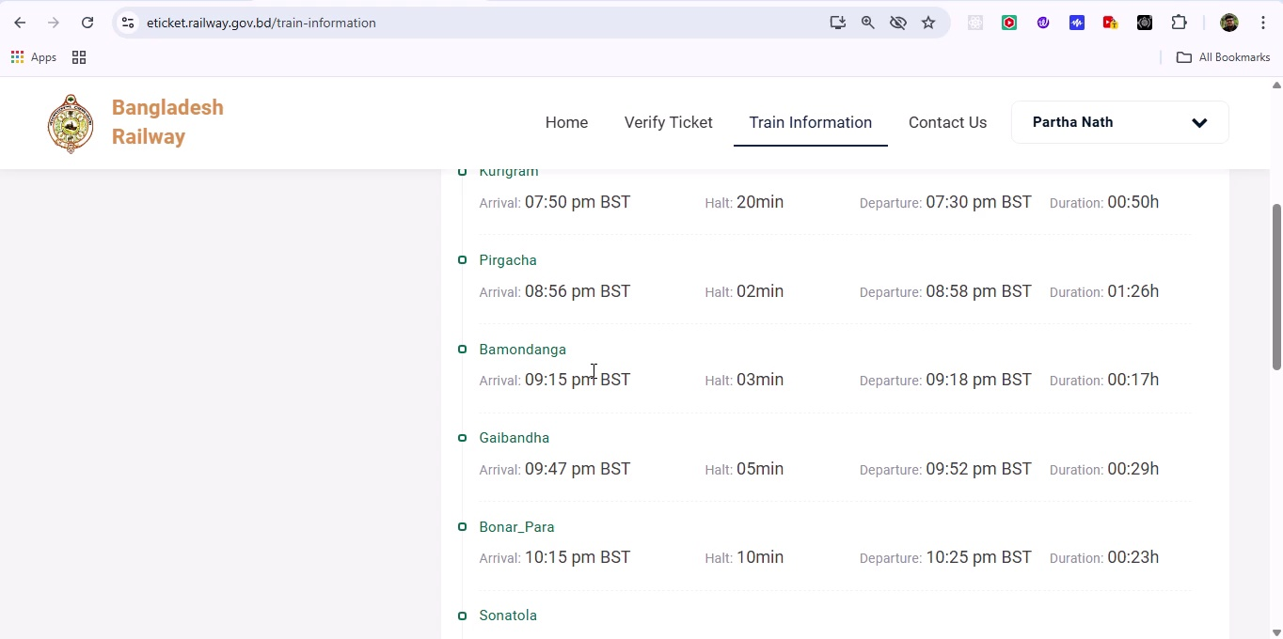

## Screenshot 122

Additional workflow step captured; refer to screenshot for details.

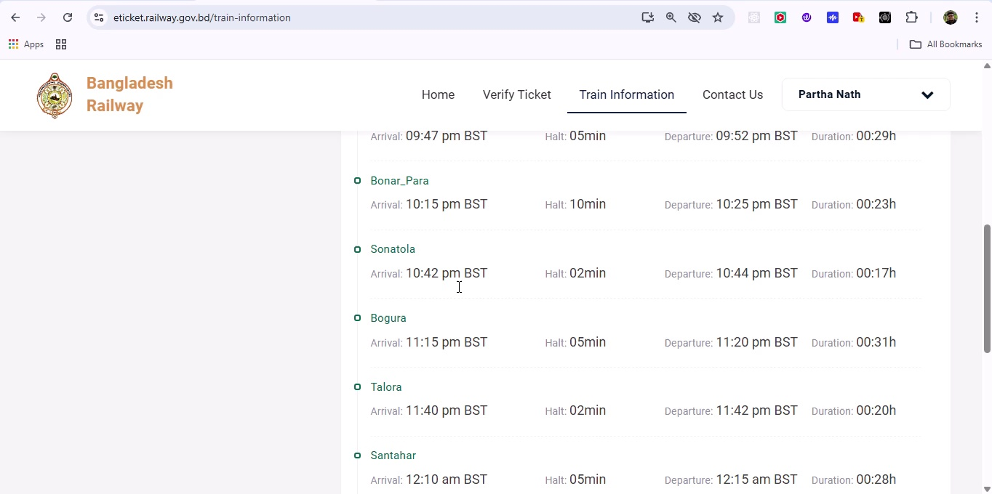

## Screenshot 123

Additional workflow step captured; refer to screenshot for details.

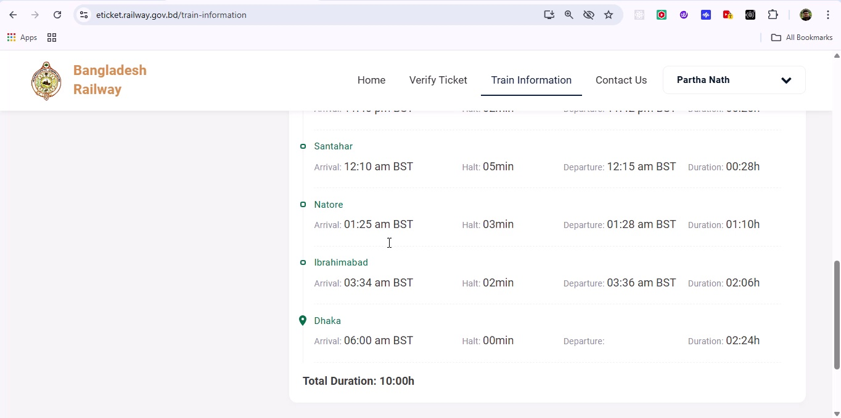

## Screenshot 124

Additional workflow step captured; refer to screenshot for details.

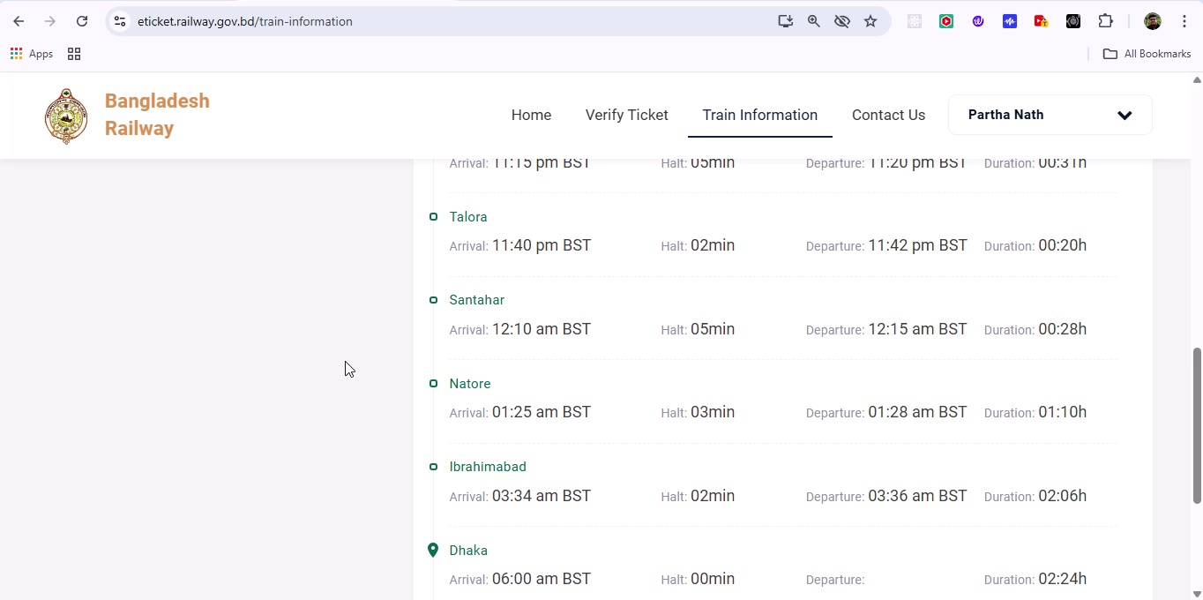

## Screenshot 125

Additional workflow step captured; refer to screenshot for details.

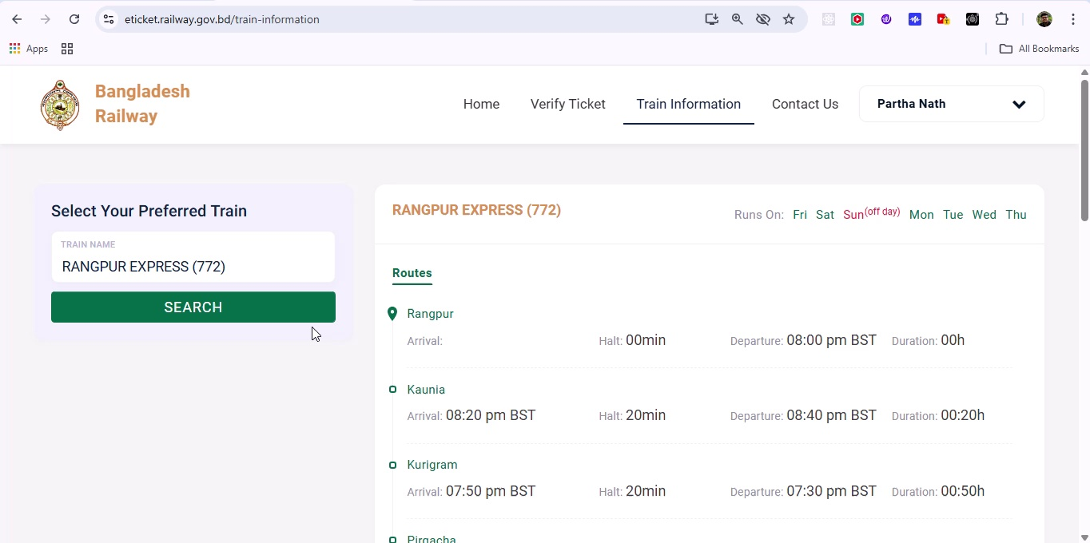

## Screenshot 126

Additional workflow step captured; refer to screenshot for details.

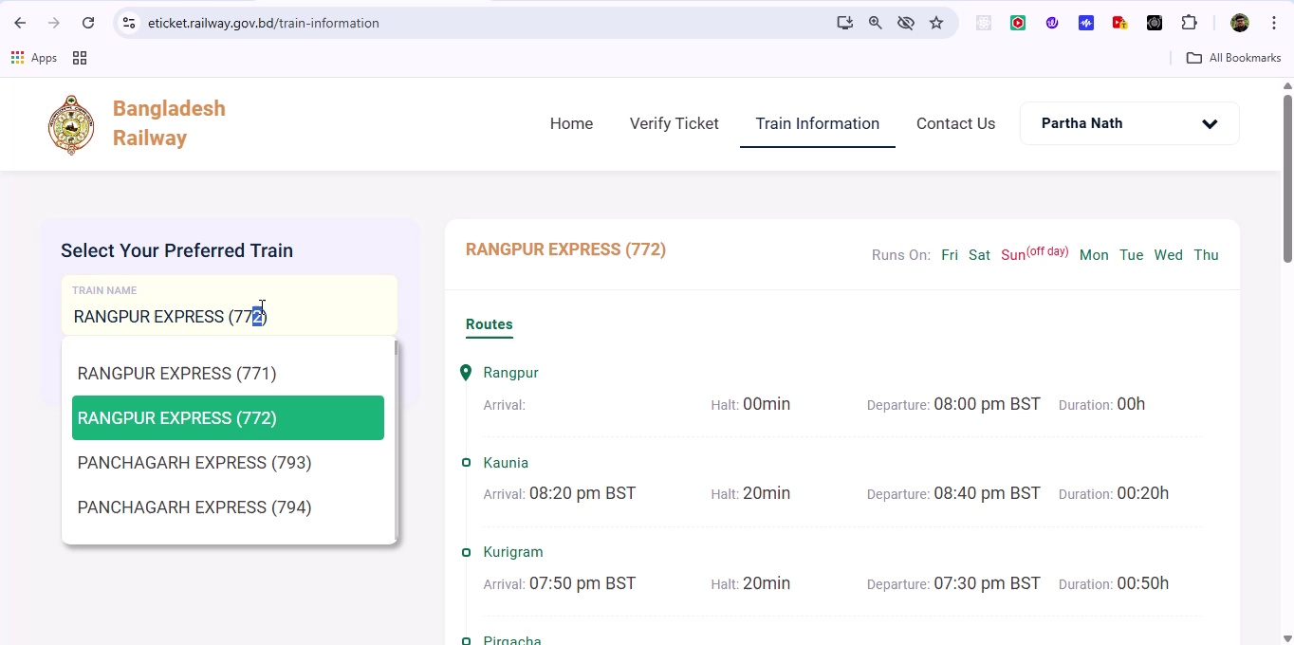

## Screenshot 127

Additional workflow step captured; refer to screenshot for details.

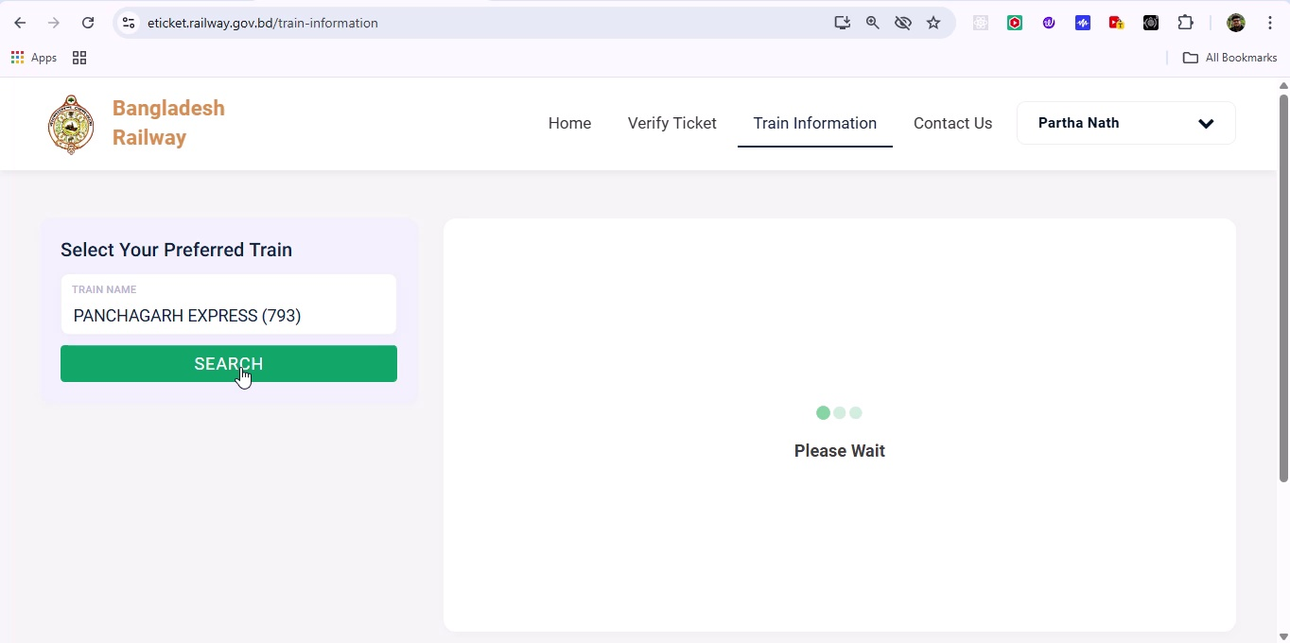

## Screenshot 128

Additional workflow step captured; refer to screenshot for details.

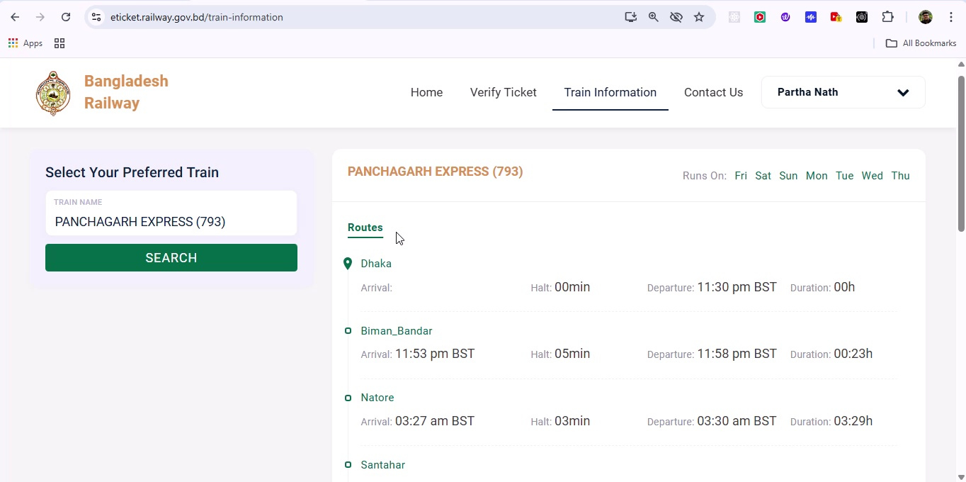

## Screenshot 129

Additional workflow step captured; refer to screenshot for details.

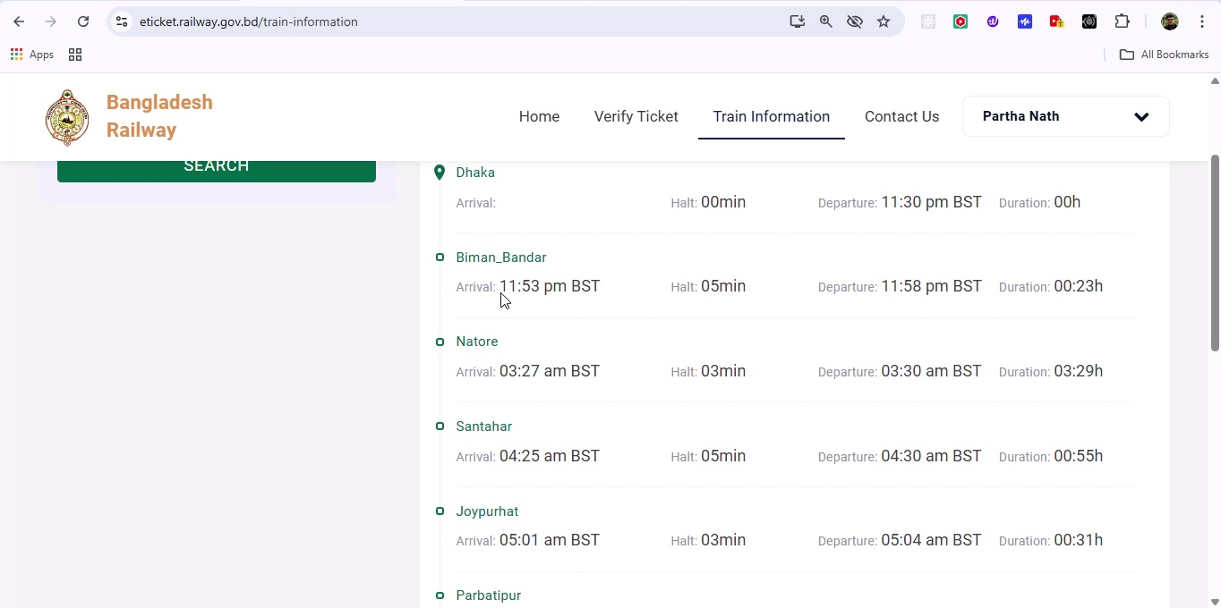

## Screenshot 130

Additional workflow step captured; refer to screenshot for details.

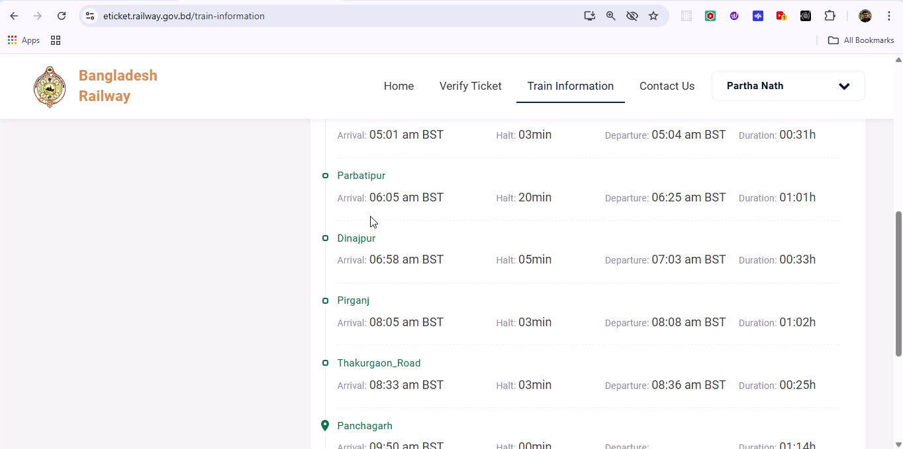

## Screenshot 131

Additional workflow step captured; refer to screenshot for details.

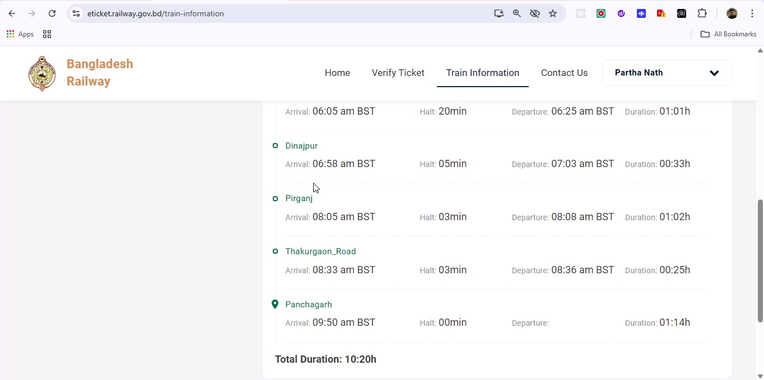

## Screenshot 132

Additional workflow step captured; refer to screenshot for details.

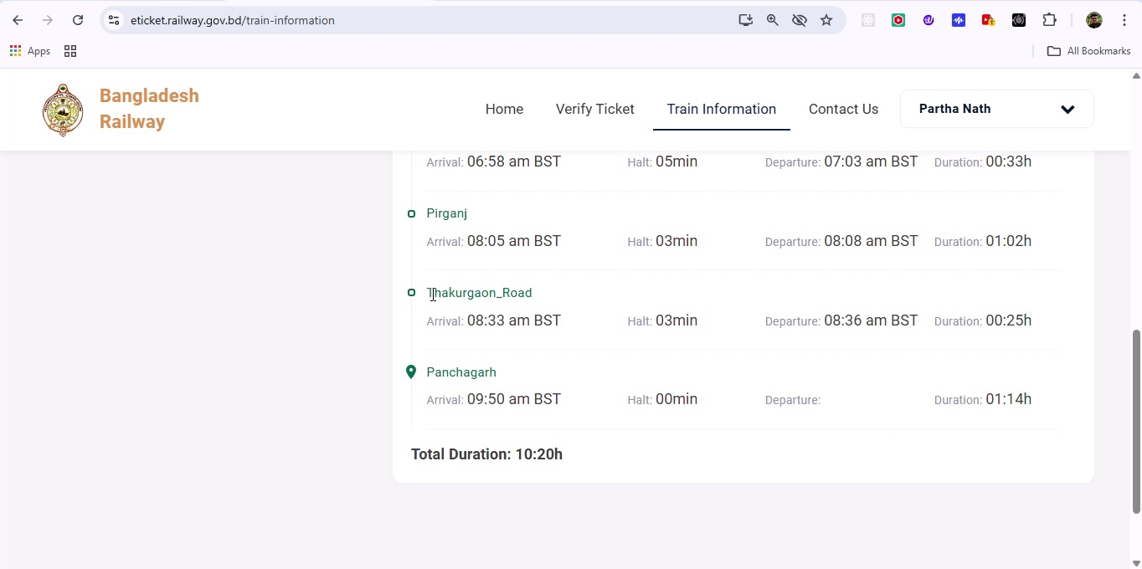

## Screenshot 133

Additional workflow step captured; refer to screenshot for details.

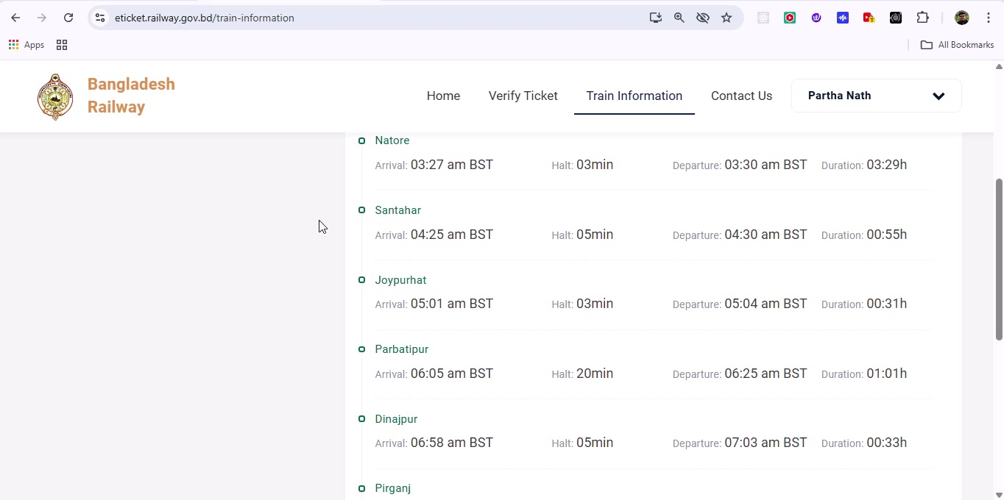

## Screenshot 134

Additional workflow step captured; refer to screenshot for details.

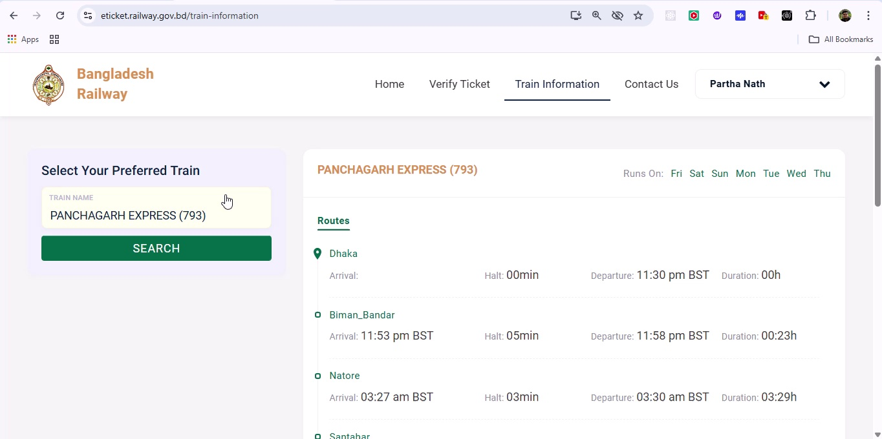

## Screenshot 135

Additional workflow step captured; refer to screenshot for details.

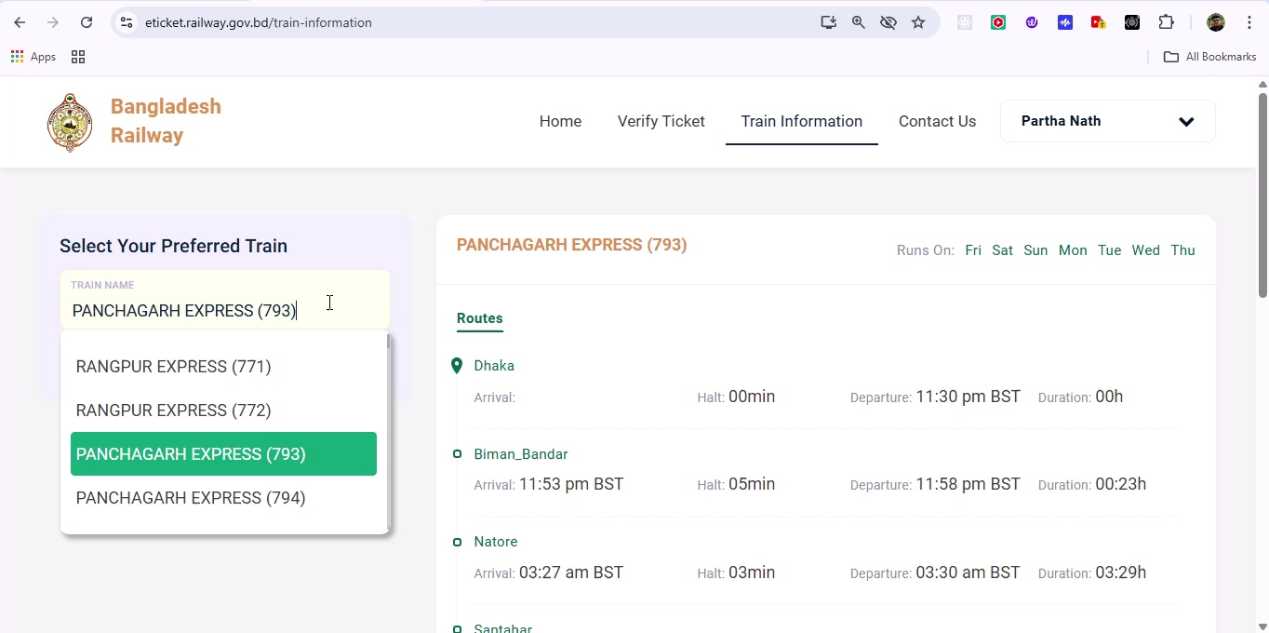

## Screenshot 136

Additional workflow step captured; refer to screenshot for details.

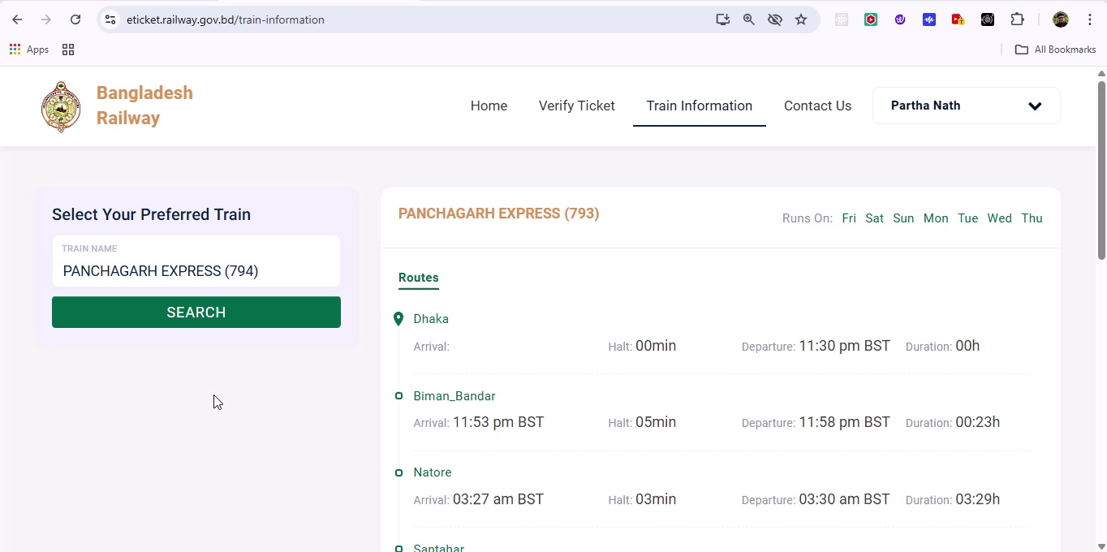

## Screenshot 137

Additional workflow step captured; refer to screenshot for details.

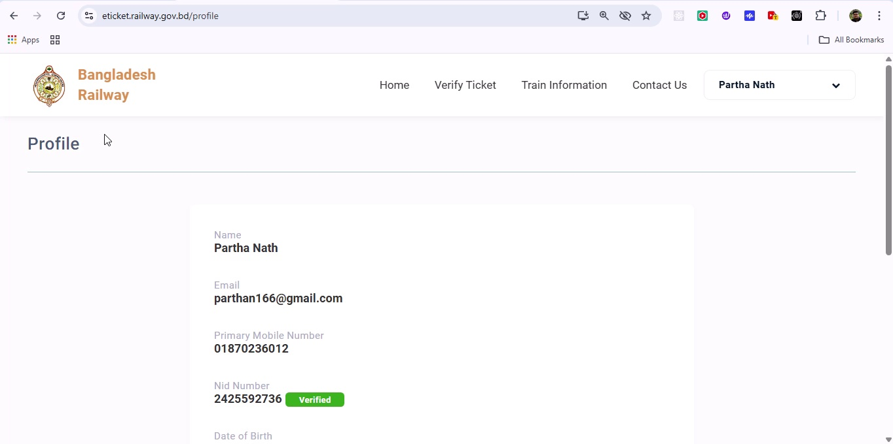

## Screenshot 138

Additional workflow step captured; refer to screenshot for details.

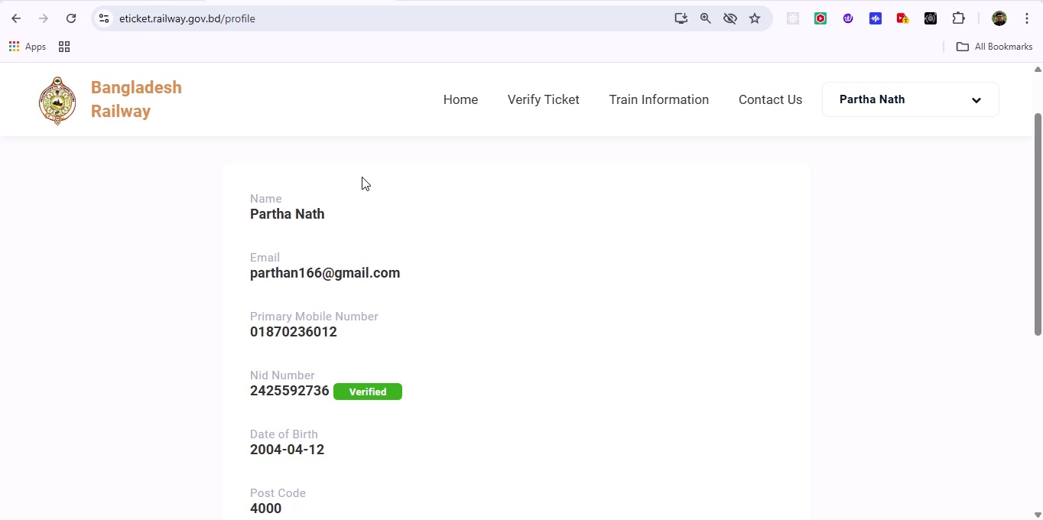

## Screenshot 139

Additional workflow step captured; refer to screenshot for details.

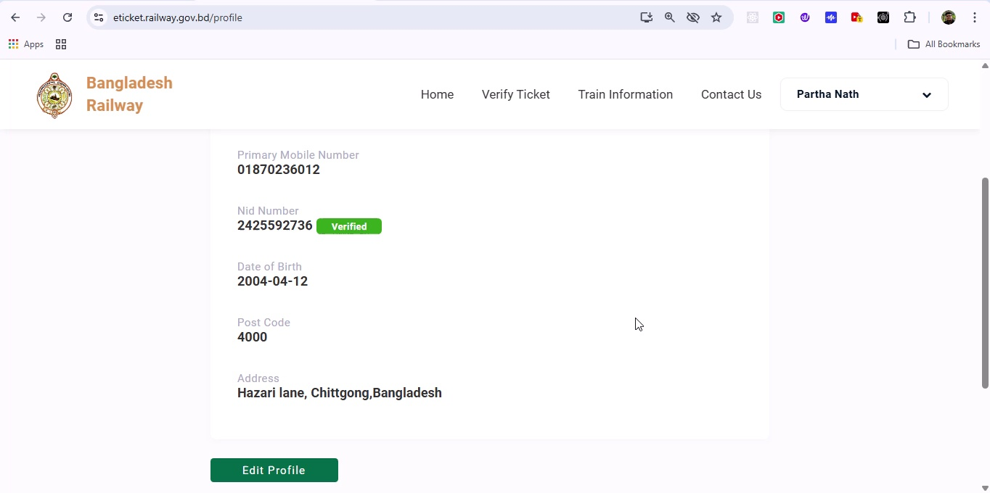

## Screenshot 140

Additional workflow step captured; refer to screenshot for details.

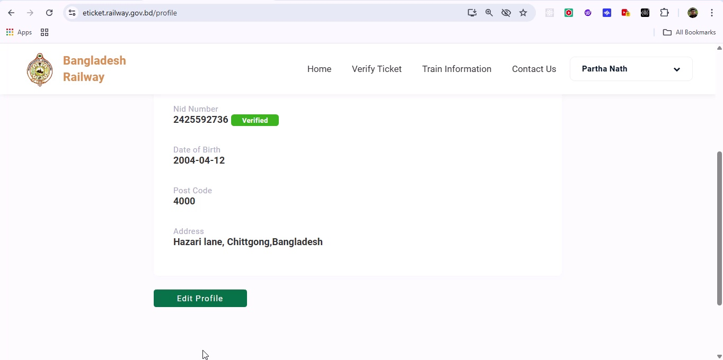

## Screenshot 141

Additional workflow step captured; refer to screenshot for details.

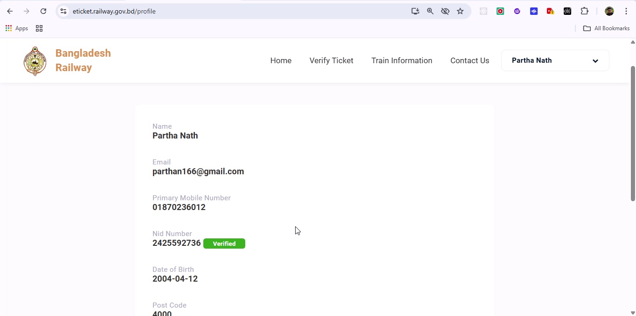

## Screenshot 142

Additional workflow step captured; refer to screenshot for details.

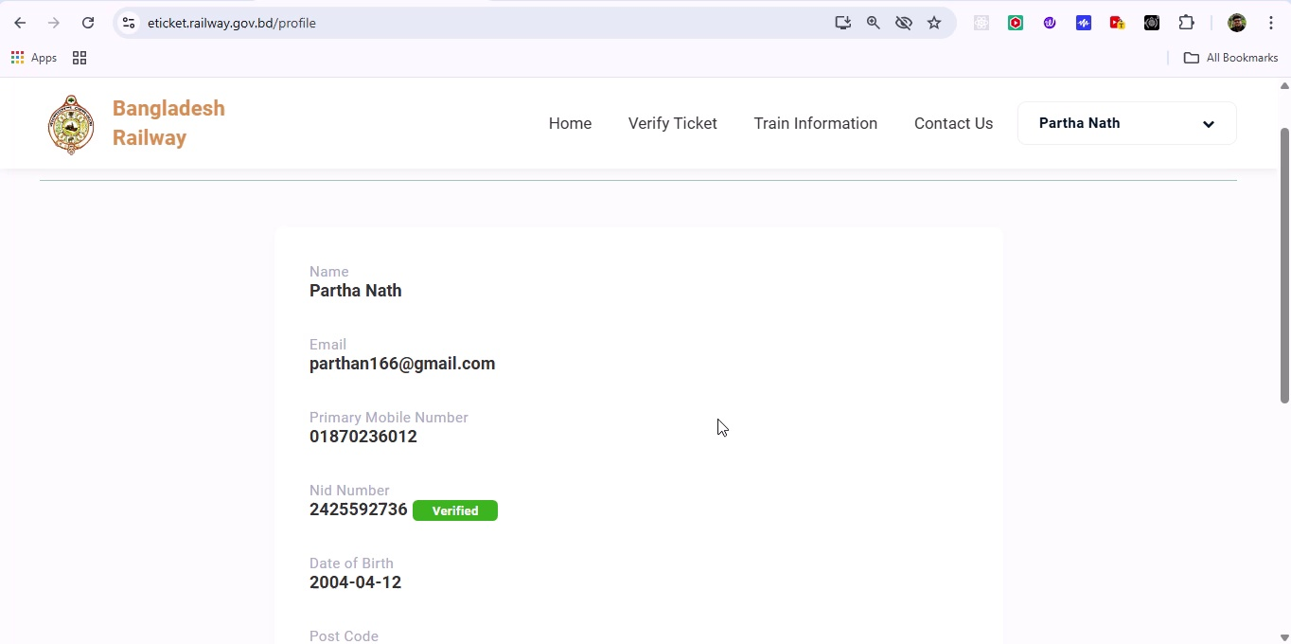

## Screenshot 143

Additional workflow step captured; refer to screenshot for details.

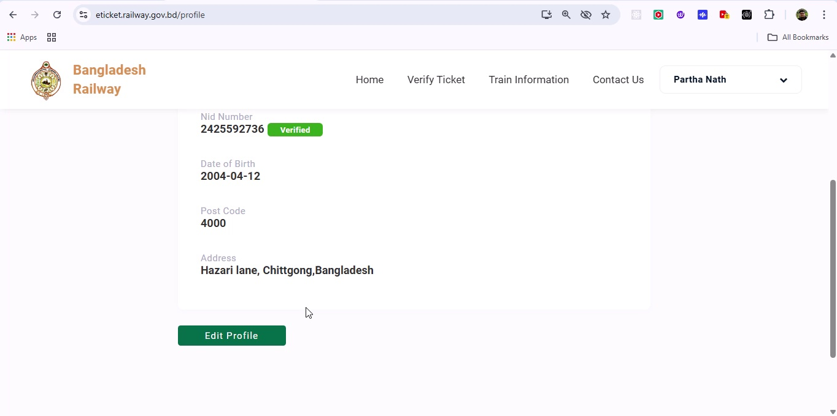

## Screenshot 144

Additional workflow step captured; refer to screenshot for details.

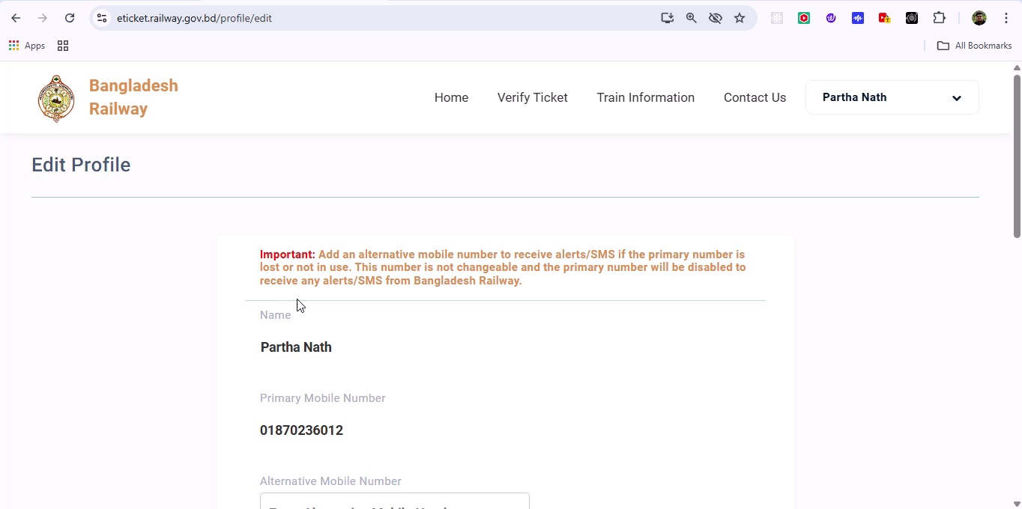

## Screenshot 145

Additional workflow step captured; refer to screenshot for details.

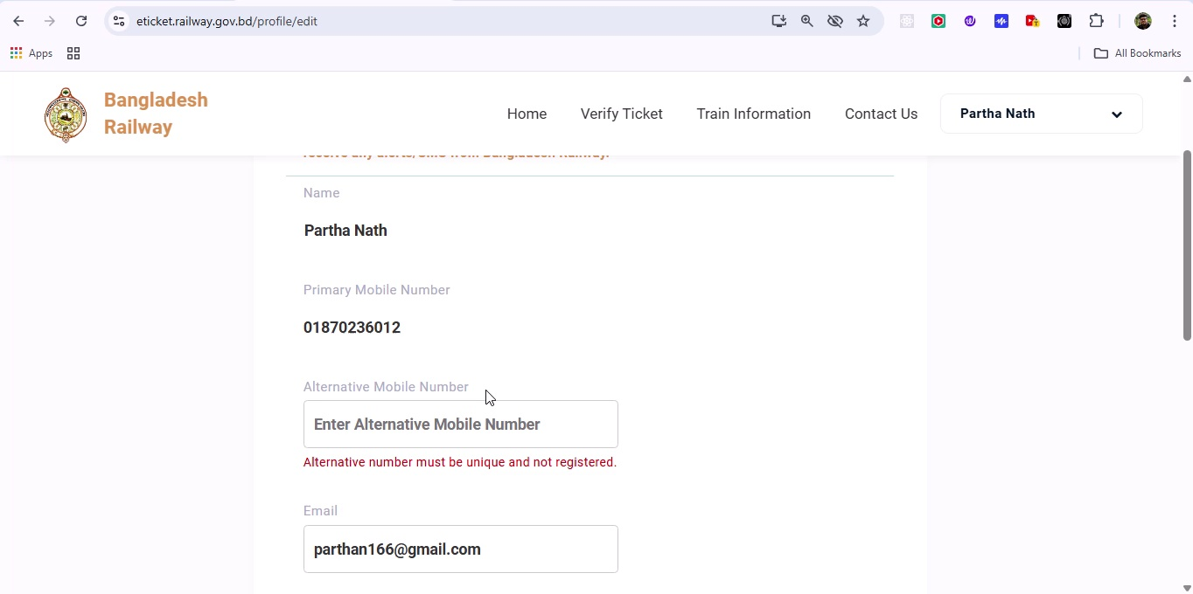

## Screenshot 146

Additional workflow step captured; refer to screenshot for details.

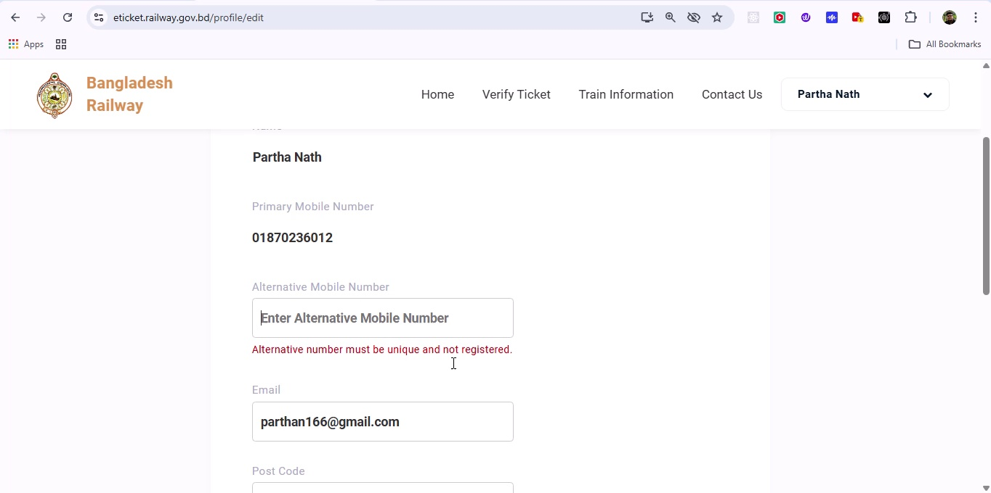

## Screenshot 147

Additional workflow step captured; refer to screenshot for details.

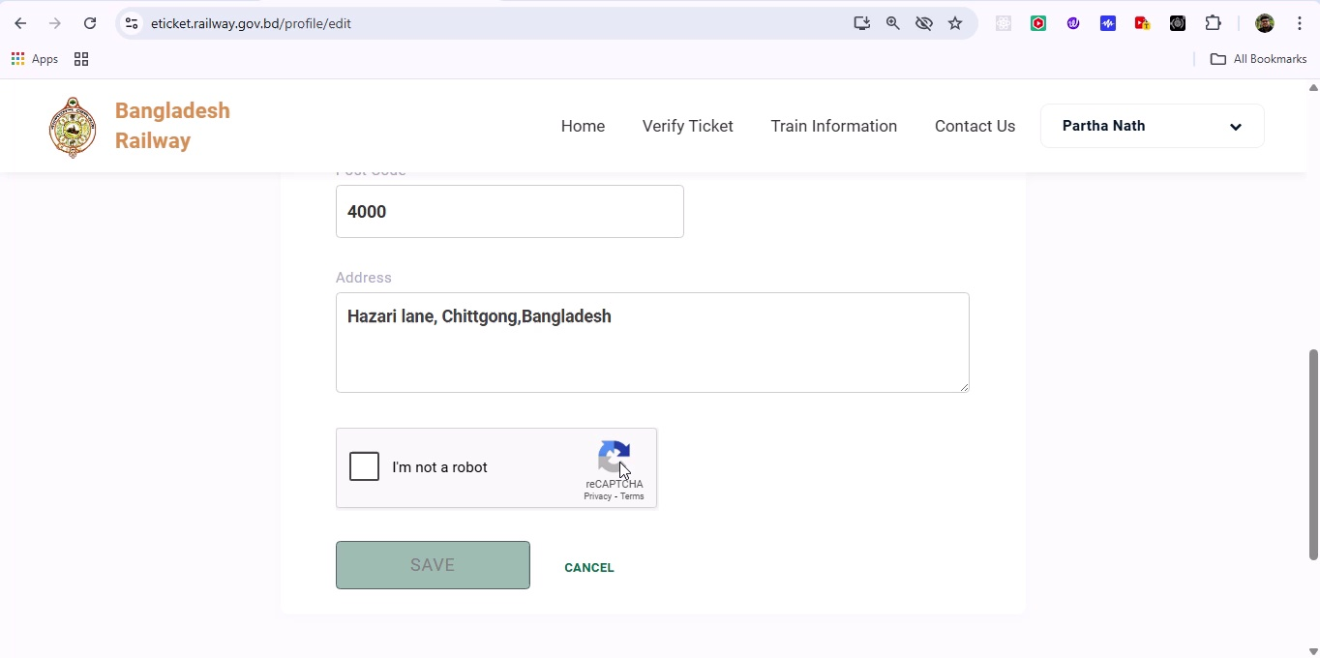

## Screenshot 148

Additional workflow step captured; refer to screenshot for details.

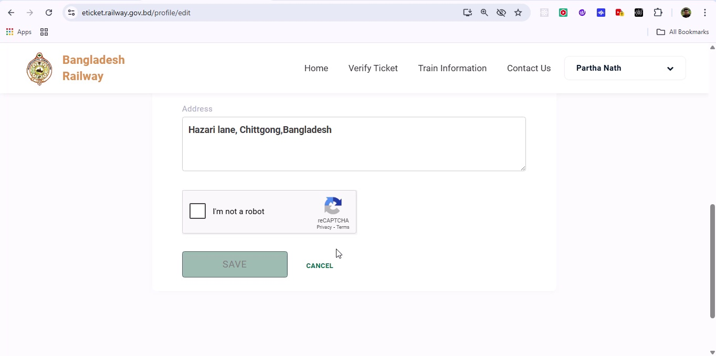

## Screenshot 149

Additional workflow step captured; refer to screenshot for details.

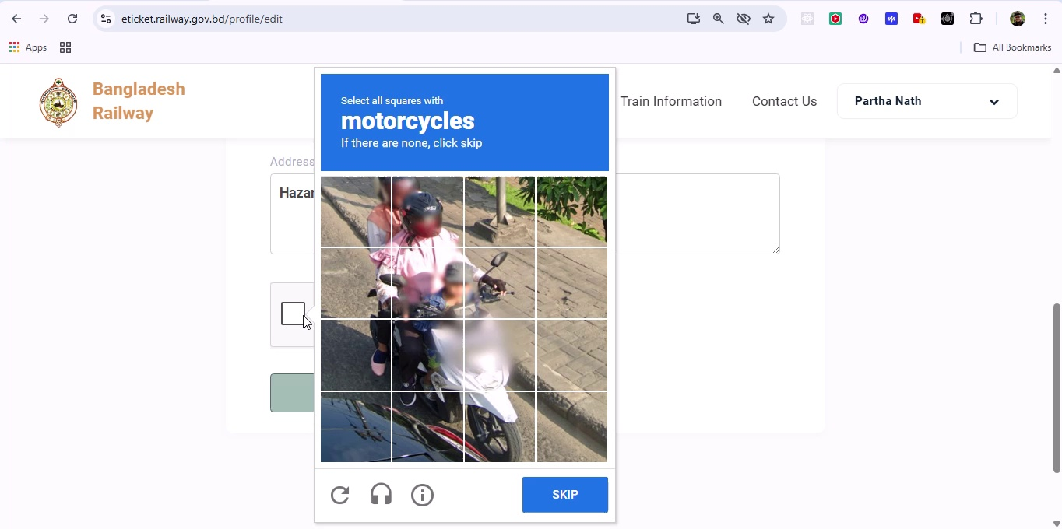

## Screenshot 150

Additional workflow step captured; refer to screenshot for details.

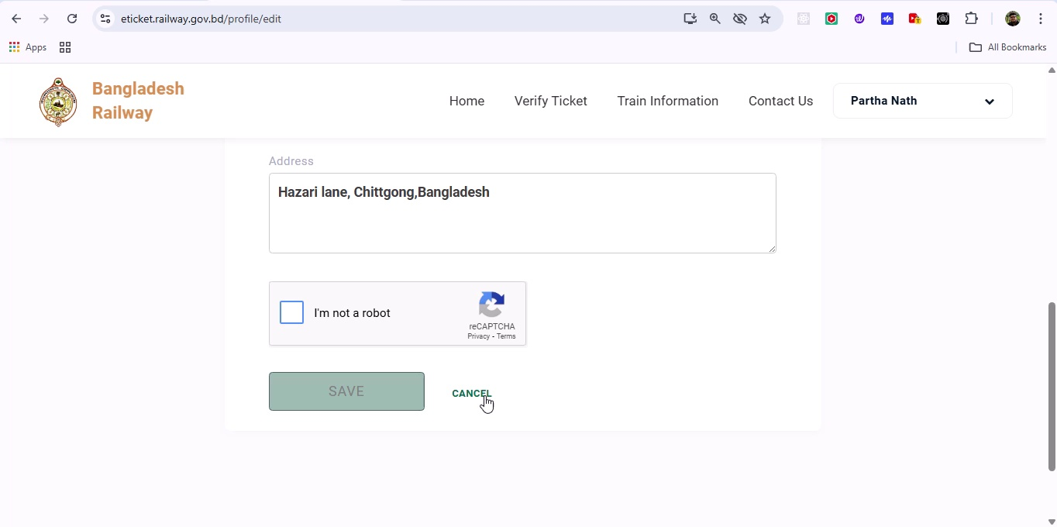

## Screenshot 151

Additional workflow step captured; refer to screenshot for details.

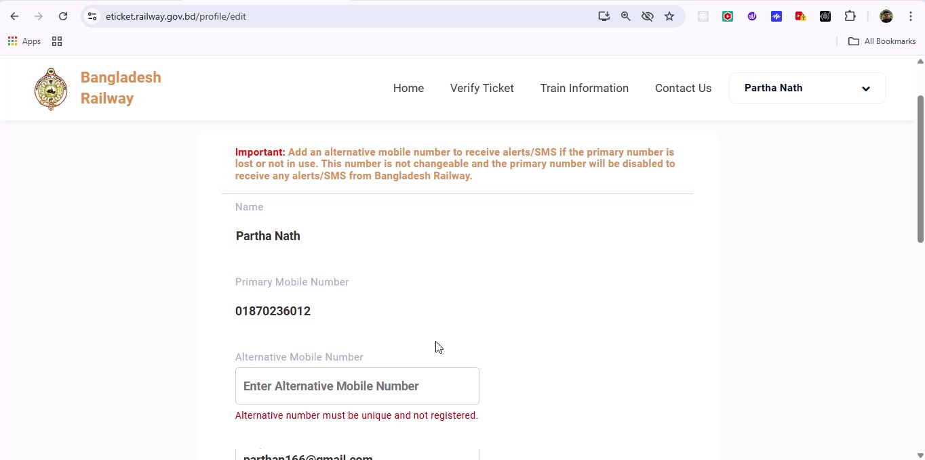

## Screenshot 152

Additional workflow step captured; refer to screenshot for details.

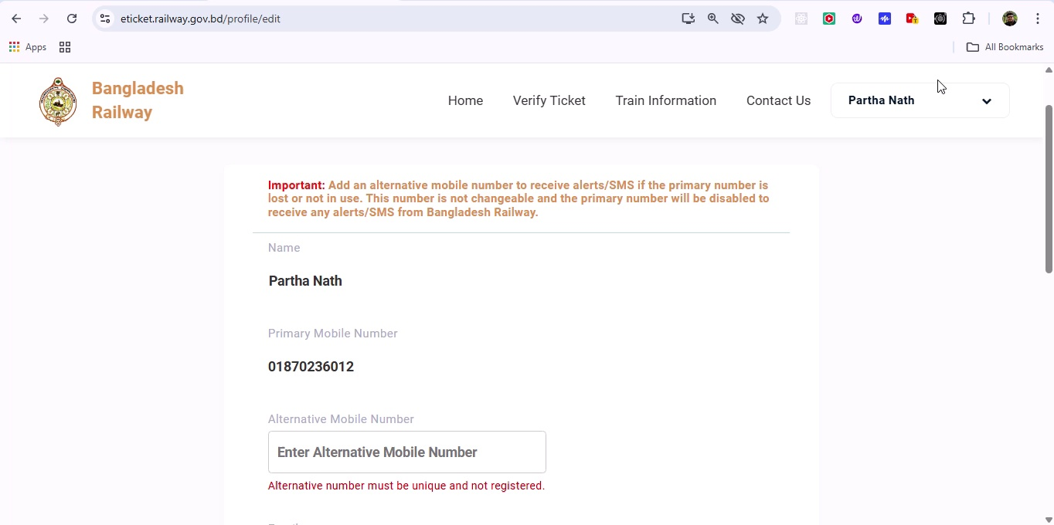

## Screenshot 153

Additional workflow step captured; refer to screenshot for details.

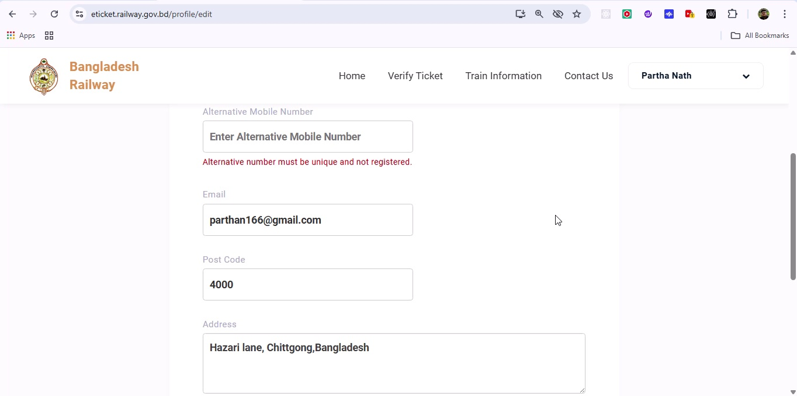

## Screenshot 154

Additional workflow step captured; refer to screenshot for details.

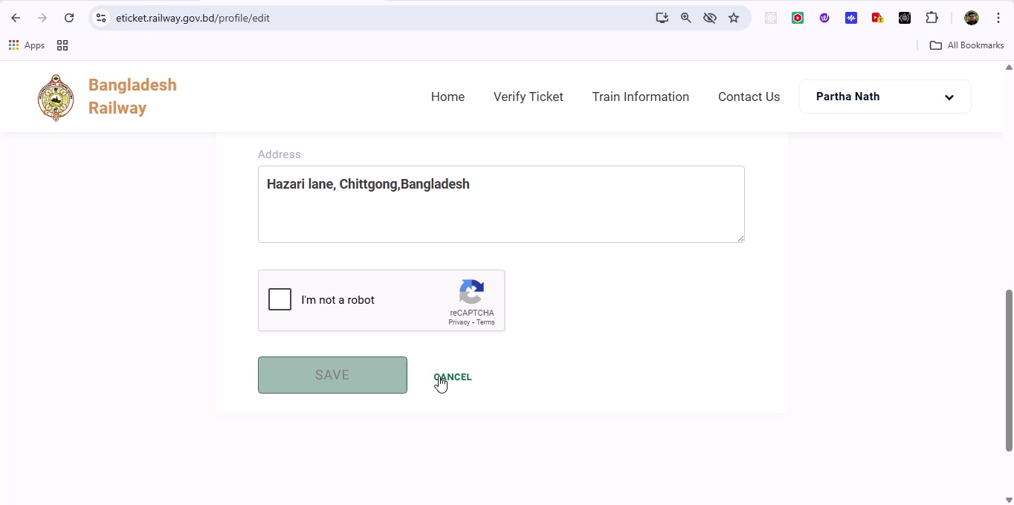

## Screenshot 155

Additional workflow step captured; refer to screenshot for details.

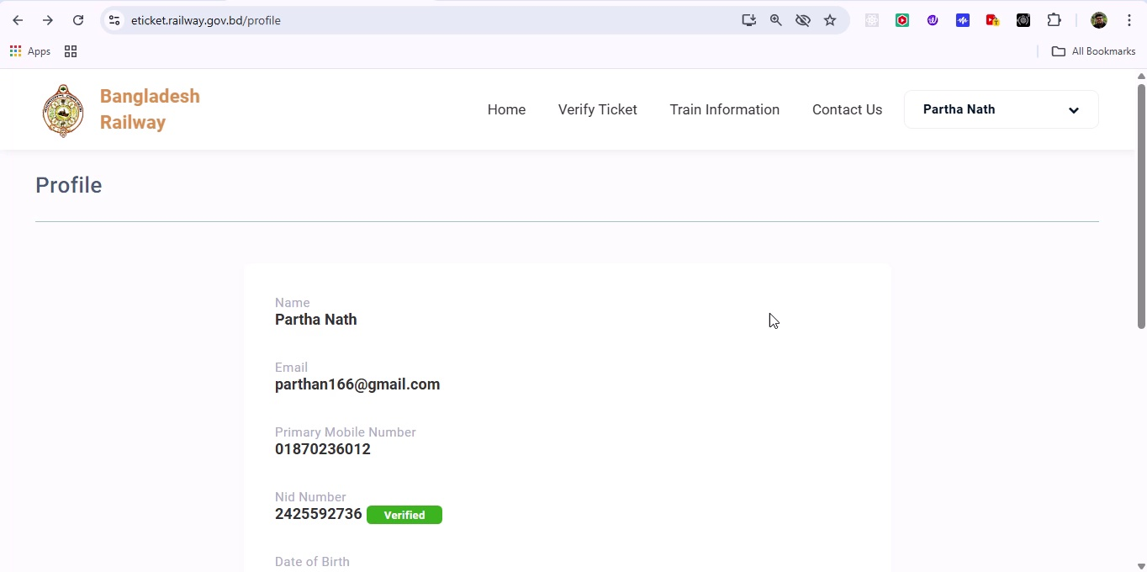

## Screenshot 156

Additional workflow step captured; refer to screenshot for details.

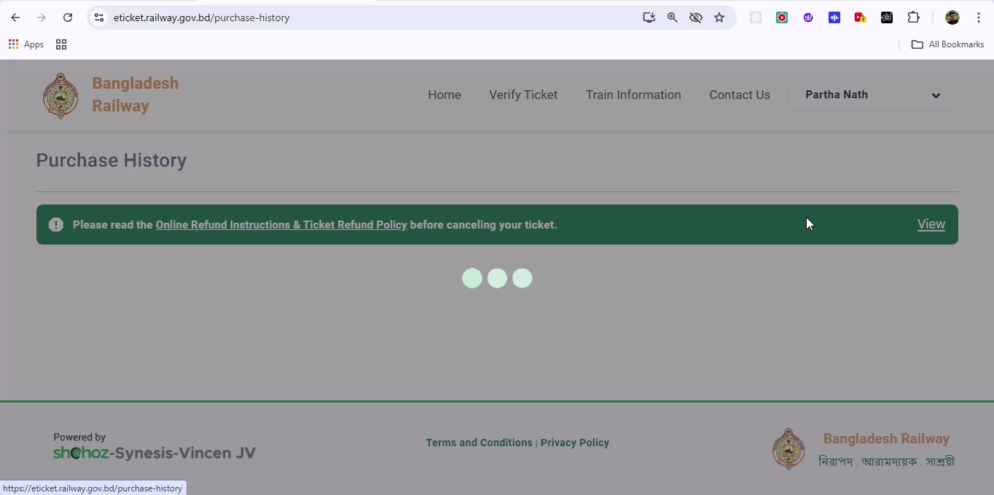

## Screenshot 157

Additional workflow step captured; refer to screenshot for details.

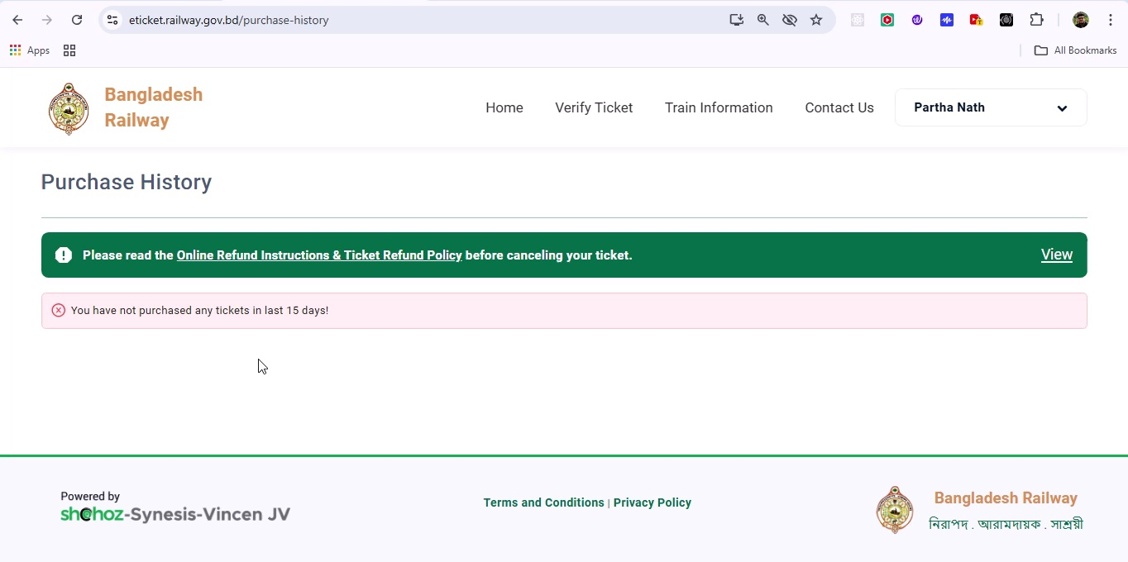

## Screenshot 158

Additional workflow step captured; refer to screenshot for details.

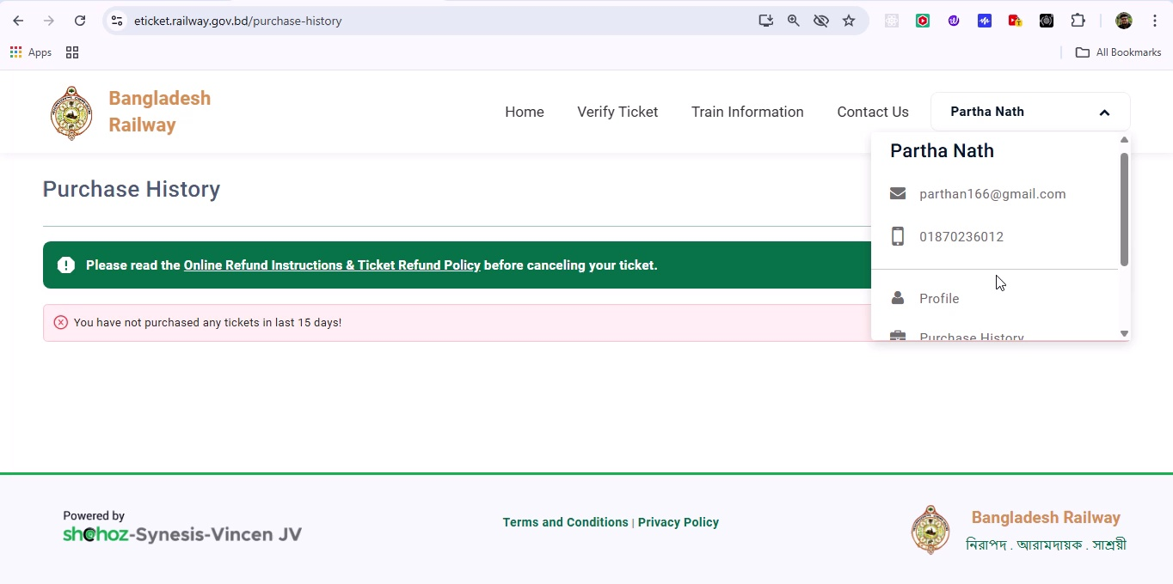

## Screenshot 159

Additional workflow step captured; refer to screenshot for details.

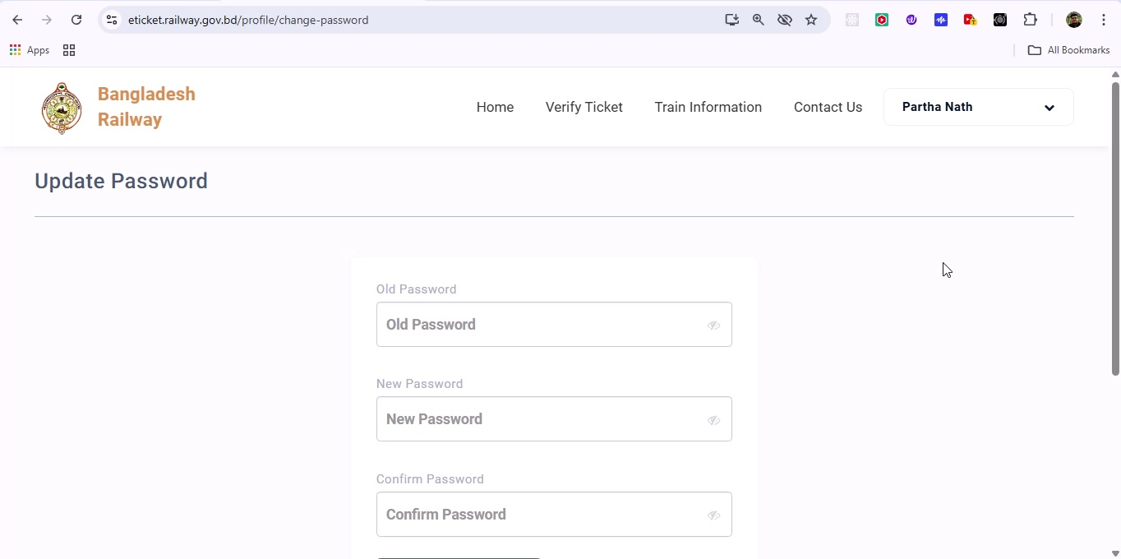

## Screenshot 160

Additional workflow step captured; refer to screenshot for details.

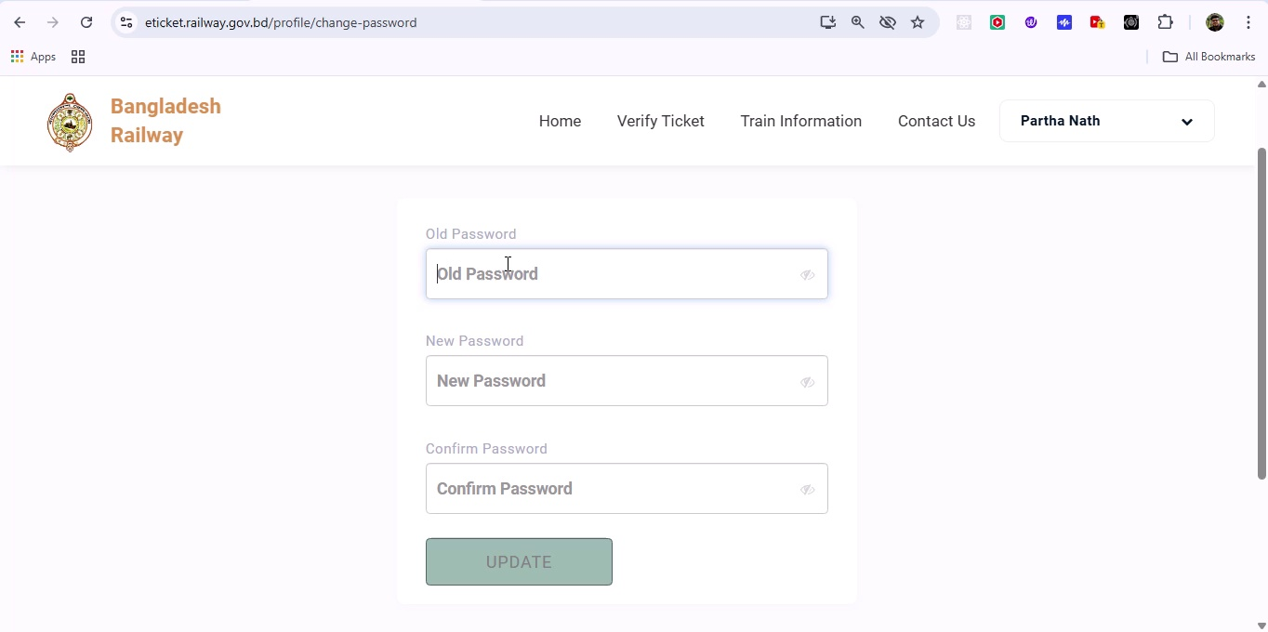

## Screenshot 161

Additional workflow step captured; refer to screenshot for details.

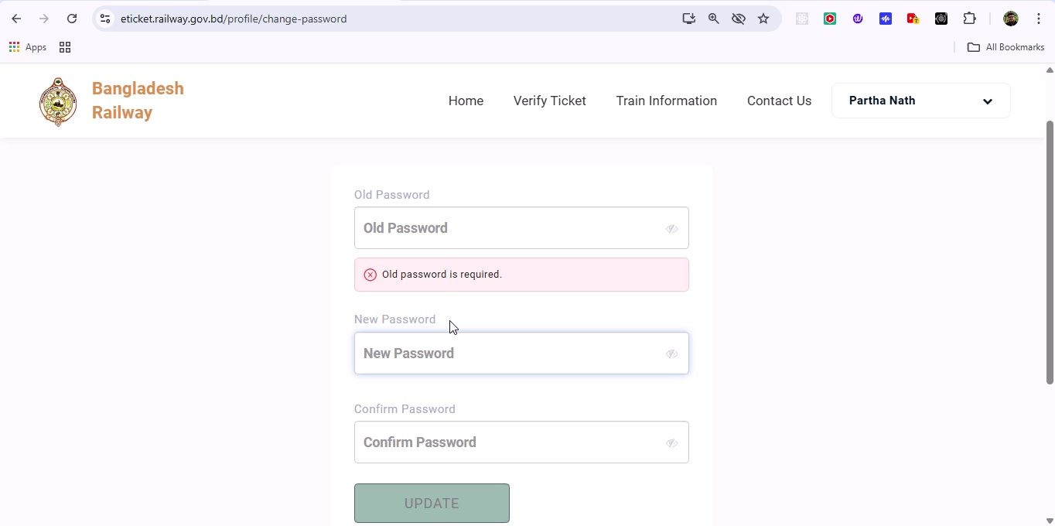

## Screenshot 162

Additional workflow step captured; refer to screenshot for details.

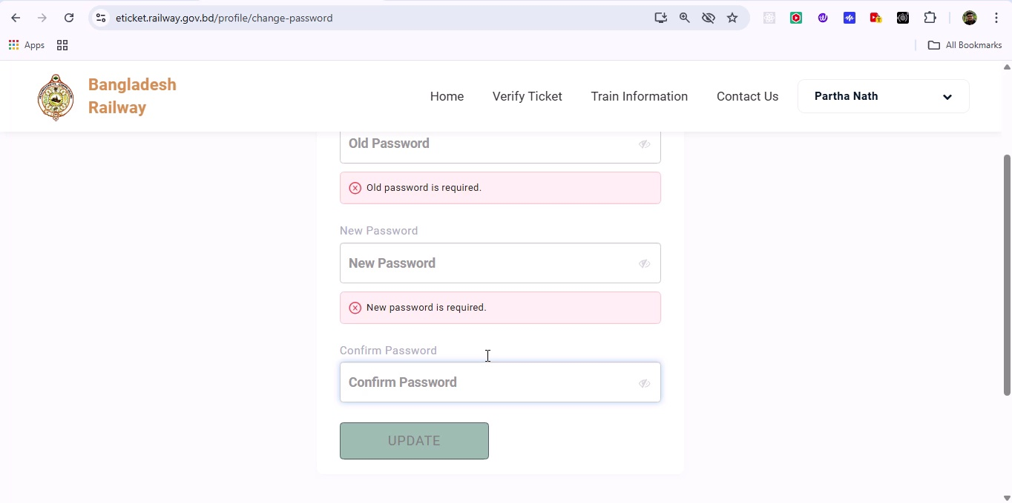

## Screenshot 163

Additional workflow step captured; refer to screenshot for details.

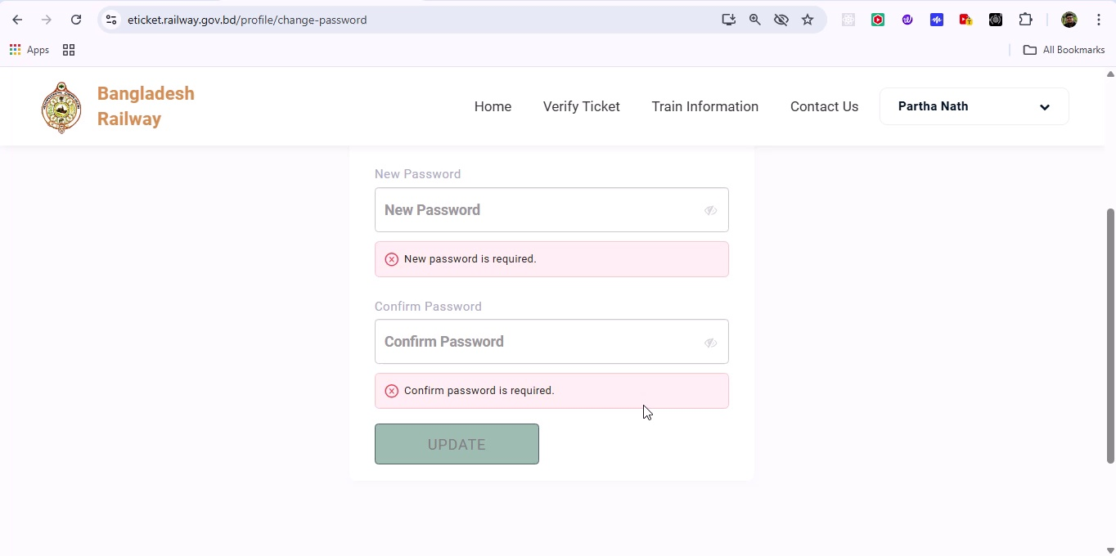

## Screenshot 164

Additional workflow step captured; refer to screenshot for details.

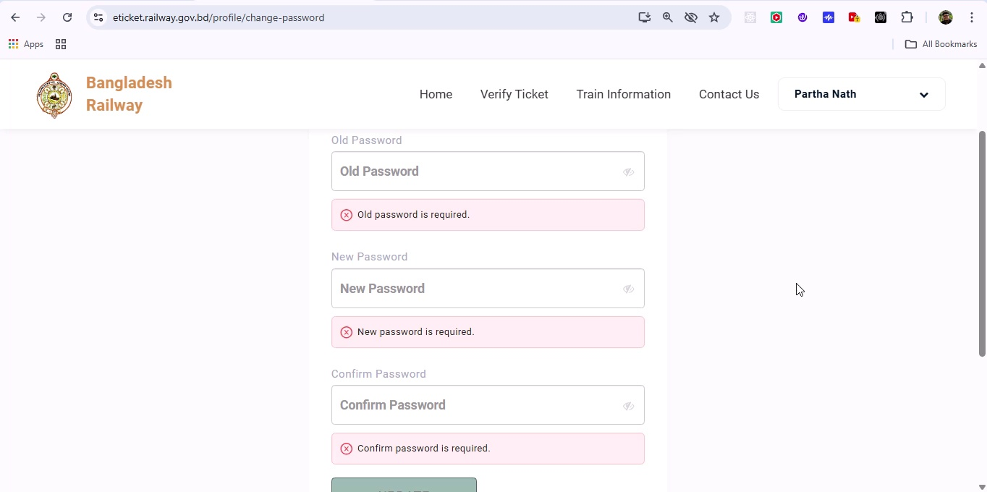

## Screenshot 165

Additional workflow step captured; refer to screenshot for details.

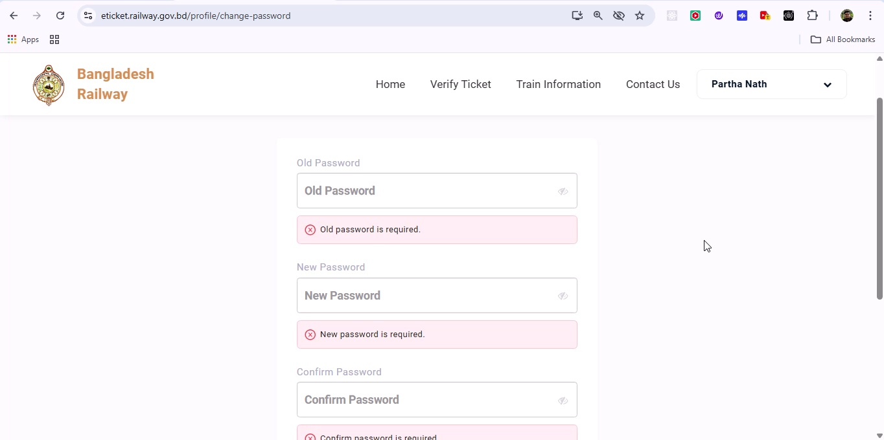

## Screenshot 166

Additional workflow step captured; refer to screenshot for details.

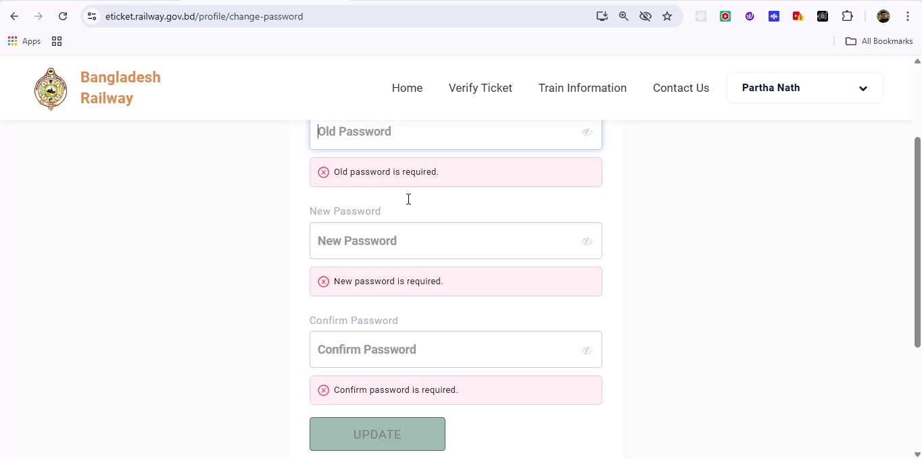

## Screenshot 167

Additional workflow step captured; refer to screenshot for details.

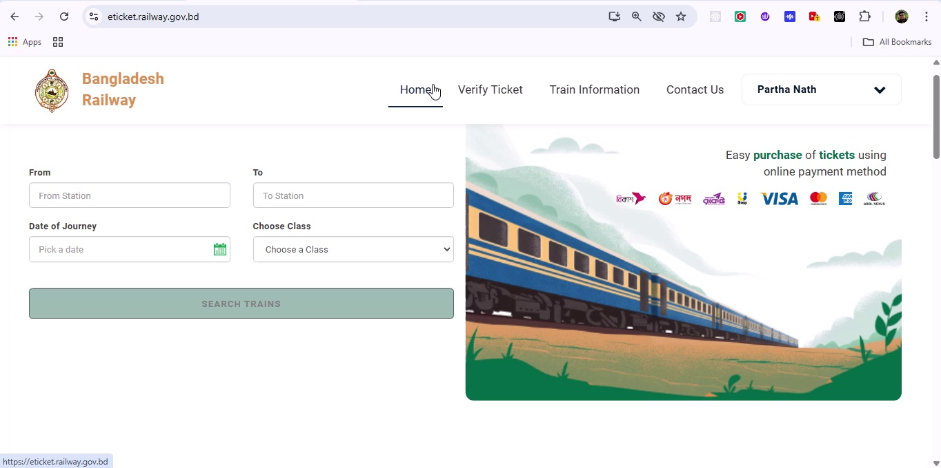

## Screenshot 168

Additional workflow step captured; refer to screenshot for details.

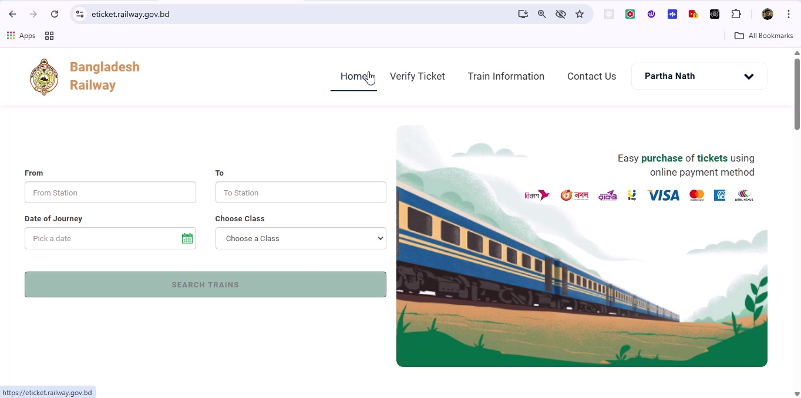

## Screenshot 169

Additional workflow step captured; refer to screenshot for details.

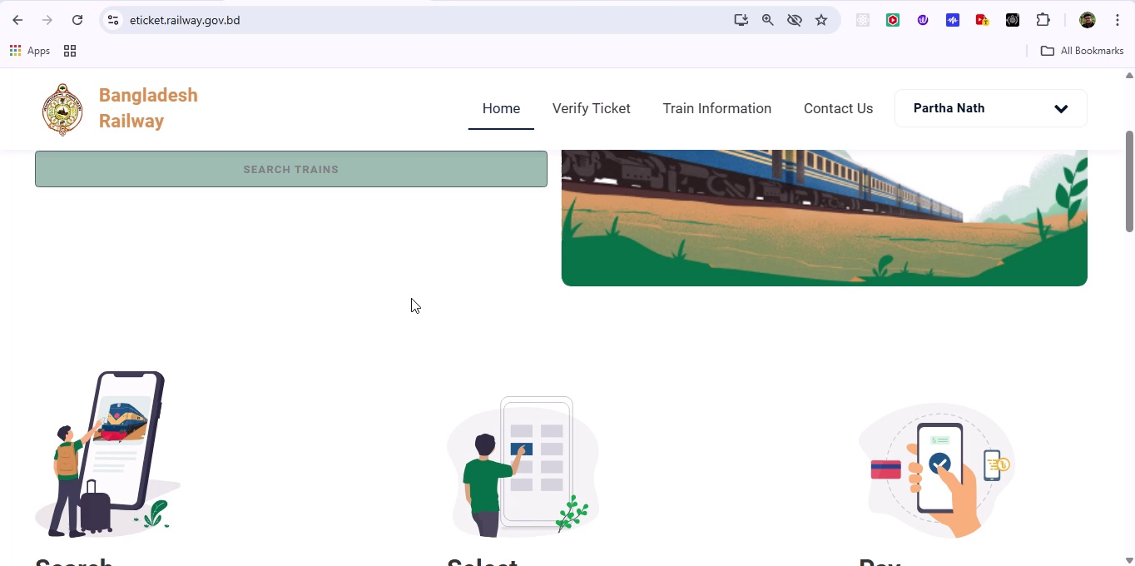

## Screenshot 170

Additional workflow step captured; refer to screenshot for details.

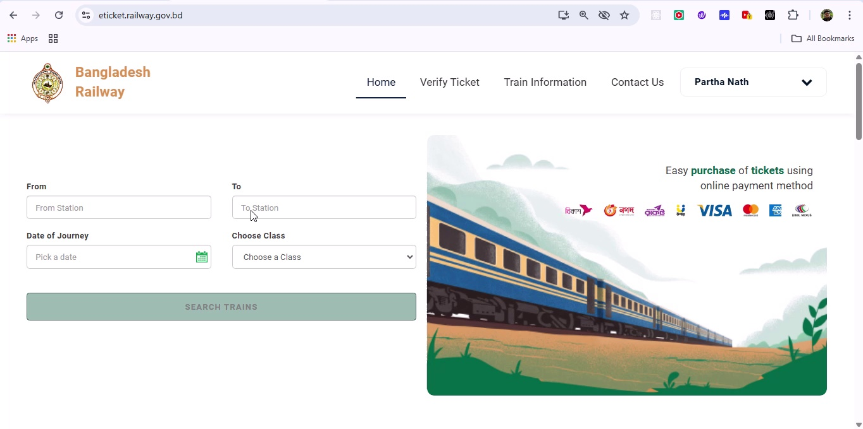

## Screenshot 171

Additional workflow step captured; refer to screenshot for details.

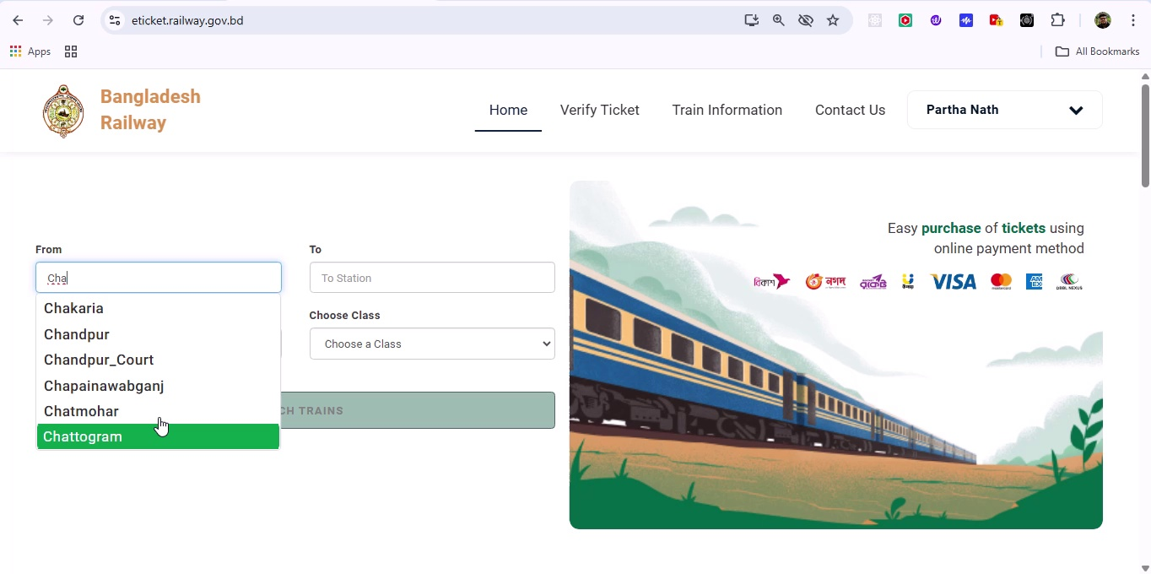

## Screenshot 172

Additional workflow step captured; refer to screenshot for details.

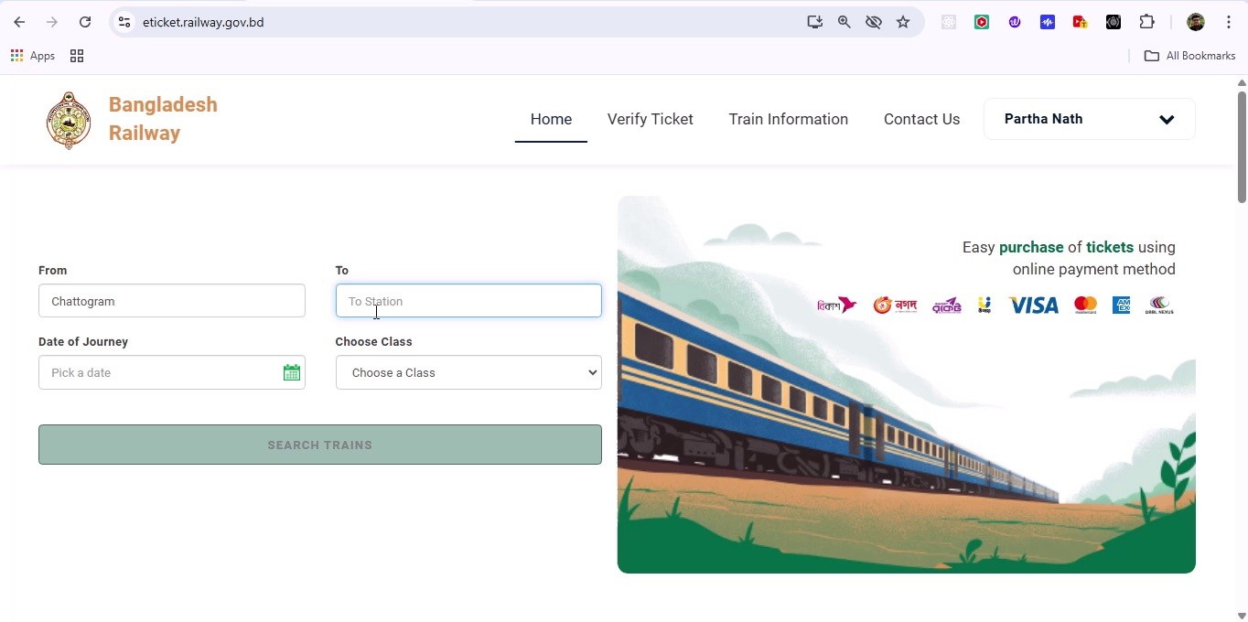

## Screenshot 173

Additional workflow step captured; refer to screenshot for details.

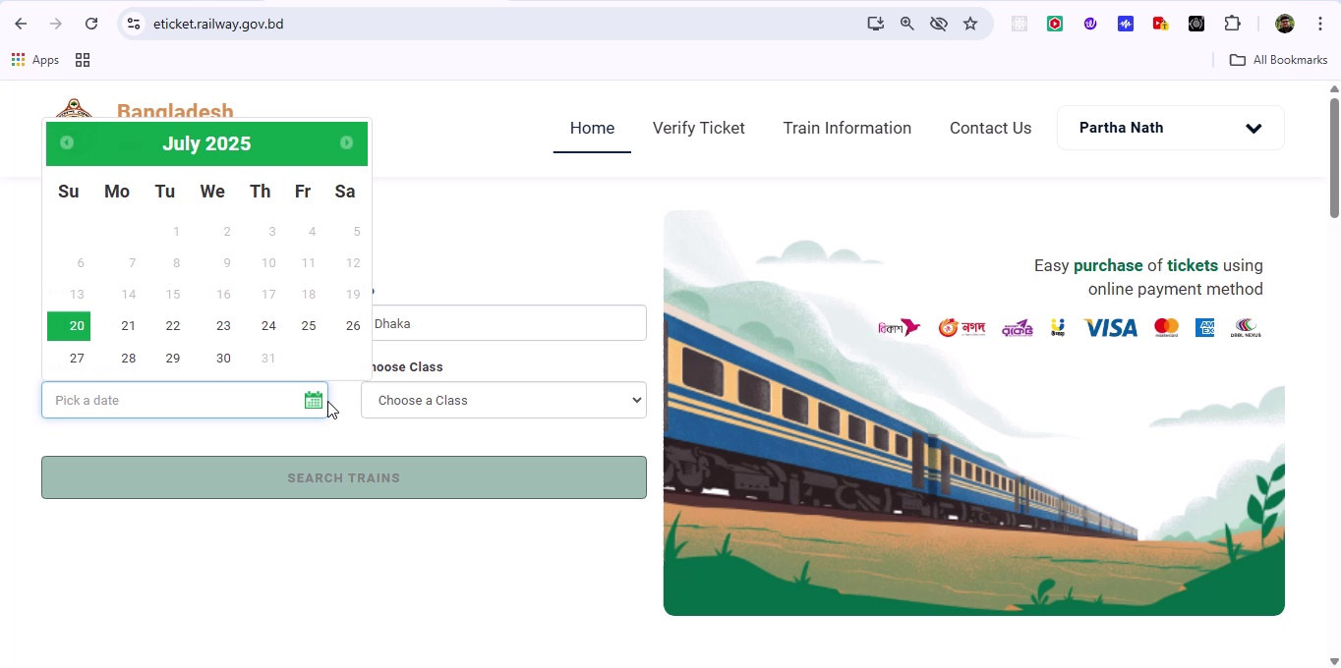

## Screenshot 174

Additional workflow step captured; refer to screenshot for details.

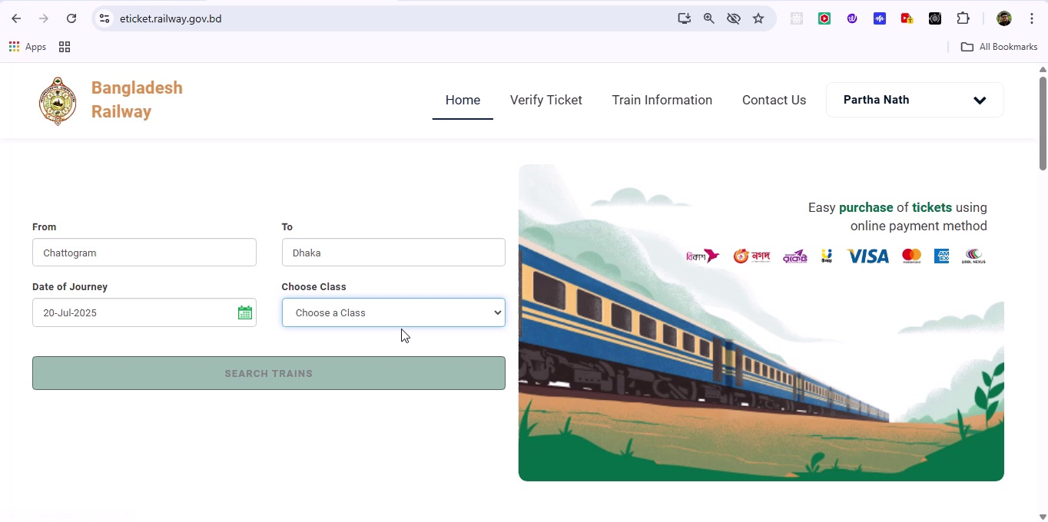

## Screenshot 175

Additional workflow step captured; refer to screenshot for details.

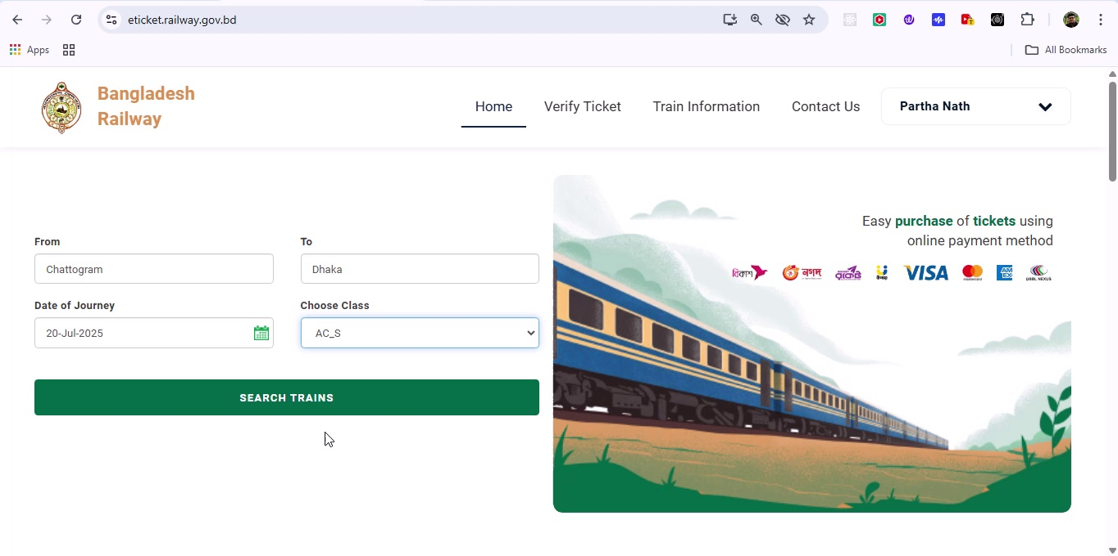

## Screenshot 176

Additional workflow step captured; refer to screenshot for details.

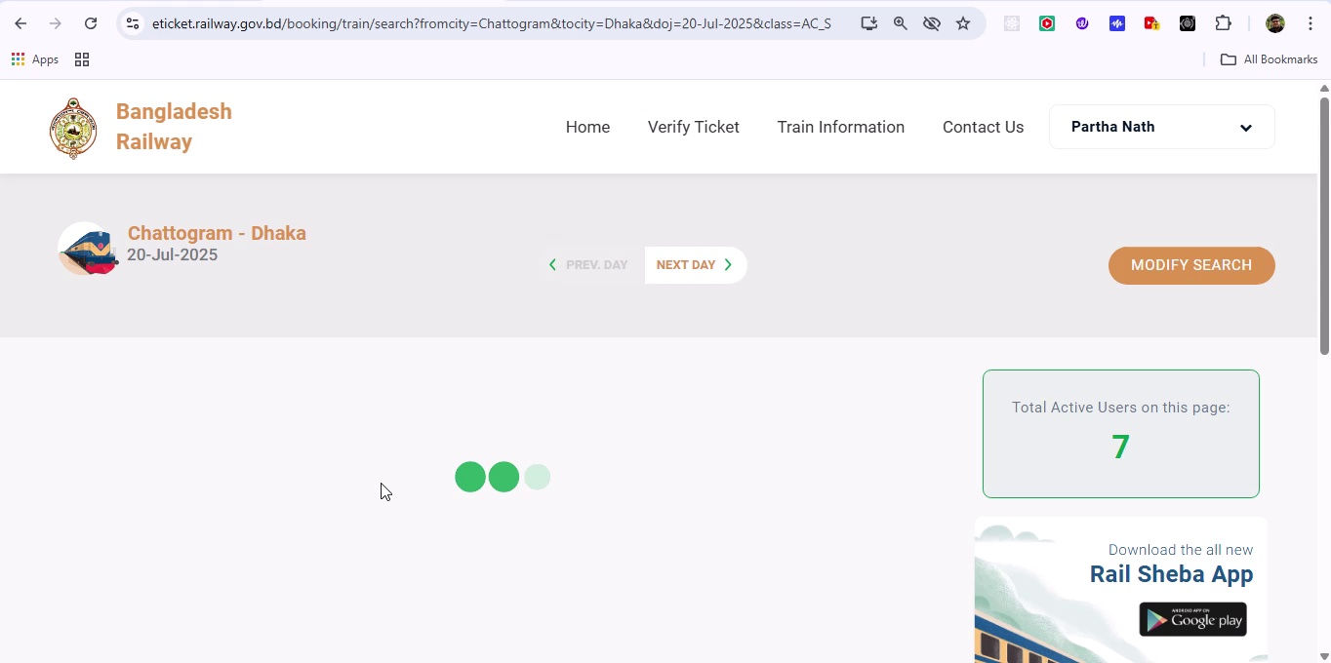

## Screenshot 177

Additional workflow step captured; refer to screenshot for details.

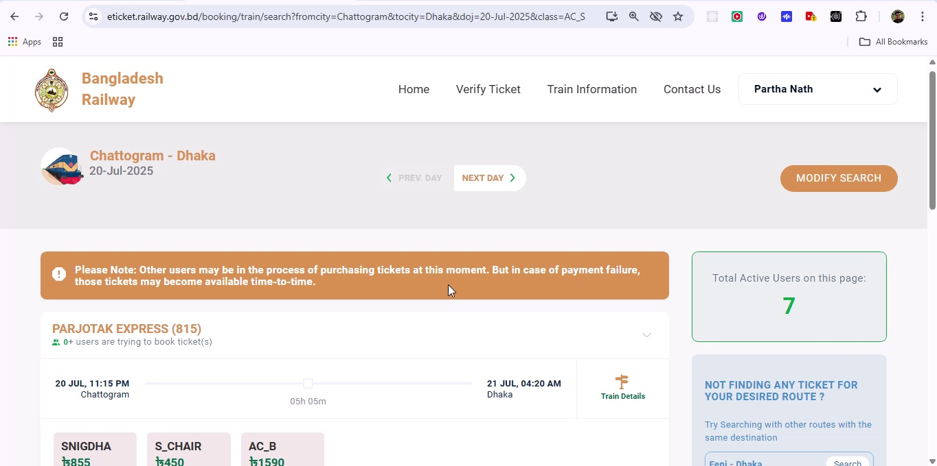

## Screenshot 178

Additional workflow step captured; refer to screenshot for details.

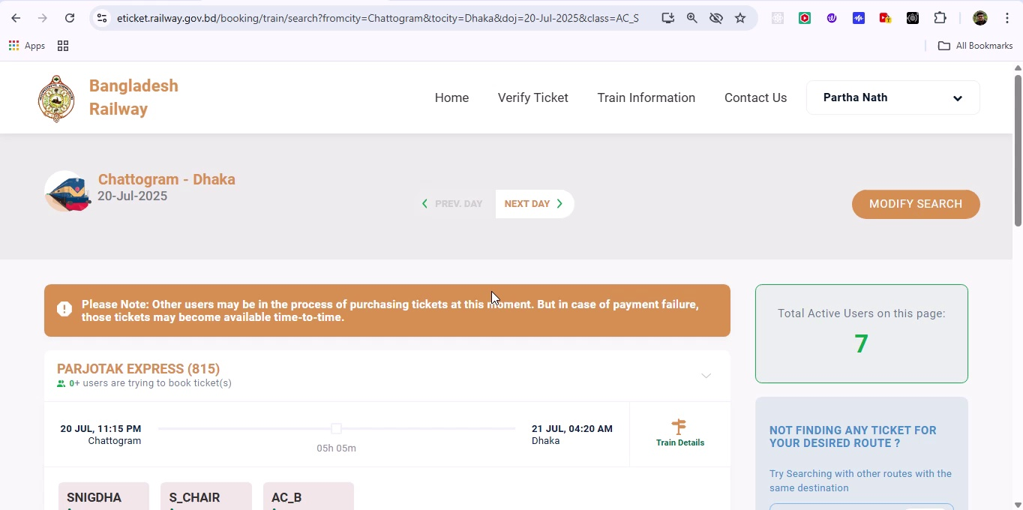

## Screenshot 179

Additional workflow step captured; refer to screenshot for details.

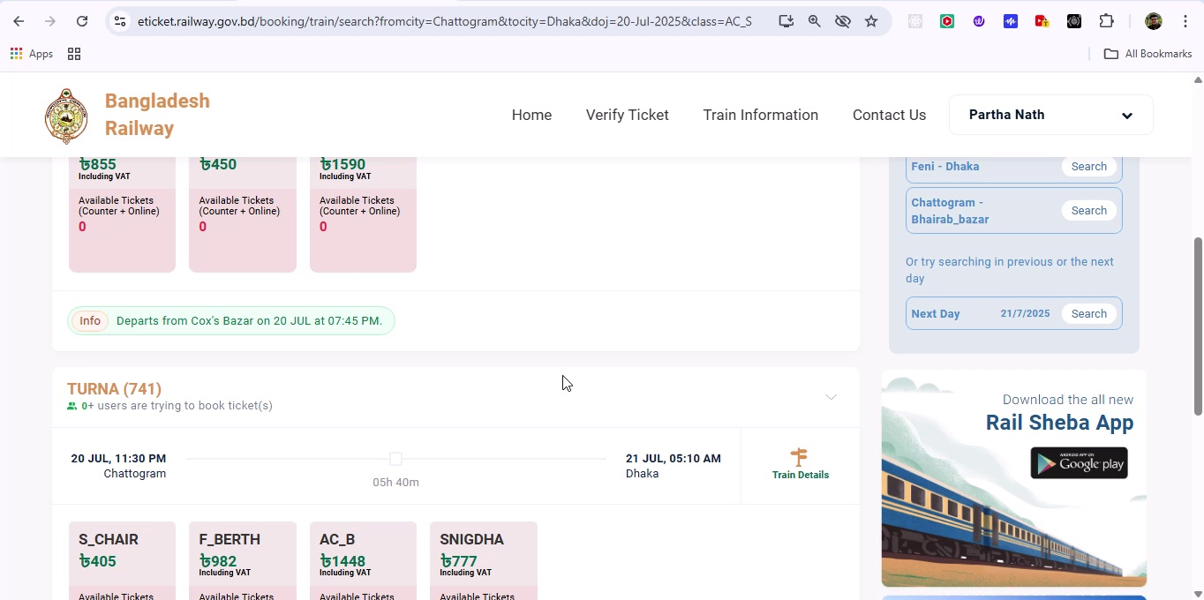

## Screenshot 180

Additional workflow step captured; refer to screenshot for details.

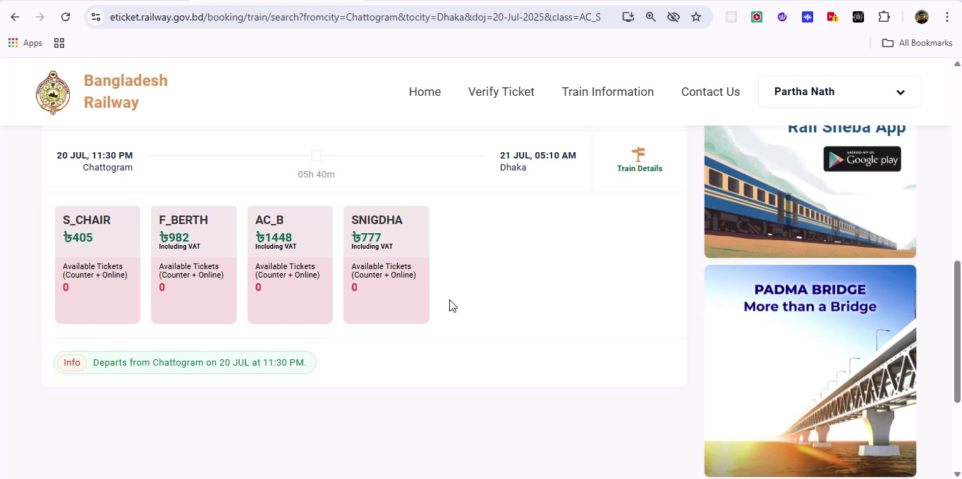

## Screenshot 181

Additional workflow step captured; refer to screenshot for details.

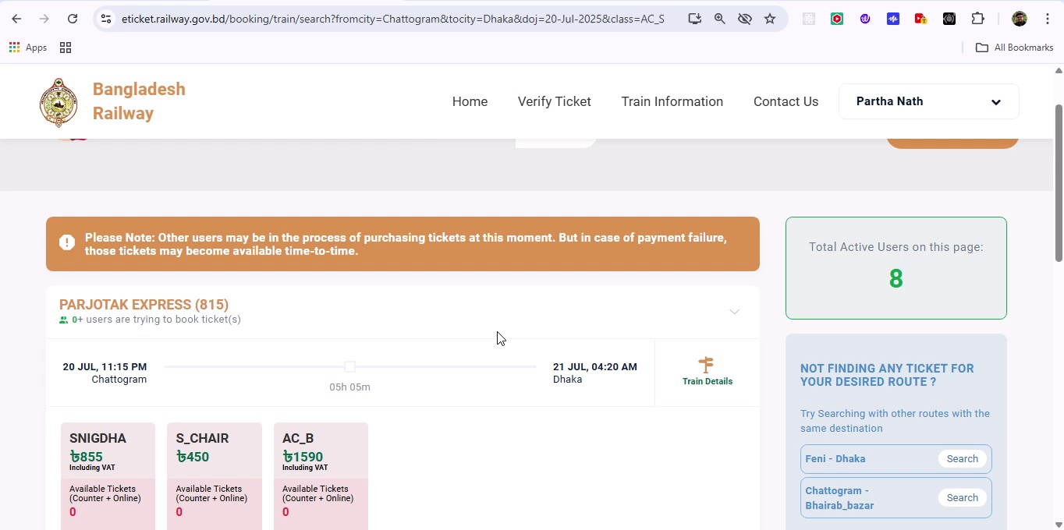

## Screenshot 182

Additional workflow step captured; refer to screenshot for details.

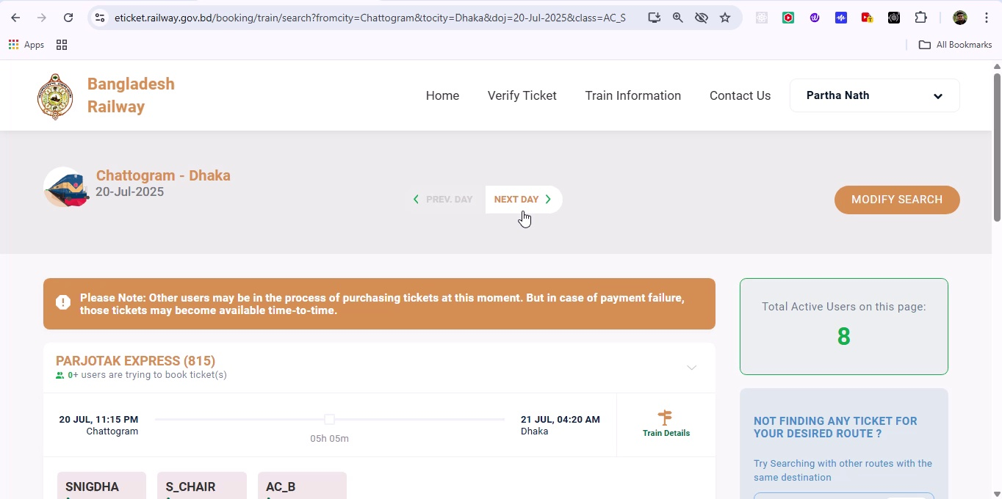

## Screenshot 183

Additional workflow step captured; refer to screenshot for details.

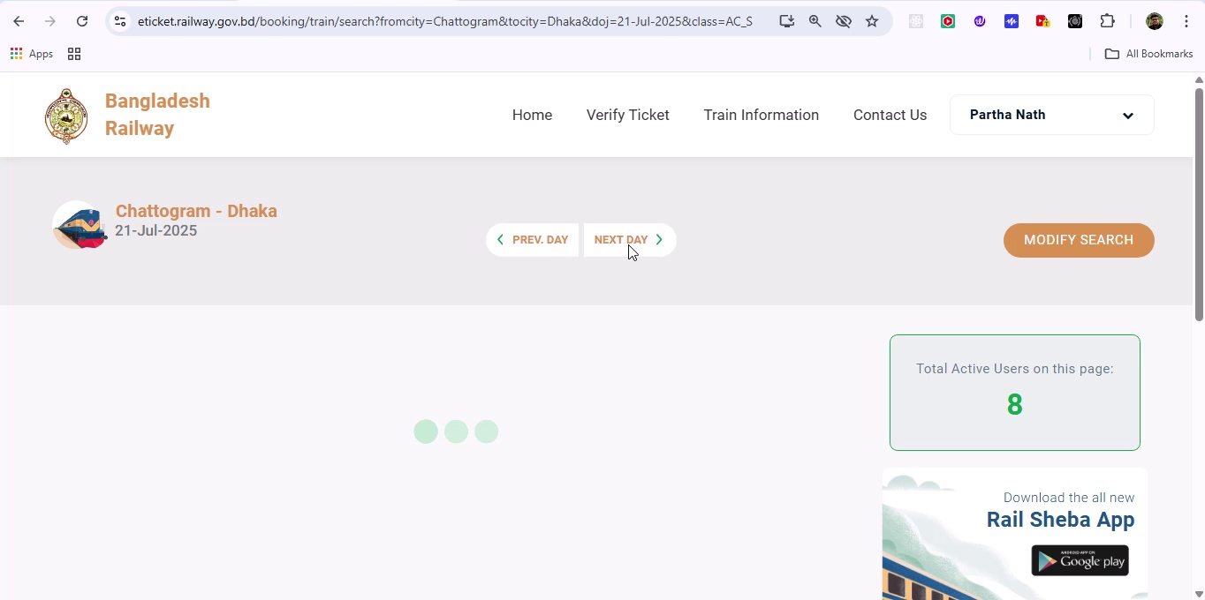

## Screenshot 184

Additional workflow step captured; refer to screenshot for details.

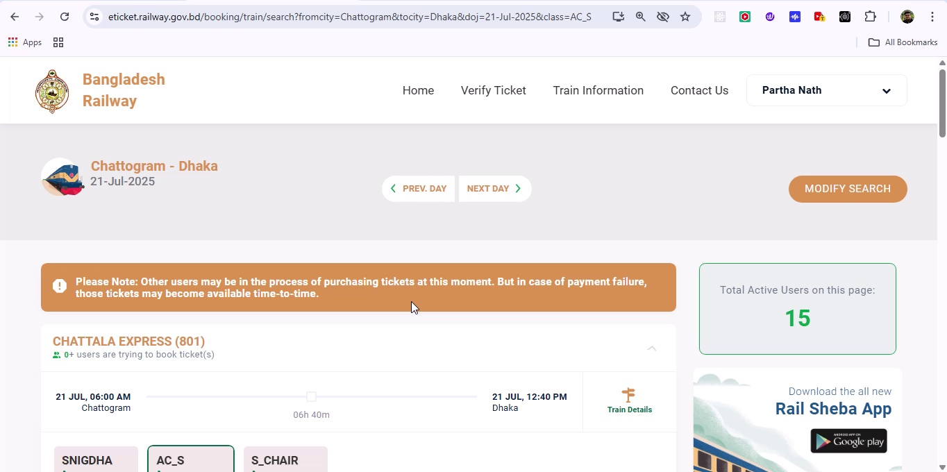

## Screenshot 185

Additional workflow step captured; refer to screenshot for details.

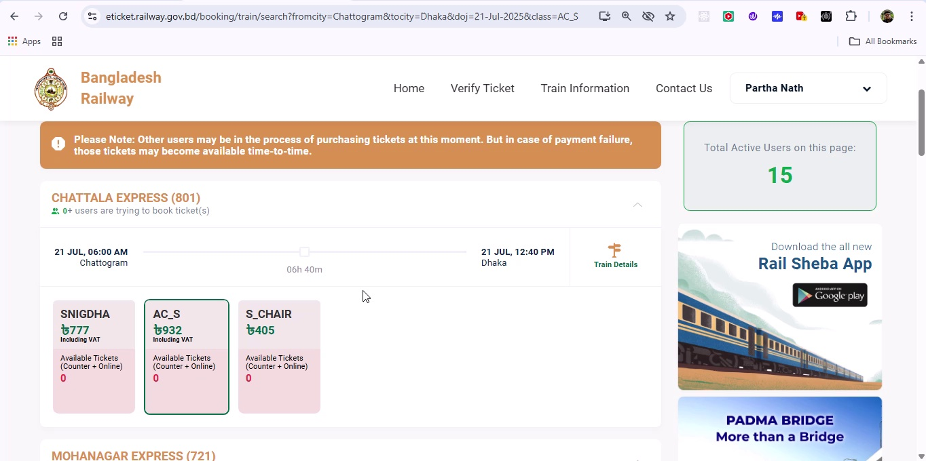

## Screenshot 186

Additional workflow step captured; refer to screenshot for details.

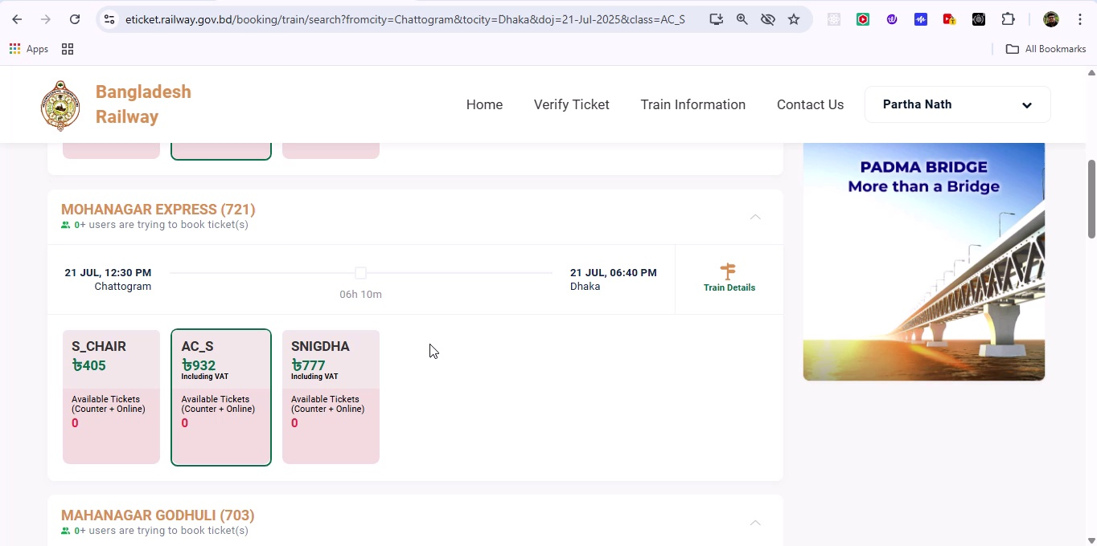

## Screenshot 187

Additional workflow step captured; refer to screenshot for details.

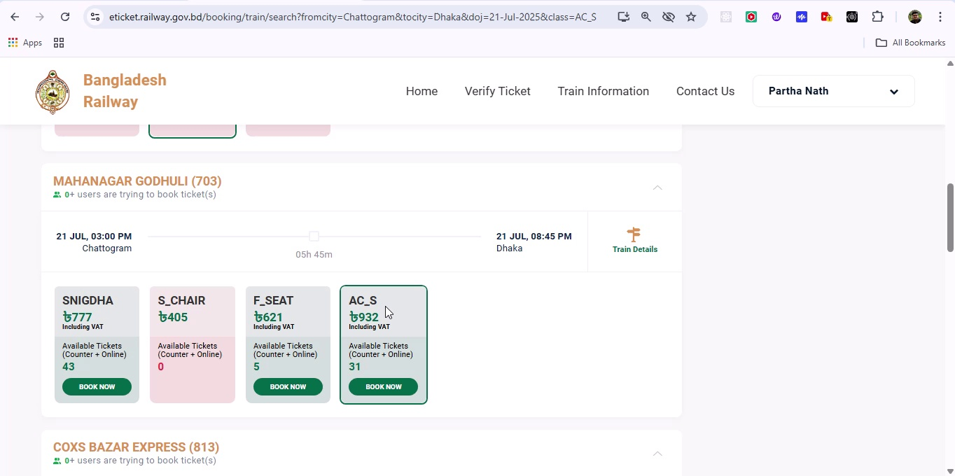

## Screenshot 188

Additional workflow step captured; refer to screenshot for details.

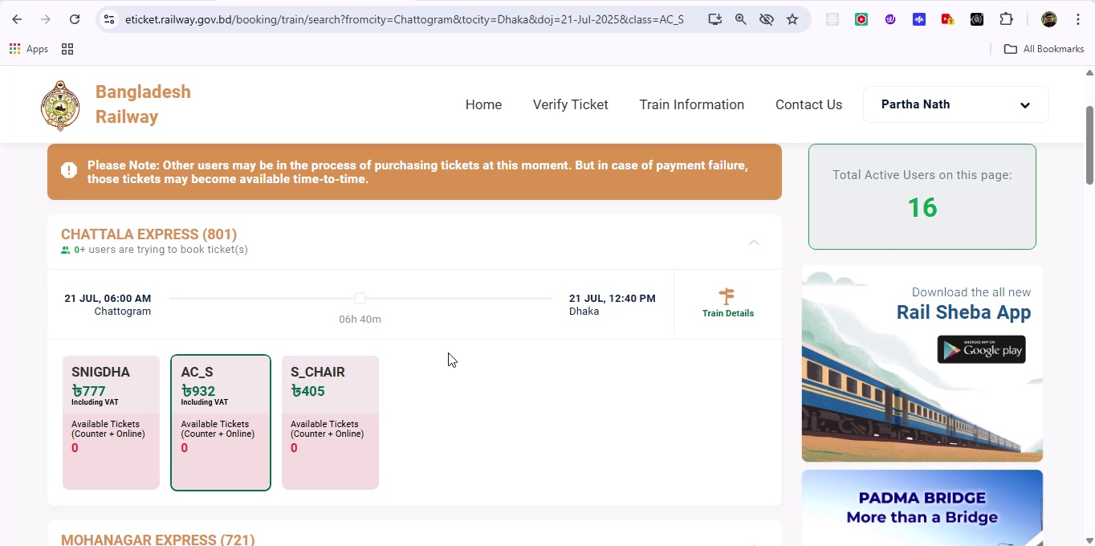

## Screenshot 189

Additional workflow step captured; refer to screenshot for details.

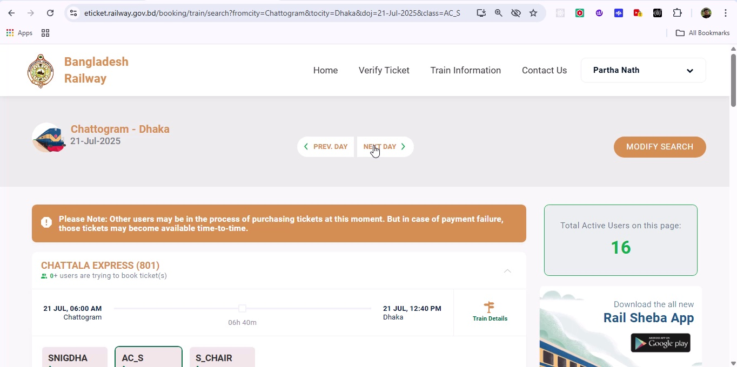

## Screenshot 190

Additional workflow step captured; refer to screenshot for details.

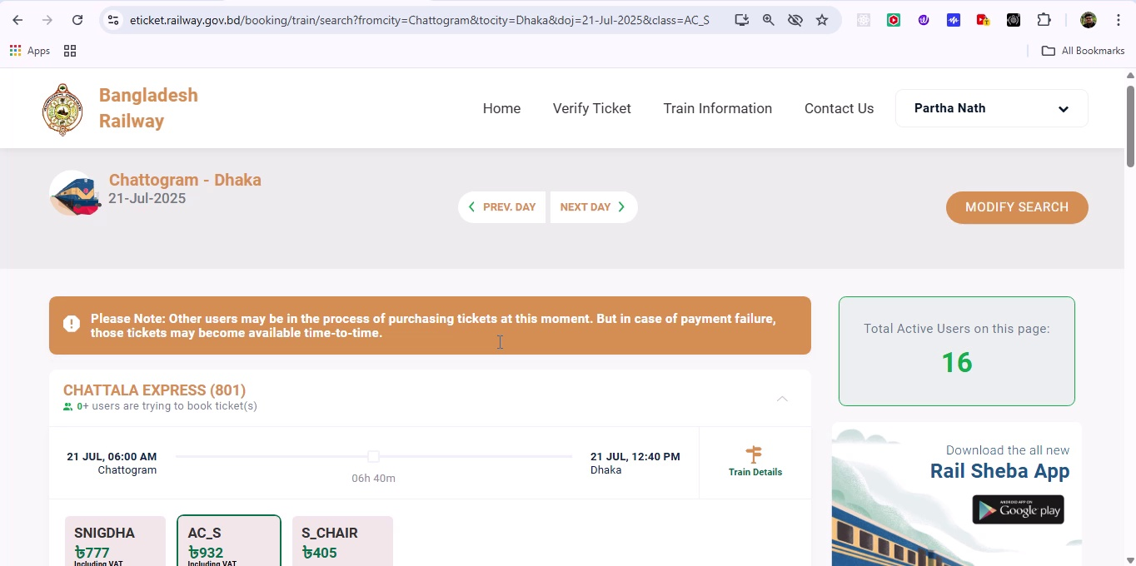

## Screenshot 191

Additional workflow step captured; refer to screenshot for details.

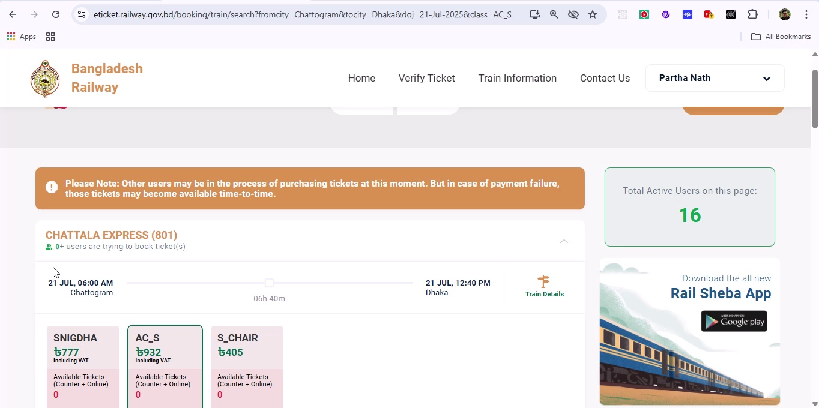

## Screenshot 192

Additional workflow step captured; refer to screenshot for details.

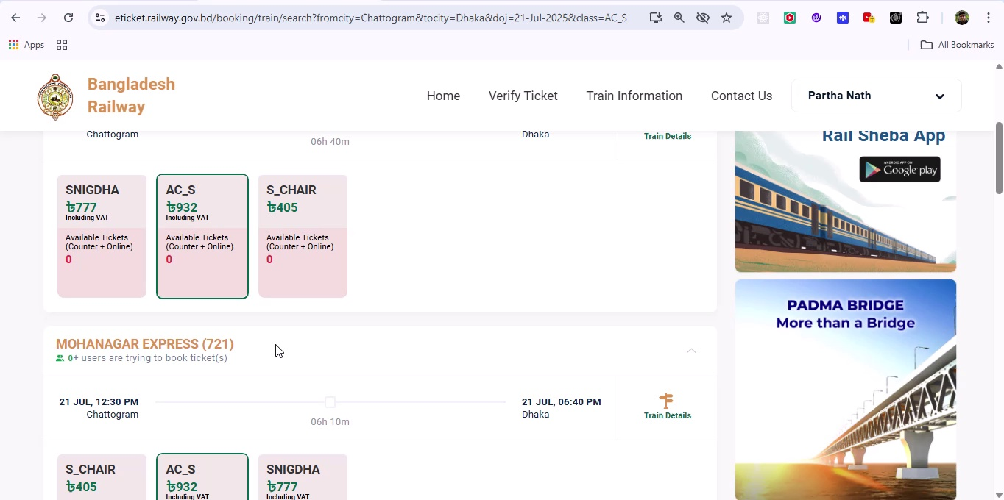

## Screenshot 193

Additional workflow step captured; refer to screenshot for details.

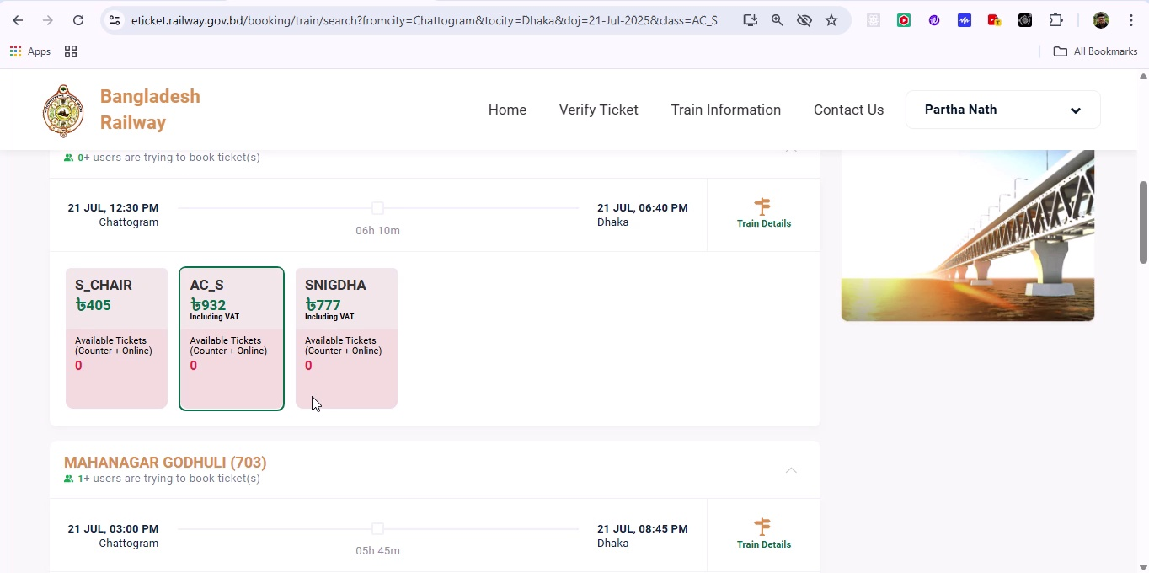

## Screenshot 194

Additional workflow step captured; refer to screenshot for details.

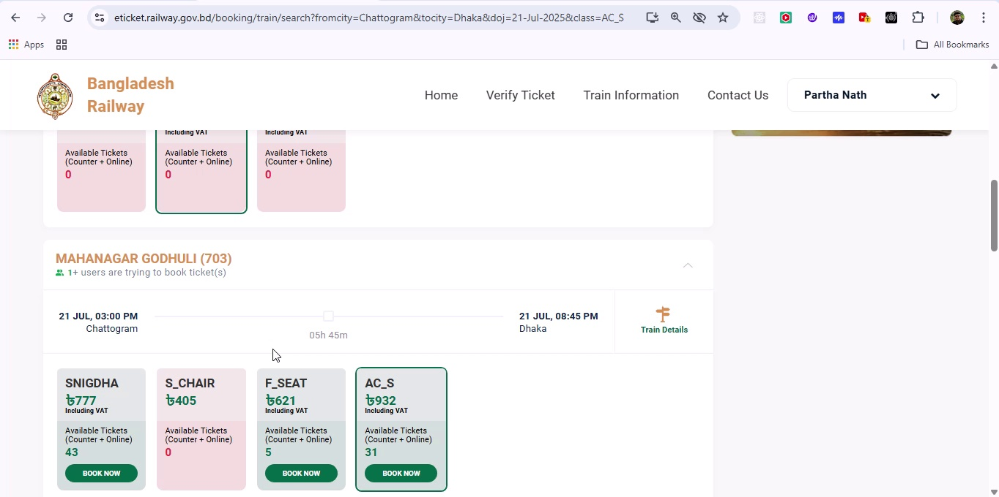

## Screenshot 195

Additional workflow step captured; refer to screenshot for details.

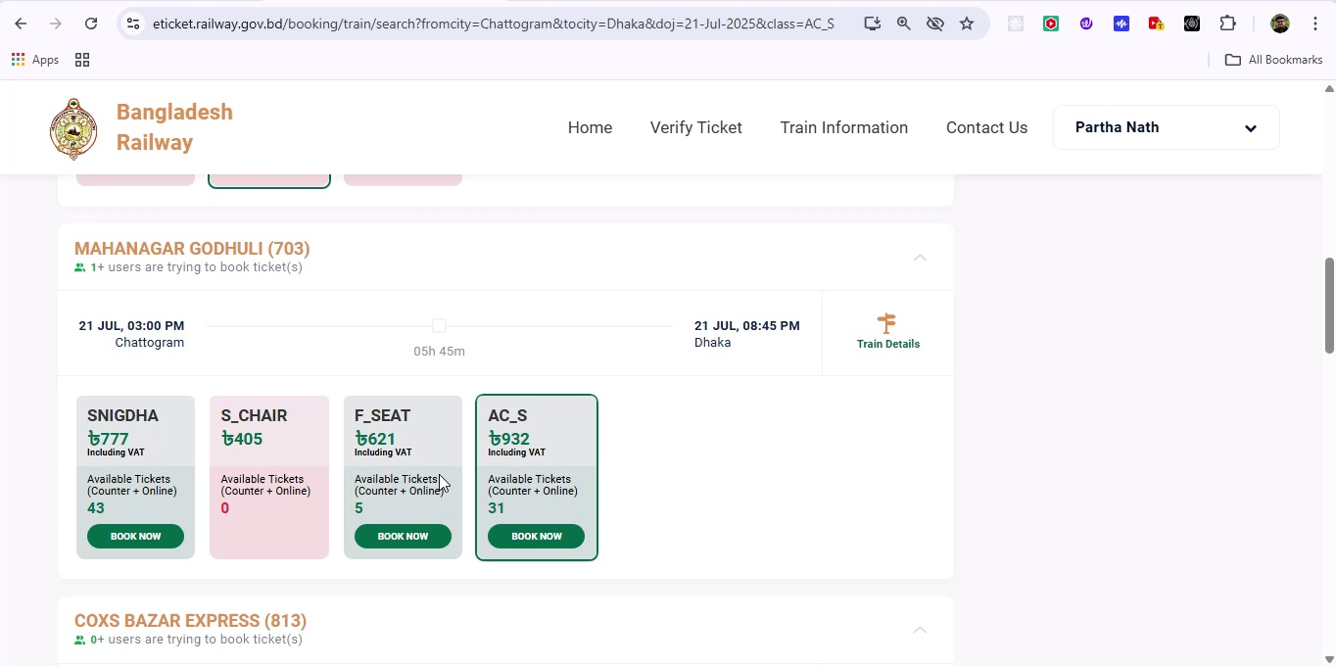

## Screenshot 196

Additional workflow step captured; refer to screenshot for details.

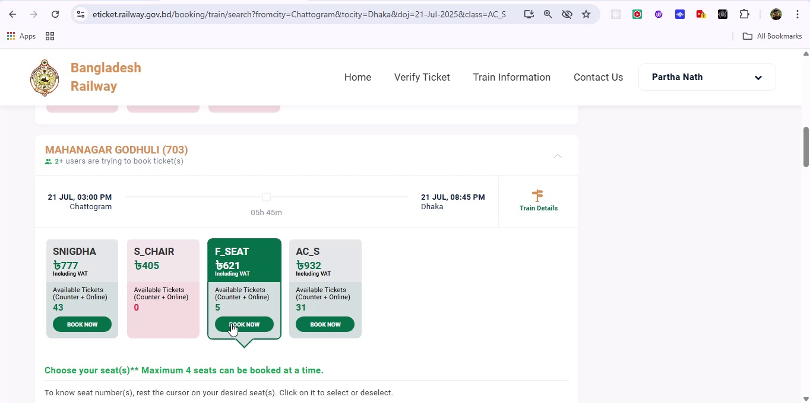

## Screenshot 197

Additional workflow step captured; refer to screenshot for details.

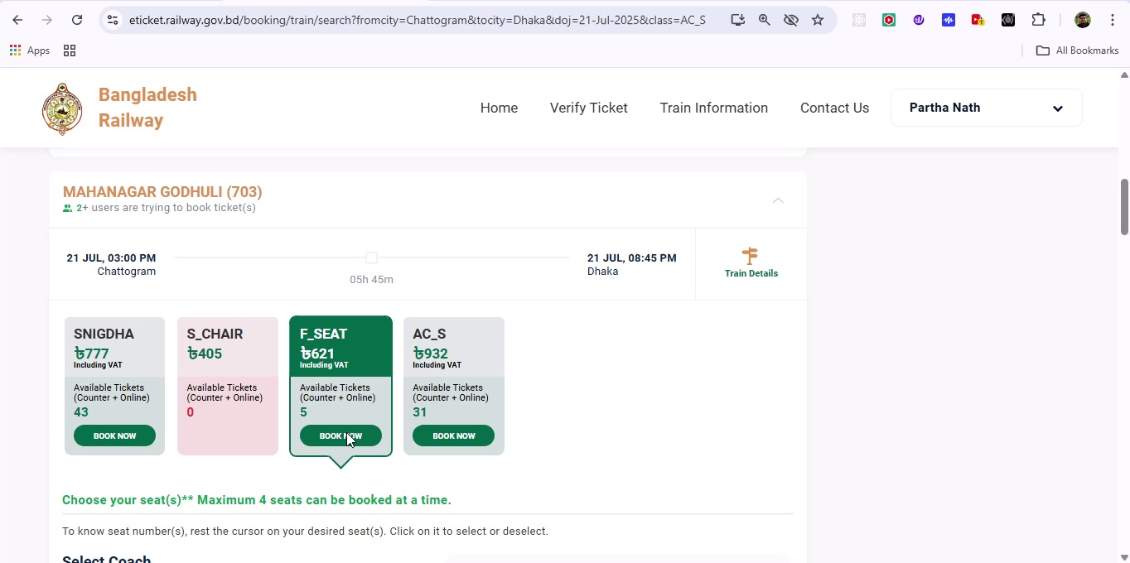

## Screenshot 198

Additional workflow step captured; refer to screenshot for details.

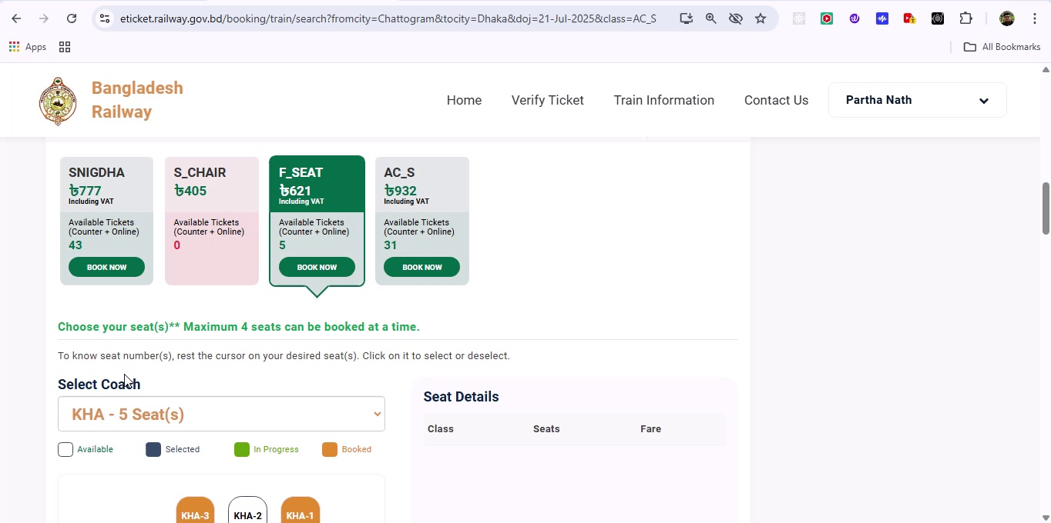

## Screenshot 199

Additional workflow step captured; refer to screenshot for details.

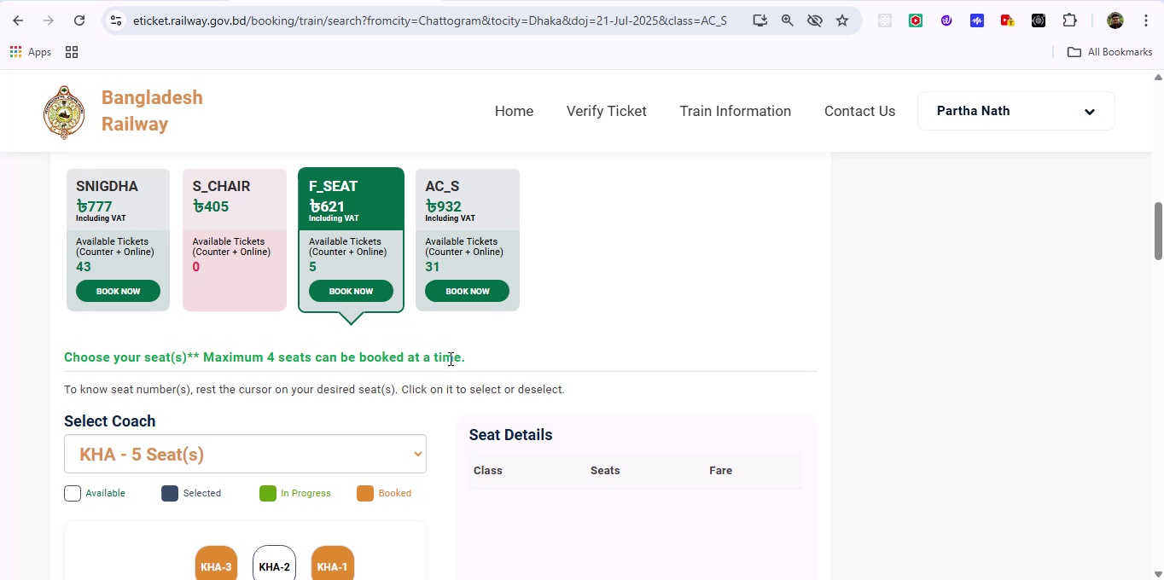

## Screenshot 200

Additional workflow step captured; refer to screenshot for details.

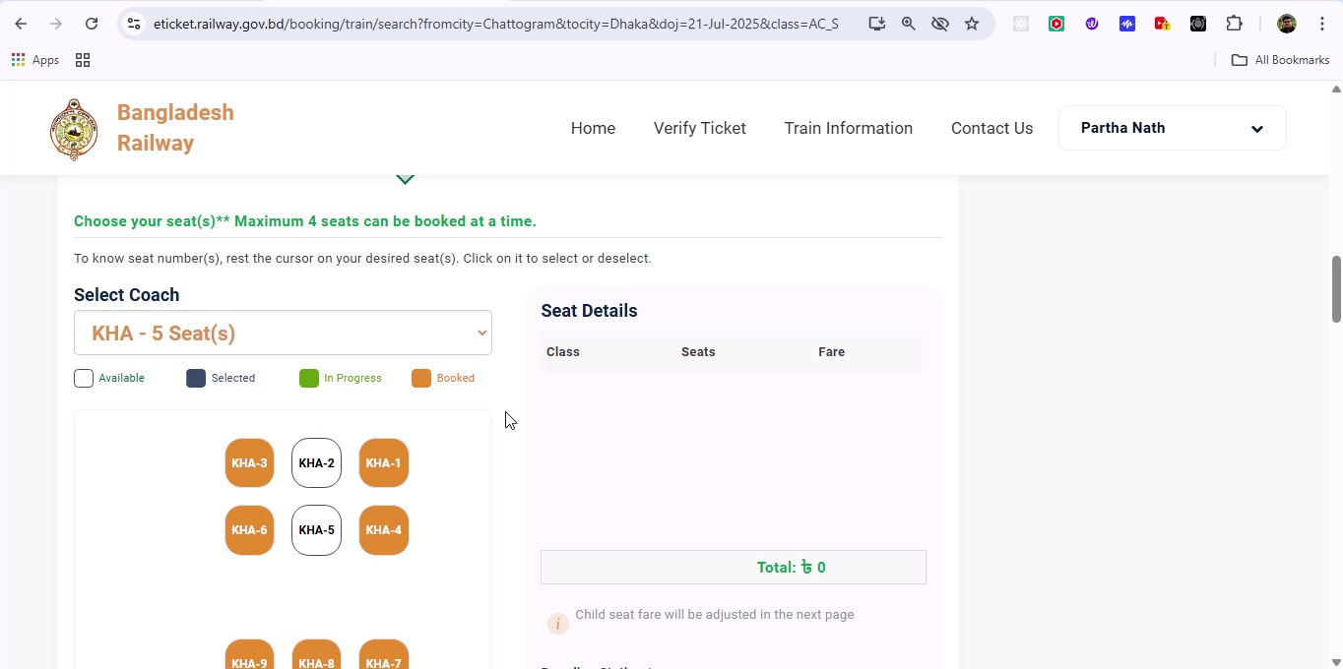

## Screenshot 201

Additional workflow step captured; refer to screenshot for details.

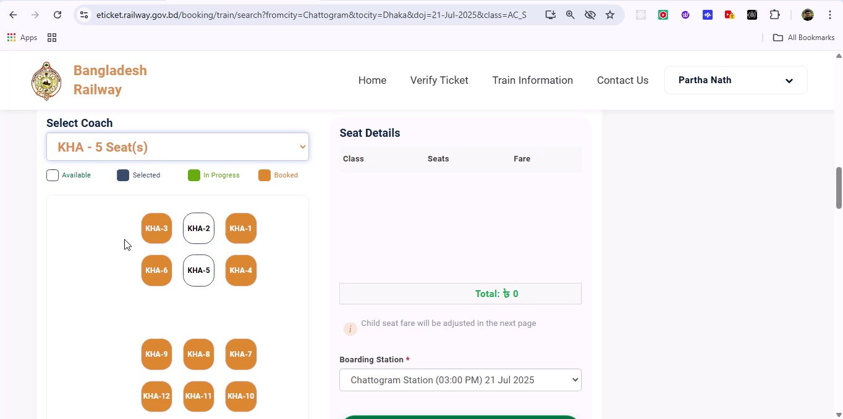

## Screenshot 202

Additional workflow step captured; refer to screenshot for details.

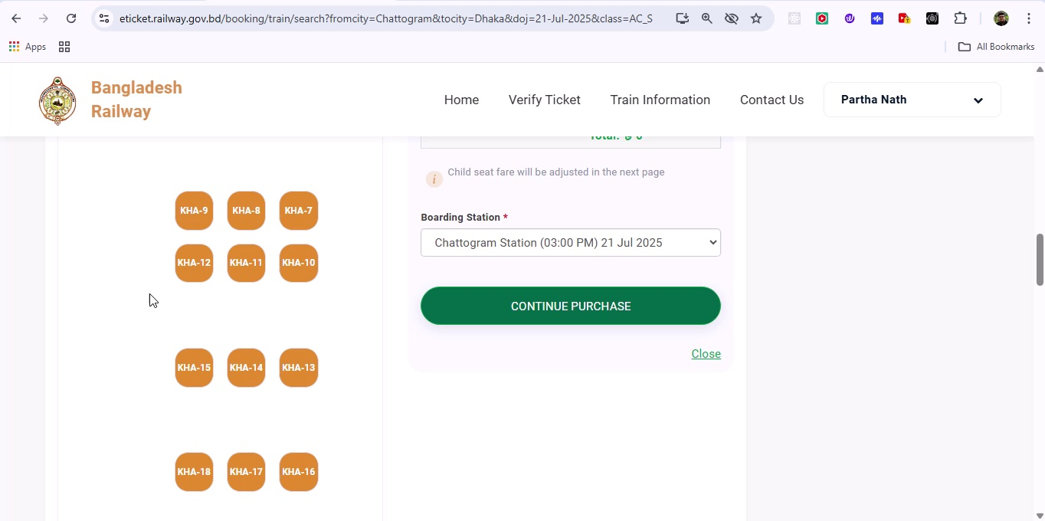

## Screenshot 203

Additional workflow step captured; refer to screenshot for details.

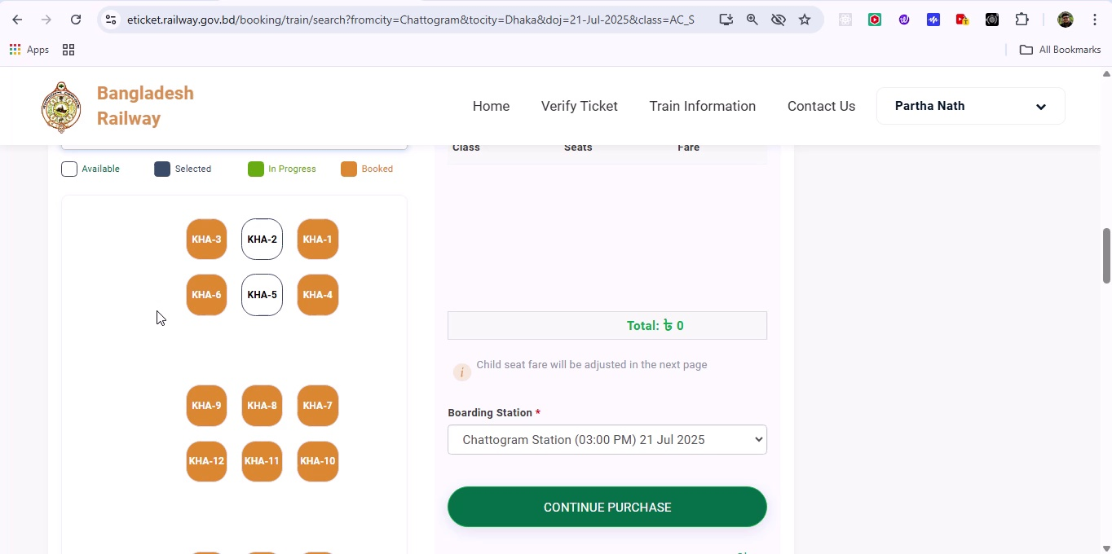

## Screenshot 204

Additional workflow step captured; refer to screenshot for details.

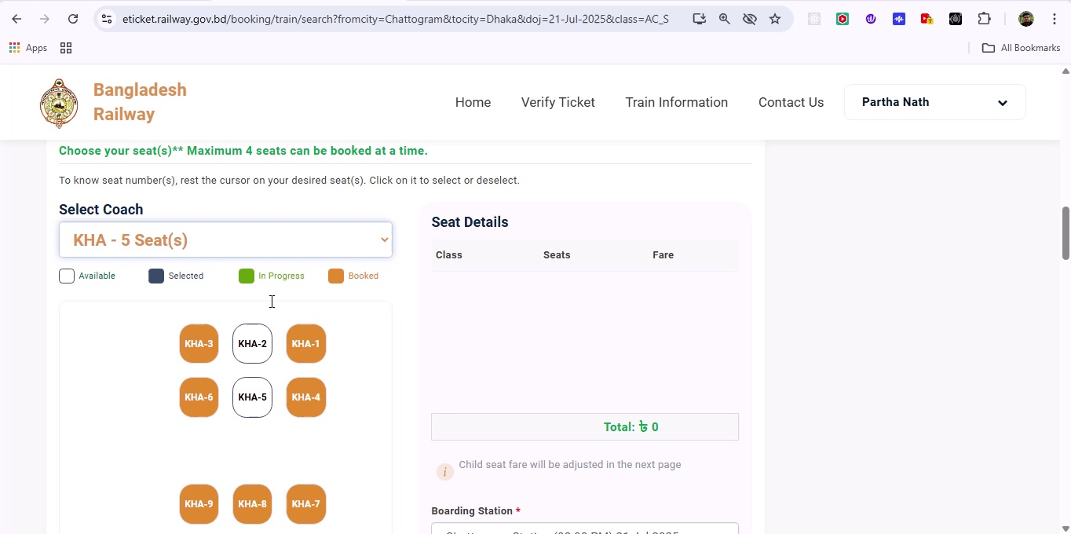

## Screenshot 205

Additional workflow step captured; refer to screenshot for details.

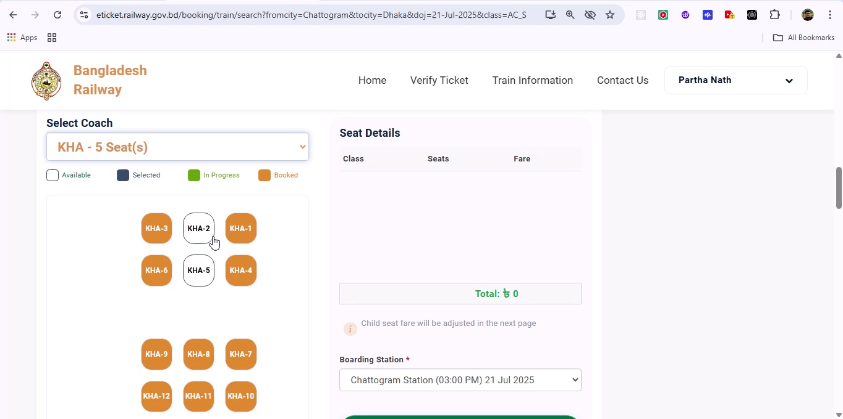

## Screenshot 206

Additional workflow step captured; refer to screenshot for details.

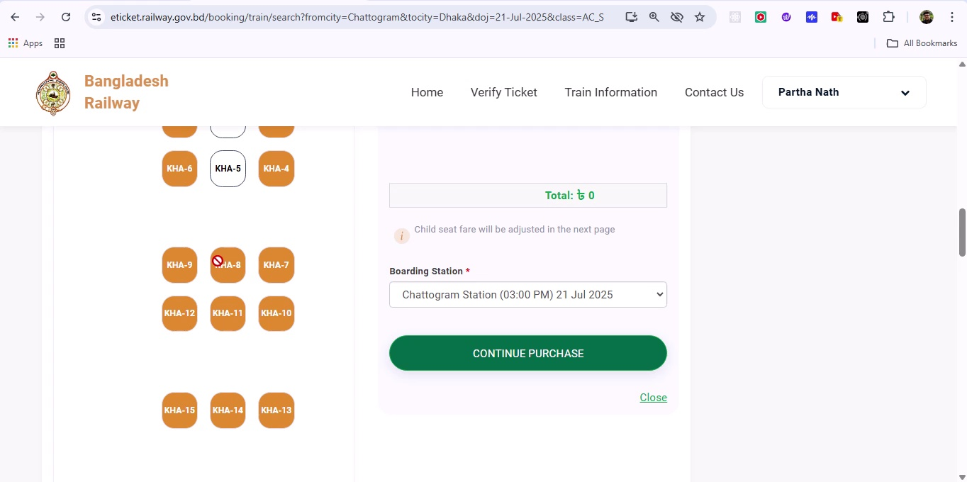

## Screenshot 207

Additional workflow step captured; refer to screenshot for details.

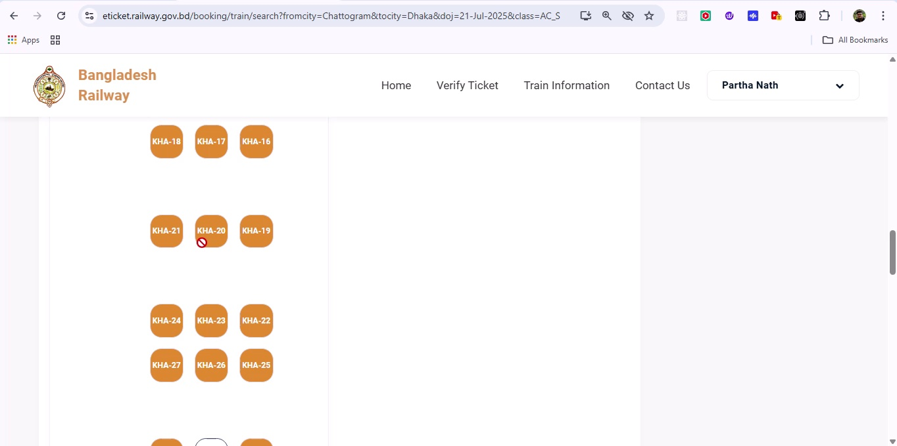

## Screenshot 208

Additional workflow step captured; refer to screenshot for details.

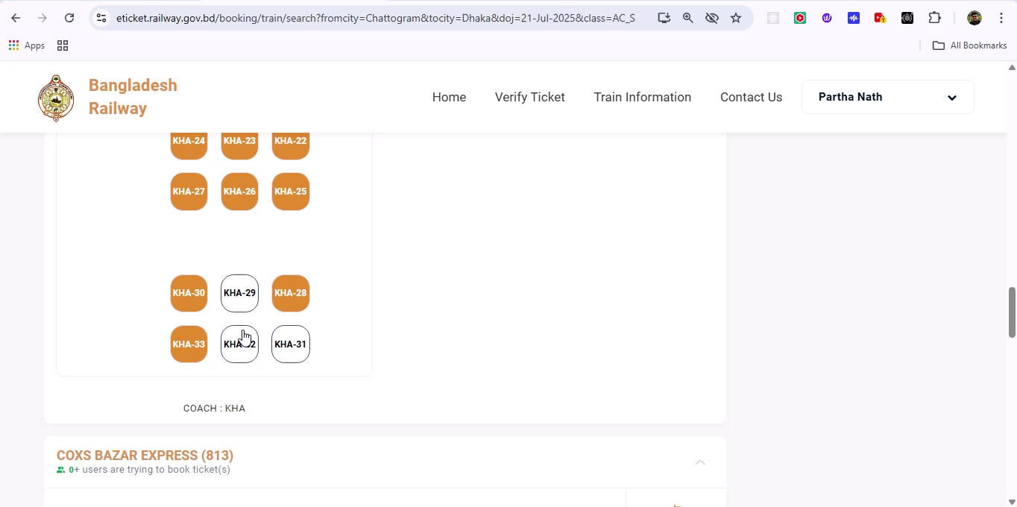

## Screenshot 209

Additional workflow step captured; refer to screenshot for details.

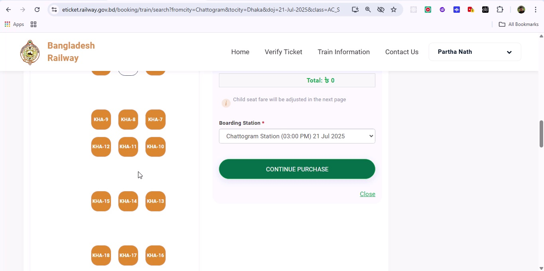

## Screenshot 210

Additional workflow step captured; refer to screenshot for details.

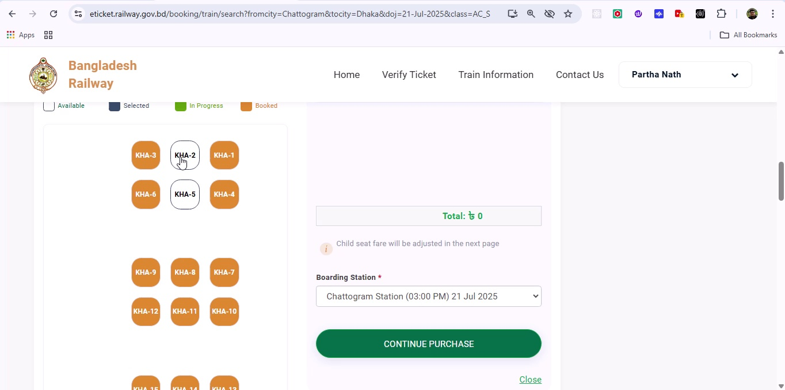

## Screenshot 211

Additional workflow step captured; refer to screenshot for details.

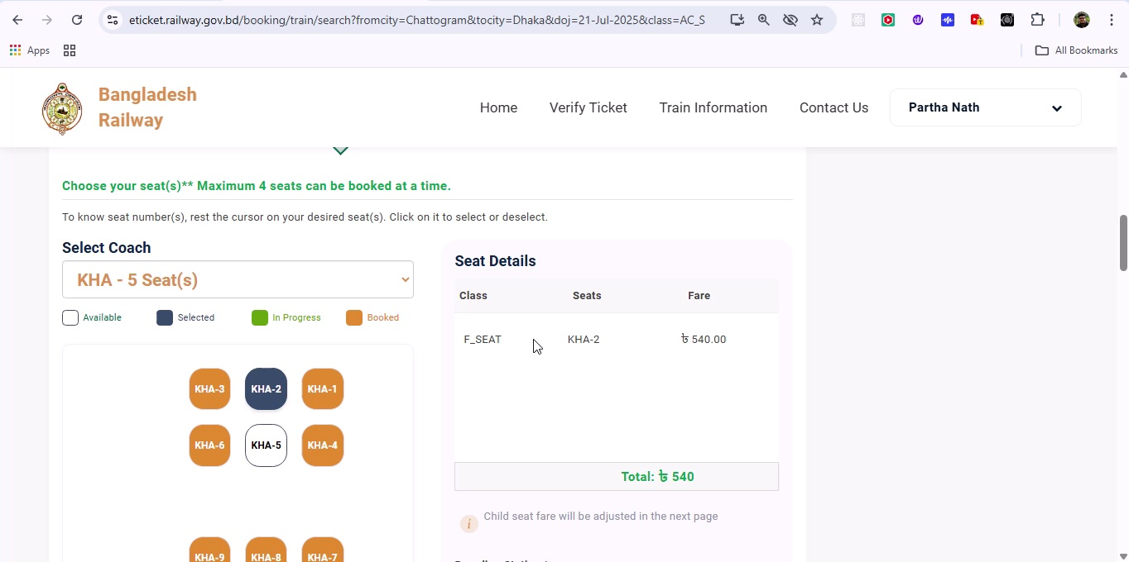

## Screenshot 212

Additional workflow step captured; refer to screenshot for details.

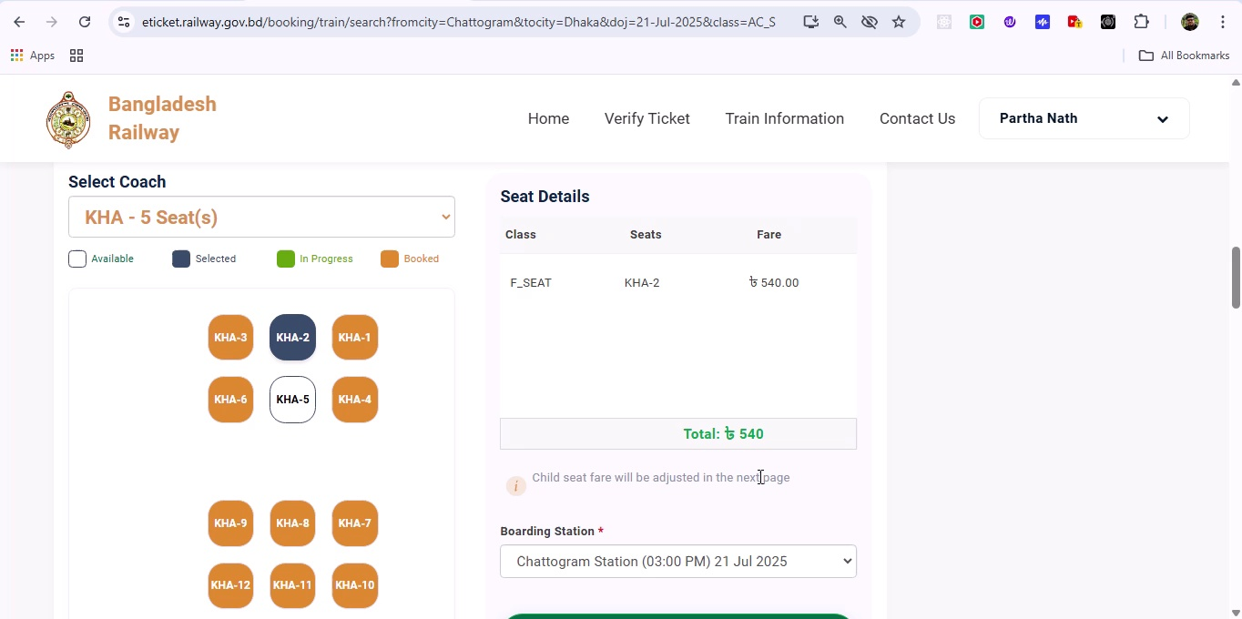

## Screenshot 213

Additional workflow step captured; refer to screenshot for details.

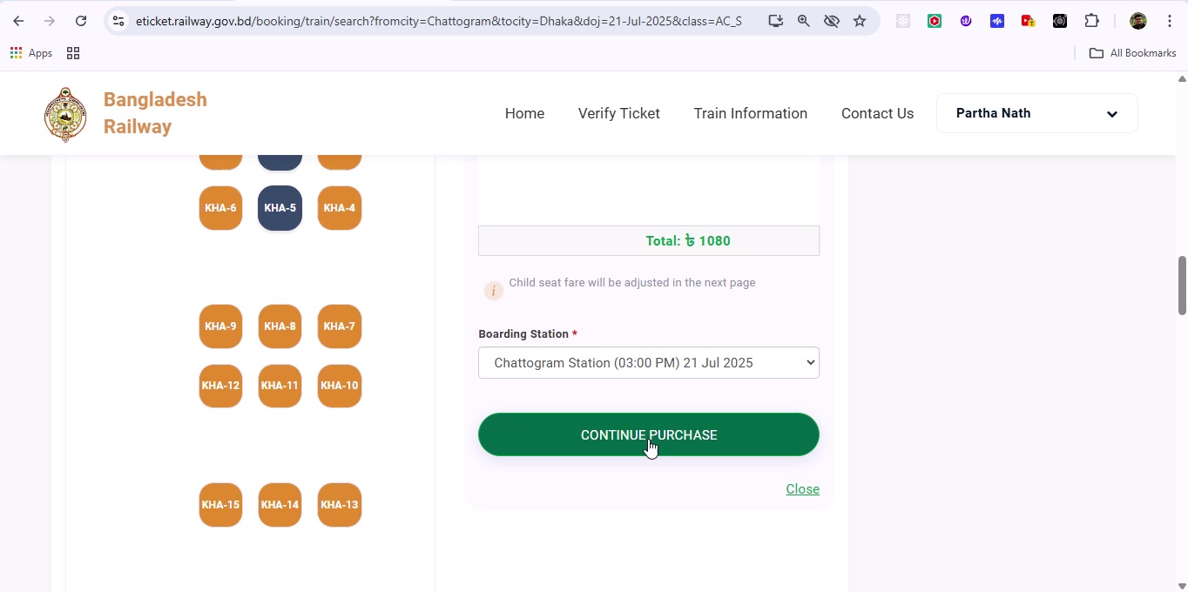

## Screenshot 214

Additional workflow step captured; refer to screenshot for details.

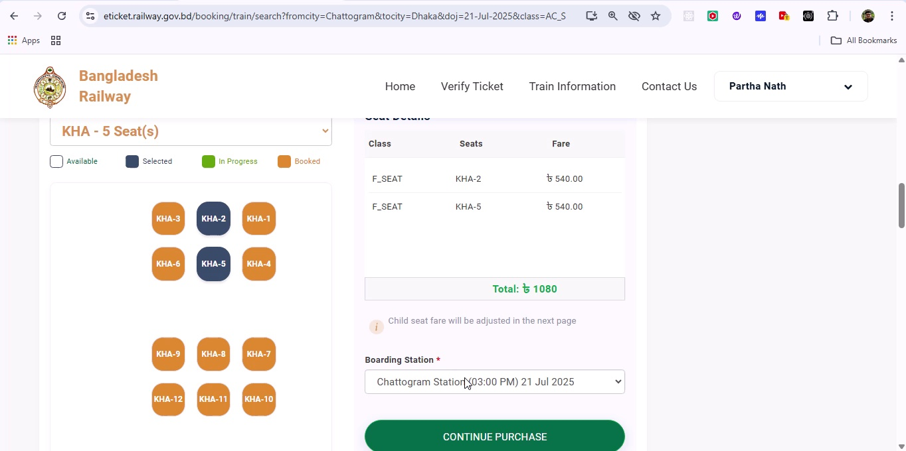

## Screenshot 215

Additional workflow step captured; refer to screenshot for details.

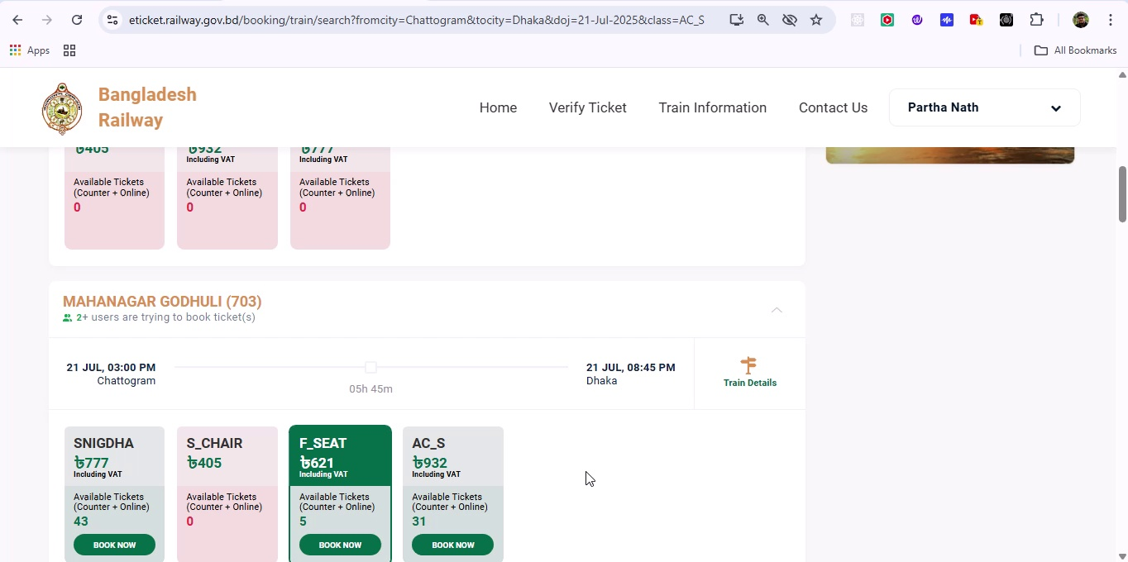

## Screenshot 216

Additional workflow step captured; refer to screenshot for details.

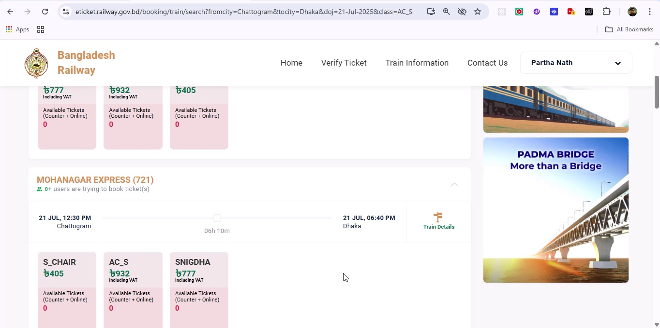

## Screenshot 217

Additional workflow step captured; refer to screenshot for details.

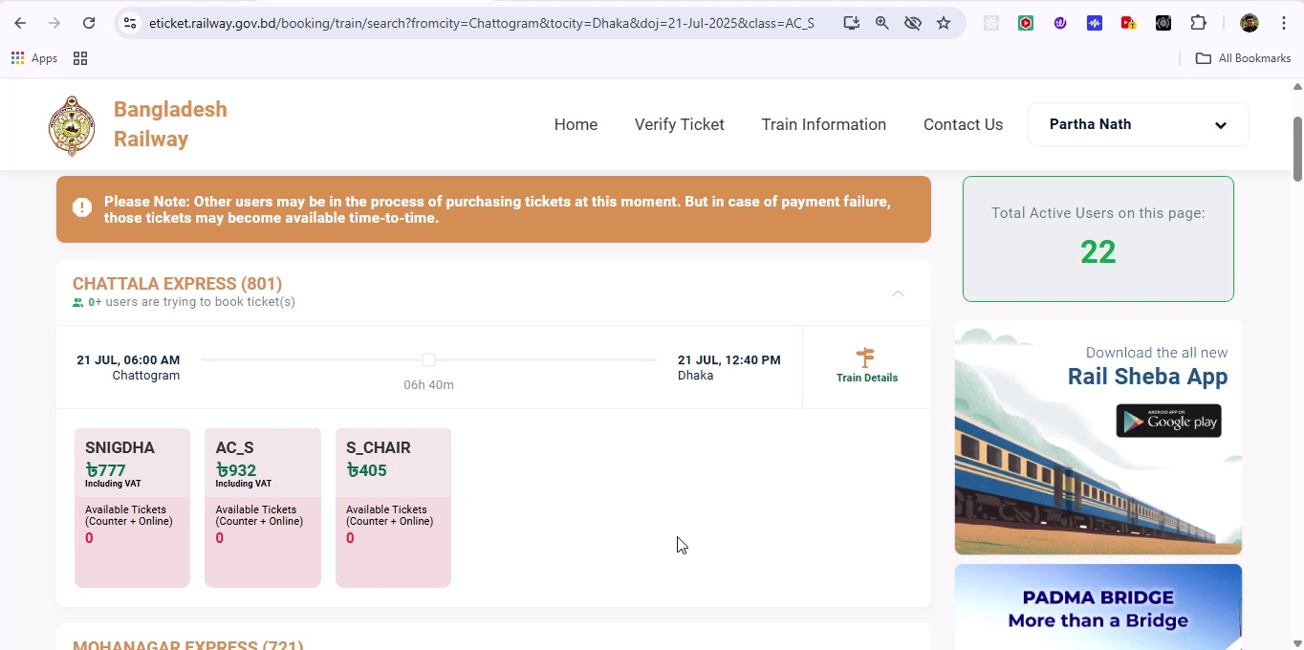

## Screenshot 218

Additional workflow step captured; refer to screenshot for details.

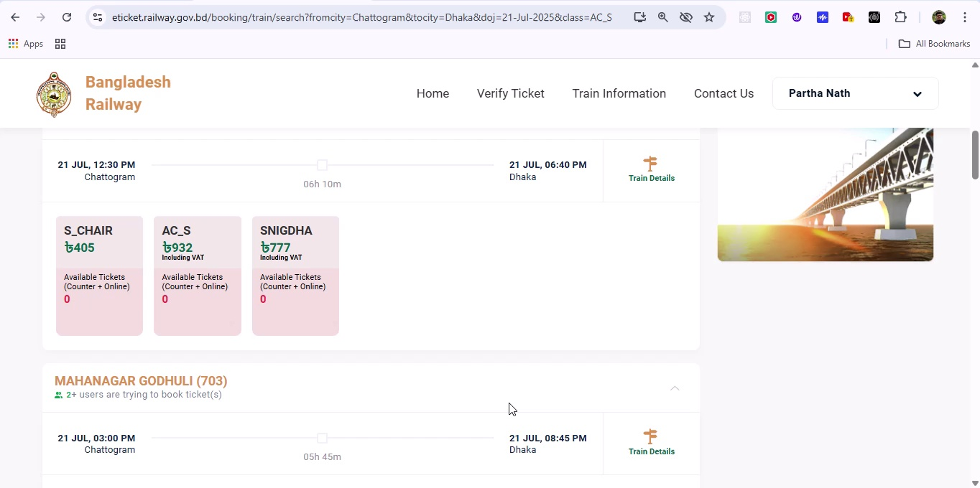

## Screenshot 219

Additional workflow step captured; refer to screenshot for details.

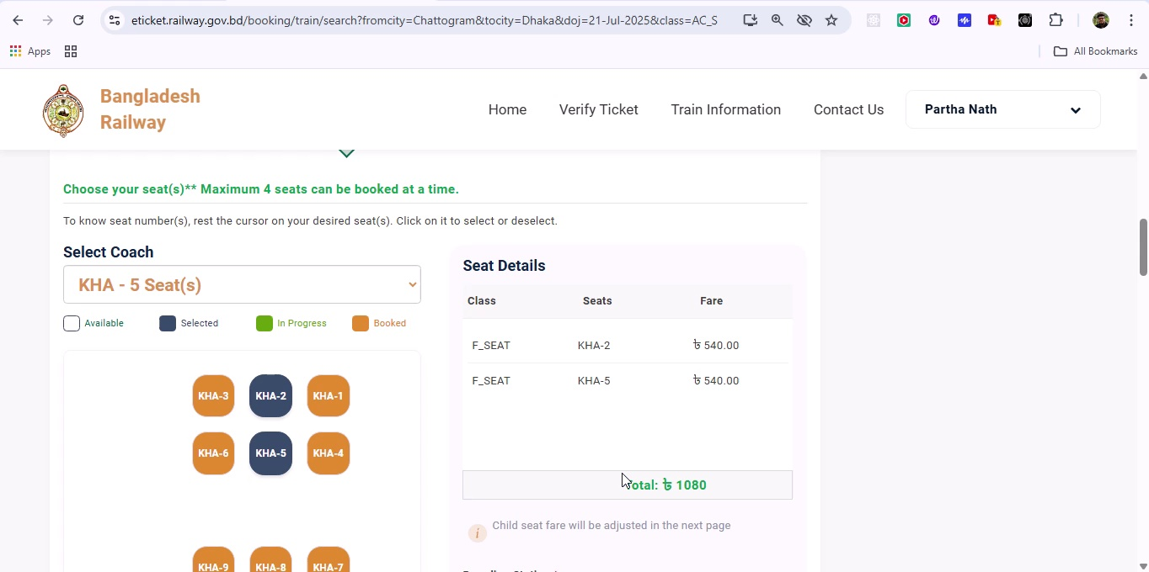

## Screenshot 220

Additional workflow step captured; refer to screenshot for details.

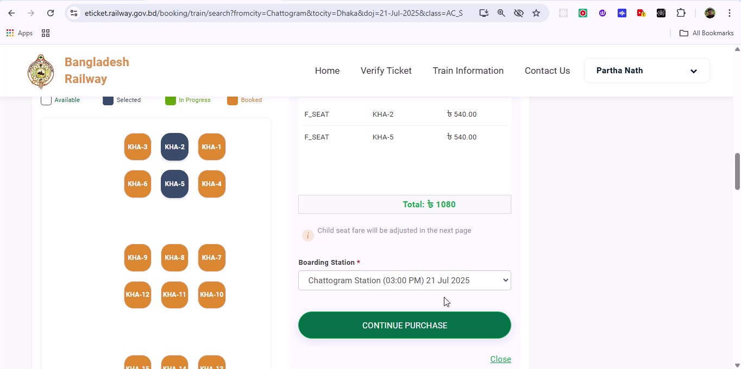

## Screenshot 221

Additional workflow step captured; refer to screenshot for details.

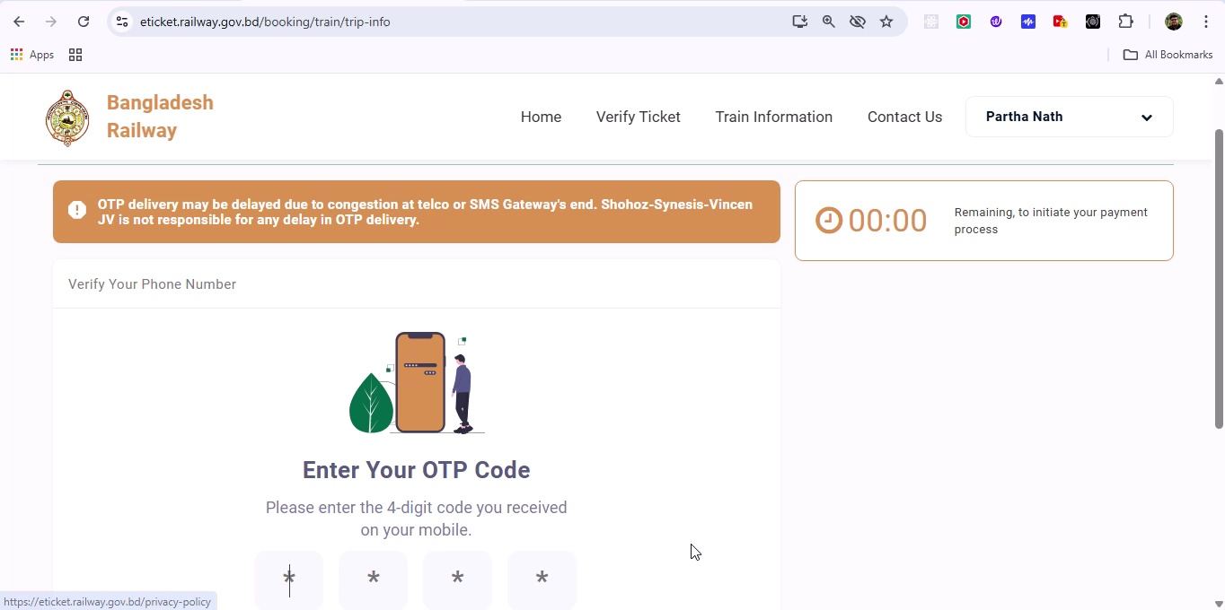

## Screenshot 222

Additional workflow step captured; refer to screenshot for details.

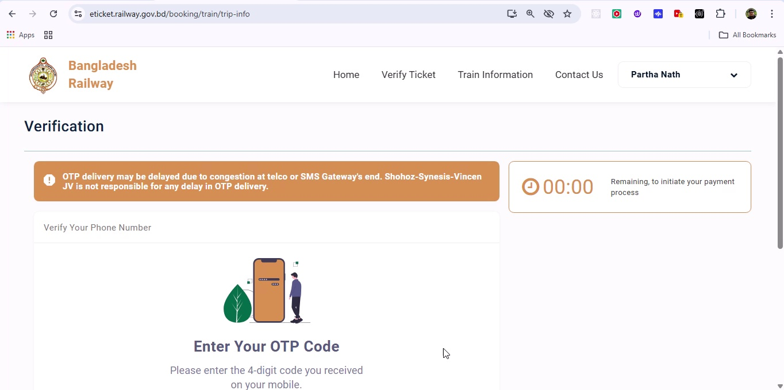

## Screenshot 223

Additional workflow step captured; refer to screenshot for details.

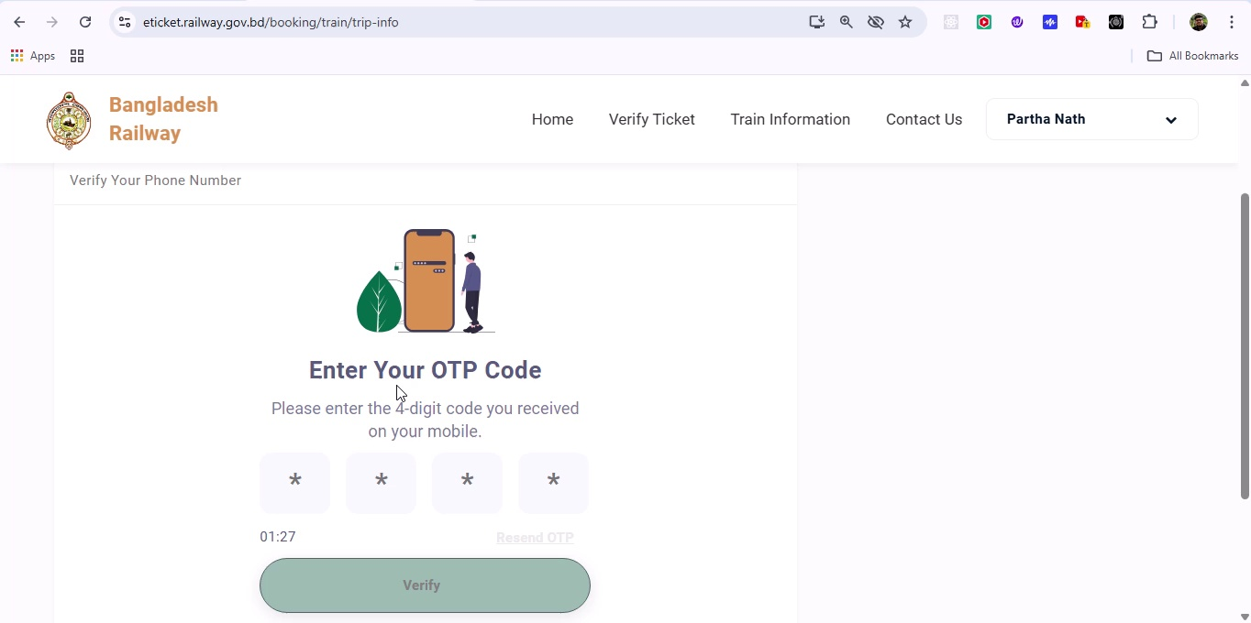

## Screenshot 224

Additional workflow step captured; refer to screenshot for details.

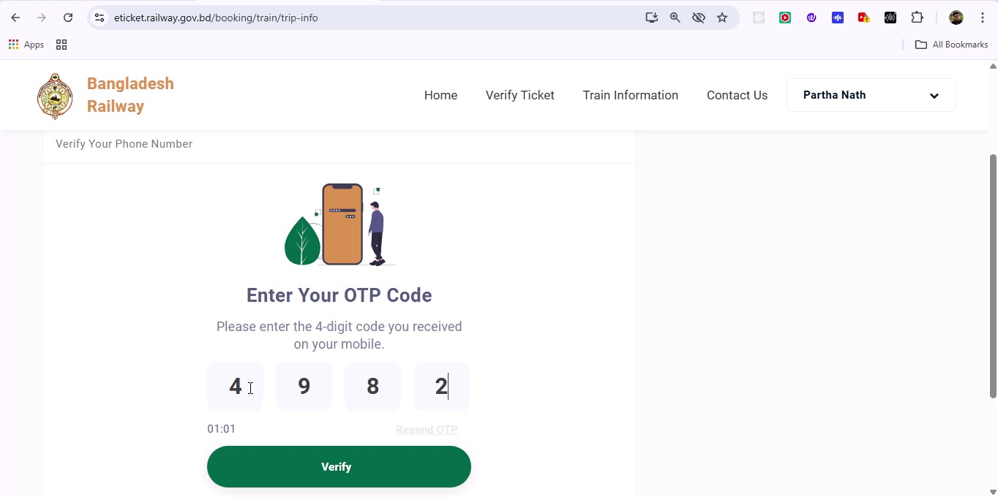

## Screenshot 225

Additional workflow step captured; refer to screenshot for details.

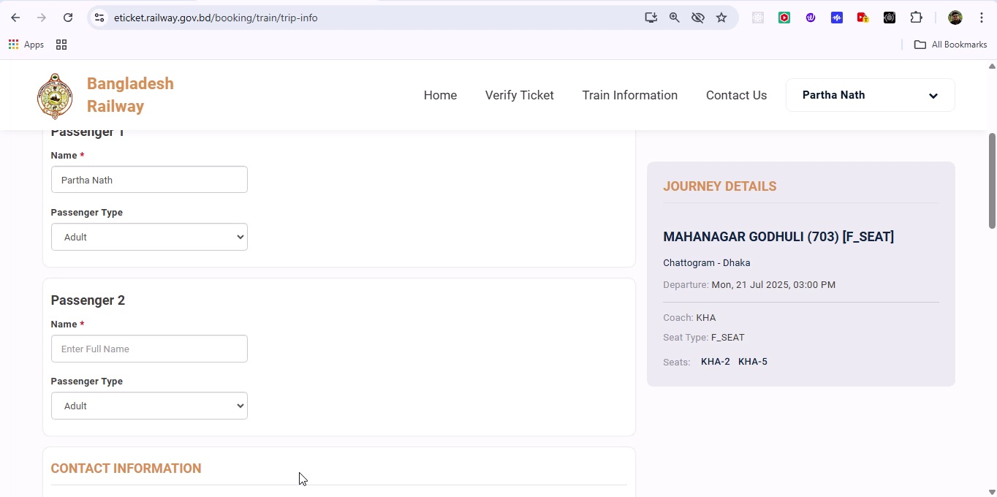

## Screenshot 226

Additional workflow step captured; refer to screenshot for details.

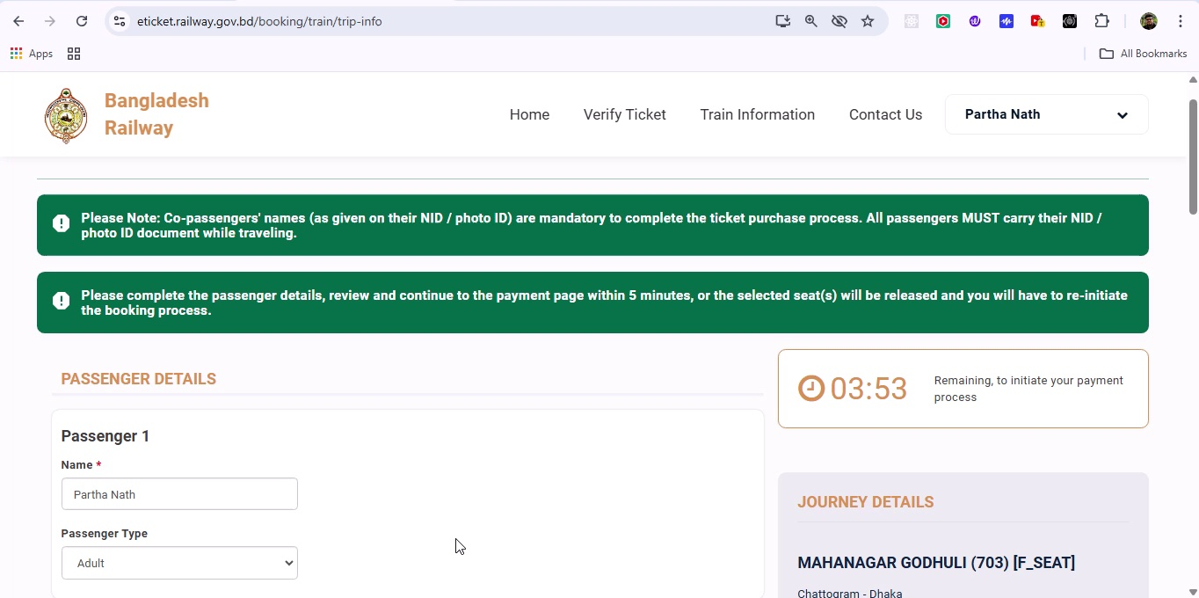

## Screenshot 227

Additional workflow step captured; refer to screenshot for details.

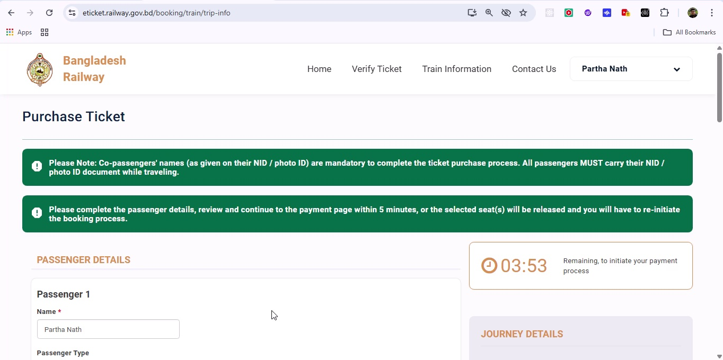

## Screenshot 228

Additional workflow step captured; refer to screenshot for details.

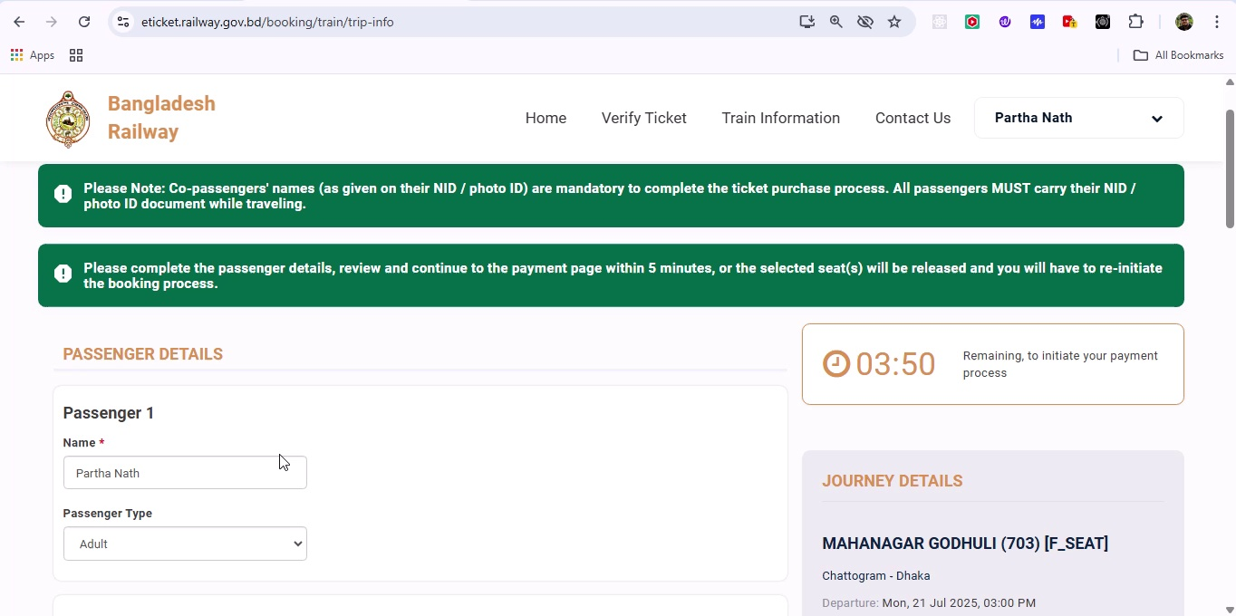

## Screenshot 229

Additional workflow step captured; refer to screenshot for details.

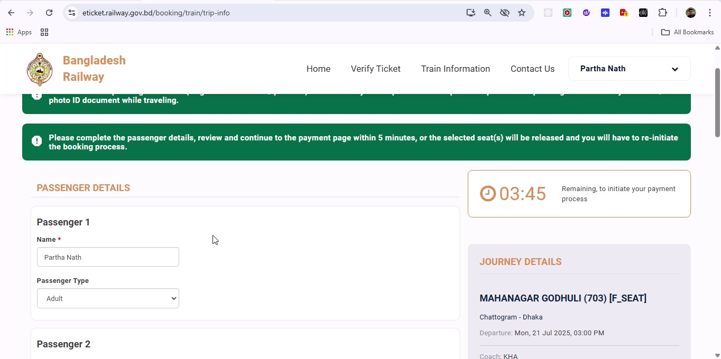

## Screenshot 230

Additional workflow step captured; refer to screenshot for details.

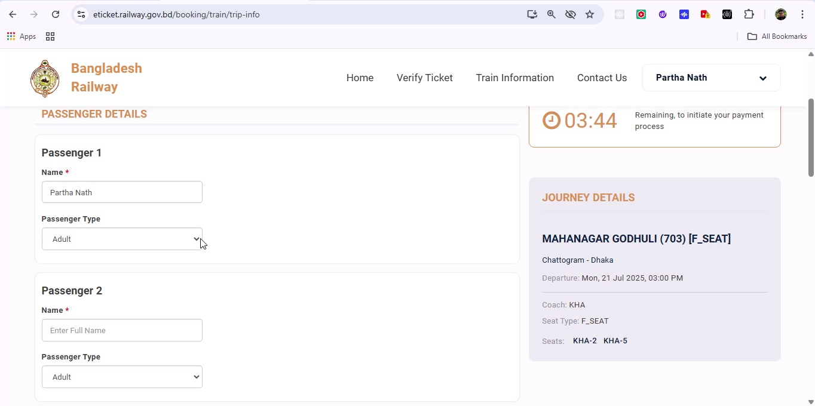

## Screenshot 231

Additional workflow step captured; refer to screenshot for details.

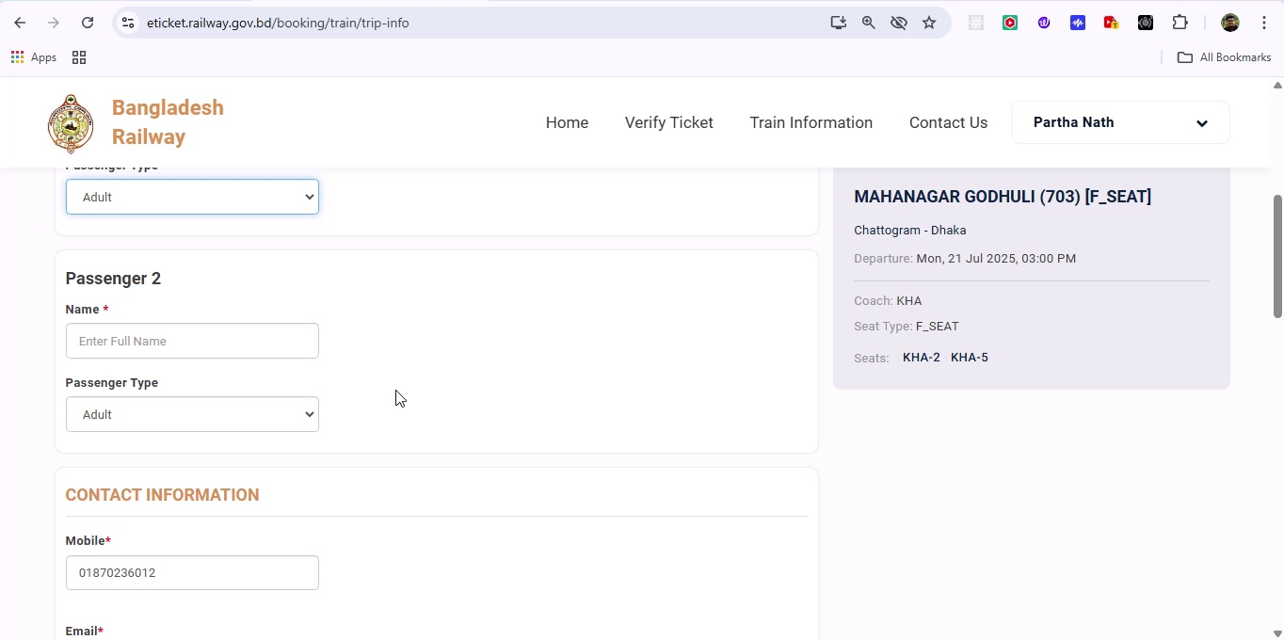

## Screenshot 232

Additional workflow step captured; refer to screenshot for details.

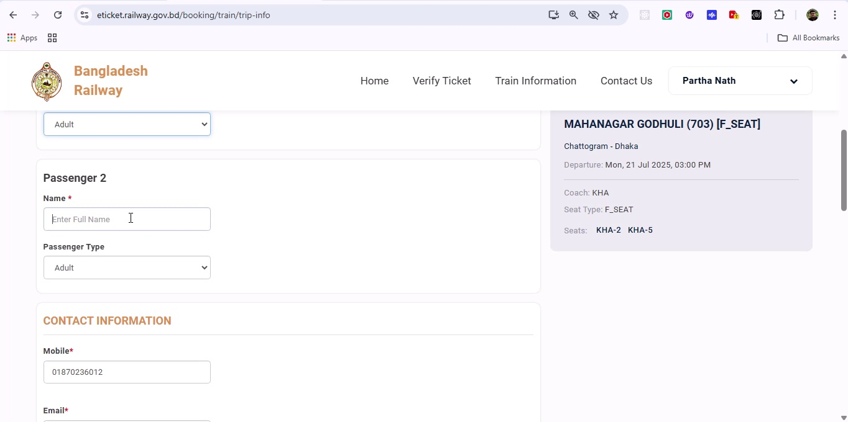

## Screenshot 233

Additional workflow step captured; refer to screenshot for details.

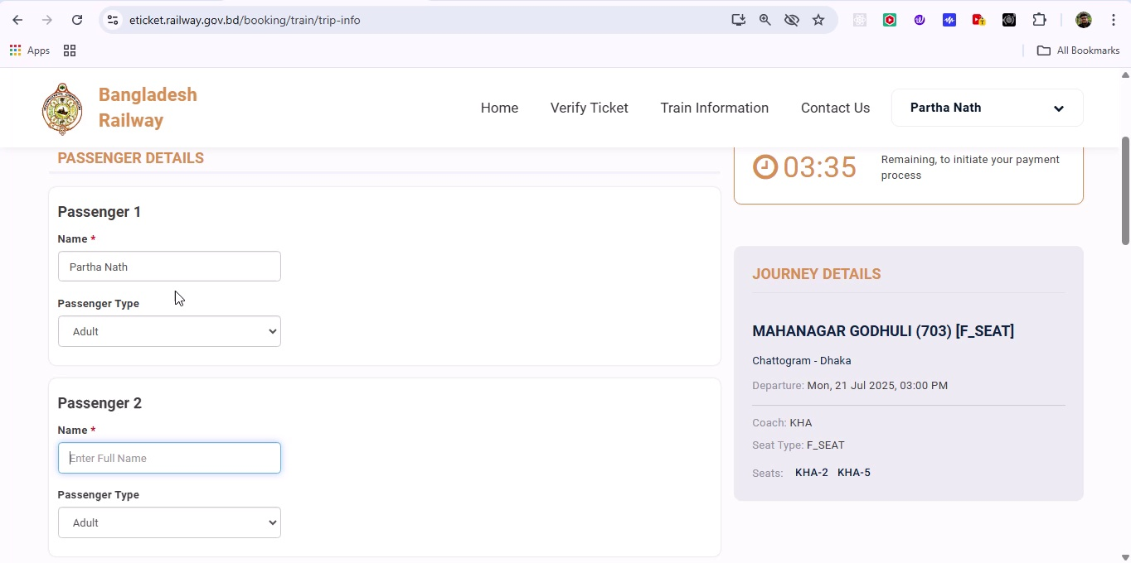

## Screenshot 234

Additional workflow step captured; refer to screenshot for details.

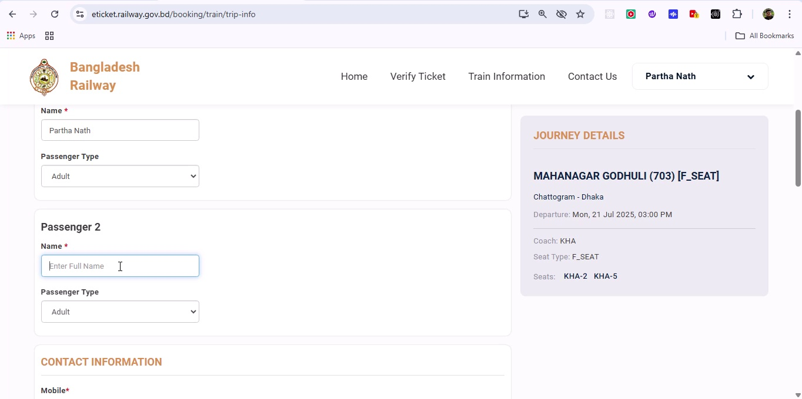

## Screenshot 235

Additional workflow step captured; refer to screenshot for details.

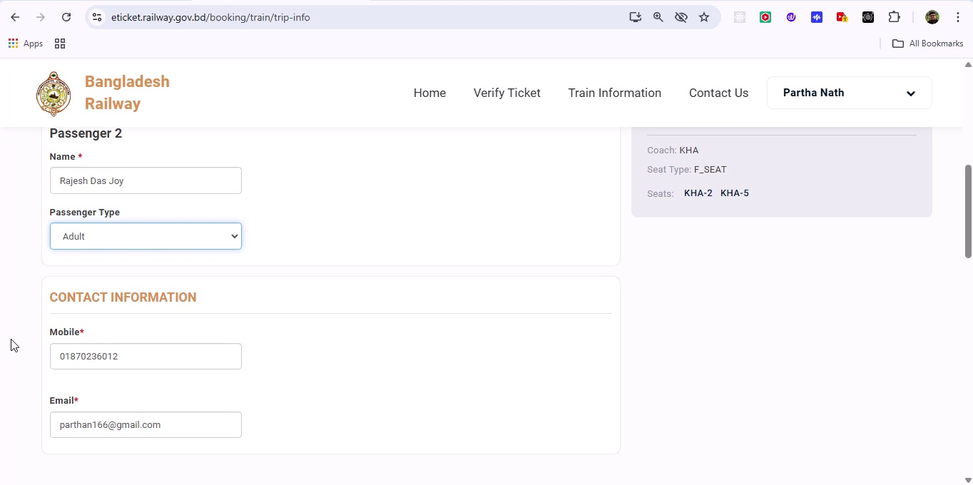

## Screenshot 236

Additional workflow step captured; refer to screenshot for details.

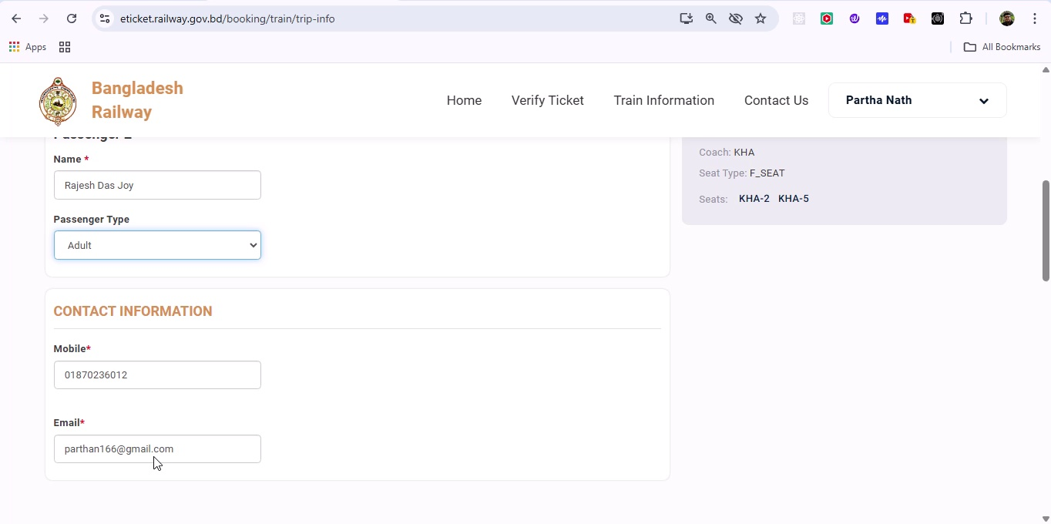

## Screenshot 237

Additional workflow step captured; refer to screenshot for details.

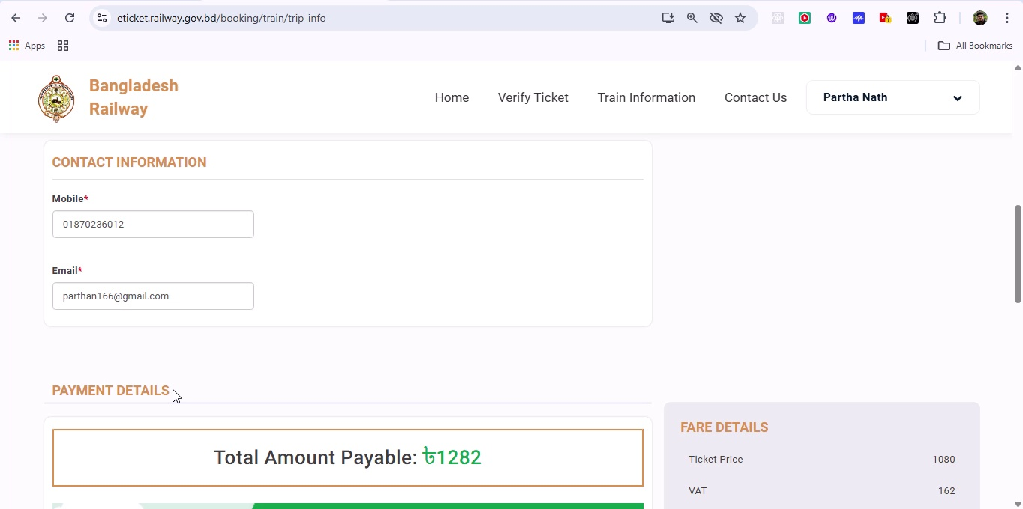

## Screenshot 238

Additional workflow step captured; refer to screenshot for details.

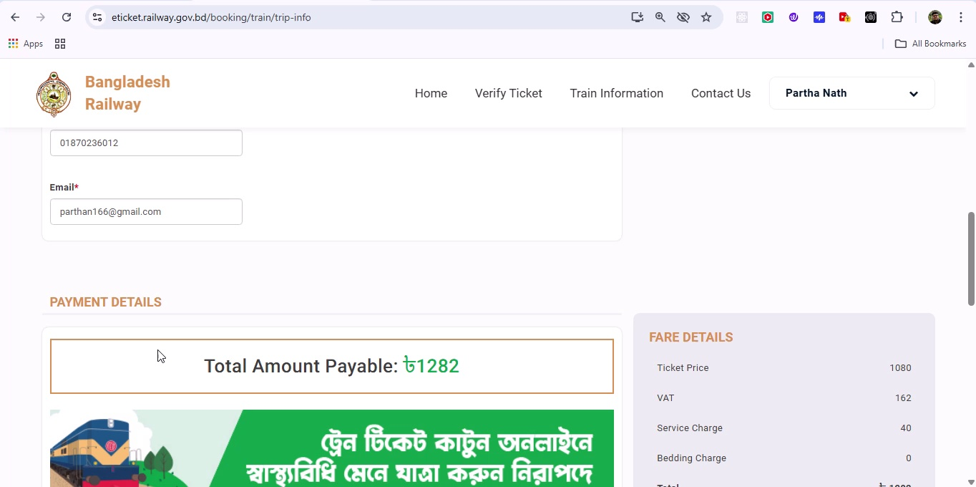

## Screenshot 239

Additional workflow step captured; refer to screenshot for details.

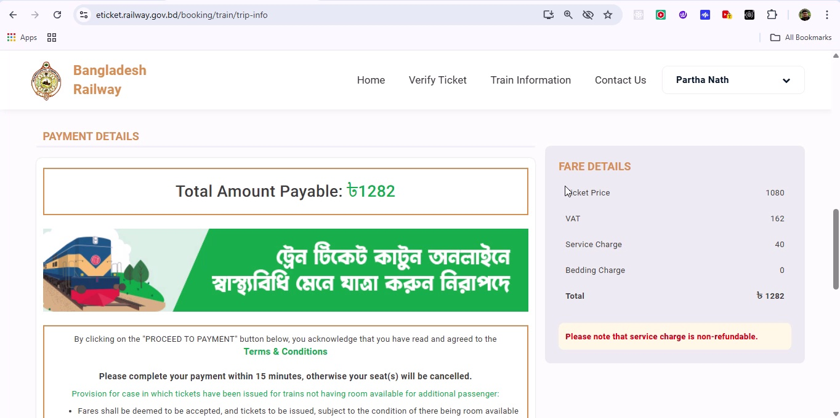

## Screenshot 240

Additional workflow step captured; refer to screenshot for details.

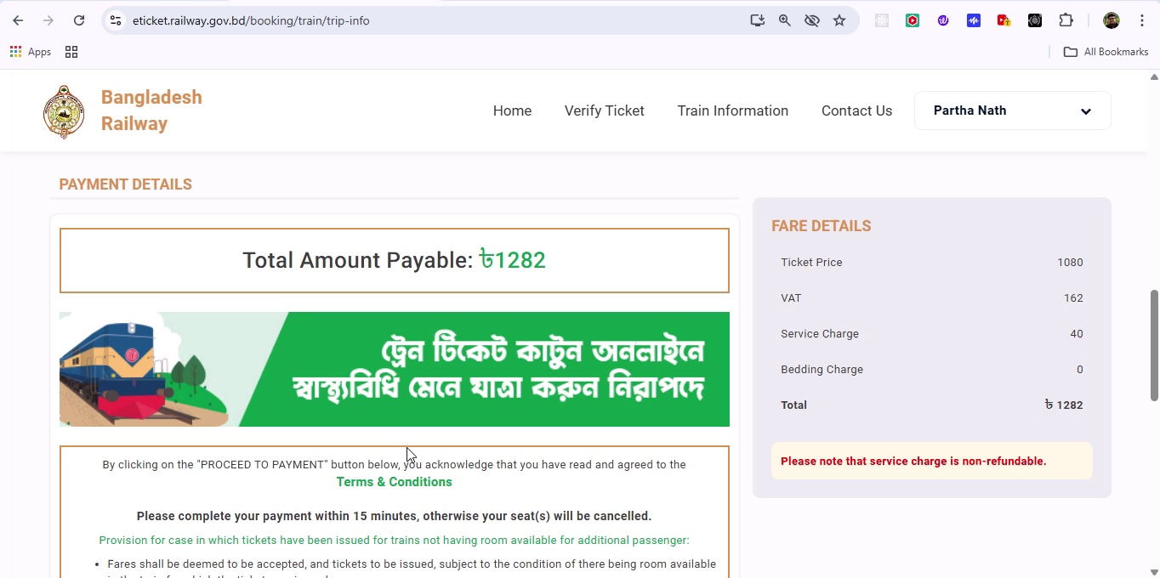

## Screenshot 241

Additional workflow step captured; refer to screenshot for details.

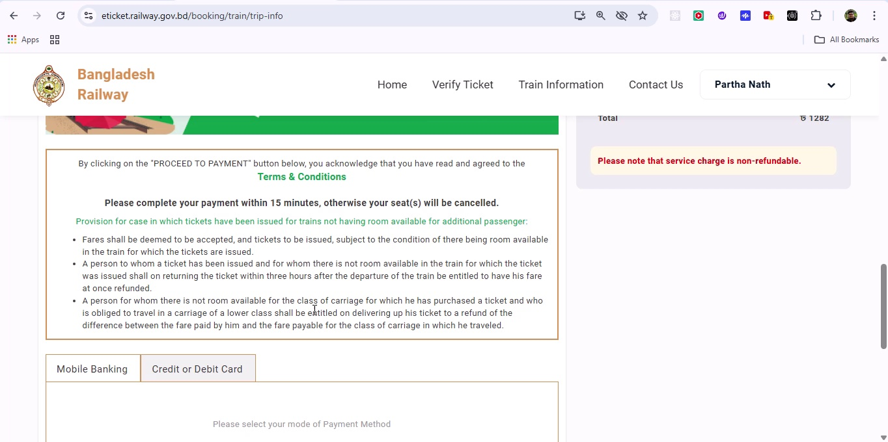

## Screenshot 242

Additional workflow step captured; refer to screenshot for details.

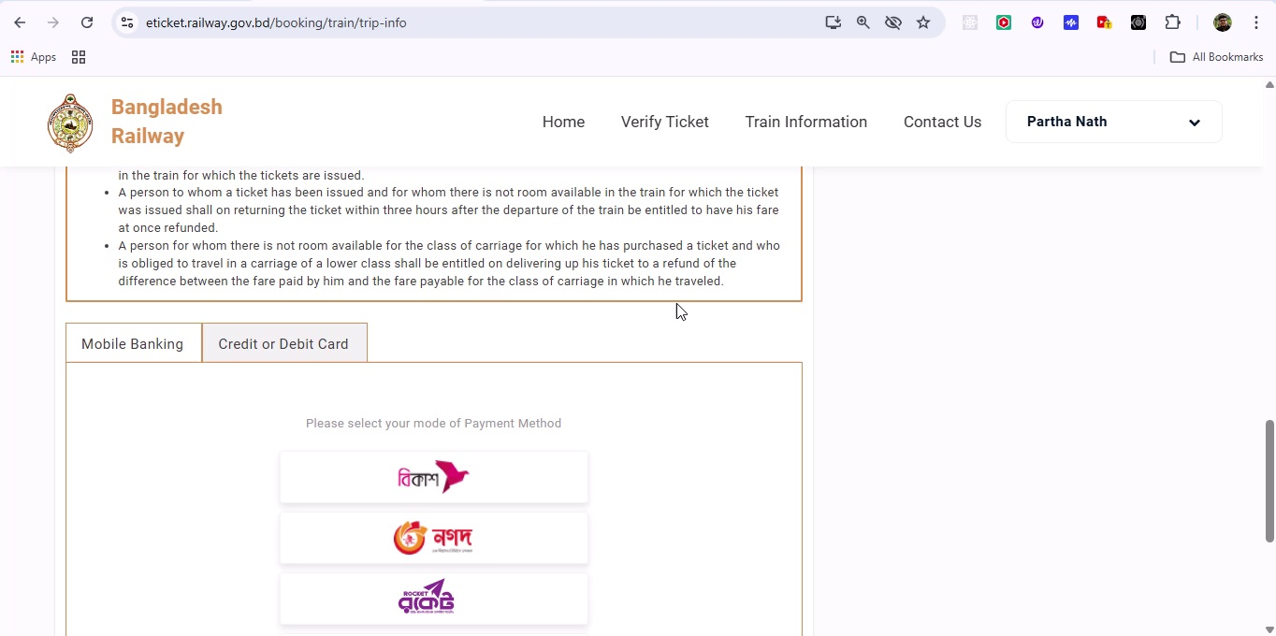

## Screenshot 243

Additional workflow step captured; refer to screenshot for details.

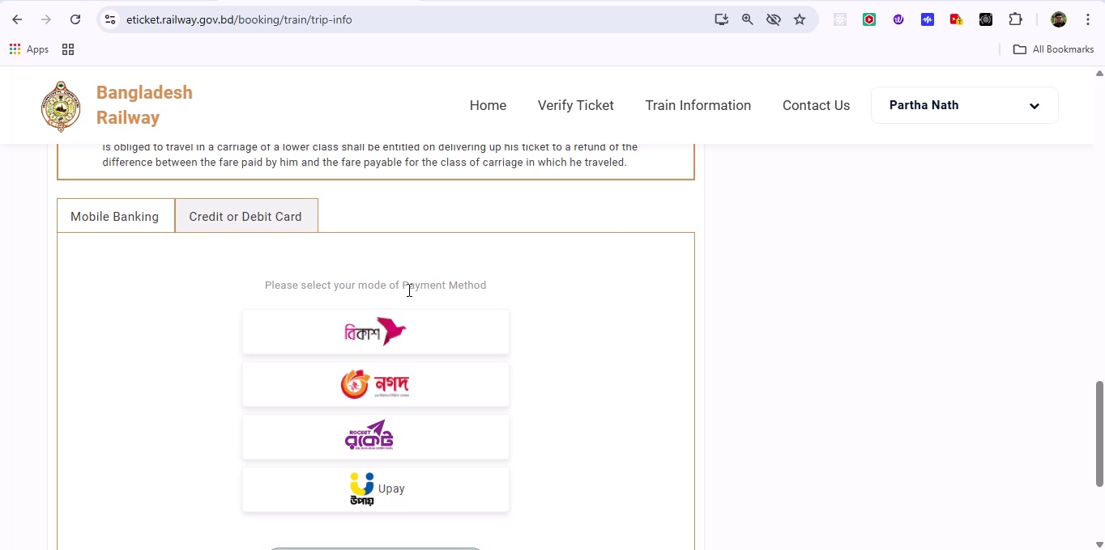

## Screenshot 244

Additional workflow step captured; refer to screenshot for details.

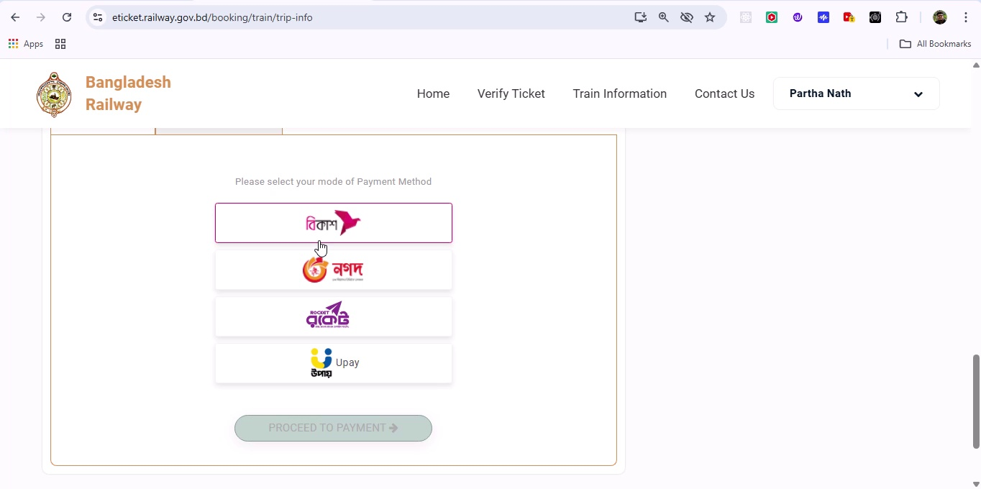

## Screenshot 245

Additional workflow step captured; refer to screenshot for details.

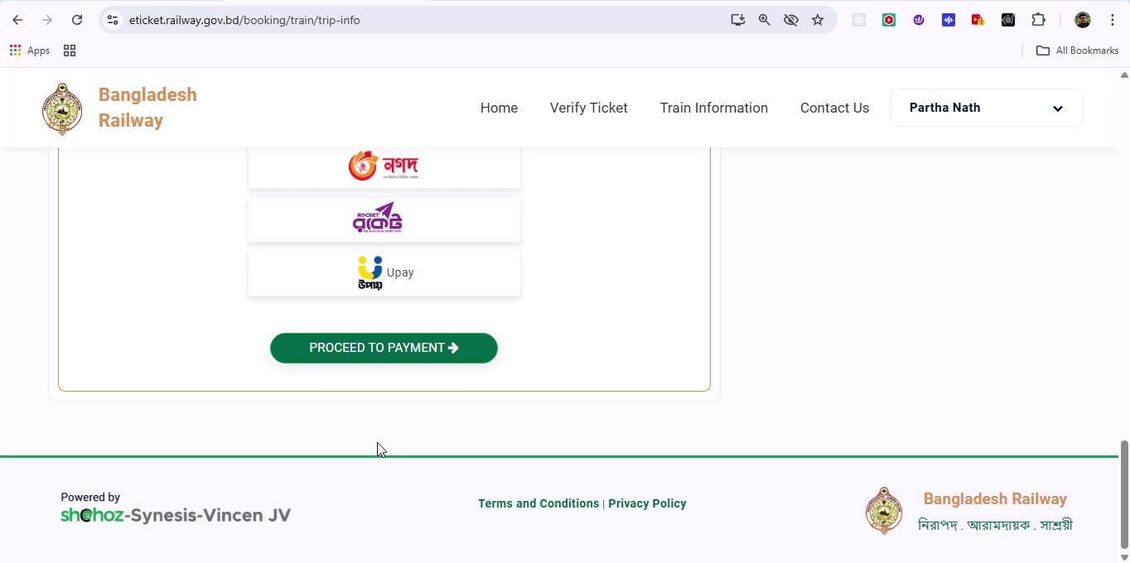

## Screenshot 246

Additional workflow step captured; refer to screenshot for details.

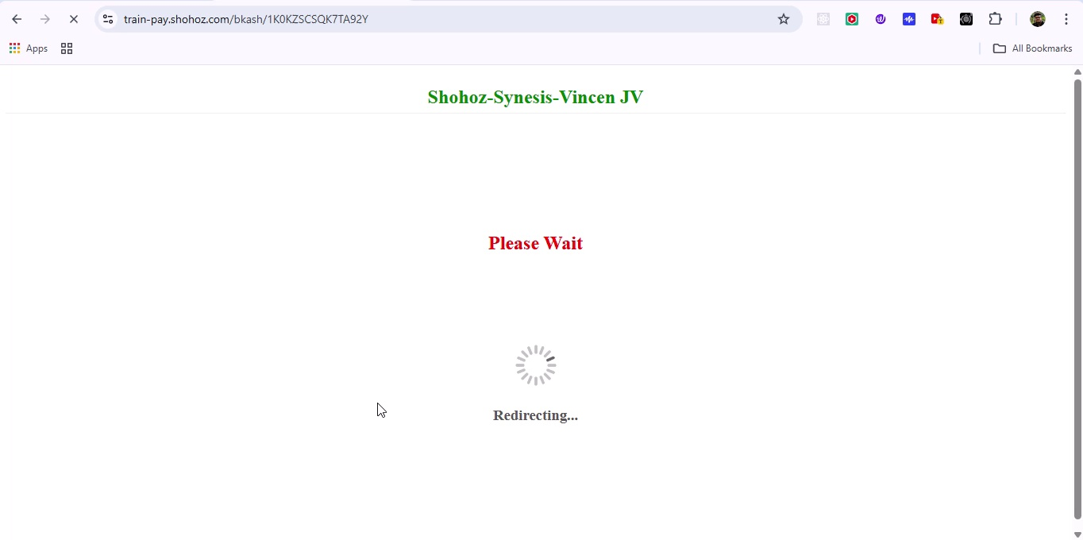

## Screenshot 247

Additional workflow step captured; refer to screenshot for details.

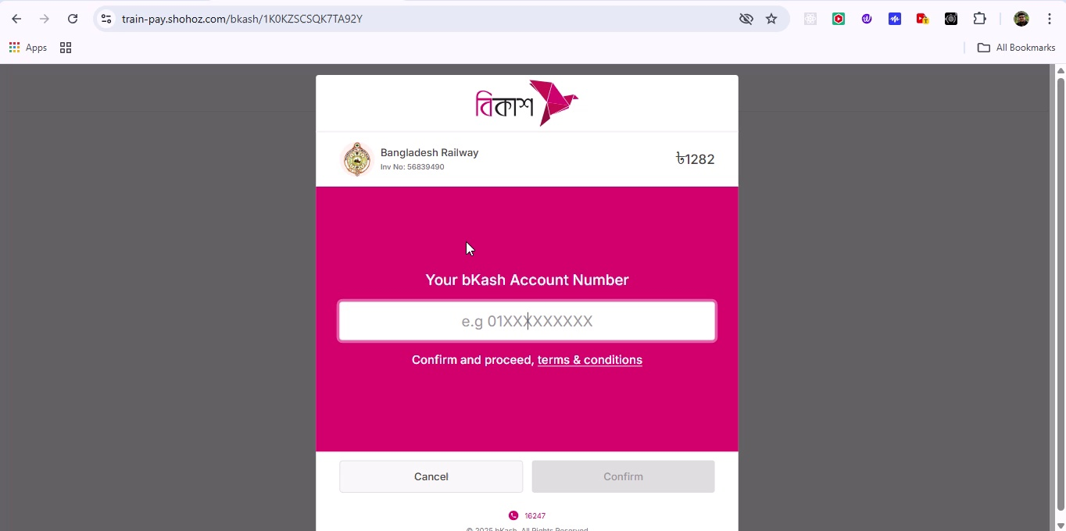

## Screenshot 248

Additional workflow step captured; refer to screenshot for details.

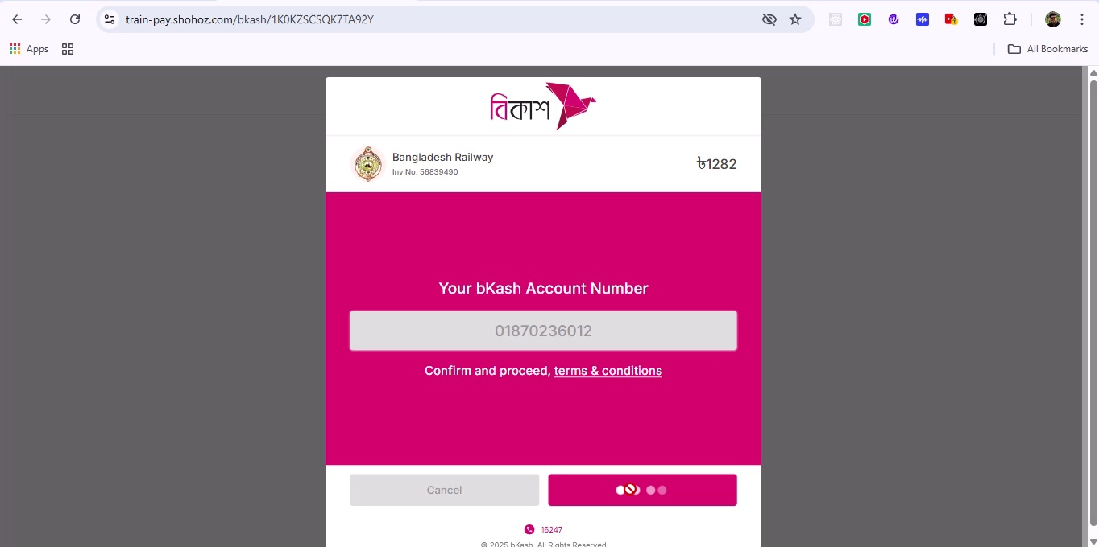

## Screenshot 249

Additional workflow step captured; refer to screenshot for details.

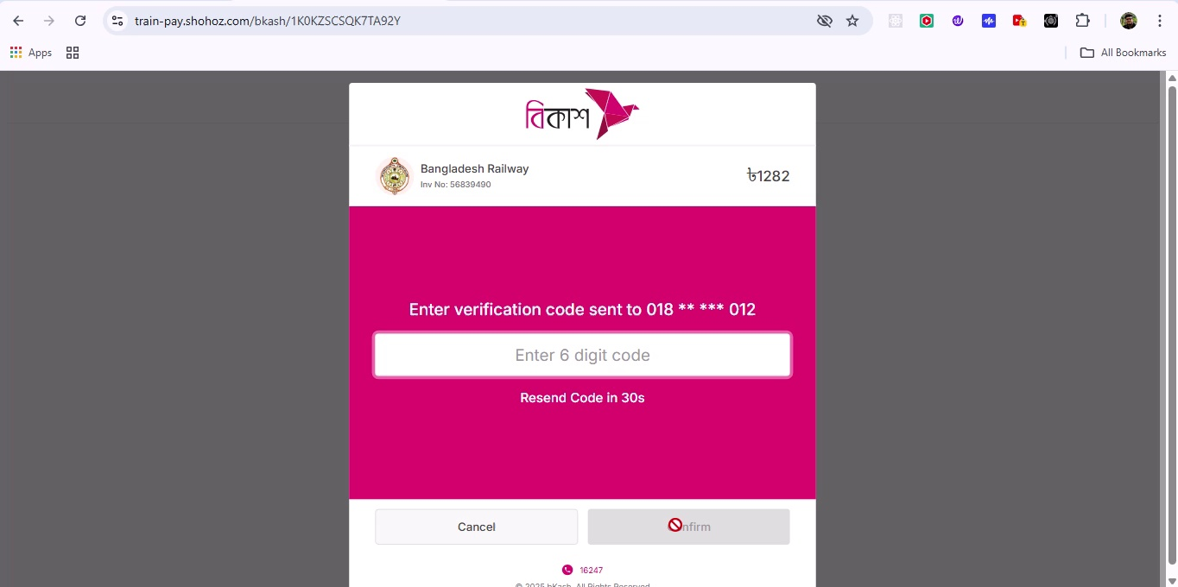

## Screenshot 250

Additional workflow step captured; refer to screenshot for details.

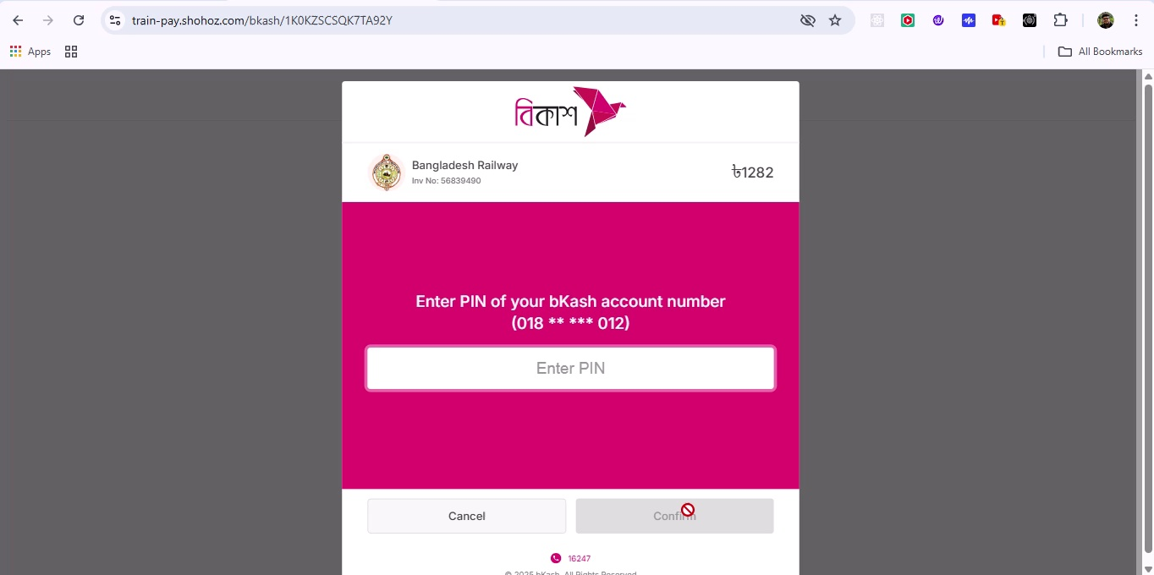

## Screenshot 251

Additional workflow step captured; refer to screenshot for details.

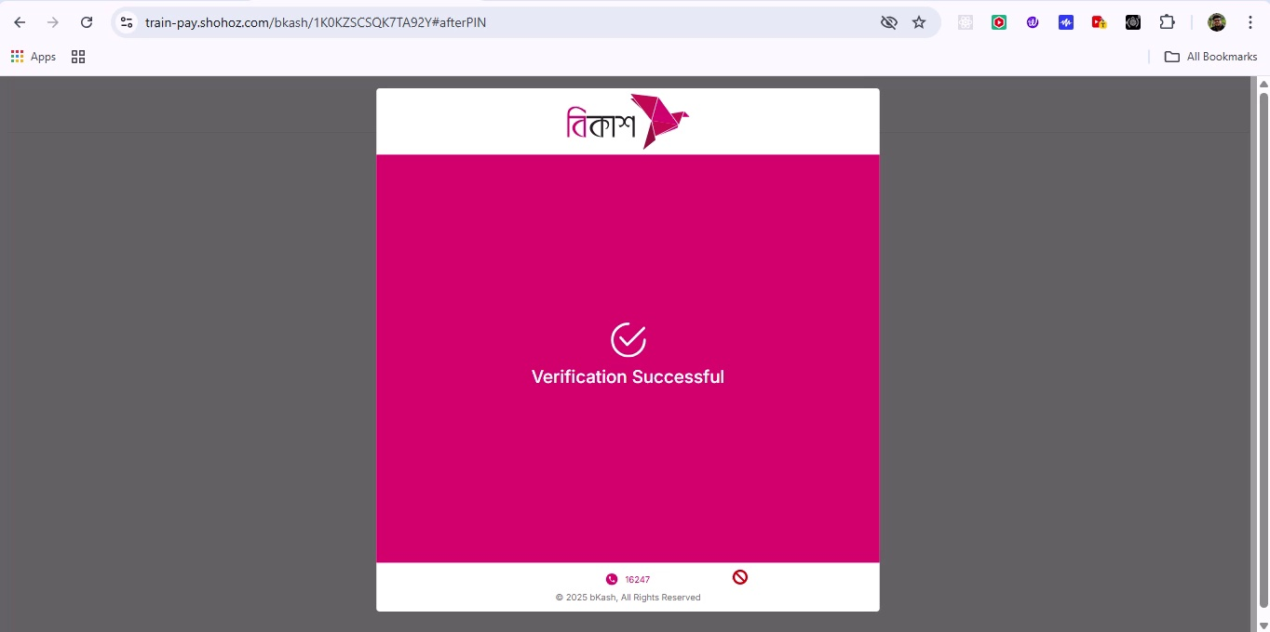

## Screenshot 252

Additional workflow step captured; refer to screenshot for details.

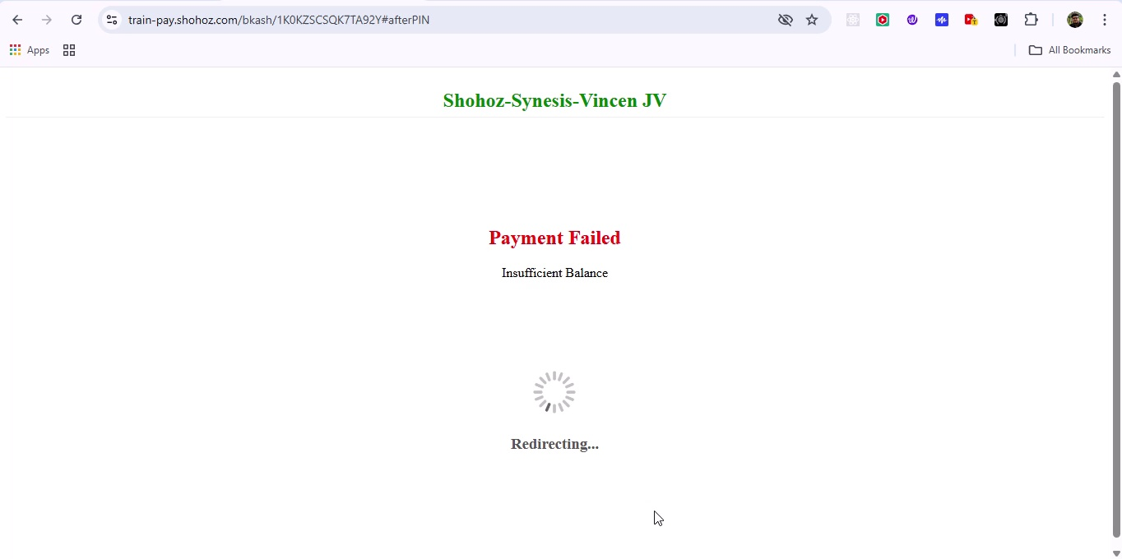

## Screenshot 253

Additional workflow step captured; refer to screenshot for details.

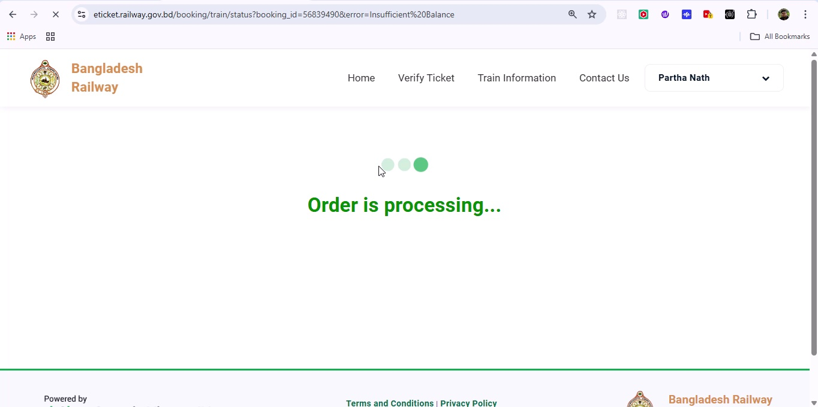

## Screenshot 254

Additional workflow step captured; refer to screenshot for details.

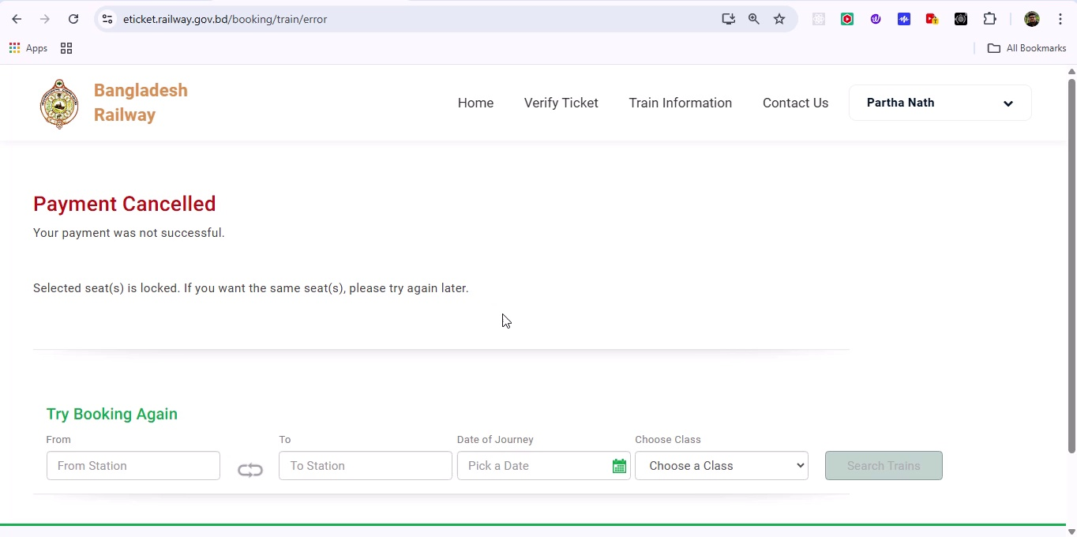

## Screenshot 255

Additional workflow step captured; refer to screenshot for details.

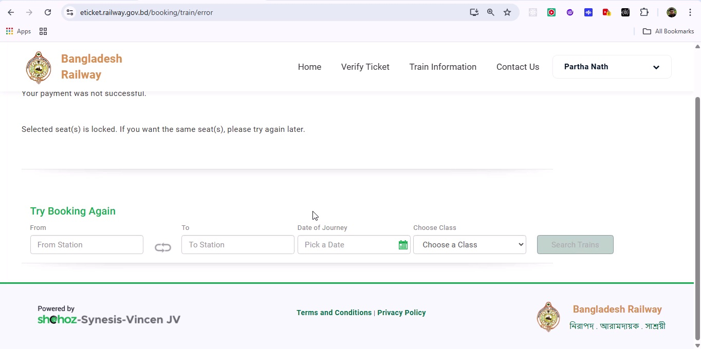

## Screenshot 256

Additional workflow step captured; refer to screenshot for details.

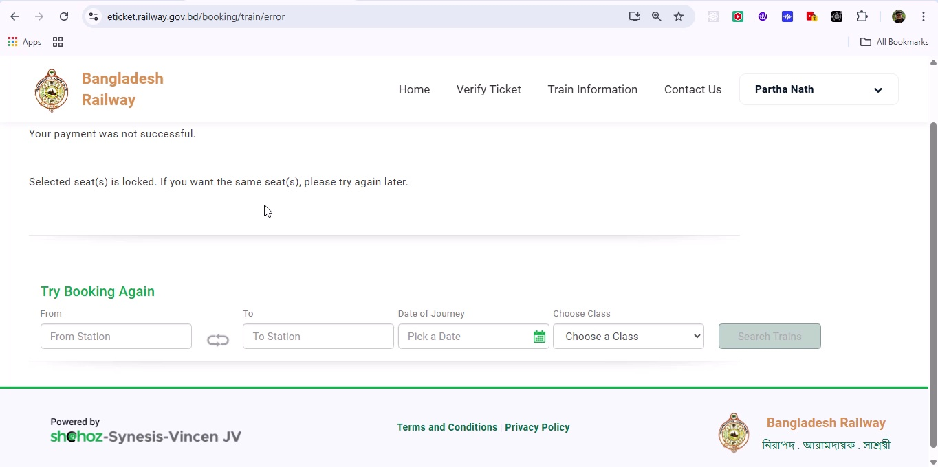

## Screenshot 257

Additional workflow step captured; refer to screenshot for details.

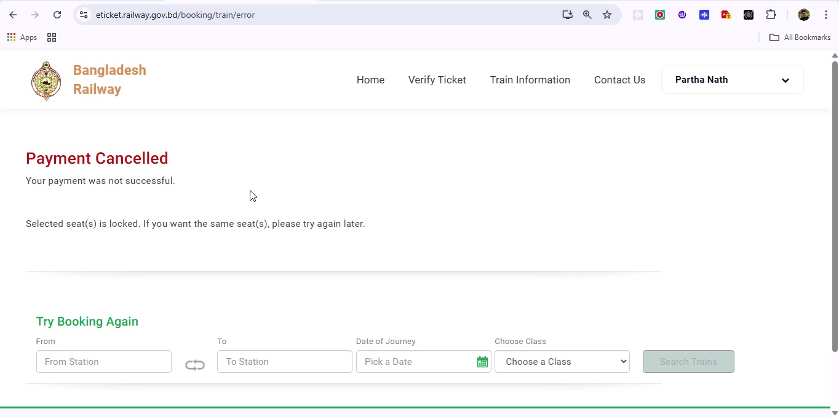

## Screenshot 258

Additional workflow step captured; refer to screenshot for details.

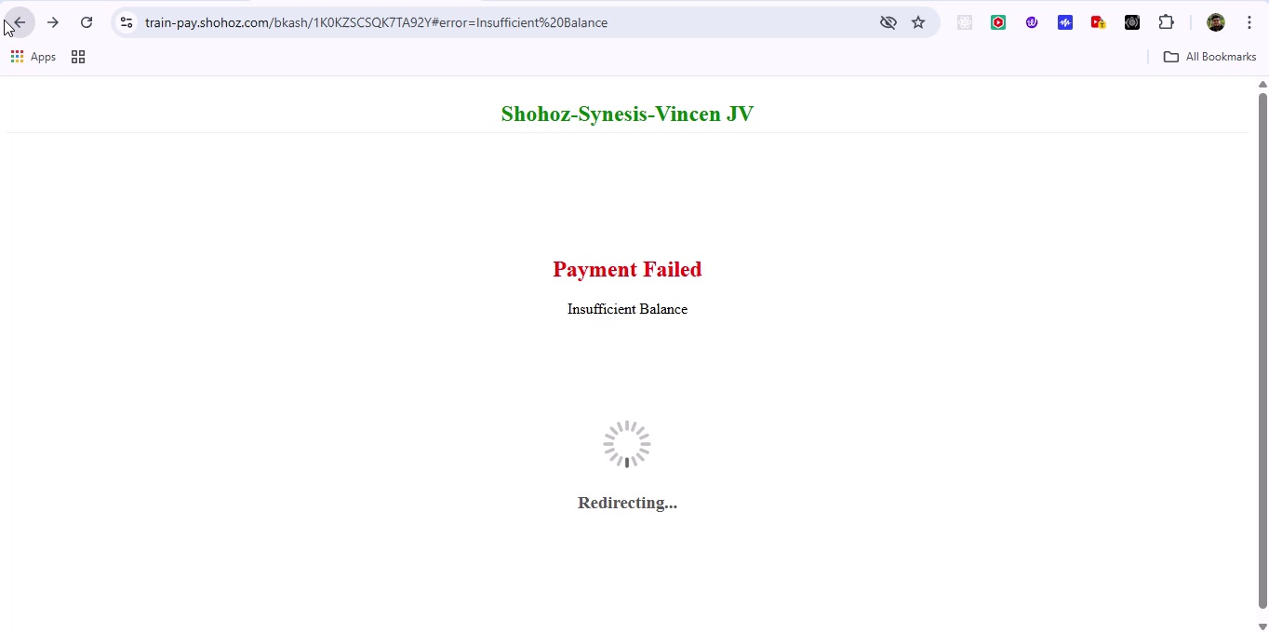

## Screenshot 259

Additional workflow step captured; refer to screenshot for details.

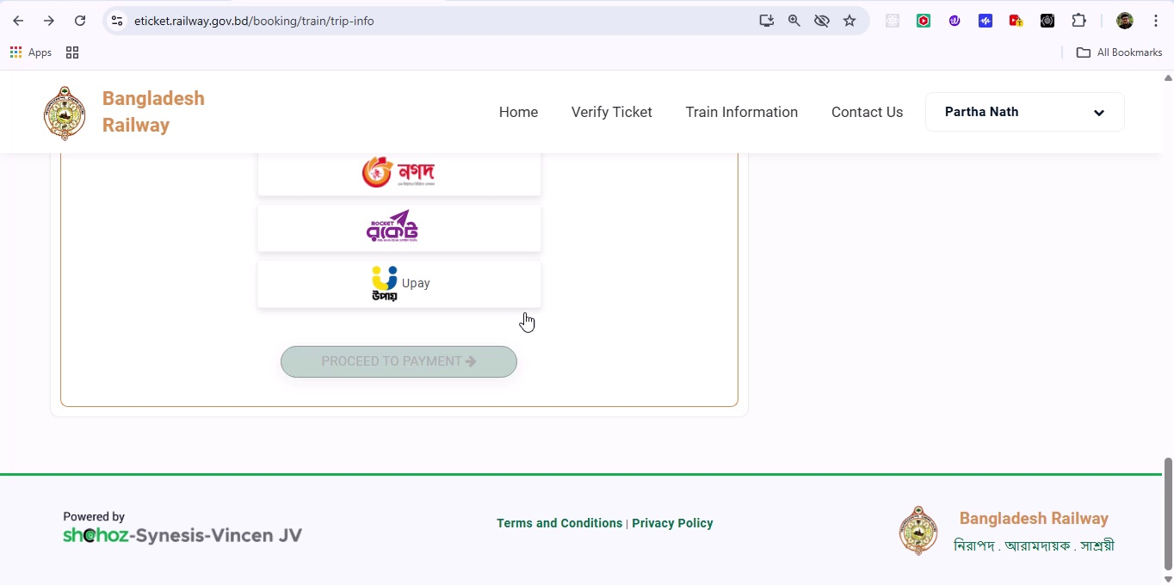

## Screenshot 260

Additional workflow step captured; refer to screenshot for details.

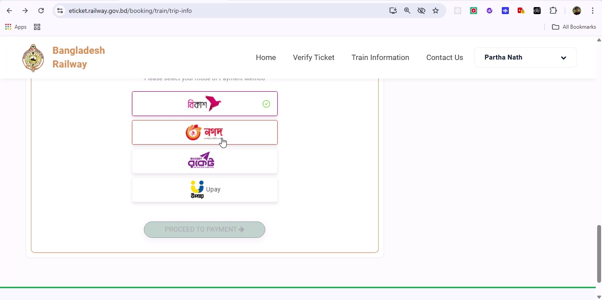

## Screenshot 261

Additional workflow step captured; refer to screenshot for details.

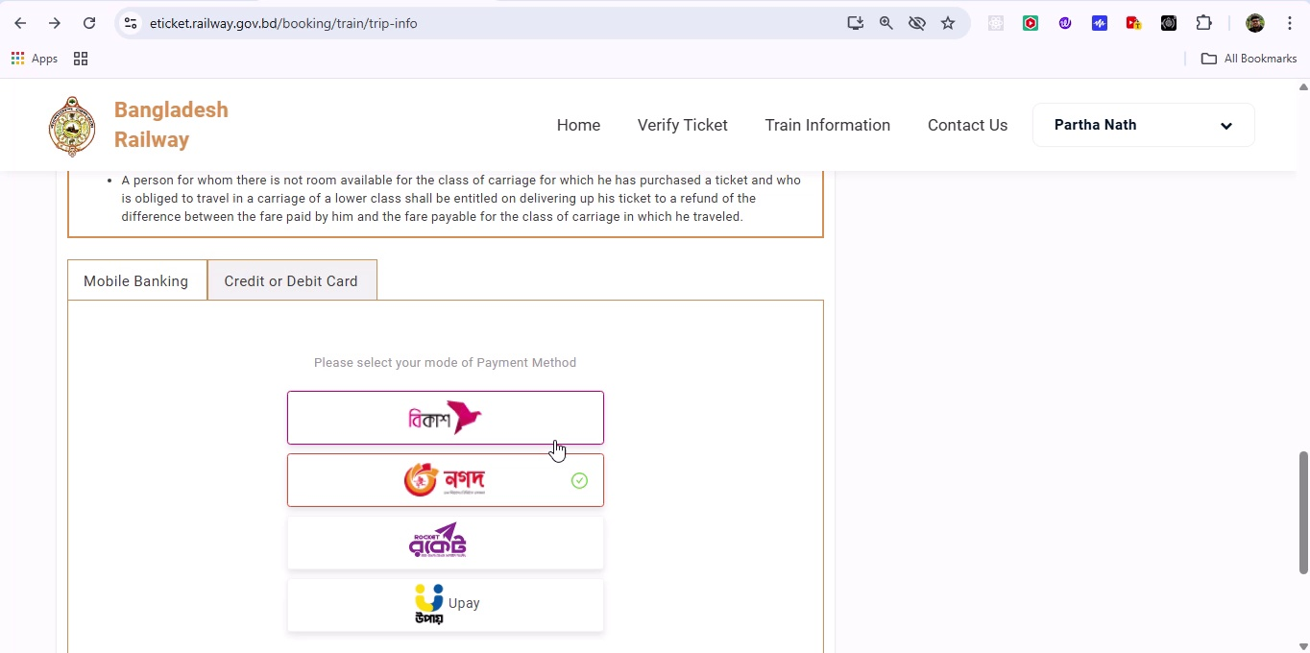

## Screenshot 262

Additional workflow step captured; refer to screenshot for details.

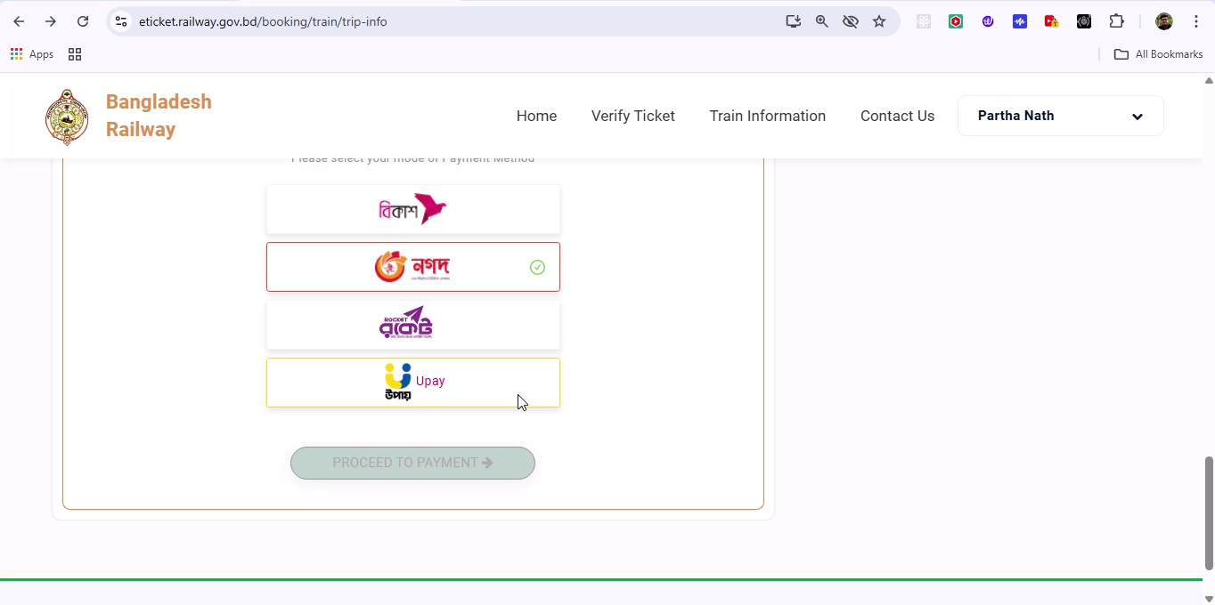

## Screenshot 263

Additional workflow step captured; refer to screenshot for details.

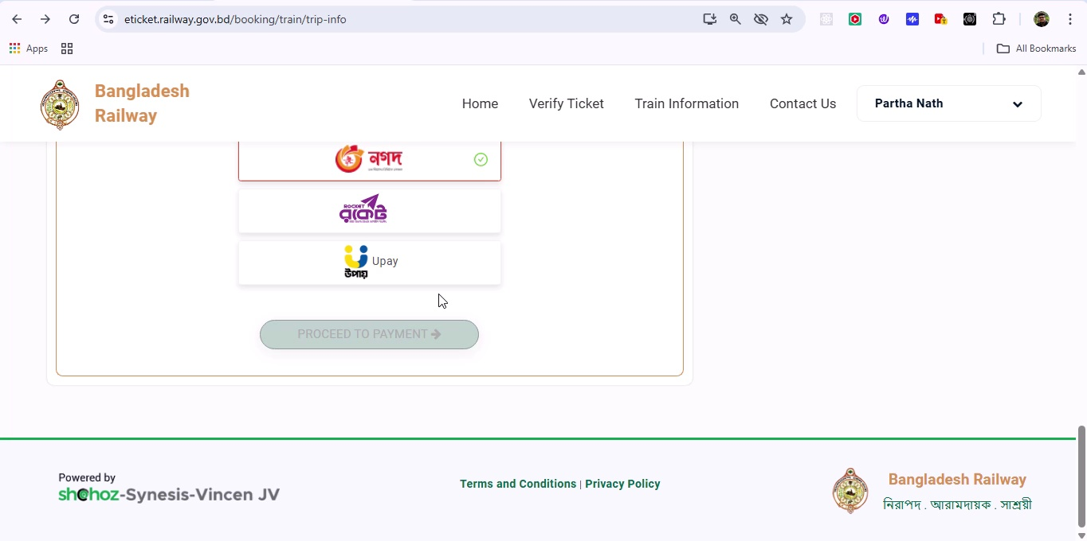

## Screenshot 264

Additional workflow step captured; refer to screenshot for details.

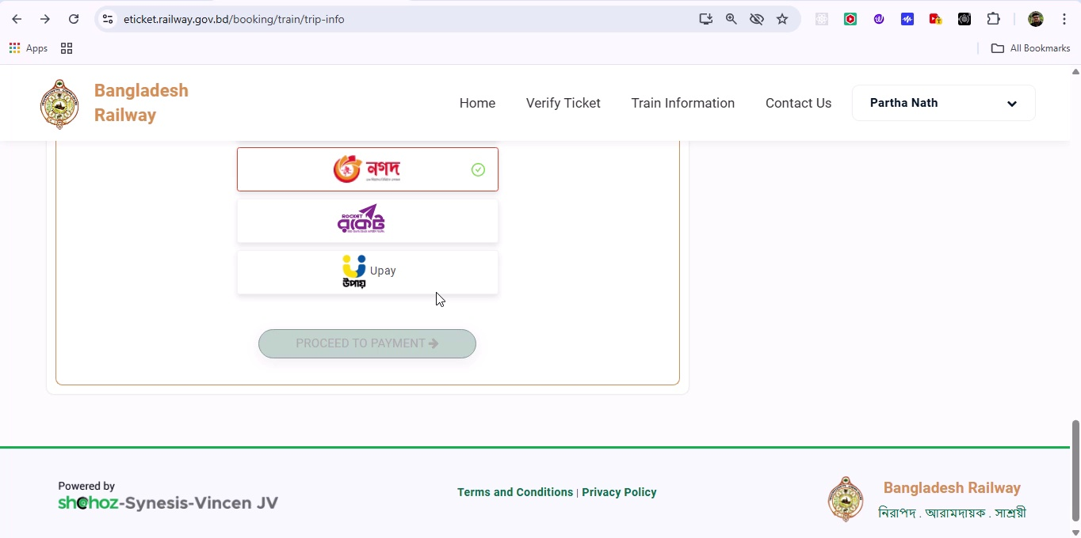

## Screenshot 265

Additional workflow step captured; refer to screenshot for details.

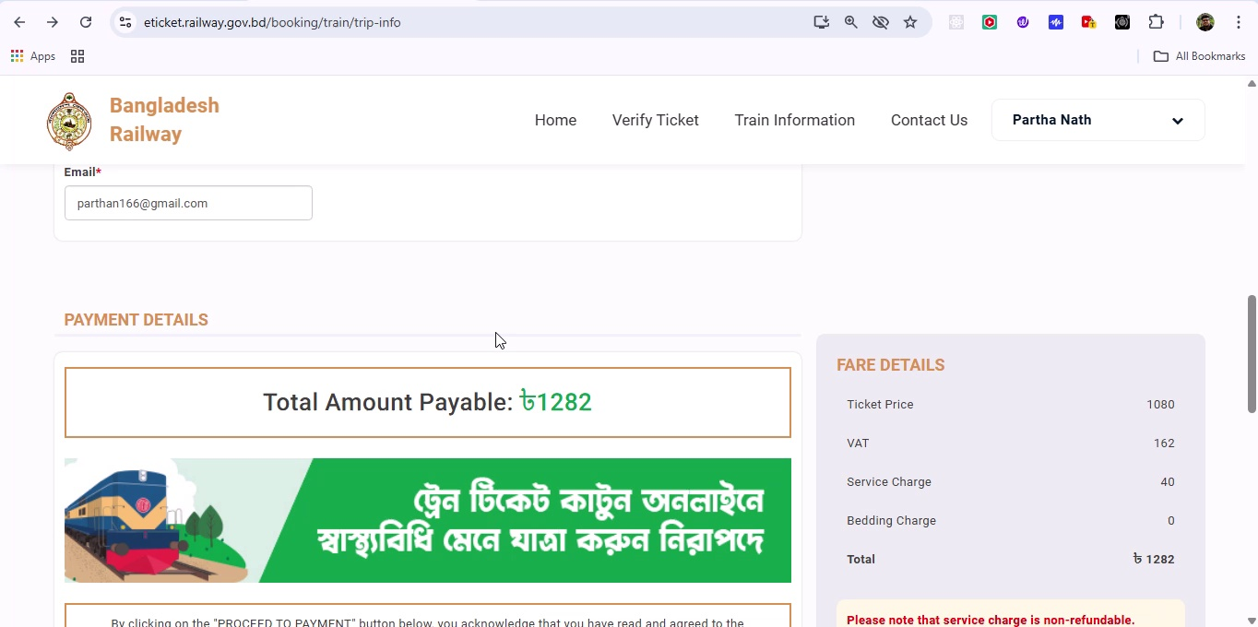

## Screenshot 266

Additional workflow step captured; refer to screenshot for details.

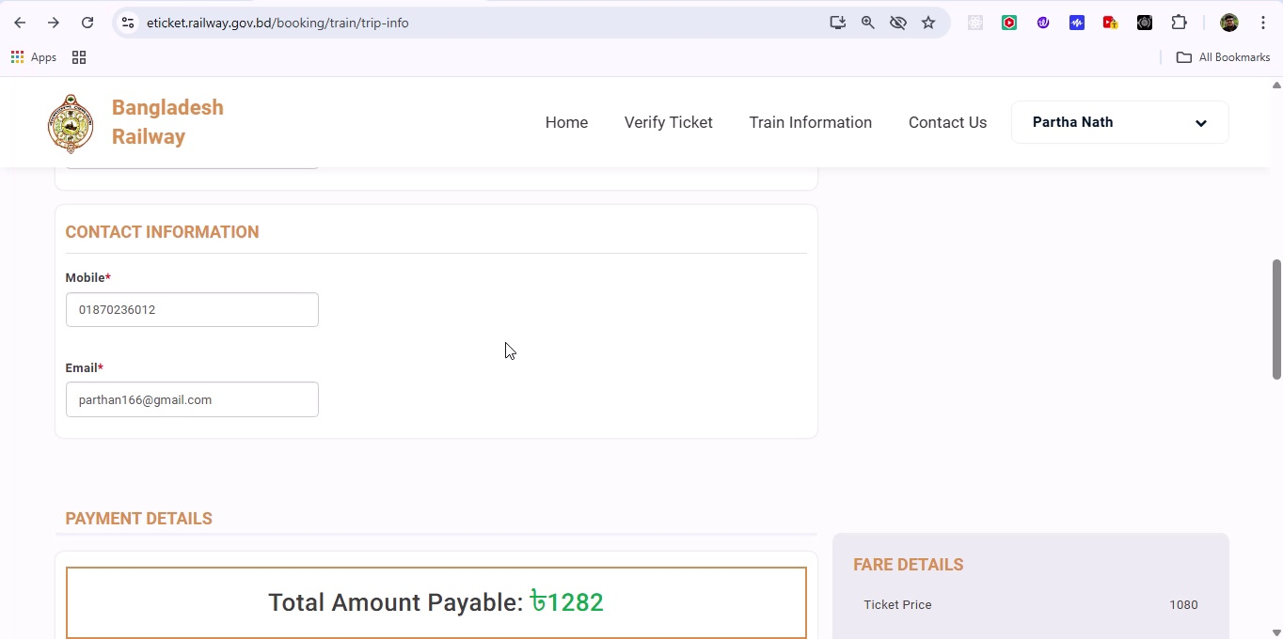

## Screenshot 267

Additional workflow step captured; refer to screenshot for details.

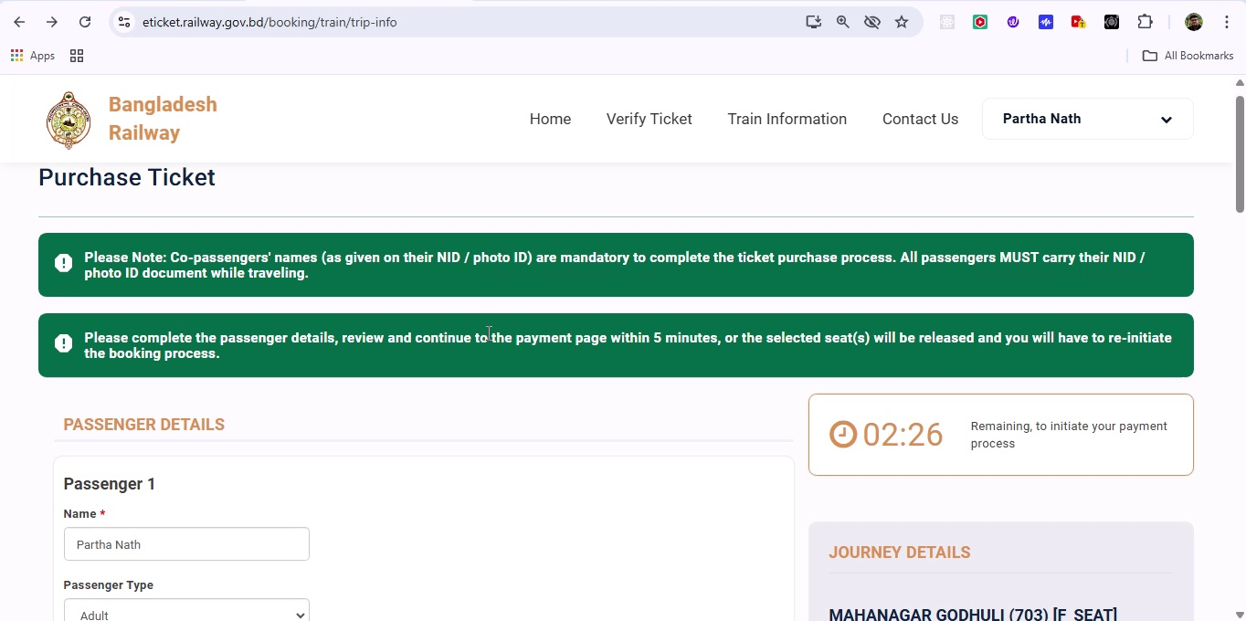

## Screenshot 268

Additional workflow step captured; refer to screenshot for details.

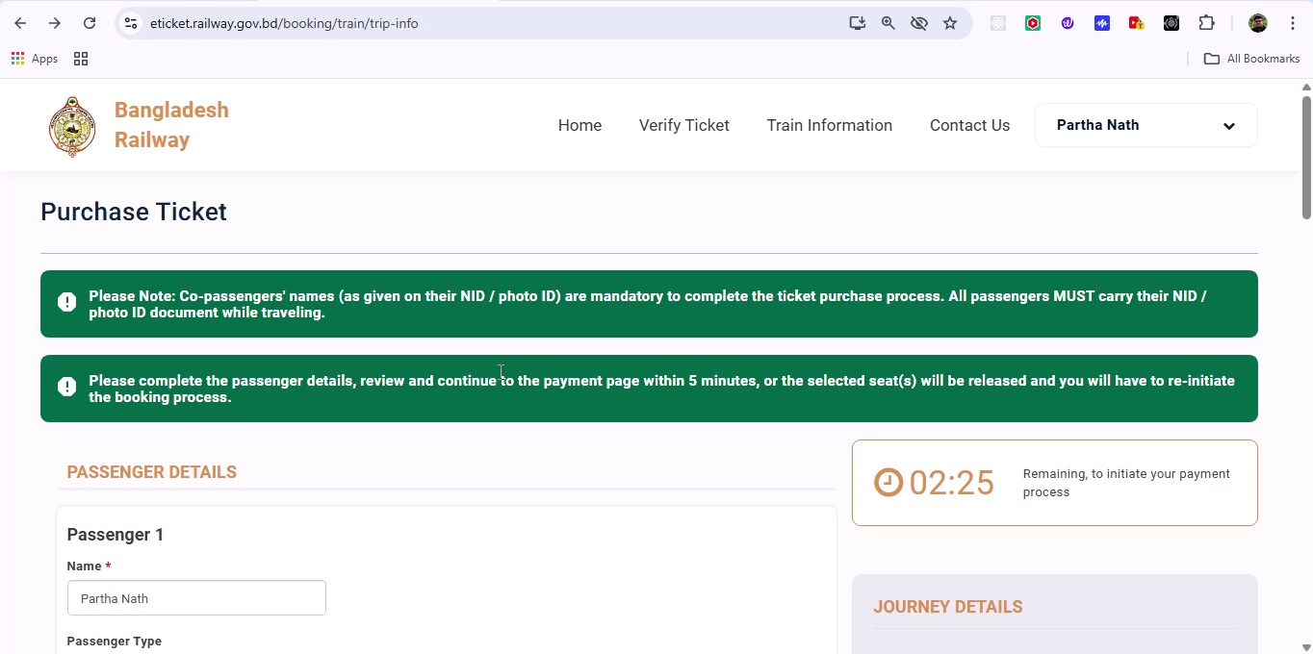

## Screenshot 269

Additional workflow step captured; refer to screenshot for details.

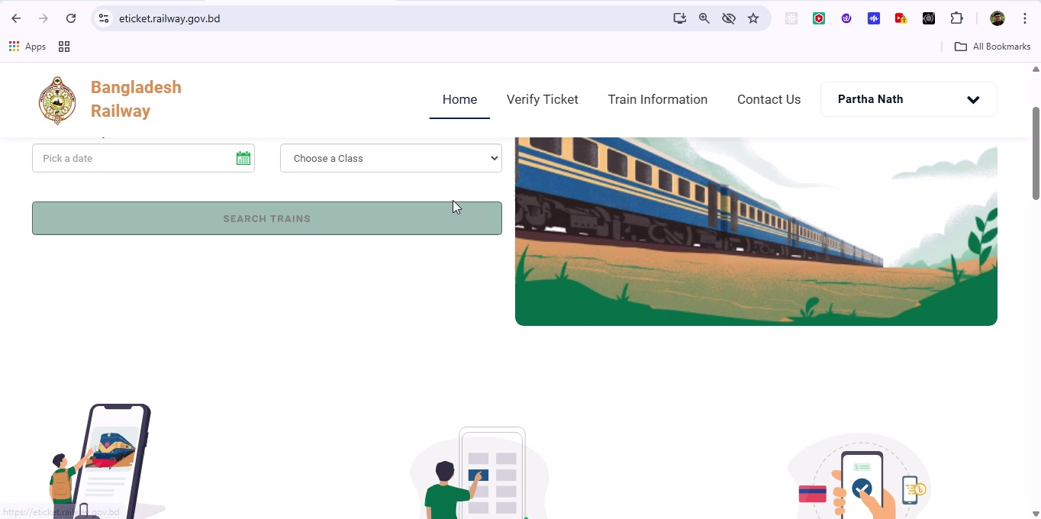

## Screenshot 270

Additional workflow step captured; refer to screenshot for details.

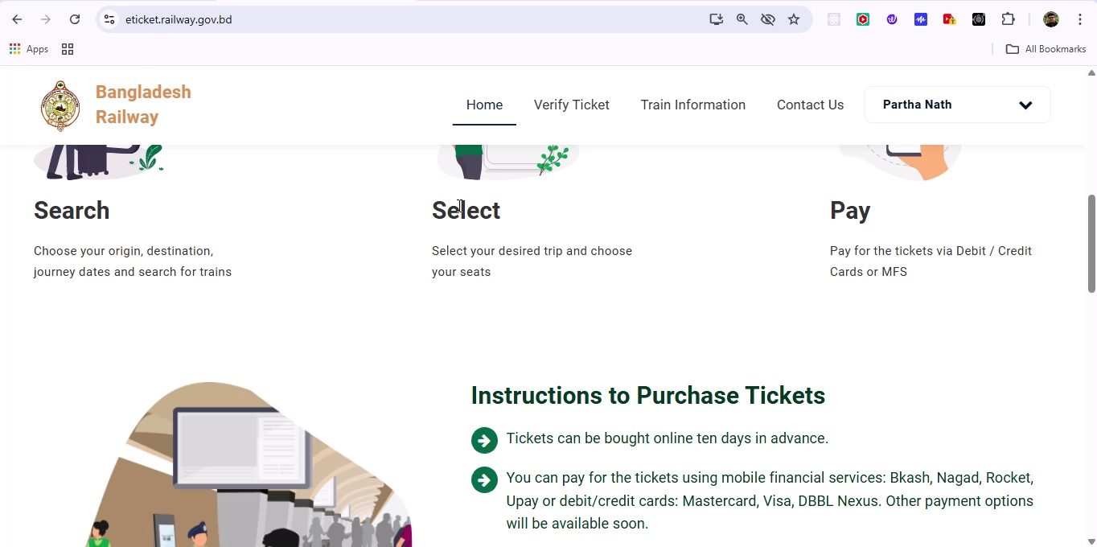

## Screenshot 271

Additional workflow step captured; refer to screenshot for details.

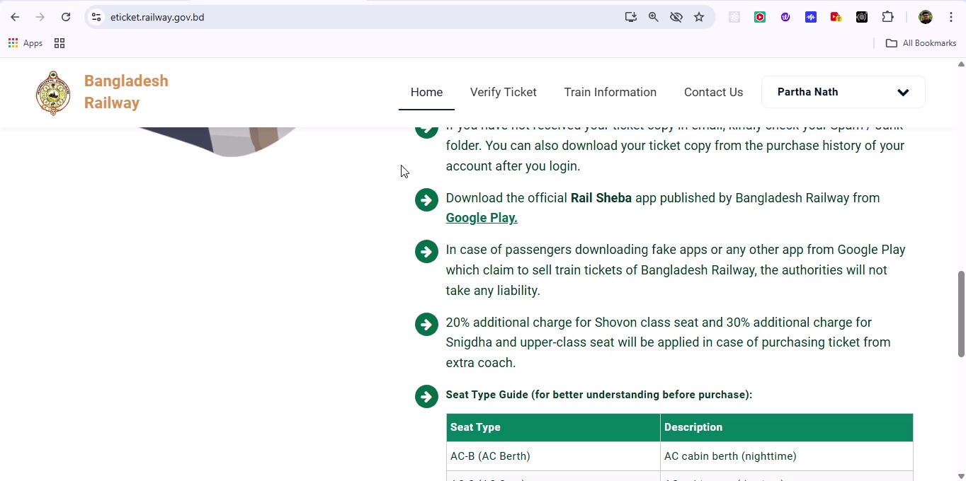

## Screenshot 272

Additional workflow step captured; refer to screenshot for details.

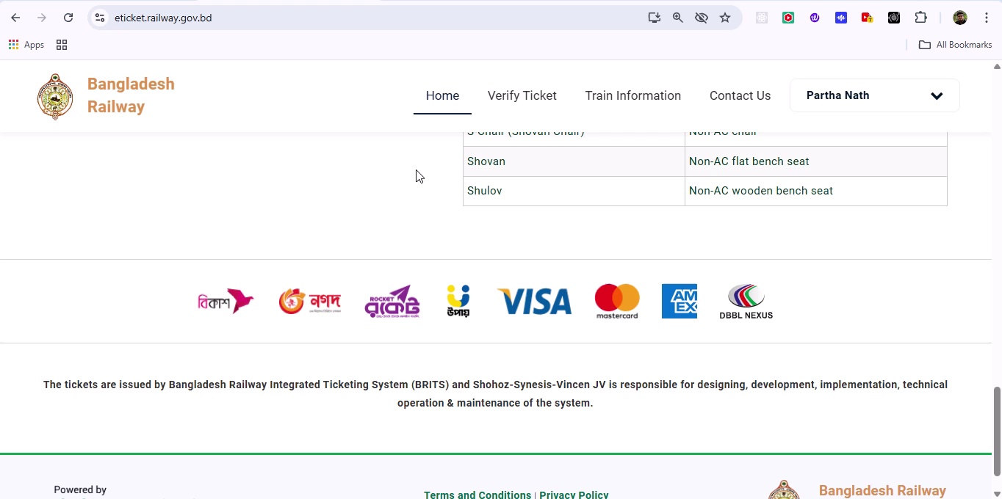

## Screenshot 273

Additional workflow step captured; refer to screenshot for details.

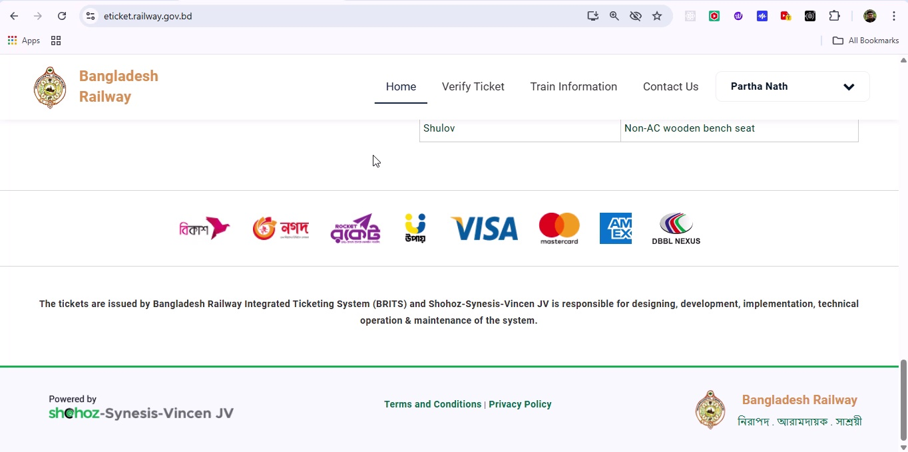

## Screenshot 274

Additional workflow step captured; refer to screenshot for details.

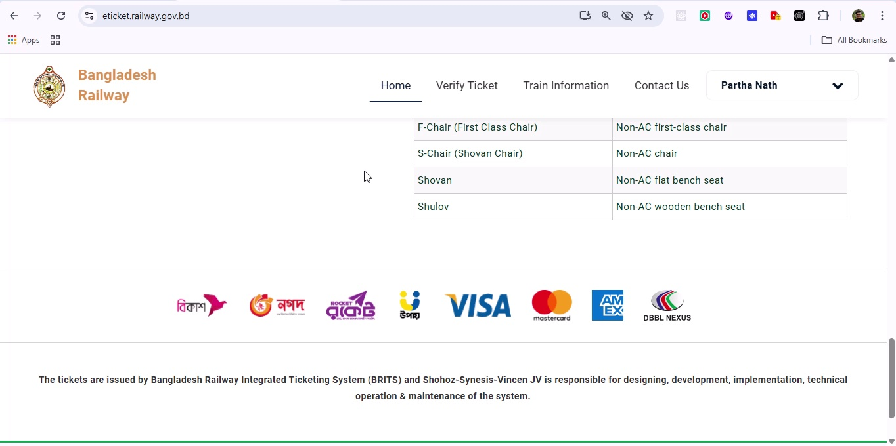

## Screenshot 275

Additional workflow step captured; refer to screenshot for details.

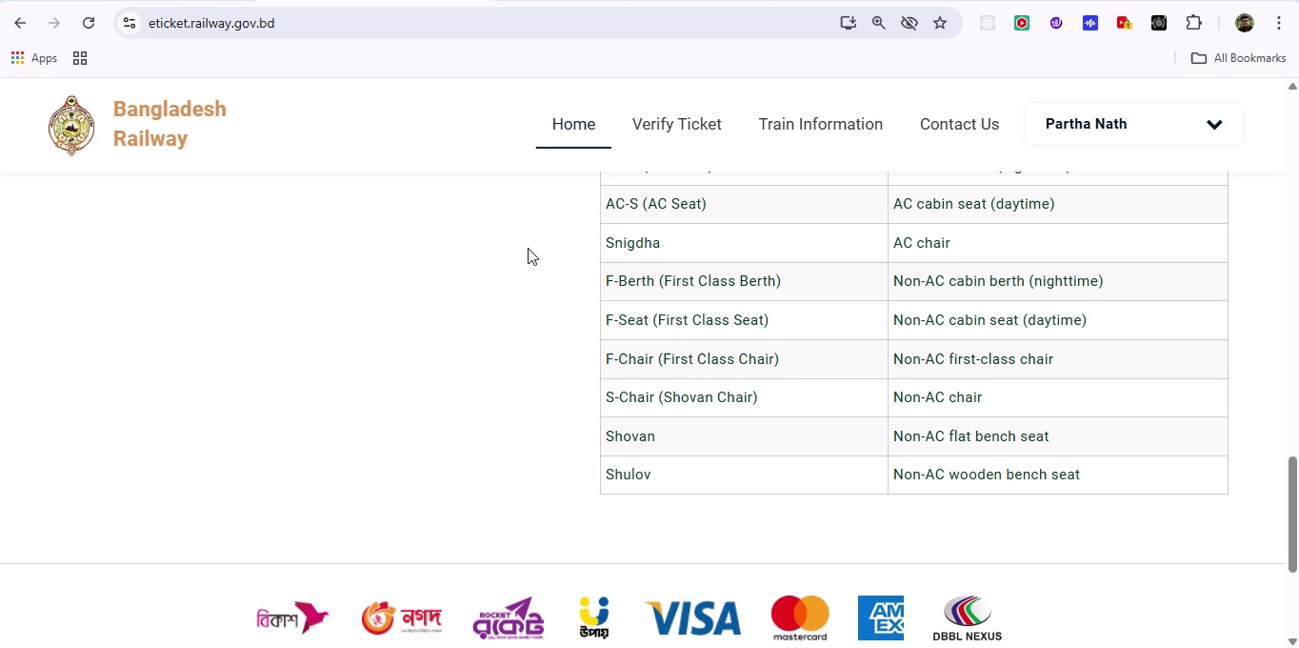

## Screenshot 276

Additional workflow step captured; refer to screenshot for details.

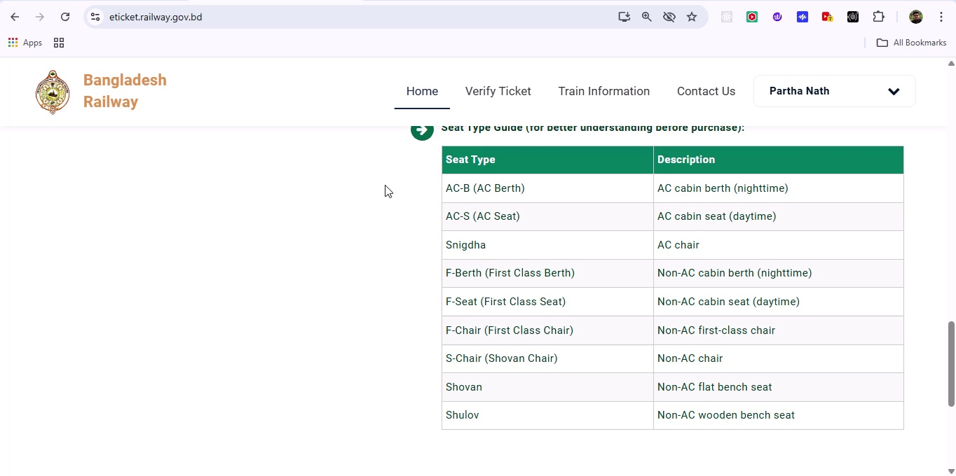

## Screenshot 277

Additional workflow step captured; refer to screenshot for details.

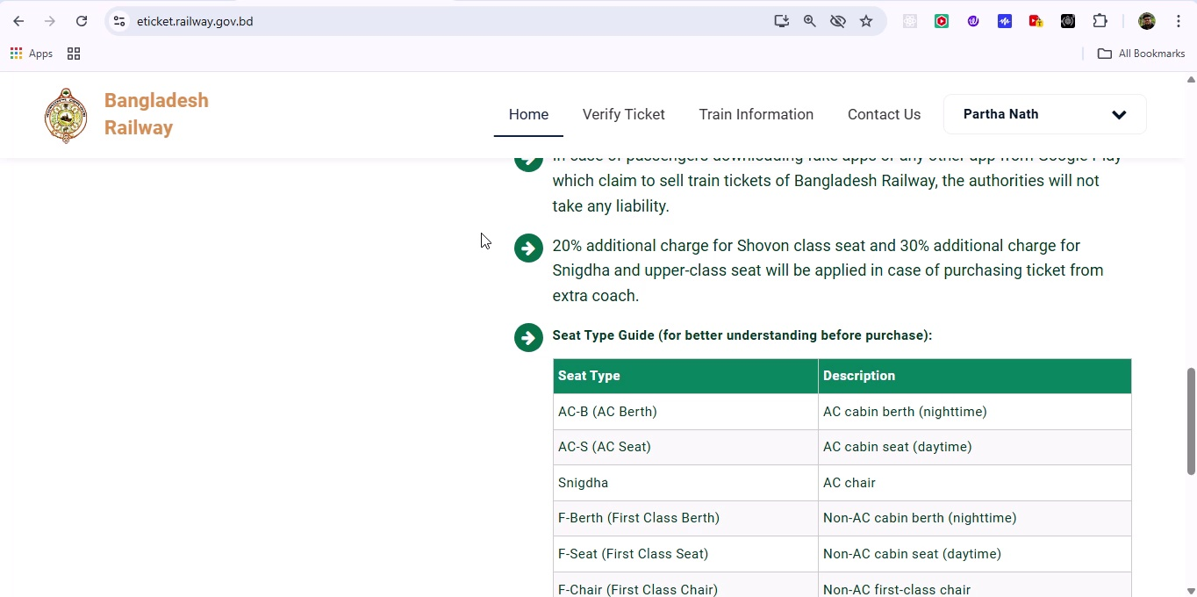

## Screenshot 278

Additional workflow step captured; refer to screenshot for details.

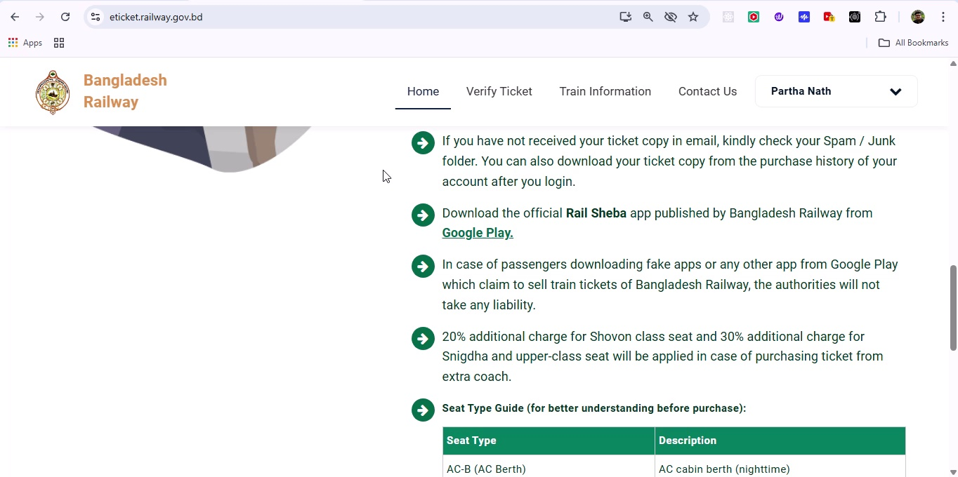

## Screenshot 279

Additional workflow step captured; refer to screenshot for details.

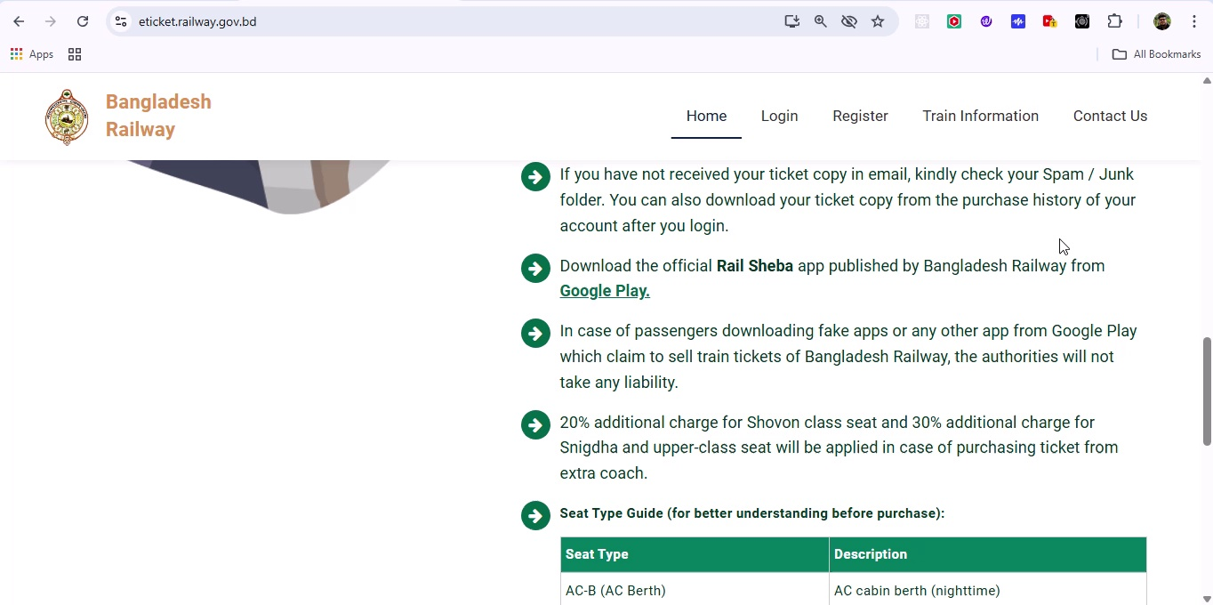

## Screenshot 280

Additional workflow step captured; refer to screenshot for details.

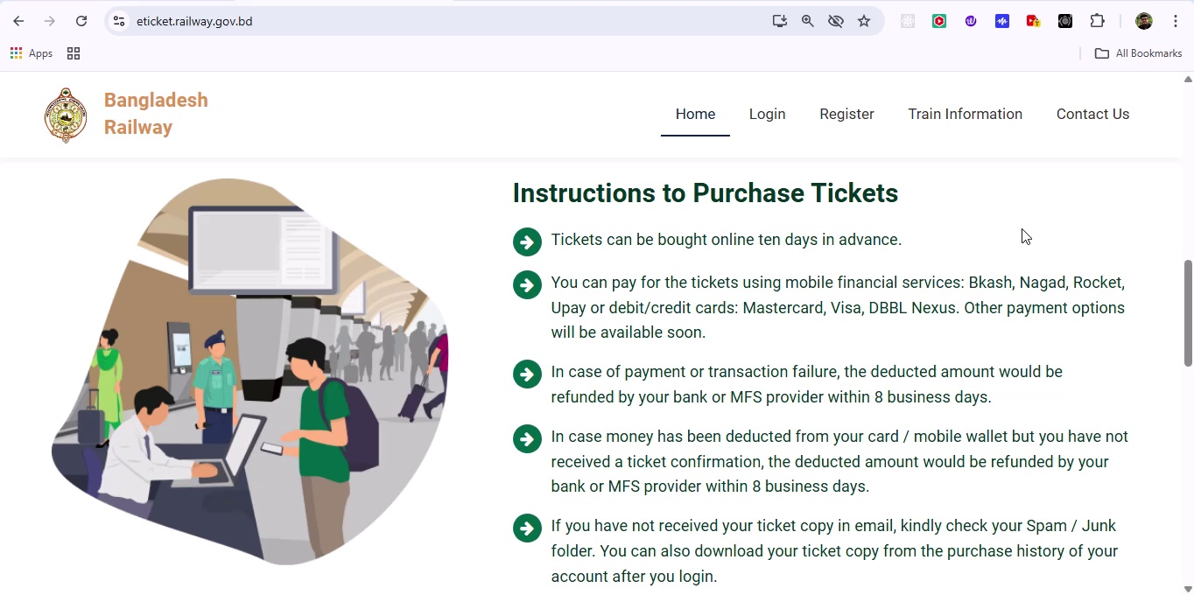

## Screenshot 281

Additional workflow step captured; refer to screenshot for details.

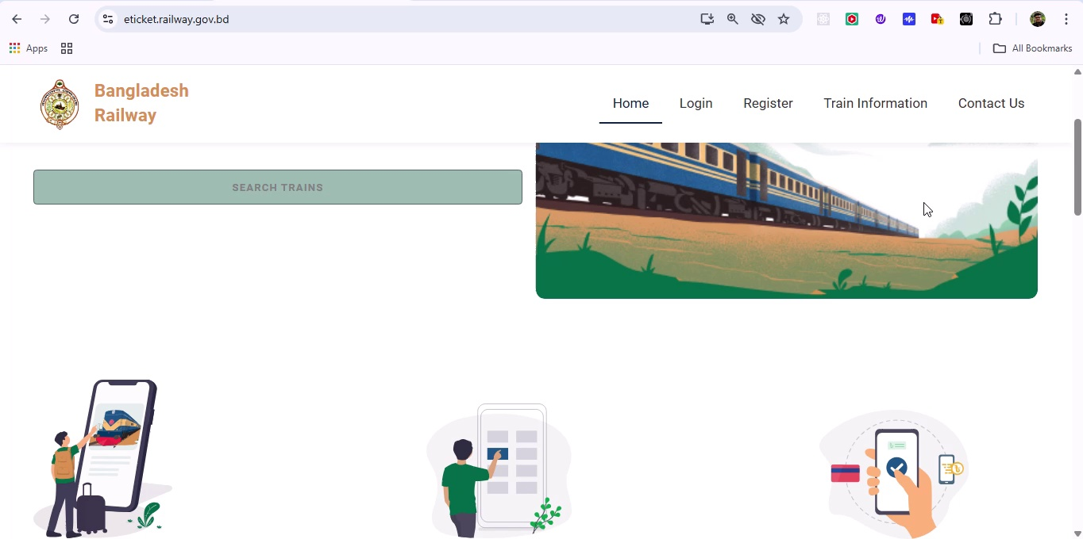

## Screenshot 282

Additional workflow step captured; refer to screenshot for details.

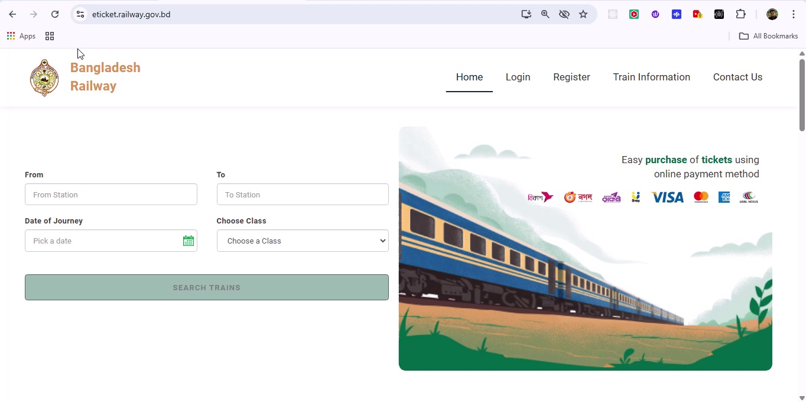

## Screenshot 283

Additional workflow step captured; refer to screenshot for details.

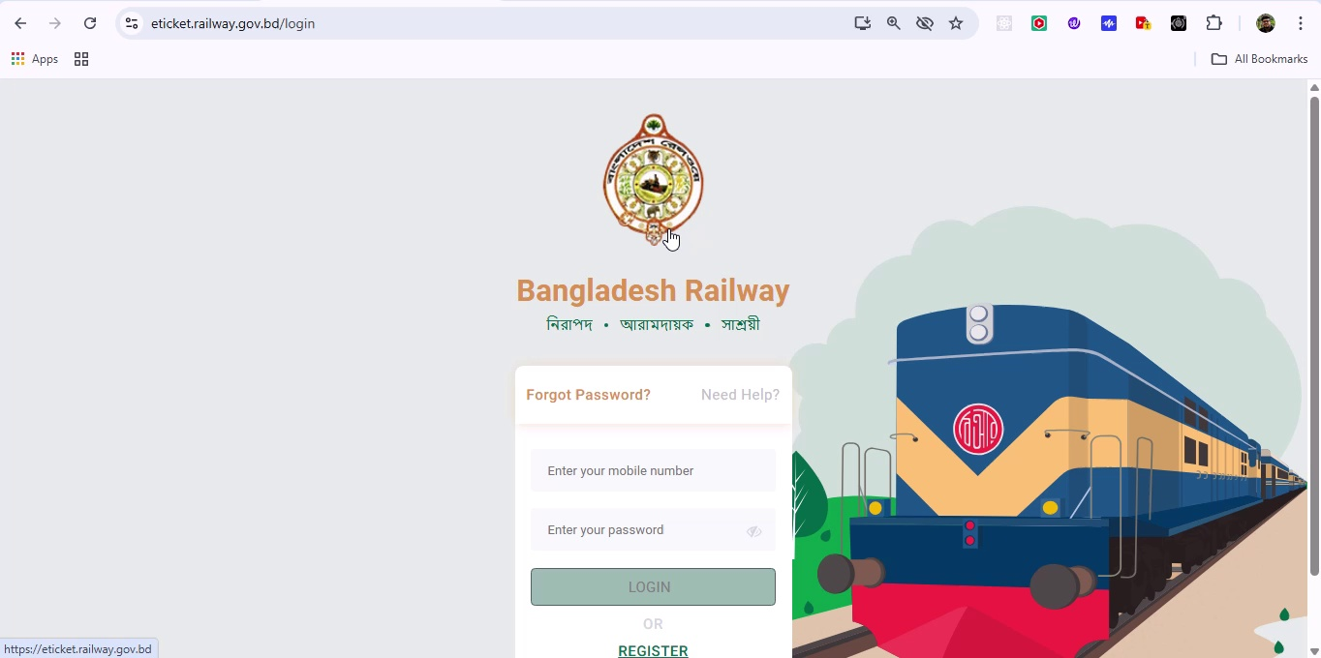

## Screenshot 284

Additional workflow step captured; refer to screenshot for details.

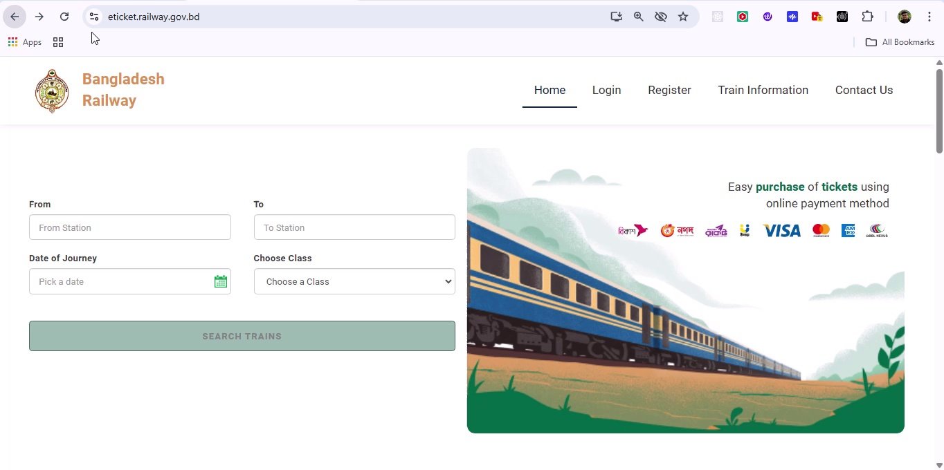

## Screenshot 285

Additional workflow step captured; refer to screenshot for details.

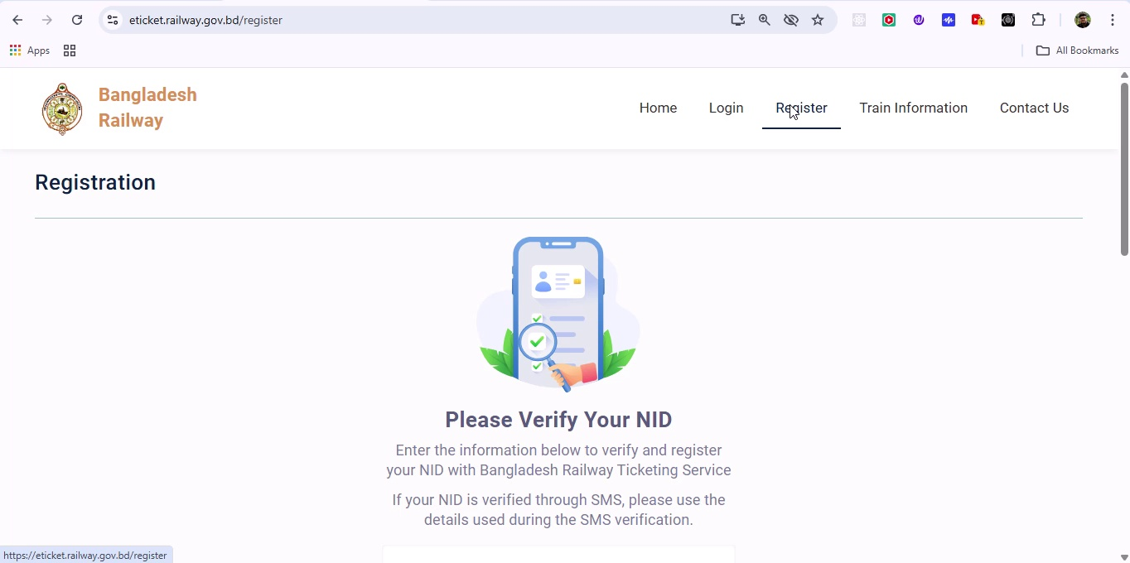

## Screenshot 286

Additional workflow step captured; refer to screenshot for details.

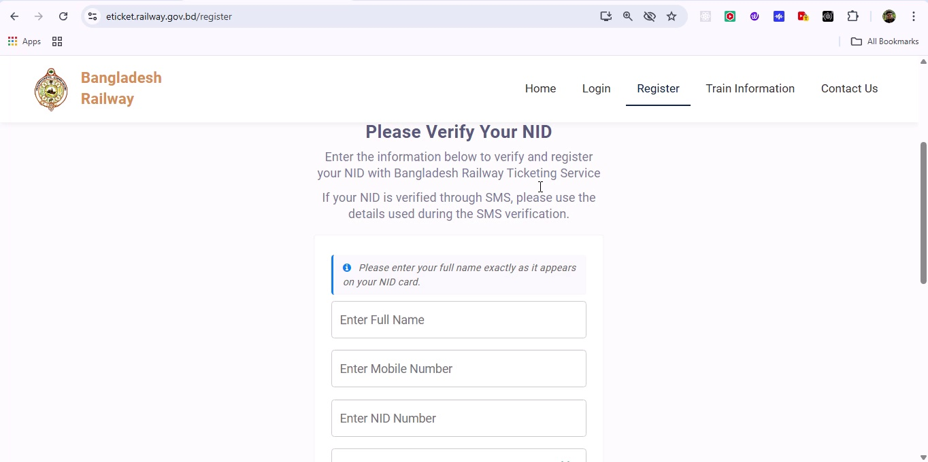

## Screenshot 287

Additional workflow step captured; refer to screenshot for details.

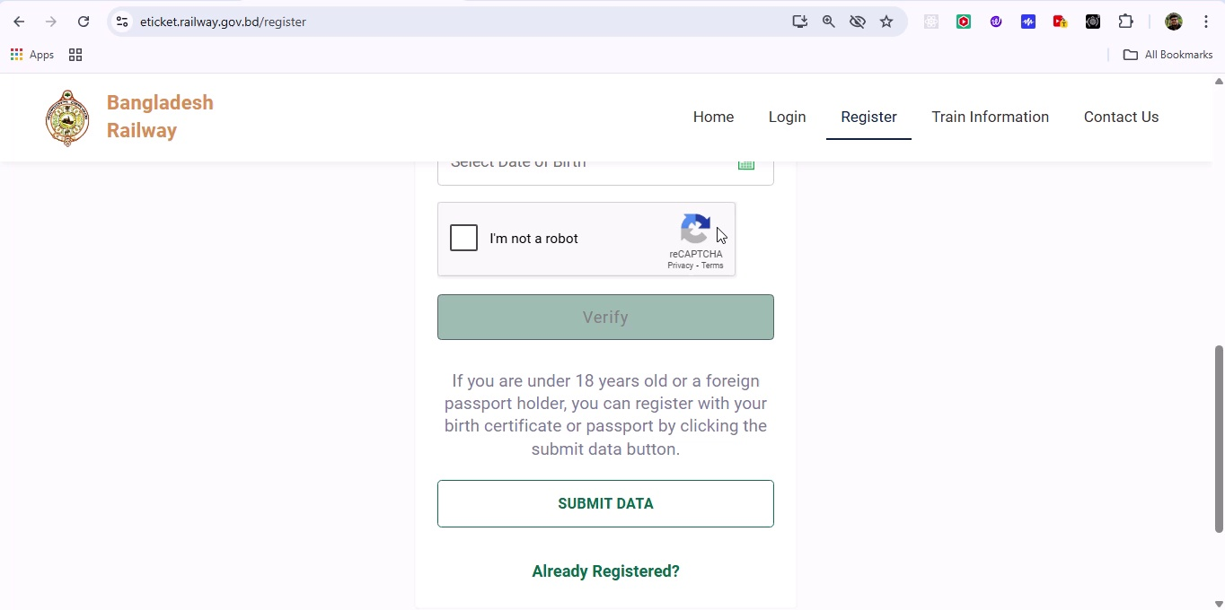

## Screenshot 288

Additional workflow step captured; refer to screenshot for details.

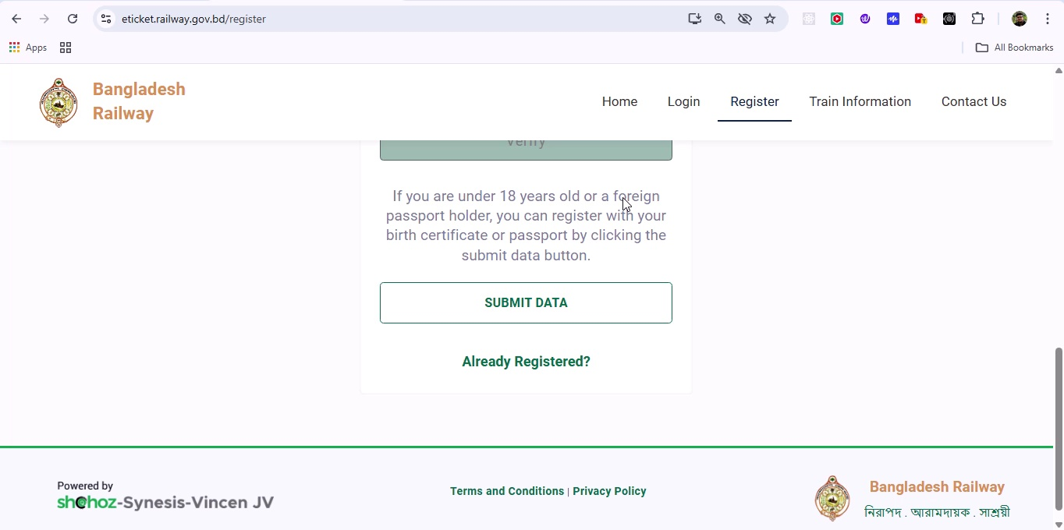

## Screenshot 289

Additional workflow step captured; refer to screenshot for details.

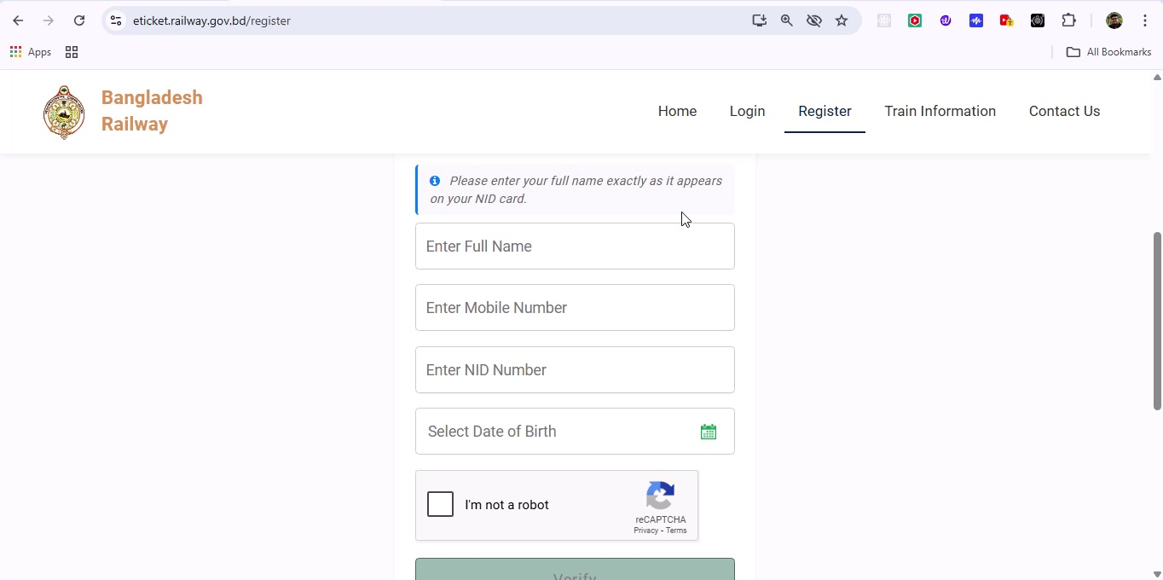

## Screenshot 290

Additional workflow step captured; refer to screenshot for details.

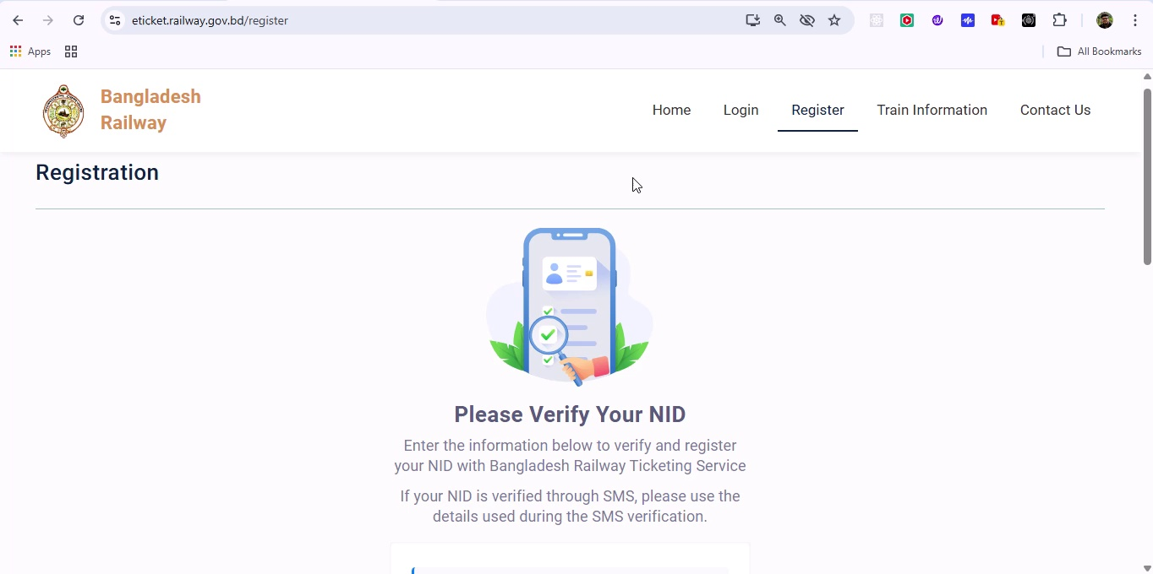

## Screenshot 291

Additional workflow step captured; refer to screenshot for details.

